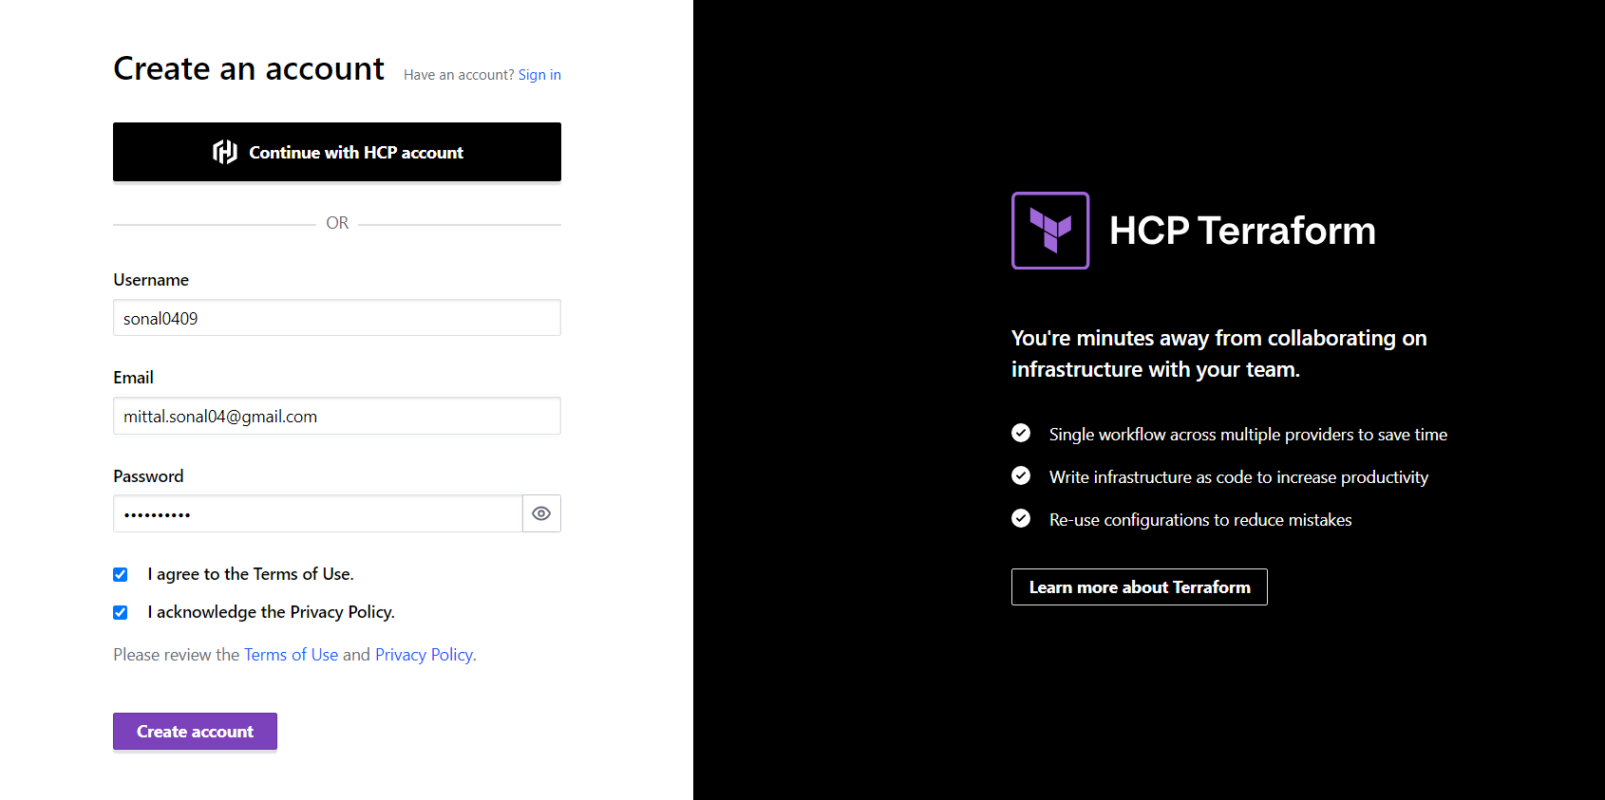

You will get confirmation email. Click on the link

Create the organizations

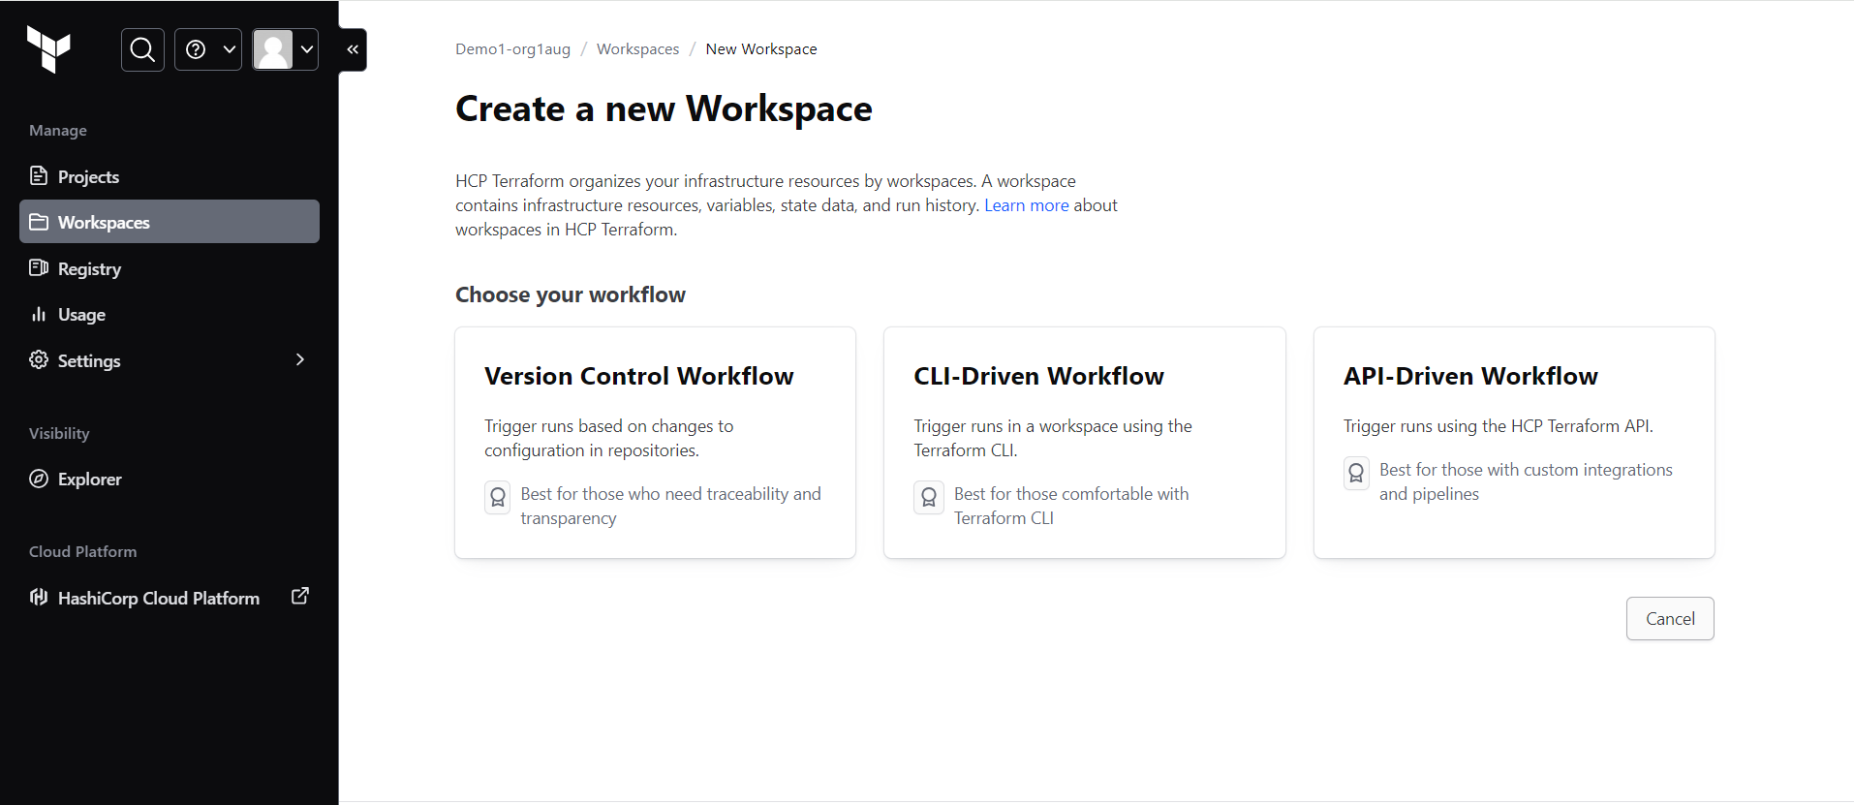

Select version control workflow

Create a workspace

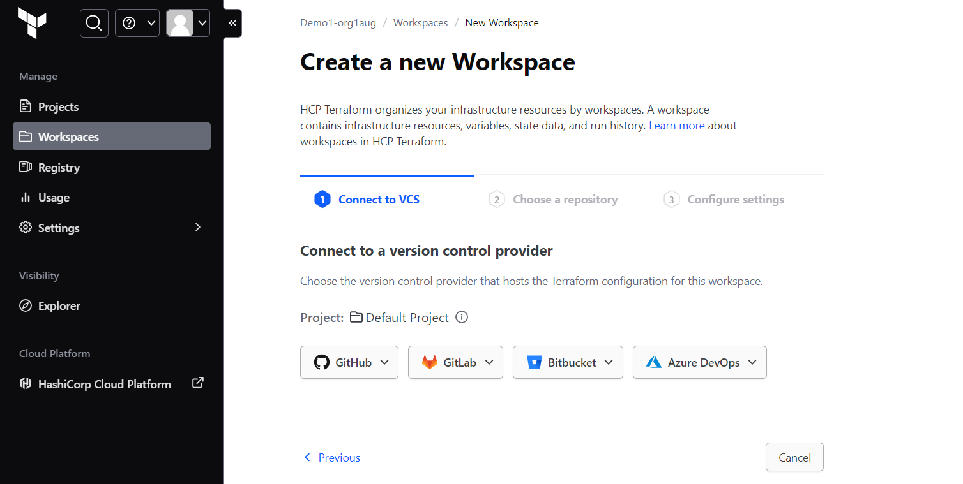

Select github.com and authorize terraform cloud

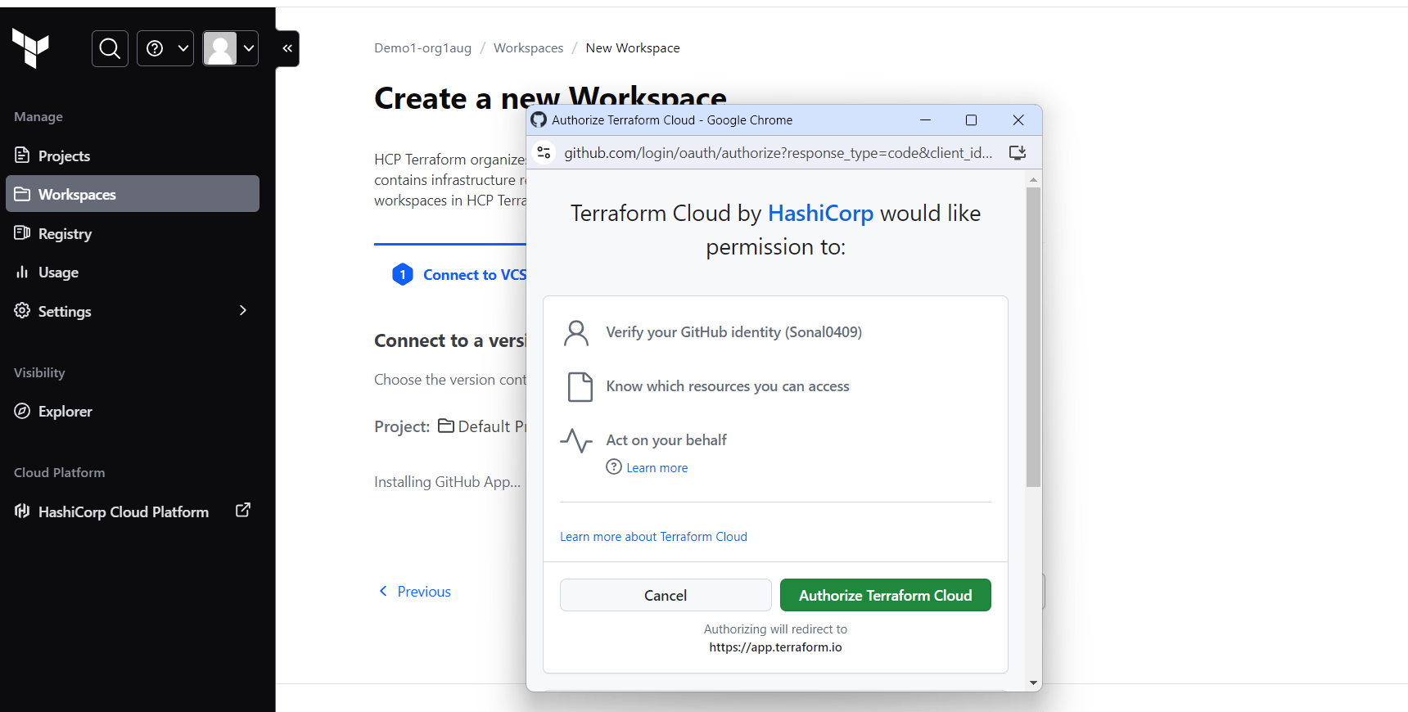

Allow pop up block

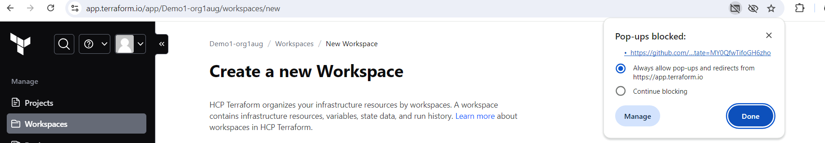

Select you github repo name

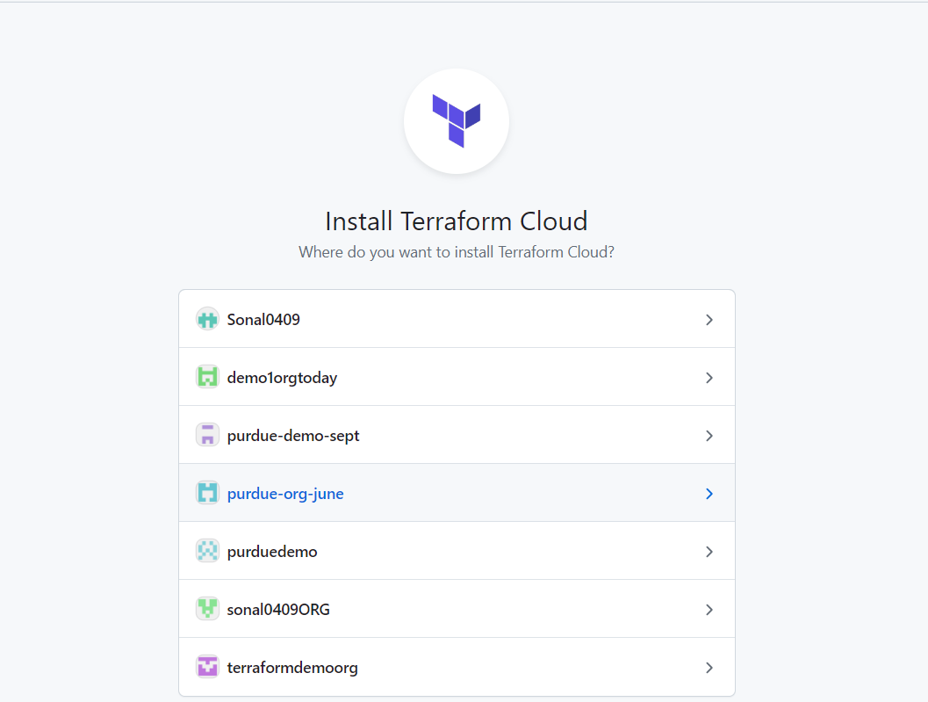

Select only selected repositories

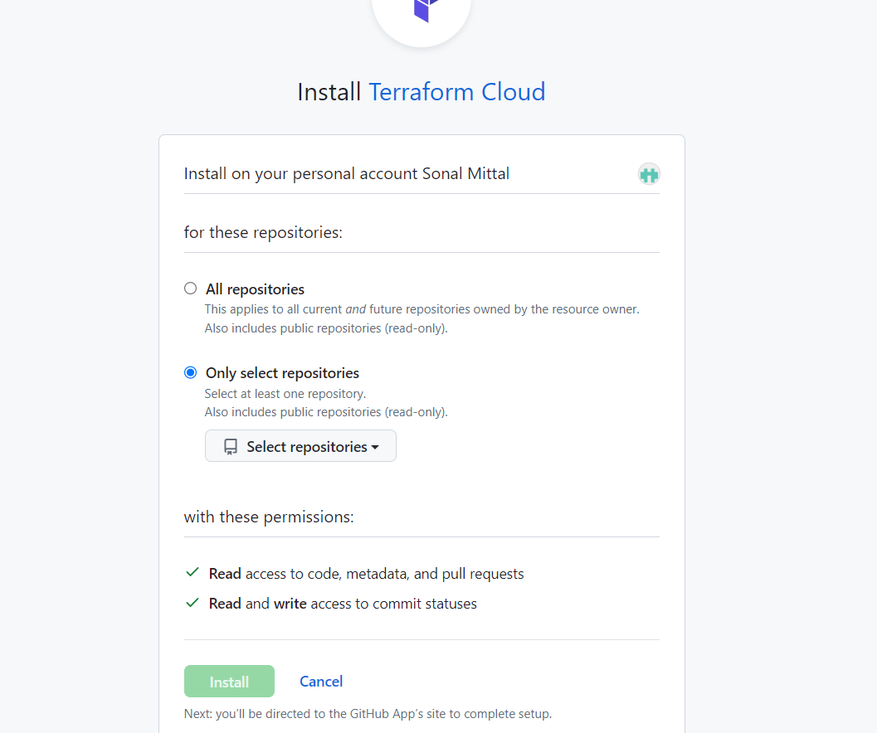

Select the repository

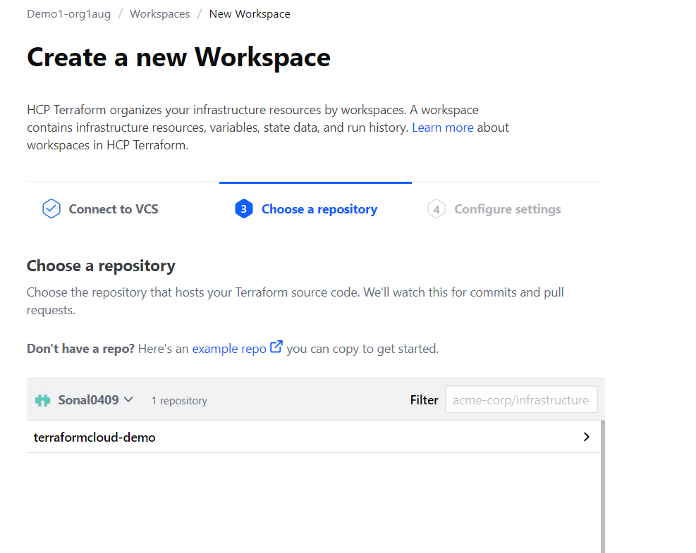

Create a workspace

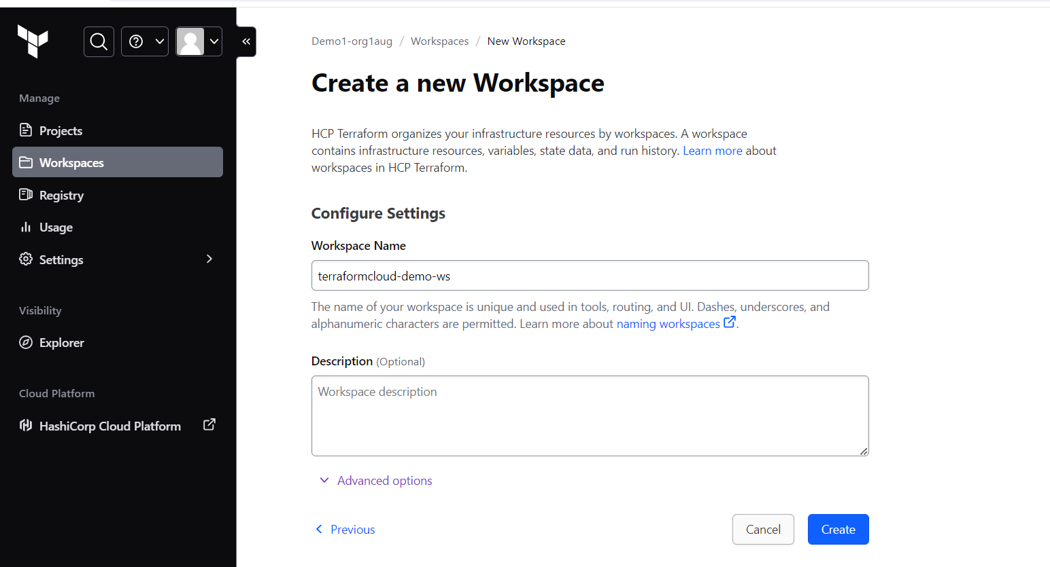

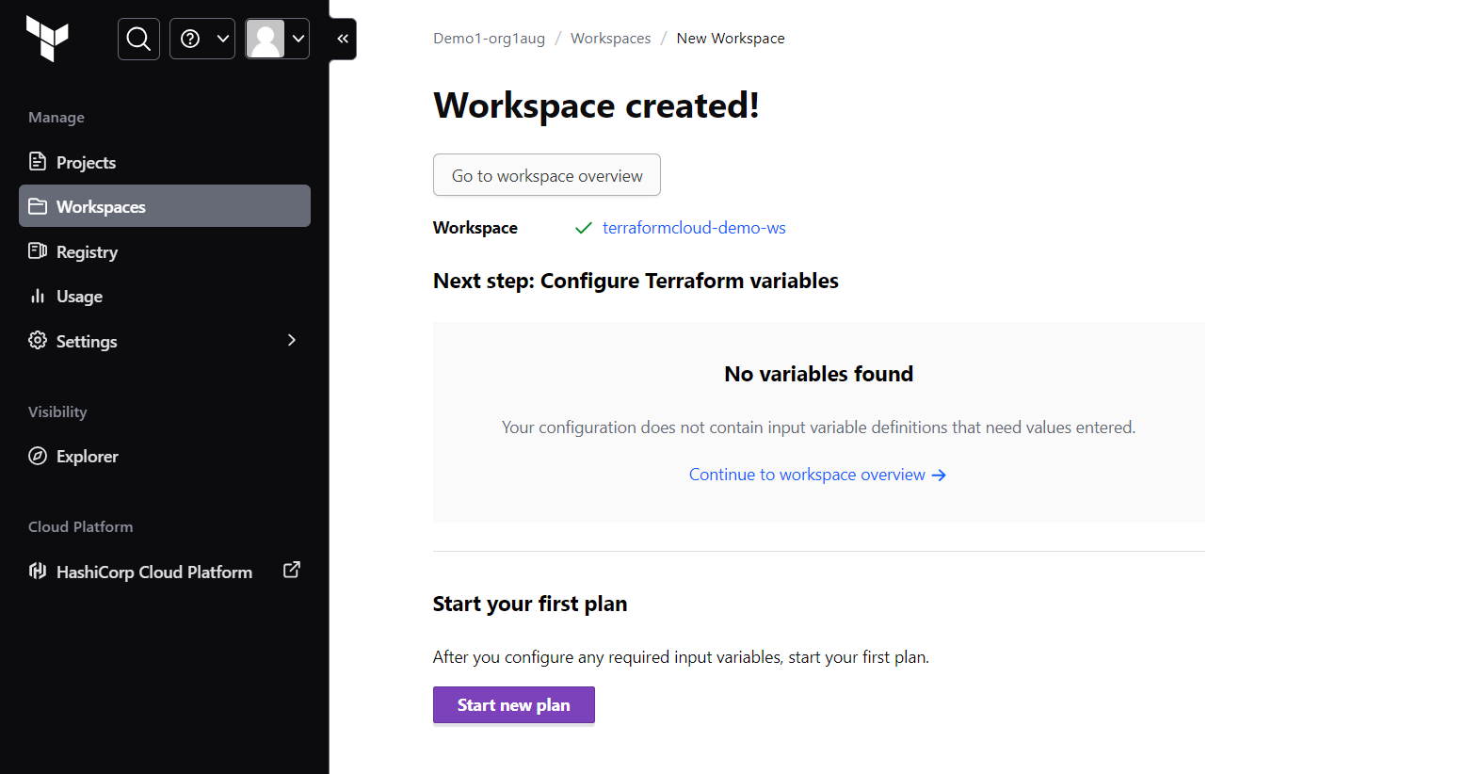

Create Variables:

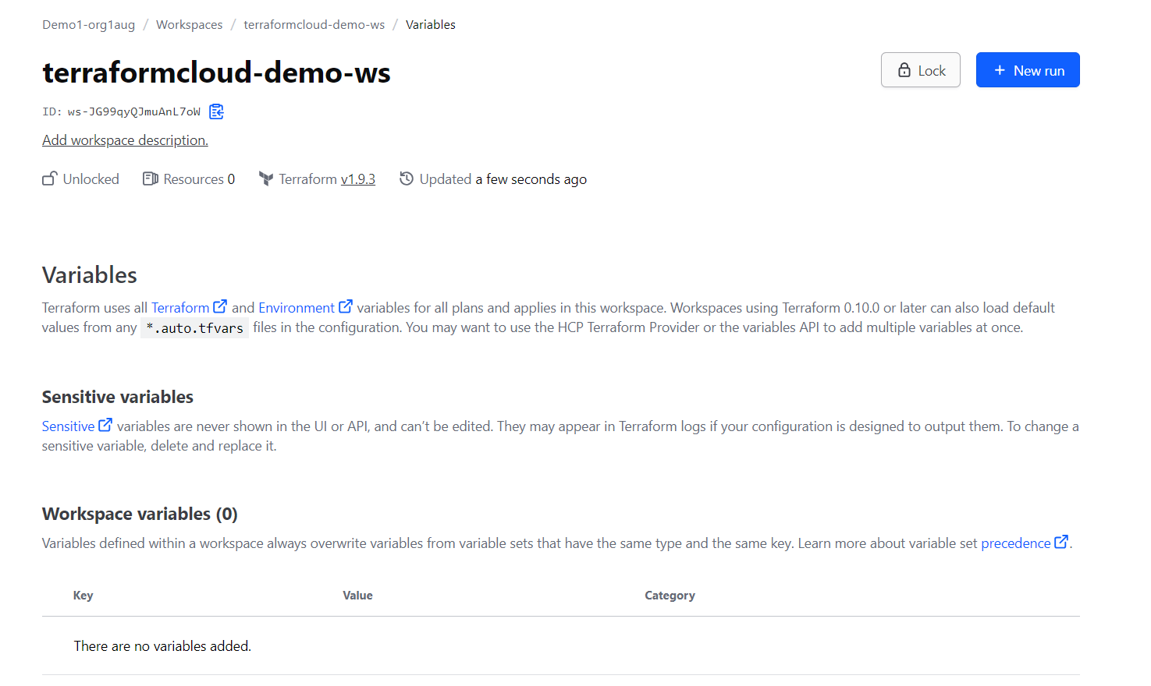

Click on add variable by scrolling down and select environment variable

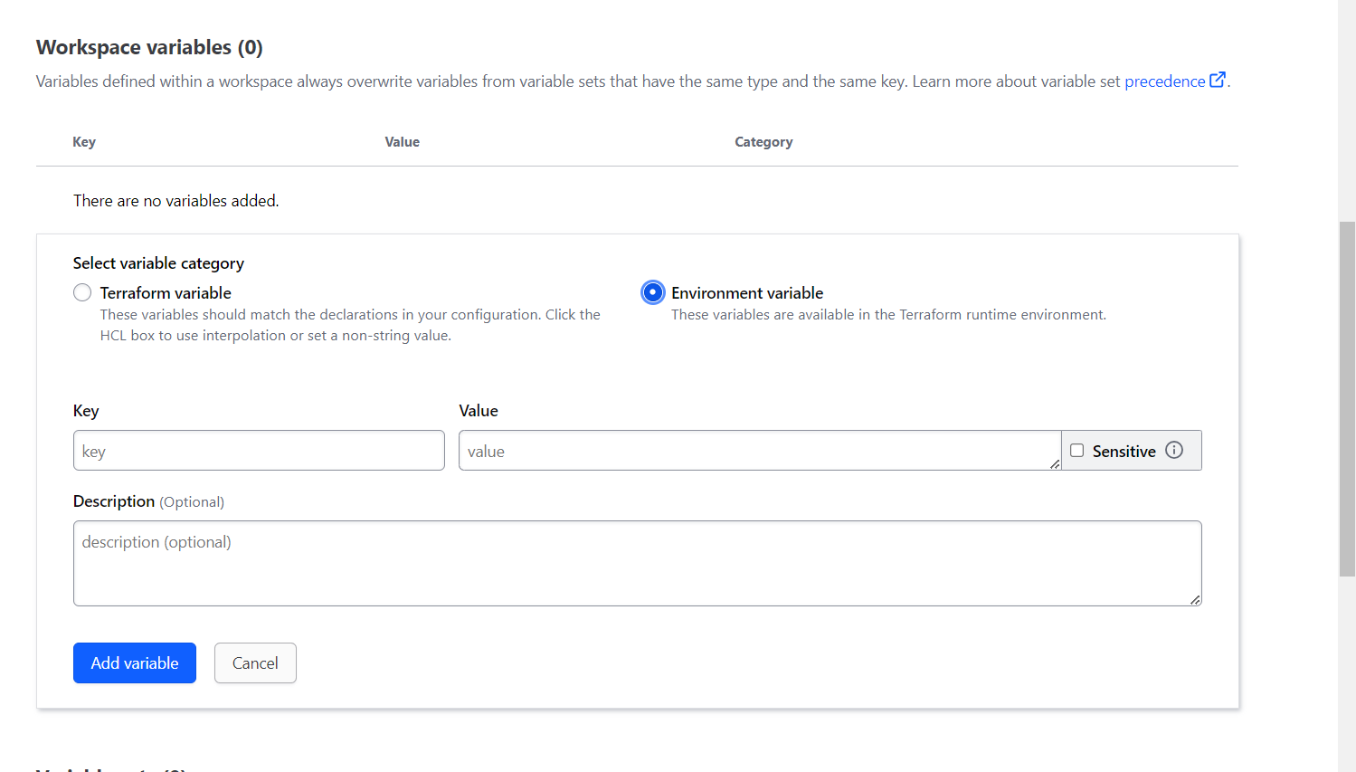

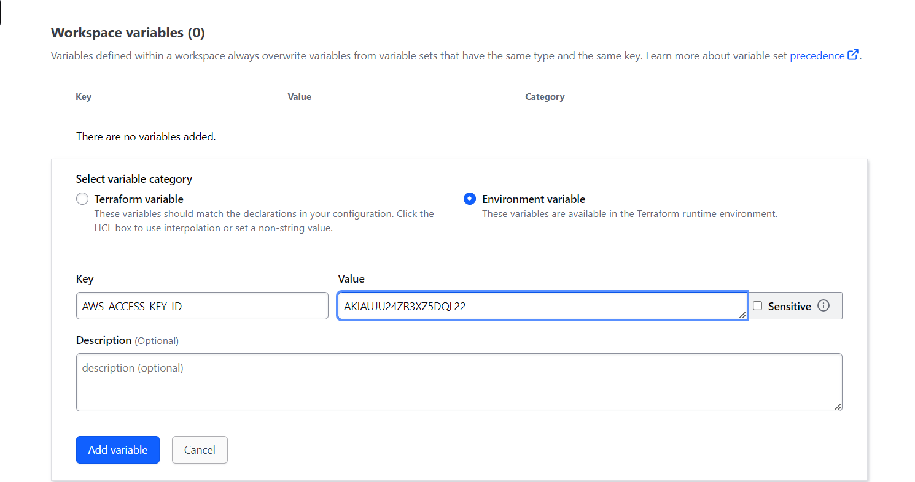

Click on add variable for secret access key -> select as environment variable and mark it as sensitive

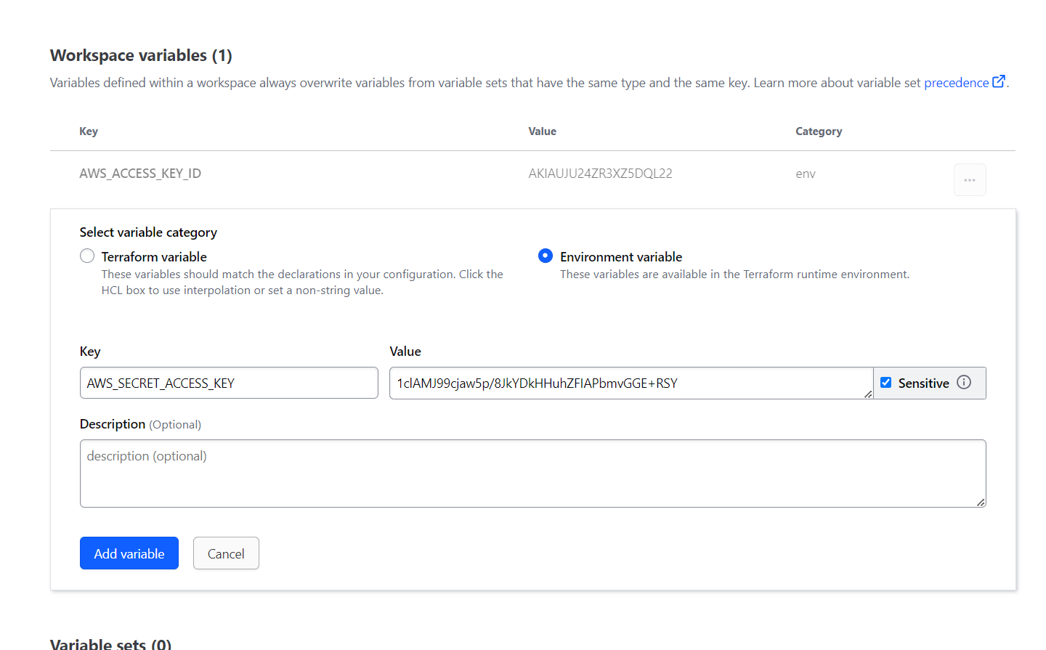

Click on Save variables.

Now click on new run

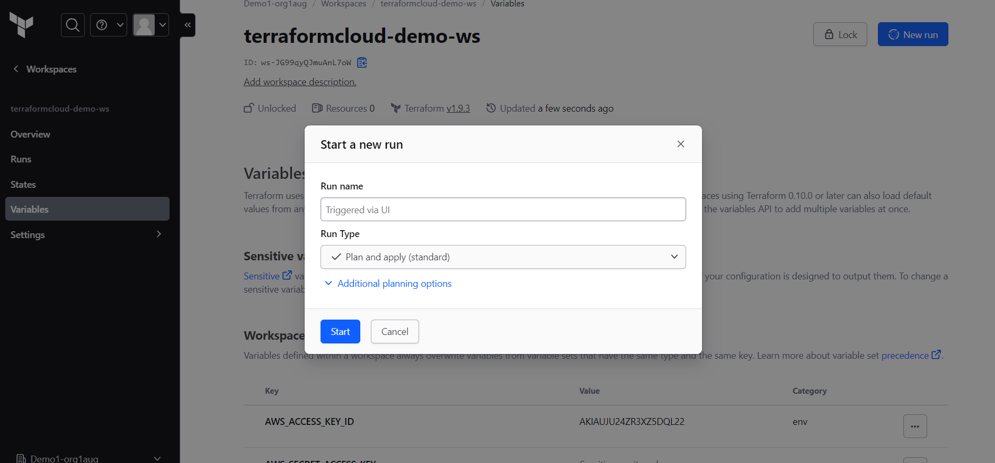

We select the default run type -> plan and apply

Click on start

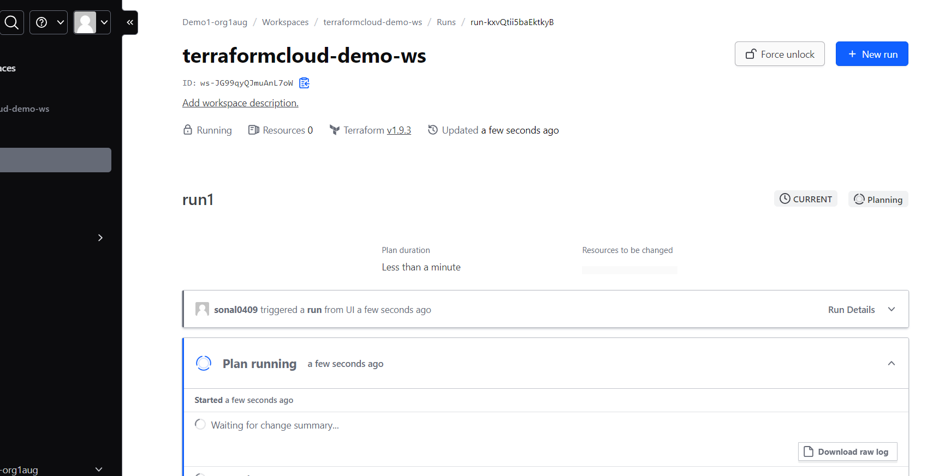

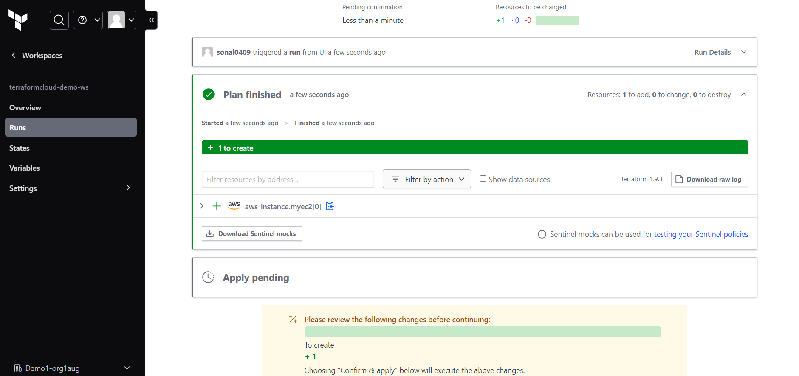

Click on confirm and apply

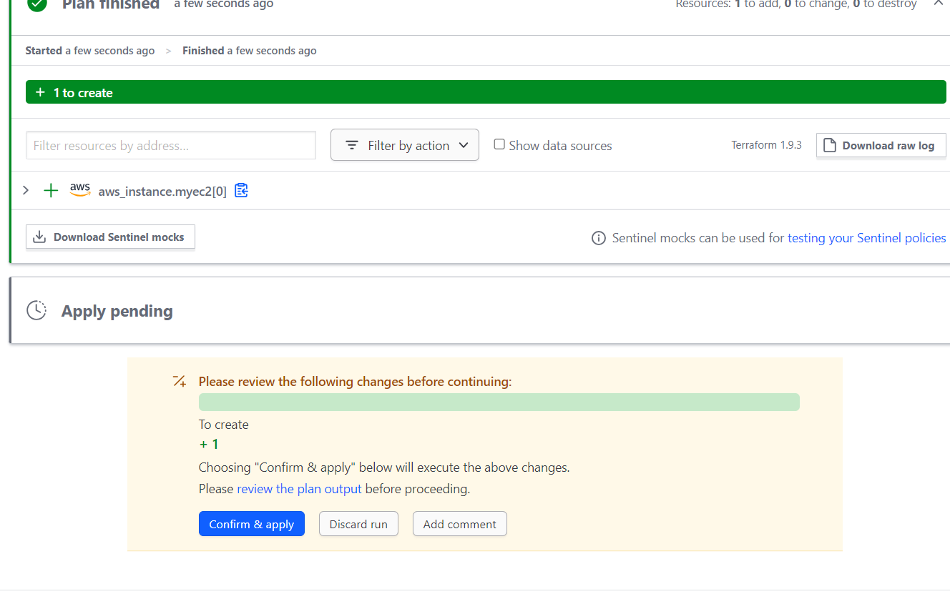

Sentinal Policy

Go to organization 🡪settings🡪 policySets

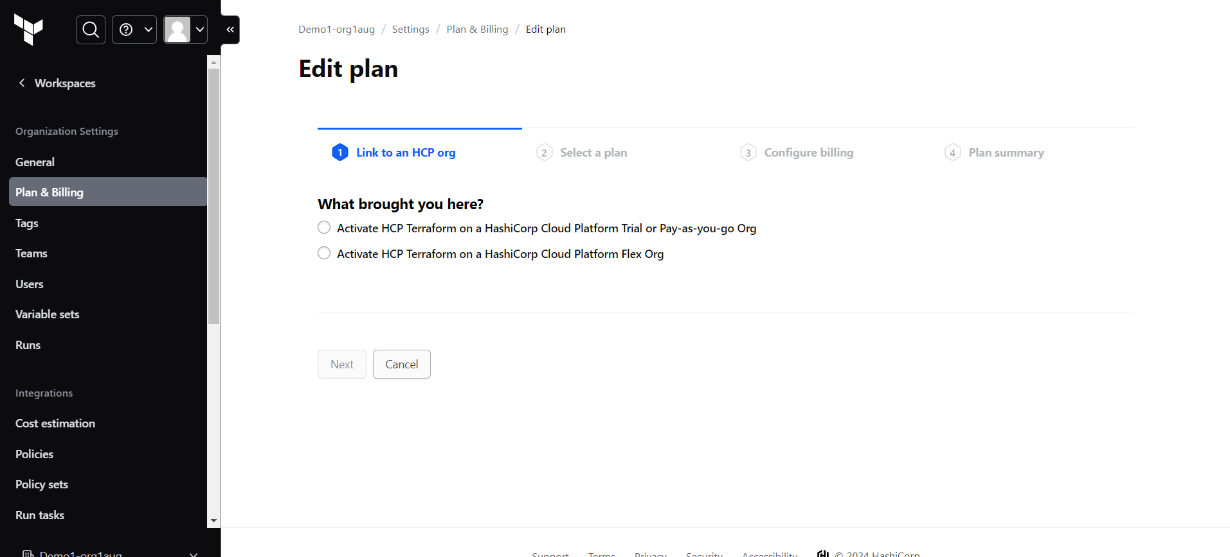

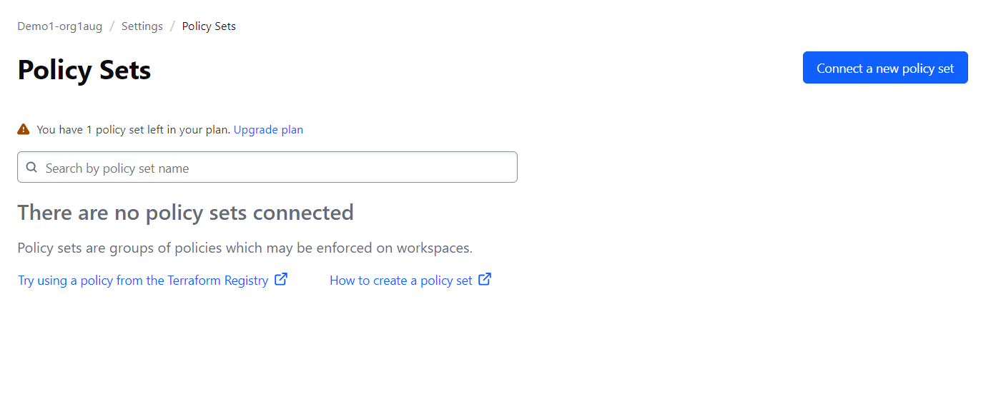

Click on new policy set 🡪 Click on Connect a new policy set

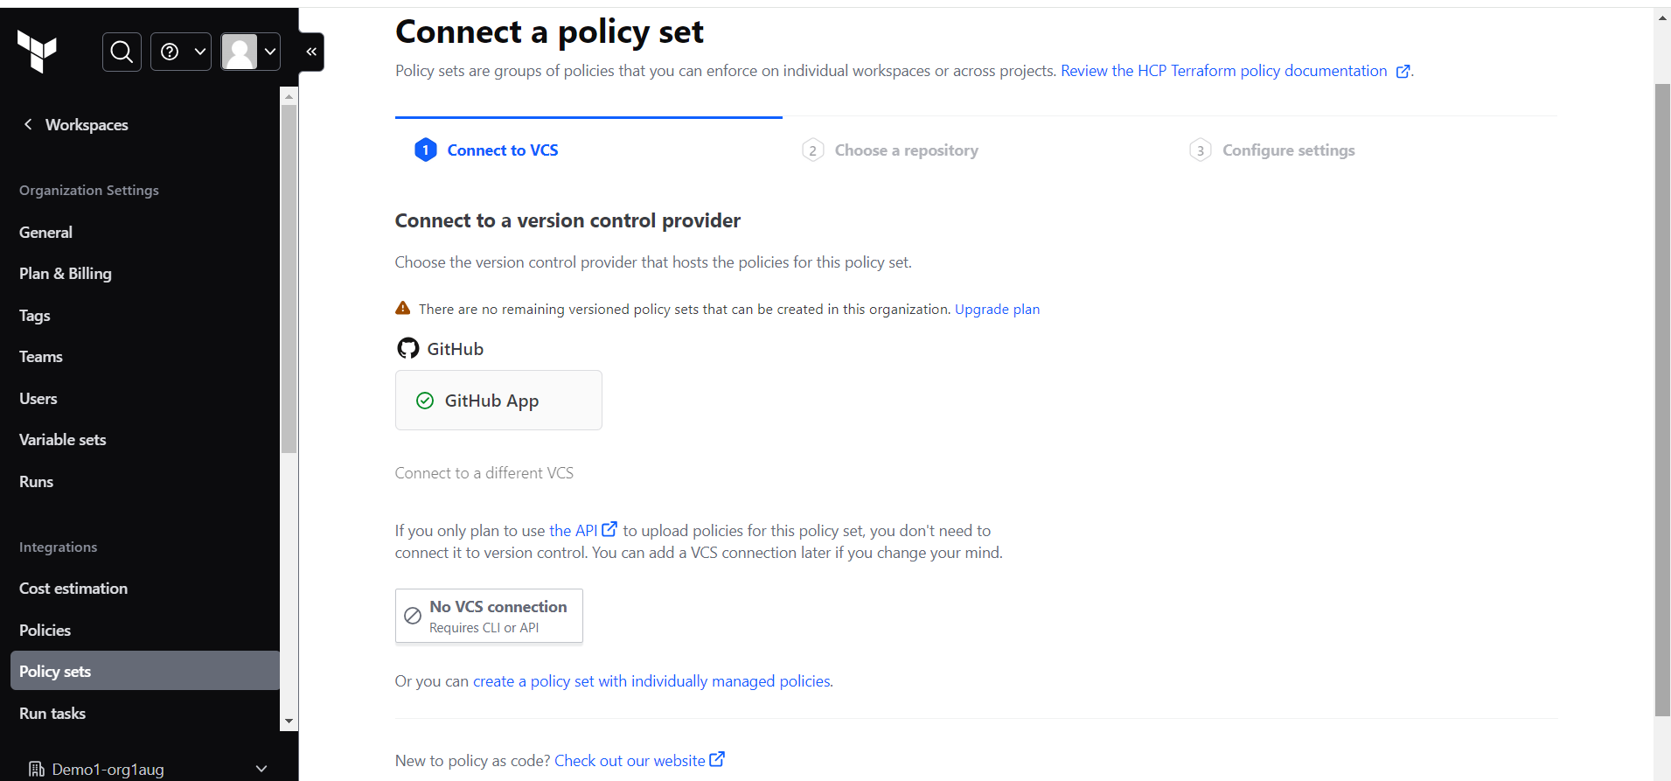

Click on No VCS connection

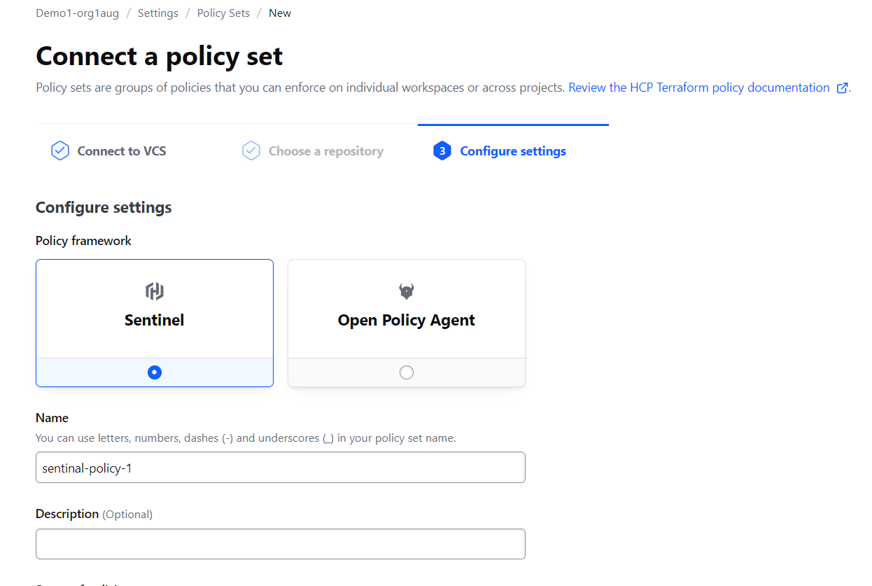

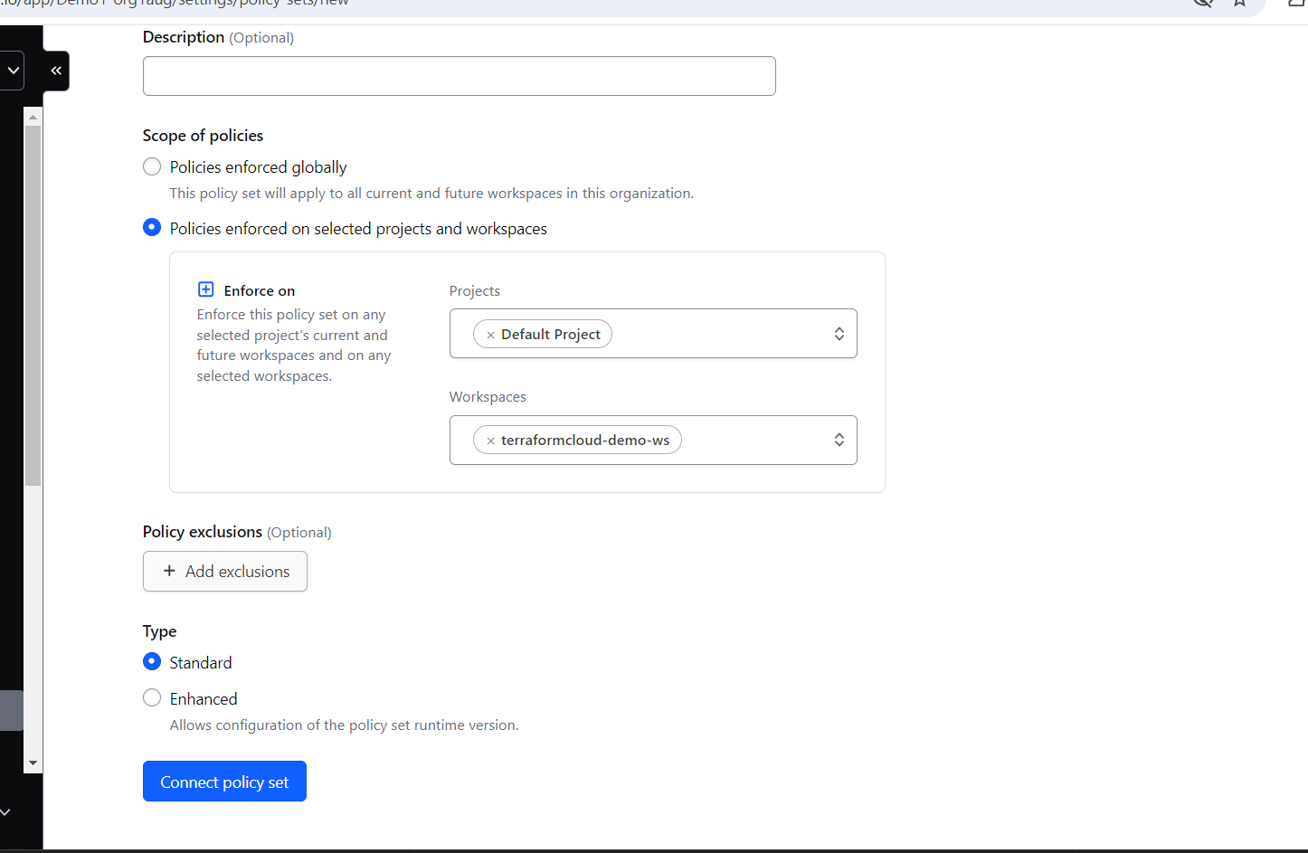

Now create a Policy

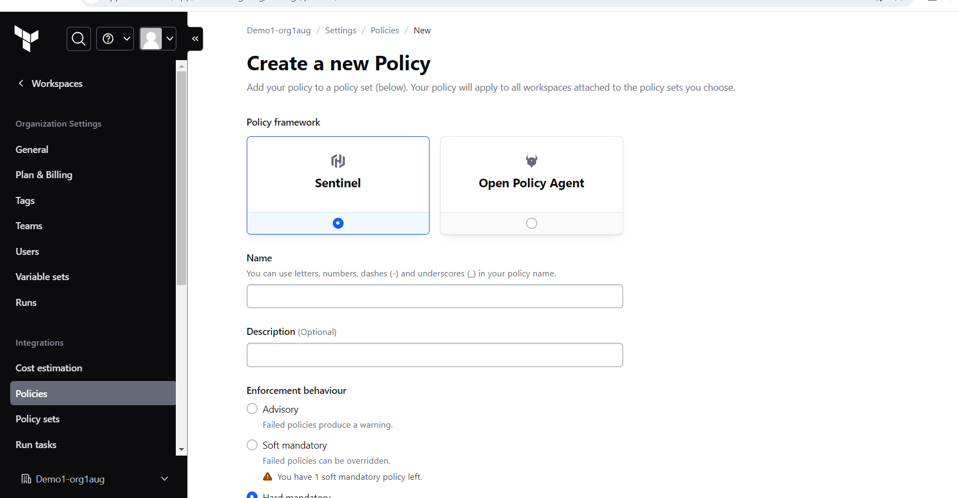

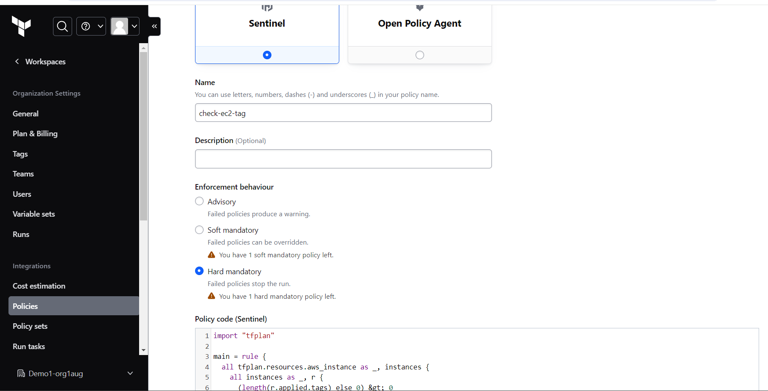

Add below policy code

import "tfplan"

main = rule {

all tfplan.resources.aws_instance as _, instances {

all instances as _, r {

(length(r.applied.tags) else 0) > 0

}

}

}

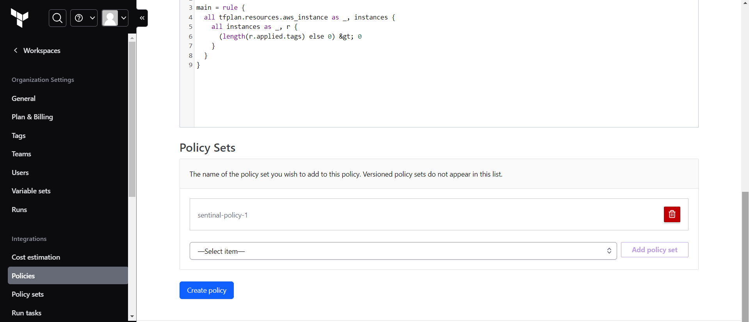

Select the policy set 🡪 Add policy Set

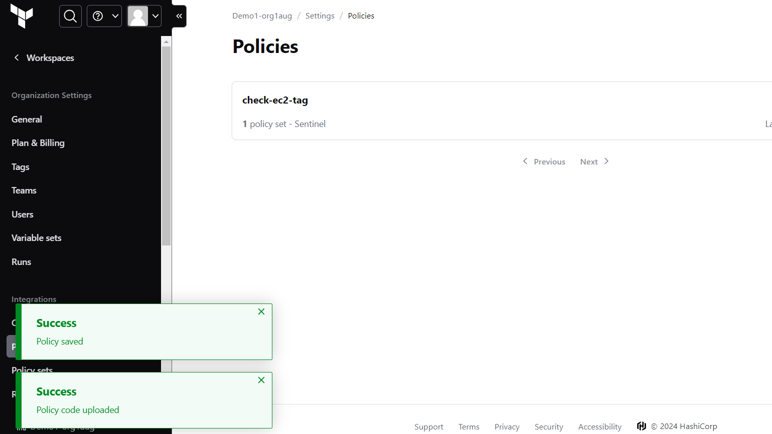

No click on workspace—Runs

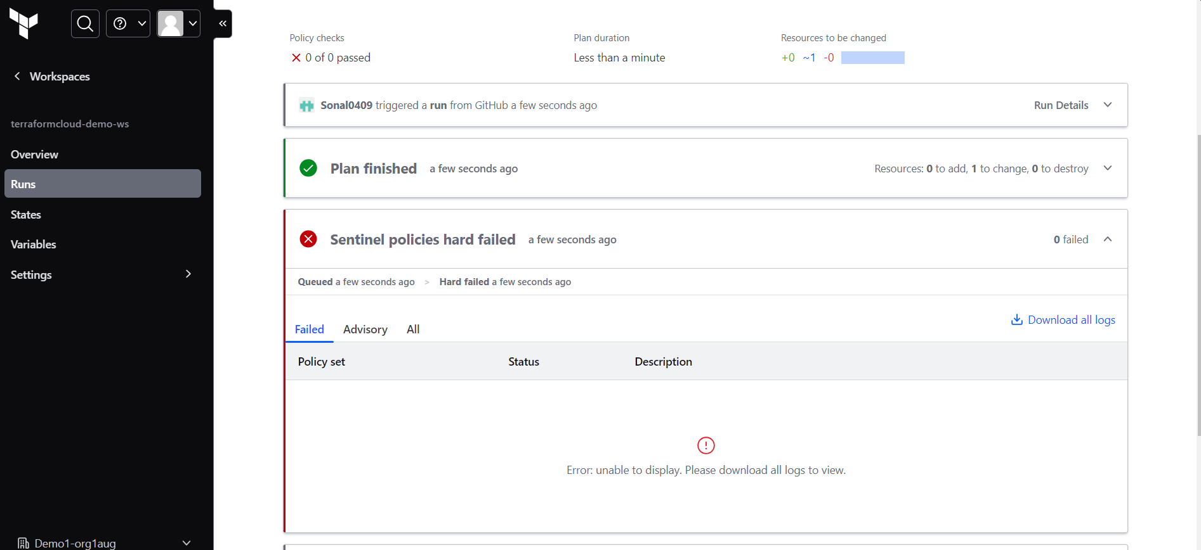

import "tfplan" as plan

# Discover any AWS VPCs in the Terraform plan

aws_vpc_in_plan = plan.find_resources("aws_vpc")

# Evaluate every VPC and validate that the cidr_block attribute starts with "10.*" using

# the filter_attribute_does_not_have_prefix function from the tfplan-functions module

violating_vpcs = plan.filter_attribute_does_not_have_prefix(

aws_vpc_in_plan,

"cidr_block",

"10.",

true,

)

main = rule {

length(violating_vpcs["messages"]) is 0

}