Step 1: Go to http://www.oracle.com/technetwork/java/javase/downloads/jdk8-downloads-2133151.html

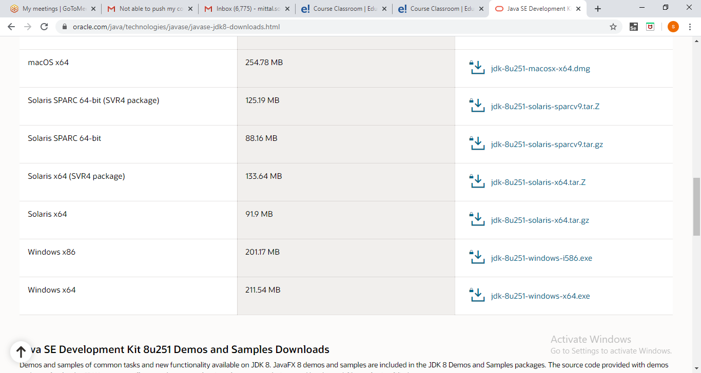

Step 2: Download Java SE Development Kit 8u251 for windowsx86 or Mac OS

Step 3: Accpet the licence and click on Download button

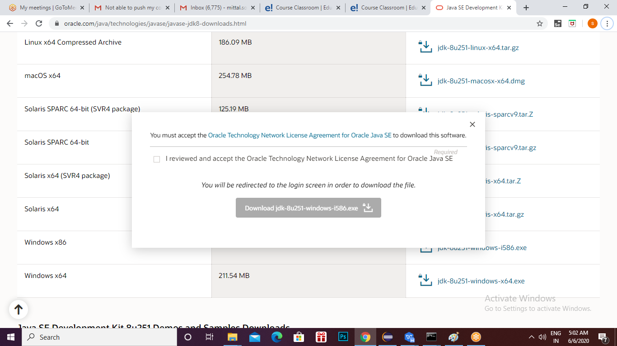

Step 4: It will take you to Oracle login page , Click on create account button to Create an Oracle User account with providing valid username, password and email id

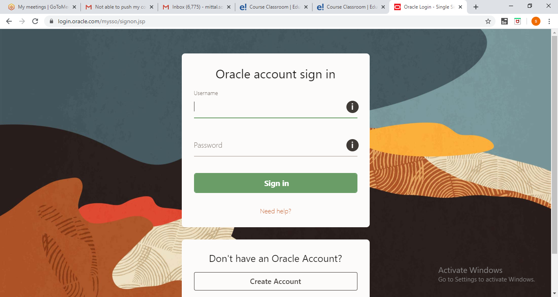

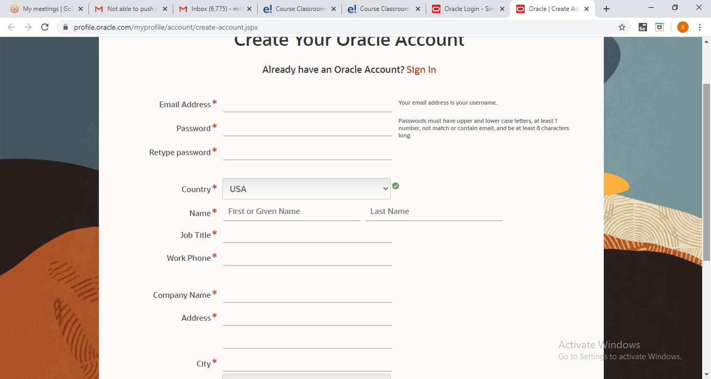

An activation email will be sent on your valid email, click on link provided in email and java will start downloading in your machine.

If download doesn’t starts on its on, go back to this oracle webpage <http://www.oracle.com/technetwork/java/javase/downloads/jdk8-downloads-2133151.html>

And select again to download java for mac or Windows machine, Accept the licence, click on download button, enter the username and password and loginto the oracle account. Download of Java will start.

java folder will be available in your C folder--> program files--->Java folder--Check for 2 folders jdk1.8.0 and jre1.8.0

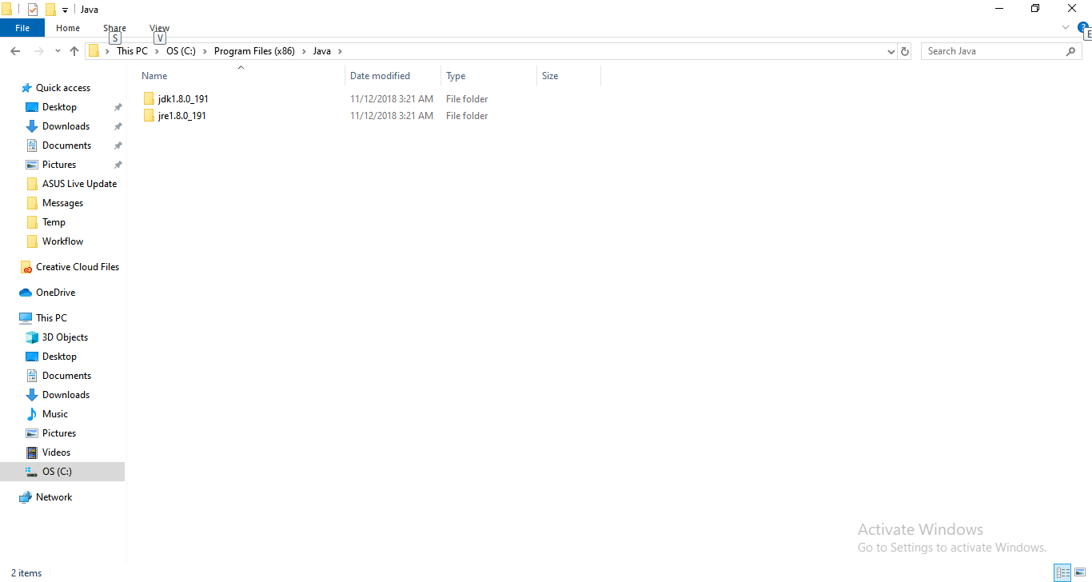

Java download is Complete.

Steps to Download Eclipse

Step1:

|  |
| --- |
| Go to https://www.eclipse.org/downloads/packages/release/oxygen/3a |

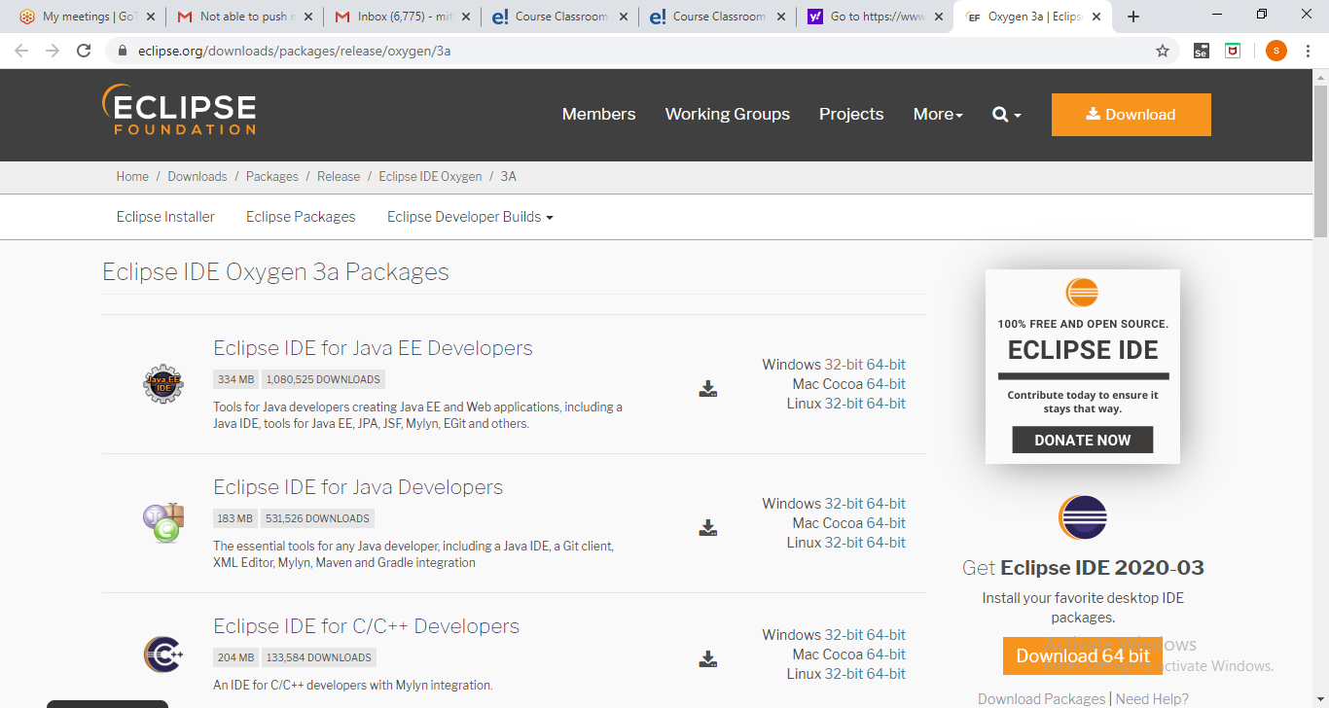

Step2: We recommend you to download Eclipse IDE for Java EE Developers

On the right side,

click on Windows 64-bit (if downloaded java 64 bit)

click on Windows 32-bit (if downloaded java x86 bit)

click on Mac Cocoa 64-bit for mac

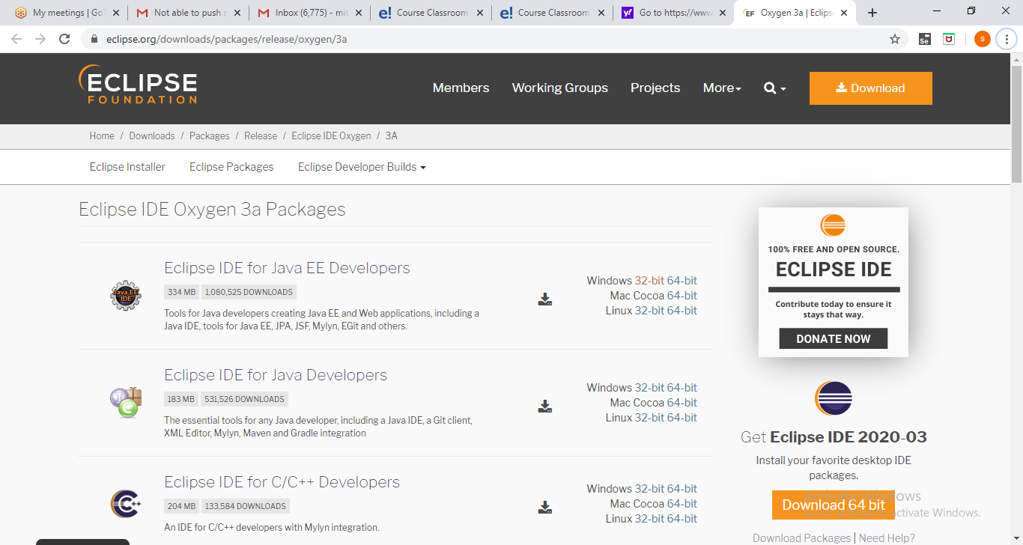

A zip file will be downloaded in your download folder of your machine. Extract the contents of the zip file in your C drive.

This how the folder structure looks like:

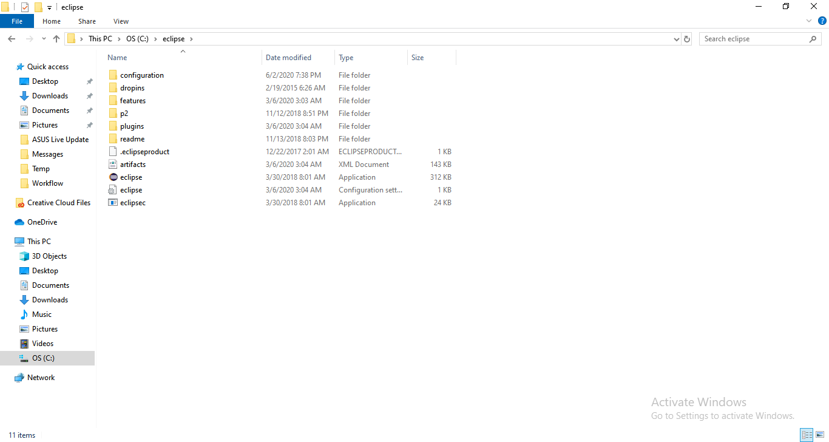

Double Click on eclipse application( shown in blue color circle with white stripes) to open eclipse

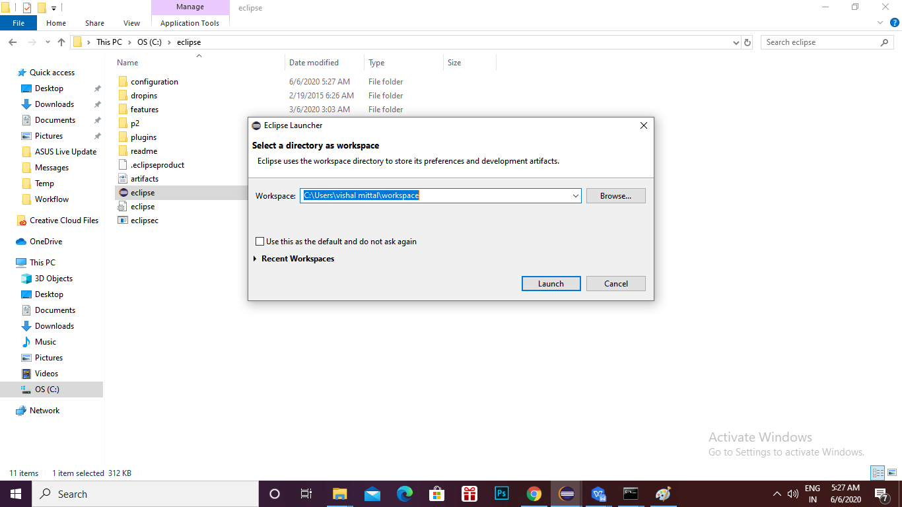

Click on launch button, to open Eclipse

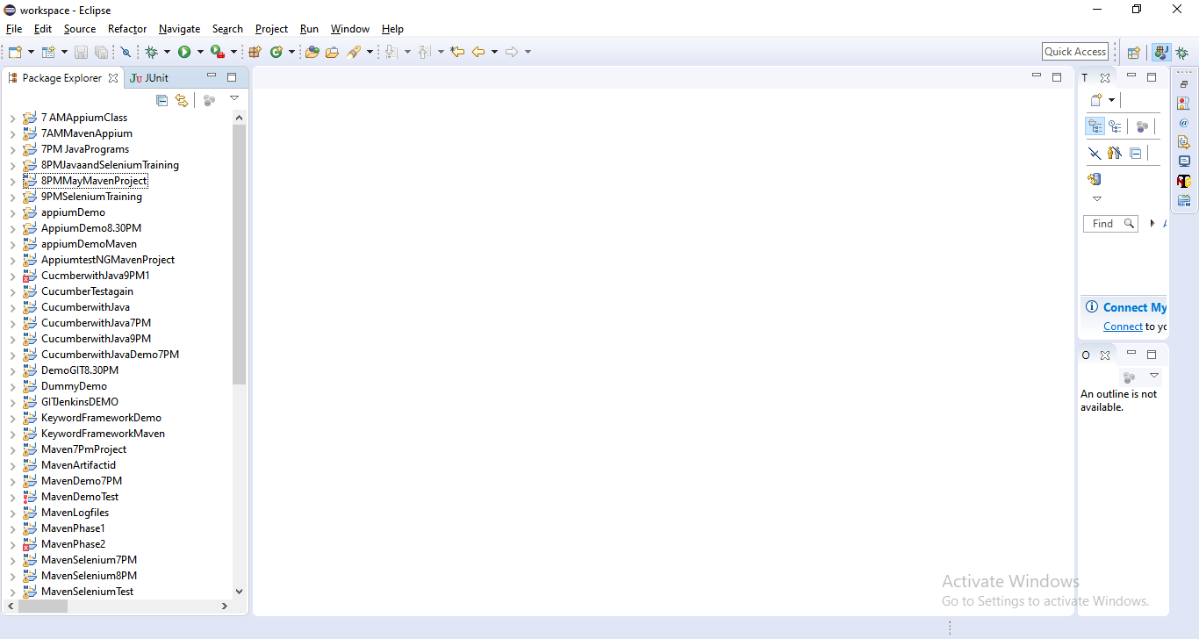

<EOD>