SapiensOntoCellMap: An Ontology-Integrated Framework for Curated Human Cell Marker Databases and Cell Type Enrichment Analysis
Problem Statement:
- Current marker repositories lack consistent integration with standardized ontologies (CL, Uberon).
- Cell/tissue/organ relationships are fragmented, making hierarchical reasoning difficult.
- Marker databases often age poorly due to missing update pipelines.
- Existing annotation tools (e.g., SingleR, Azimuth) don’t fully leverage ontological structure.
Objective:
- Adopt and integrate a standardized cell and tissue nomenclature using the Cell Ontology (CL) and Uberon respectively.
- Establish hierarchical and positional relationships between cells, tissues, and organs by strictly adhering to the structure of the Uberon ontology.
- Build a high-quality, curated database of cell-type specific markers with complete metadata (using CellMarkerDB)
- Develop the database as a portable SQLite file with a well-defined schema.
- Develop a secure, semi-automated pipeline for user-submitted marker data for comparison to the exiting database and update if required
- Provide a query tool that uses statistical enrichment tests (e.g., Fisher's exact test, hypergeometric test) to assign cell types to user-submitted marker lists, generating ranked results with statistical significance (p-values and false discovery rates).

Literature Review:
Ontology Integration: The use of the Cell Ontology (CL) and Uberon is a well-established standard in the field. Major international consortia like the Human Cell Atlas (HCA), HuBMAP, and the ENCODE project rely on these ontologies for standardized cell and tissue annotation.
Cell Type Annotation and Enrichment Tools:
Feature | xCell2 | CHETAH | scClassify | SingleR | CellTypist | deCS
Primary Goal | Cell Type Enrichment | Cell Type Classification | Cell Type Classification | Cell Type Annotation | Cell Type Classification | Cell Type Annotation
Core Method | Gene Set Variation Analysis | Hierarchical Decision Tree | Weighted Gene Correlation | Spearman Correlation | Logistic Regression (ML) | Statistical Enrichment (Fisher's)
Input Data | Gene Expression Matrix (Bulk or scRNA-seq) | scRNA-seq Data (e.g., Seurat object) | scRNA-seq Data | scRNA-seq Data | scRNA-seq Data | List of Marker Genes
Ontology/Hierarchy | ✅ Yes, post-classification | ✅ Core Feature | ✅ Core Feature | ❌ No (but can use hierarchical references) | ❌ No (but models can be hierarchical) | ❌ No
Handles Novel Types? | N/A (Enrichment) | ✅ Yes (assigns to intermediate nodes) | ✅ Yes (assigns to intermediate nodes) | ❌ No (assigns to best match) | ❌ No (assigns to closest class) | ❌ No (finds best match)
Output | Enrichment scores per sample/cluster | Cell type label per cell | Cell type label per cell | Cell type label per cell | Cell type label per cell | Ranked list of cell types with p-values
Implementation | R | R | R | R | Python | R

Implementation Plan:
Github link: https://github.com/Sonal1510/SapiensOntoCellMap

Phase 1: Data Acquisition and Integration
- Resource Download: Download the complete datasets for CellMarkerDB and the Uberon ontology.
- Ontology Parsing and Graph Construction: Parse the Uberon ontology to extract its internal structure. This will be used to build a directed acyclic graph (DAG) that represents the hierarchical relationships between organs, tissues, and cells. This graph will serve as the core framework for a consistent naming system.
- Marker Database Curation and Integration: Parse the CellMarkerDB. For entries with missing cell or tissue IDs, use the constructed Uberon graph to programmatically map and standardize the nomenclature. This ensures all marker data is linked to a consistent ontological framework.
- Database Assembly: Consolidate the curated marker data and the hierarchical graph into a single, portable SQLite database. A well-defined schema is essential here to link marker genes to cell IDs, tissue IDs, and their metadata.

Phase 2: Database Enrichment and Validation
- Atlas-Based Marker Discovery: Perform differential gene expression analysis on the Tabula Sapiens Atlas data. The analysis should identify marker genes for each unique combination of cell ID, tissue ID, and cell-tissue ID present in the atlas. This is a crucial step to generate your own high-quality marker list from a trusted source.
- Comparative Analysis and Scoring: Compare the marker genes identified in the Tabula Sapiens Atlas with the markers already present in your curated SQLite database (from CellMarkerDB). Instead of a simple "union," a more robust approach is to implement a scoring system that prioritizes markers found in both sources or those with strong statistical significance in the atlas. This ensures the highest confidence markers are given more weight.
- Database Update: Update the SQLite database with the new markers and their associated confidence scores from the Tabula Sapiens analysis. This creates a more comprehensive and validated resource.

Phase 3: Querying and Annotation Tool Development
- Annotation Tool Core Logic: Develop the core algorithm that accepts a user-submitted dictionary of genes from a single-cell cluster given a spatial/single-cell object with clusters. Perform quality control based on the metadata to understand if the particular cluster is not annotated because of the quality of cells/information at the particular spot.
- Statistical Enrichment Analysis: Use the Fisher's exact test or a hypergeometric test to compare the user's gene list against the marker lists in the SQLite database. The result should be a ranked list of potential cell types.
- Output Generation: The final output should not just be a list of cell types, but also include the statistical significance for each assignment (p-value) and a corrected p-value (e.g., False Discovery Rate, FDR). This allows the user to make a data-driven decision on cell identity.

Current update (22nd Aug 2025):
Github status:
.
├── README.md
├── SapiensOntoCellMap_documentation.docx
├── __init__.py
├── config
│ ├── __init__.py
│ └── config.py
├── data
│ ├── processed
│ └── raw
│ ├── Cell_marker_Human.xlsx
│ ├── human-view.obo
│ └── human-view.tsv
├── src
│ ├── __init__.py
│ ├── db_manager
│ │ ├── db_manager.py
│ │ └── db_schema.py
│ ├── download
│ │ └── bio_database_downloader.py
│ ├── parser
│ │ ├── cell_ontology_parser.py
│ │ ├── cellmarker_parser.py
│ │ └── uberon_parser.py
│ └── visualization
│ └── app.py
└── test
└── test_download.py

- Phase 1:
  - Resource Download ✅
  - Ontology Parsing and Graph Construction – On going
    - Challenge: It looks like a mesh
    - Potential solution: use toposort to linearize and parse in such a way to have the connections between the UB terms associated with organs and tissues; and also CL
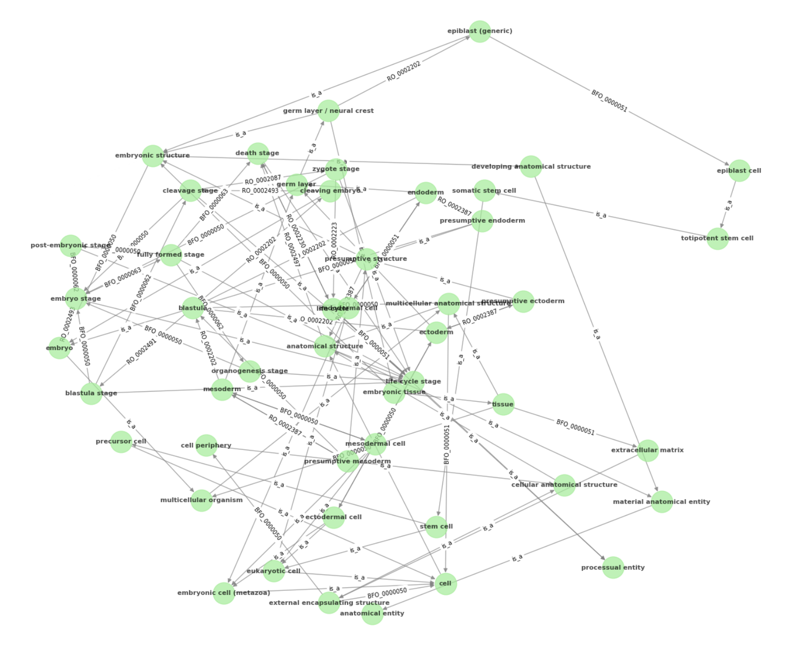
- Phase 2:
  - Atlas-Based Marker Discovery -> ongoing.
It has been tested on a subset of tabula sapiens atlas – skin
But I keep running into some errors and end up optimizing the algorithm to make it more robust.
Current version:
for each cluster defined as (cell_id, tissue_id, cell_tissue_id){
iterate over 100 times {
scanpy differential using logistic regression
scanpy differential using Wilcoxon
Filteration of each of the two test:
Logistic regression -> regression score threshold based on the elbow knee
Wilcoxon -> padj < 0.05 & abs(log2FC) > 0.25 & percent_cells_expressed > 0.3 & percent_cell_expressing_outside_cluster > 0.1
}
Marker found in atleast 75% of the iteration -> defined as marker
}

- Phase 3:
  - Hypergeometric test:
    - Given the DEG marker file -> use the padj < 0.05 & abs(log2FC) > 1
-> convert to dictionary of markers per cluster as key
    - Reference marker dictionary with tissue_id + cell_id as key and markers as value
    - Perform the hypergeometric test per list to return cell_id+tissue_id
      - N: Total number of genes in your dataset's background (e.g., all genes measured by the Xenium panel).
      - K: Total number of markers for a specific cell type in the background (e.g., how many astrocyte markers are in your gene panel).
      - n: The number of top differential genes you selected for your cluster.
      - k: The number of genes that are in BOTH your differential gene list AND the known cell type marker list (the overlap).
The probability is calculated as:
P(X≥k)=i=k∑min(n,K)​(nN​)(iK​)(n−iN−K​)​

Return:
Overlapping Genes: the exact genes that are common between your cluster and the reference cell type
Overlap Size (k): The number of overlapping genes.
Cluster Markers (n): The total number of significant genes you found for your cluster.
Cell Type Markers (K): The total number of markers for that cell type that exist in your experiment's background panel.
Enrichment Ratio: It's calculated as (k/n)/(K/N).
k/n is the proportion of your cluster's genes that are cell-type markers.
K/N is the proportion of all genes in the background that are cell-type markers.
An enrichment ratio > 1.0 indicates that the markers are more concentrated in your cluster list than in the background, which is what you expect for a positive result. A higher ratio means stronger enrichment.

