**C++ ASSIGNMENT 1.**

1.Write a program to print “Hello World” on the screen.

**Code**

1. #include <iostream>
2. using namespace std;
3. int main()
4. {
5. cout<<"Hello World";
6. return 0;
7. }

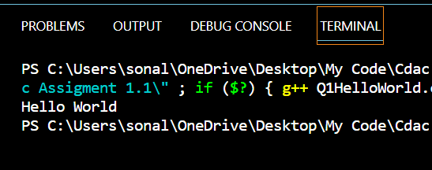 **Output**

2. Write a program that generate the following output

10, 20, 19

Use an integer constant for 10, an arithmetic C++ ASSIGNMENT operator to generate the 20, and a decrement operator to generate 19.

**Code**

1. #include <iostream>
2. using namespace std;
3. int main()
4. {
5. int a,b,c;
6. a = 10;
7. b = a*2;
8. c = b--;
9. cout << a<<" "<<c<<" "<<b ;
10. return 0;
11. }

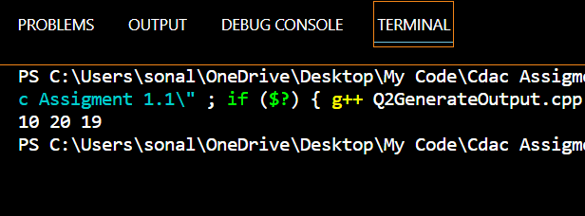

3. Write a program that asks the user to enter a radius value and then compute the volume of a sphere with the input radius.

**Code**

1. #include <iostream>
2. using namespace std;
3. int main()
4. {
5. double r,v;
6. cout << "Enter Radius of Sphere = ";
7. cin >> r;
8. v = (4.0/3.0) * (22.0/7.0) * (r*r*r);
9. cout << "Volume of Sphere = " << v;
10. return 0;
11. }

**Output**

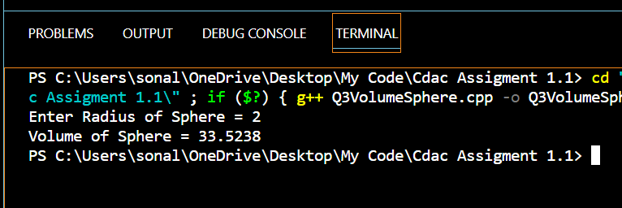

4. Write a program that takes three input of sides of a triangle. The program should indicate whether the triangle would be formed or not. If it can be formed it also indicates the type.

**Code**

1. #include <iostream>
2. using namespace std;
3. int main()
4. {
5. double s1,s2,s3;
6. cout << "Enter lenght of Side 1 = ";
7. cin >> s1;
8. cout << "Enter lenght of Side 2 = ";
9. cin >> s2;
10. cout << "Enter lenght of Side 3 = ";
11. cin >> s3;
12. if(((s1+s2)>s3) || ((s2+s3)>s1) || ((s1+s3)>s2))
13. {
14. cout << "Triangle Will Form" << "\n";
15. if(s1==s2==s3)
16. {
17. cout << "Its Equilateral Triangle";
18. }
19. else
20. if((s1==s2)||(s2==s3)||(s3==s1))
21. {
22. cout << "Its Isoceles Triangle";
23. }
24. else
25. if((s1=!s2)||(s2=!s3)||(s3=!s1))
26. {
27. cout << "Its Scalene Triangle";
28. }
29. }
30. else
31. {
32. cout << "Triangle Will not Form";
33. }
34. return 0;
35. }

**Output**

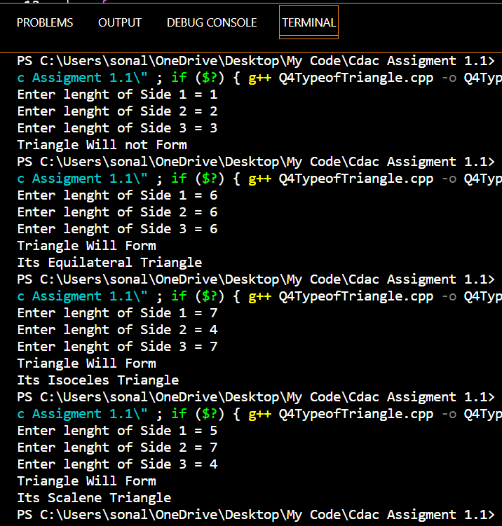

5. Write a program that takes one input as number and it will display whether the number is +ve, -ve or zero. If the number is +ve, then it will display whether the number is odd or even.

**Code**

1. #include <iostream>
2. using namespace std;
3. int main()
4. {
5. int a;
6. cout << "Enter Number = ";
7. cin >> a;
8. if(a>0)
9. {
10. cout << "Number Is Positive" << "\n";
11. {
12. if((a%2)==0)
13. cout << "Number Is Even";
14. else
15. cout << "Number Is Odd";
16. }
17. }
18. else
19. if(a<0)
20. {
21. cout << "Number Is Negative";
22. }
23. else
24. if(a==0)
25. {
26. cout << "Number Is Zero";
27. }
28. return 0;
29. }

**Output**

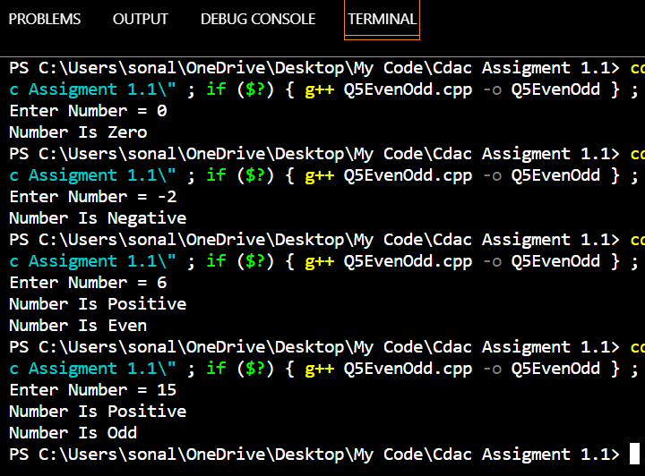

6. Write a program which takes username as input and it greets to user with his name.

**Code**

1. #include <iostream>
2. using namespace std;
3. int main()
4. {
5. string n ;
6. cout << "Enter Your Name = ";
7. cin >> n;
8. cout<<"Hello "<<n ;
9. return 0;
10. }

**Output**

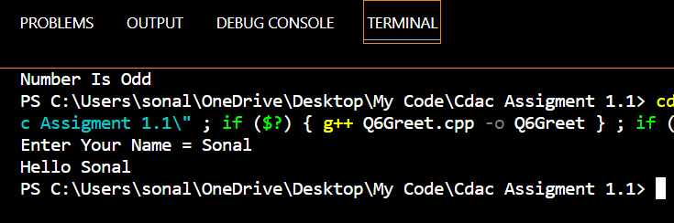

7. Write a program, which takes two integer numbers as input and it shows their exchanged value. (Don’t use third variable)

**Code**

1. #include <iostream>
2. using namespace std;
3. int main()
4. {
5. int a,b;
6. cout << "Enter Number Value of A = ";
7. cin >> a;
8. cout << "Enter Number Value of B = ";
9. cin >> b;
10. cout << " Value of A = "<< b <<"\n";
11. cout << " Value of B = "<< a <<"\n";
12. return 0;
13. }

**Output**

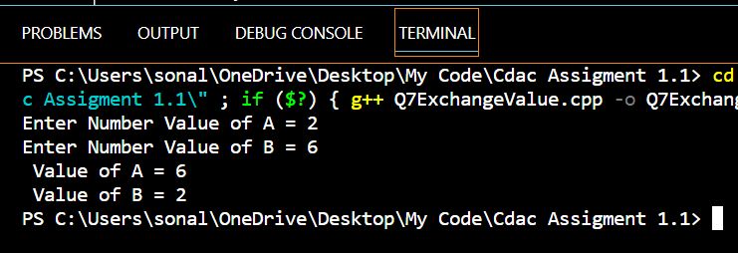

1. WAP to check Leap Year.

**Code**

1. #include <iostream>
2. using namespace std;
3. int main()
4. {
5. int a,b;
6. cout << "Enter Year = ";
7. cin >> a;
8. if((a%4)==00)
9. {
10. if((a%100)==00)
11. {
12. if((a%400)==00)
13. {
14. cout << " This is Leap Year";
15. }
16. else
17. {
18. cout << " This is Not Leap Year";
19. }
20. }
21. else
22. {
23. cout << " This is Leap Year";
24. }
25. }
26. else
27. {
28. cout << " This is Not Leap Year";
29. }
30. return 0;
31. }

**Output**

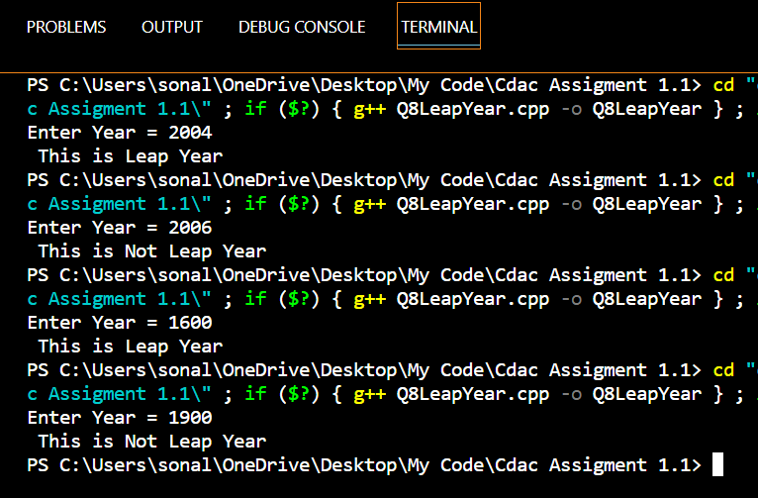

9. WAP for finding remainder of division of 2 numbers.

**Code**

1. #include <iostream>
2. using namespace std;
3. int main()
4. {
5. int a,b,c;
6. cout << "Enter Number 1 = ";
7. cin >> a;
8. cout << "Enter Number 2 = ";
9. cin >> b;
10. c = a%b;
11. cout<< "Reminder is = " << c;
12. return 0;
13. }

**Output**

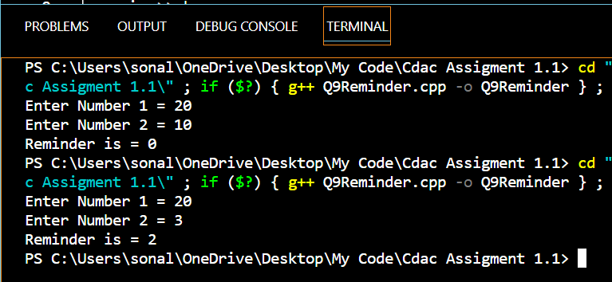

10. WAP to calculate Area of Rectangle.

**Code**

1. #include <iostream>
2. using namespace std;
3. int main()
4. {
5. int l,w,a;
6. cout << "Enter Length = ";
7. cin >> l;
8. cout << "Enter Width = ";
9. cin >> w;
10. a = l*w;
11. cout << "Area of Rectangle = " << a;
12. return 0;
13. }

**Output**

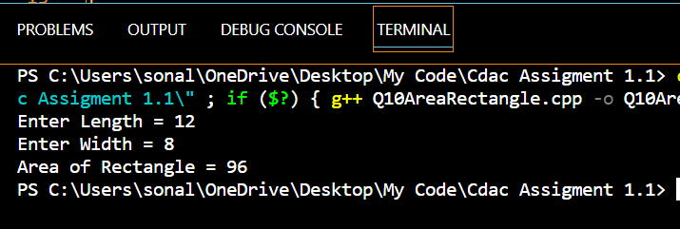

1. .WAP to calculate Area of Square.

**Code**

1. #include <iostream>
2. using namespace std;
3. int main()
4. {
5. int l,a;
6. cout << "Enter Length of Side = ";
7. cin >> l;
8. a = (l*l);
9. cout << "Area of Square = " << a;
10. return 0;
11. }

**Output**

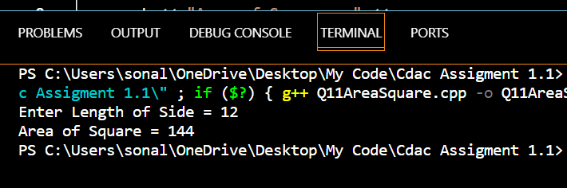

1. WAP to calculate the area of Triangle.

**Code**

1. #include <iostream>
2. using namespace std;
3. int main()
4. {
5. double b,h,a;
6. cout << "Enter Length of Base = ";
7. cin >> b;
8. cout << "Enter Length of Height = ";
9. cin >> h;
10. a = (1.0/2.0)*b*h;
11. cout << "Area of Triangle = " << a;
12. return 0;
13. }

**Output**

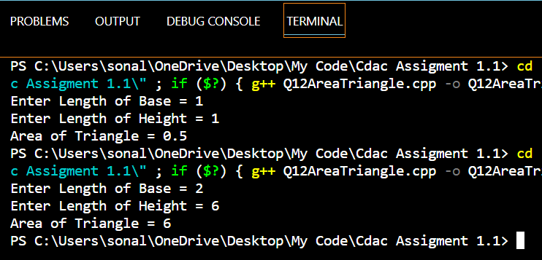

13. WAP to calculate Area and Circumference of Circle.

**Code**

1. #include <iostream>
2. using namespace std;
3. int main()
4. {
5. double r,a,c;
6. cout << "Enter Radius = ";
7. cin >> r;
8. a = (22.0/7.0)*(r*r);
9. c = (2.0)*(22.0/7.0)*r;
10. cout << "Area of Circle = " << a <<"\n";
11. cout << "Circumfrence of Circle = " << c ;
12. return 0;
13. }

**Output**

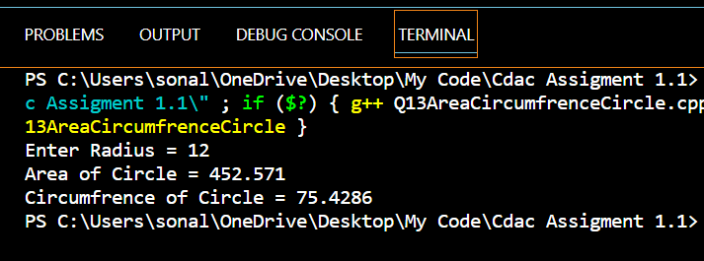

14. WAP for two item’s weight (floating points' values) and number of purchase (floating points' values) and calculate the average value of the items.

Test Data: Weight - Item1: 15 No. of item1: 5 Weight - Item2: 25 No. of item2: 4 Expected Output: Average Value = 19.444444

**Code**

1. #include <iostream>
2. using namespace std;
3. int main()
4. {
5. float w1,w2,n1,n2,avg;
6. cout << "Weight of Item NO 1 = ";
7. cin >> w1;
8. cout << "Number of Item NO 1 = ";
9. cin >> n1;
10. cout << "Weight of Item NO 2 = ";
11. cin >> w2;
12. cout << "Number of Item NO 2 = ";
13. cin >> n2;
14. avg = (((w1*n1)+(w2*n2))/(n1+n2));
15. cout << "Area of Circle = " << avg ;
16. return 0;
17. }

**Output**

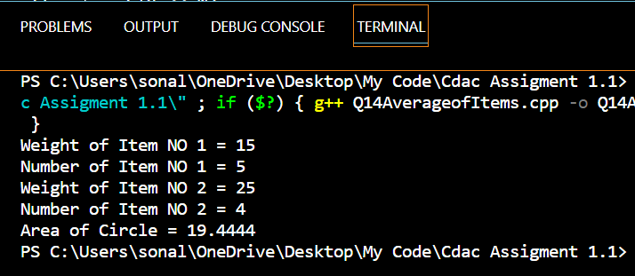

15. WAP to calculate a bike’s average consumption from the given total distance (integer value) travelled (in km) and spent fuel.

Test Data: Input total distance in km: 350 Input total fuel spent in litres: 5 Expected Output: Average consumption (km/lt) 70.00

**Code**

1. #include <iostream>
2. using namespace std;
3. int main()
4. {
5. float a,b,cons;
6. cout << "Input Total Distance (Km)= ";
7. cin >> a;
8. cout << "Input Total Fuel (Lit)= ";
9. cin >> b;
10. cons = a/b;
11. cout << "Average Consumption (Km/Lit)= " << cons;
12. return 0;
13. }

**Output**

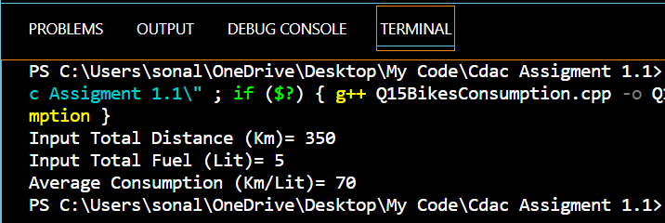

16. Write a program that will give the grade of the student based on the percentage he got in the course.

Use the following criteria for assigning grades:

Grade = A ( when percentage >= 60)

Grade = B ( when percentage >= 50 and percentage < 60)

Grade = C ( when percentage >= 40 and percentage < 50)

Grade = D ( when percentage >= 30 and percentage < 40)

Grade = E ( when percentage >= 20 and percentage < 30)

**Code**

1. #include <iostream>
2. using namespace std;
3. int main()
4. {
5. double p;
6. char g;
7. cout << "Enter Percentange = ";
8. cin >> p;
9. if(p>=60)
10. {
11. g = 'A';
12. cout<<"Grade "<< g;
13. }
14. else
15. if((p>=50)&&(p<60))
16. {
17. g = 'B';
18. cout<<"Grade "<< g;
19. }
20. else
21. if((p>=40)&&(p<50))
22. {
23. g = 'C';
24. cout<<"Grade "<< g;
25. }
26. else
27. if((p>=30)&&(p<40))
28. {
29. g = 'D';
30. cout<<"Grade "<< g;
31. }
32. else
33. if((p>=20)&&(p<30))
34. {
35. g = 'E';
36. cout<<"Grade "<< g;
37. }
38. return 0;
39. }

**Output**

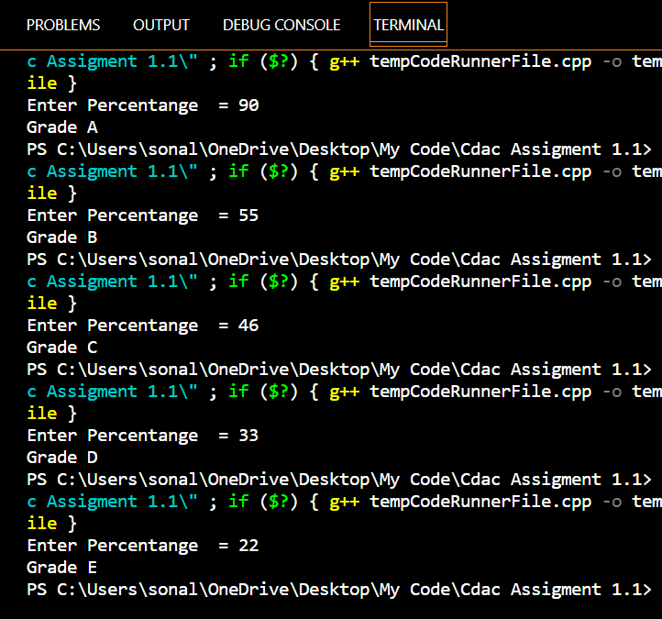

17. WAP to check whether a number is divisible by 5.

**Code**

1. #include <iostream>
2. using namespace std;
3. int main()
4. {
5. int a,b;
6. cout << "Enter Number = ";
7. cin >> a;
8. if((a%5)==0)
9. {
10. cout<<"Number is Divisible by 5";
11. }
12. else
13. {
14. cout<<"Number is Not Divisible by 5";
15. }
16. return 0;
17. }

**Output**

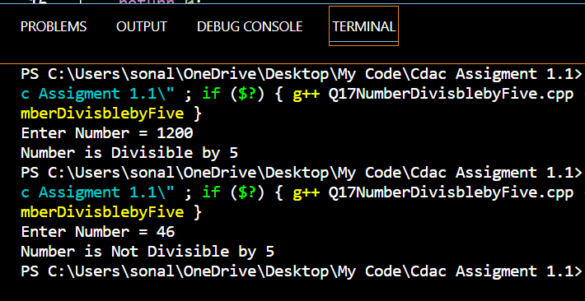

18. WAP to input basic salary of an employee and calculate its Gross salary according to following: Basic Salary <= 10000 : HRA = 20%, DA = 80%

Basic Salary <= 20000 : HRA = 25%, DA = 90%

Basic Salary > 20000 : HRA = 30%, DA = 95%

**Code**

1. #include <iostream>
2. using namespace std;
3. int main()
4. {
5. float BSal ,HRA ,DA ,GrossSal;
6. cout << "Enter Basic Salary of Employee = ";
7. cin >> BSal ;
8. if(BSal<=10000)
9. {
10. HRA = BSal*0.2;
11. DA = BSal*0.8;
12. GrossSal = BSal + HRA + DA ;
13. cout << "Gross Salary of Empolyee is = " << GrossSal ;
14. }
15. else
16. if((BSal<=20000)&&(BSal>10000))
17. {
18. HRA = BSal*0.25;
19. DA = BSal*0.9;
20. GrossSal = BSal + HRA + DA ;
21. cout << "Gross Salary of Empolyee is = " << GrossSal ;
22. }
23. else
24. if(BSal>20000)
25. {
26. HRA = BSal*0.3;
27. DA = BSal*0.95;
28. GrossSal = BSal + HRA + DA ;
29. cout << "Gross Salary of Empolyee is = " << GrossSal ;
30. }
31. return 0;
32. }

**Output**

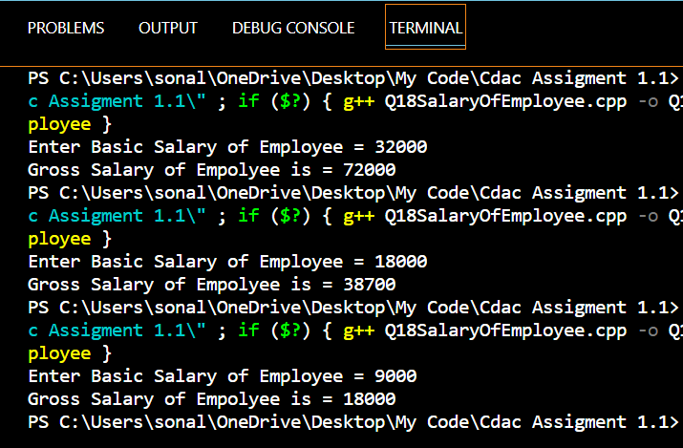

19. WAP to input electricity unit charges and calculate total electricity bill according to the given condition: For first 50 units Rs. 0.50/unit For next 100 units Rs. 0.75/unit For next 100 units Rs. 1.20/unit For unit above 250 Rs. 1.50/unit An additional surcharge of 20% is added to the bill

**Code**

1. #include <iostream>
2. using namespace std;
3. int main()
4. {
5. float a,b;
6. cout << "Enter Number Of Units = ";
7. cin >> a;
8. if (a<=50)
9. {
10. b = (0.50*a);
11. cout << "Electricity Bill is = " << b ;
12. }
13. else
14. if ((a>50)&&(a<=150))
15. {
16. b = (0.75*a);
17. cout << "Electricity Bill is = " << b;
18. }
19. else
20. if ((a>150)&&(a<=250))
21. {
22. b = (1.20*a);
23. cout << "Electricity Bill is = " << b;
24. }
25. else
26. if (a>250)
27. {
28. b = (1.50*a)+ (0.20*a);
29. cout << "Electricity Bill is = " << b;
30. }
31. return 0;
32. }

**Output**

