Bigdata - HDFS
- HDFS – Hadoop distributed File system
- Built on commodity hardware
- highly fault tolerant, hardware failure is the norm
- suited to batch processing – data access has hoigh throughput rather than low latency
- supports very large data sets
- manage file storage across multiple disks
- each disk on a different machine in a cluster
- In cluster there are so many nodes, but among them 1 node is master node, which calleds as Name node
- Hdfs runs a java process on master node and which is receive all the requests made to the cluster and forward those request to other slave nodes, this process is called name node
- other slave nodes are called as Data nodes.
- EX : If the data in the distributed file system is a book, then
    - the name node us the table of contents
    - The data nodes hold the actual text in each page
- Name node : manages the overall file system.
    - Stores : The directory structure and metadata of the files
- Data Nodes : physically stores the avtual data in the files

1) Storing a file in HDFS
- Break the data into blocks, so different legths files are treated the same way
- storage is simplified in this way
- unit for replication and fault tolerance
- The blocks are of size 128 MB
- Block 3 size is a trade off (अदला - बदली or exchange)

- time taken is devided into 2 blocks
    - 1) the size helps minmize the time taken to the block on the disk where the block lives
    - 2) time taken to actually read the blocks
    - take a ratio for both the times
- Store the blocks across the data nodes
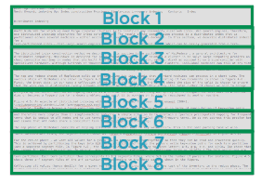
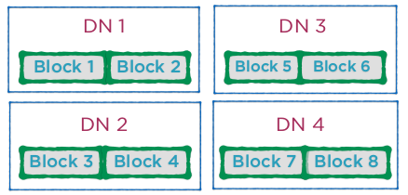

- Each node contains a partition or a split of data
    - 1. Use metadata in the name node to look up block locations
    - 2. Read the blocks from respective locations
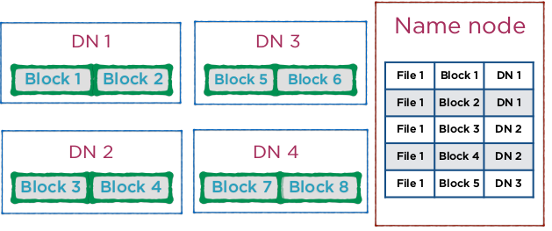
2) Demo :
- > ls -l
- > cd bin
- > ls -l
- > cd ..
- > bin/hadoop fs
- > bin/hadoop fs -help
- > bin/hdfs fs
- here in above command “hadoop = hdfs “
- > nano ~/.bashrc
- > source ~/.bashrc
- > hdfs fs
- > hadoop fs -mkdir /test
- > hadoop fs -mkdir /test/subdir
- > hadoop fs -ls /test

3) Moving files from the local file system to HDFS and vice versa
- copyFromLocal and copyToLocal
- put and get
- Viewing the contents of a file
- > hadoop fs -copyFromLocal etc/hadoop/hadoop-env.sh /test/
- > hadoop fs -ls /test
- > hadoop fs -put etc/hadoop/core-site.xml /test/
- Here in above commands “-copyFromLocal = -put”
- > hadoop fs -ls /test
- > hadoop fs -mkdir /test-dst
- > hadoop fs -cp /test/* /test-dst/
- > hadoop fs -ls /test-dst
- > mkdir fromhdfs
- > hadoop fs -copyToLocal /test/* fromhdfs/
- > ls fromhdfs/
- > cd fromhdfs/
- > rm -rf *
- > ls -l
- > cd ..
- > hadoop fs -get /test/* fromhdfs/
- > ls fromhdfs/
- > hadoop fs -cat /test/core-site.xml
- > hadoop fs -rm -r /test/core-site.xml
- > hadoop fs -ls /test

3) Challanges of distributed storage :
- 1) Failure management in the data nodes
- 2) Failure management in the name node
Solution:
- Define a replication factor
Replication :
- 1. Replicate blocks based on the replication factor
- 2. Store replicas in different locations
- The replica locations are also stored in the name node
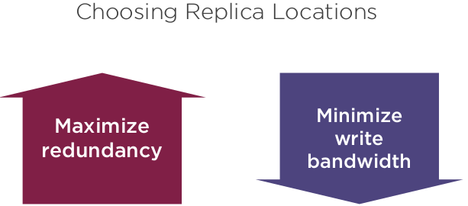
- Maximize redundancy:
  - There are many servers are in Data center
  - In data center, it Store replicas “far away” i.e. on different nodes
- Minimize write bandwidth:
  - This requires that replicas be stored close to each other
  - Node that runs the replication pipeline
  - This node chooses the location for the first replica
  - Data is forwarded from here to the next replica location
  - Forwarded further to the next replica location
  - Forwarding requires a large amount of bandwidth
  - Increases the cost of write operations
- Now, requrie to balane both needs, so Default Hadoop Replication Strategy :
  - .First location chosen at random
  - Second location has to be on a different rack (if possible)
  - Third replica is on the same rack at the second but on different nodes
  - Reduces inter-rack traffic andimproves write performance
  - Read operations are sent to the rack closest to the client
  - this replication factor is Defined in the configuration file hdfs-site.xml
  - dfs.replication = 3
  - This is the default in fully-distributed mode
- Name Node Failures :
  - The name node is the heart of HDFS
  - Block locations are not persistent
  - i.e. they are stored in memory block cachin
  - This process called cashing
  - If the name node fails, File-Block Location mapping is lost!
  - This data is worthless without the name node

- Solution for Name node Failure:
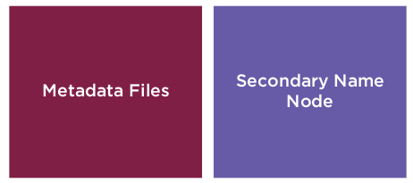

- Metadata Files:
  - 1) fsimage , 2) edits
  - these two files that stores the filesystem metadata
  - fsimage File :
    - A snapshot of the completefile system at start up
    - Loaded into memory
  - edits File :
    - A log of all in-memory edits to the file system
  - “fsimage and edits”, These together can help reconstruct a name node
  - these files’s Default backup location Name node local file system
  - Alternative backup location a remote drive
  - Set the property dfs.namenode.name.dir in hdfs-site.xml
  - Problem in merging files :
    - Merging these 2 files is very compute heavy
    - Bringing a system back online could take a long time
- Secondary Name node:
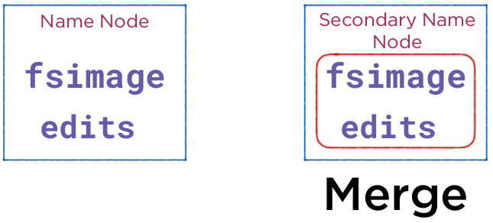
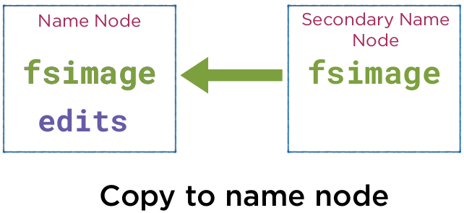
  - resets the edits file to empty on both nodes
  - Checkpointing is done at a specified frequency
  - In name Node,is there is a failure, then secondary Name node becomes the name node.
  - They both sync up by to Set properties in hdfs-site.xml
  - property – dfs.namenode.checkpoint.period :
    - The number of seconds between each checkpoint
  - Property – dfs.namenode.checkpoint.check.period :
    - The period when the secondary name node polls the name node for uncheckpointed transactions
  - Property – dfs.namenode.checkpoint.txns :
    - The number of transactions (edits to the file system) before checkpointing

4) Processing Data with MapReduce :

- MapReduce - Processing huge amounts of data
- MapReduce is a programming paradigm to allow processing in distributed computing system.
- It takes advantage of the inherent parallelism in data processing
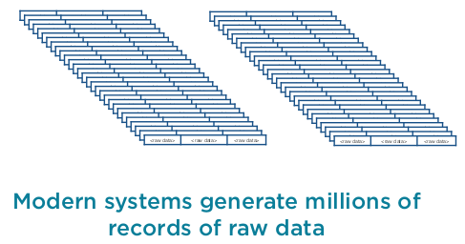

- A task of this scale is processed in two stages
  - 1) map (which runs in mu;tiple nodes in the cluster)
  - 2) reduce (which taken output of map and further process to give you final result)
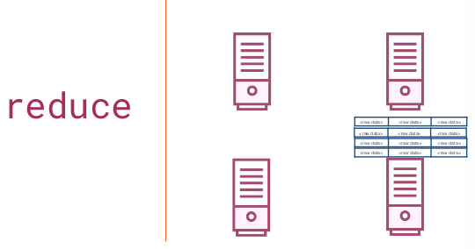
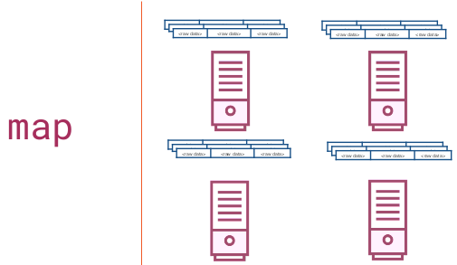

- map works on own data ,and reduce is collect th ouput of the map and trafered to network
- map And reduce
  - The programmer defines these 2 functions.
  - Hadoop does the rest - behind the scenes
- map :
  - An operation performed in parallel, on small portions of the dataset
  - A step that can be performed in parallel
- reduce :
  - An operation to combine the results of the map step.
  - A step to combine the intermediate results
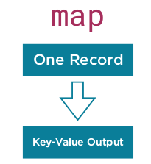
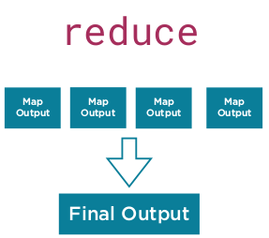

- Lets take an Example :

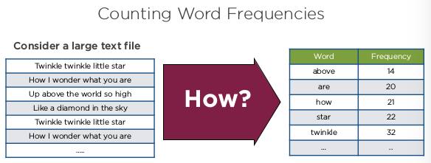

- MapReduce Flow :
  - The raw data is really large (potentially in PetaBytes)
  - It’s distributed across many machines in a cluster so entire file is not stored only one machine.
  - Each machine holds a partition of data
  - Each partition is given to a different process i.e. to mappers
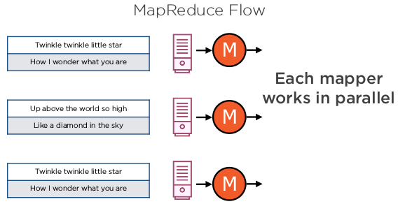
- Map Flow : each mapper, the rows are processed serially
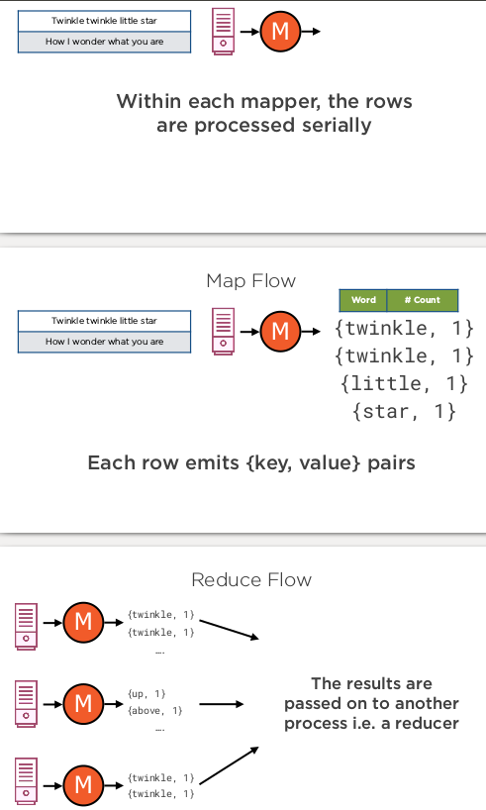
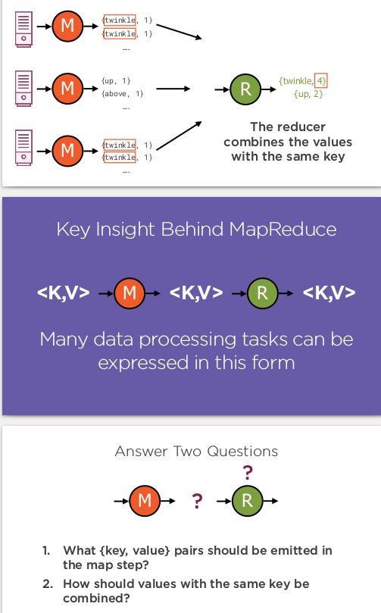
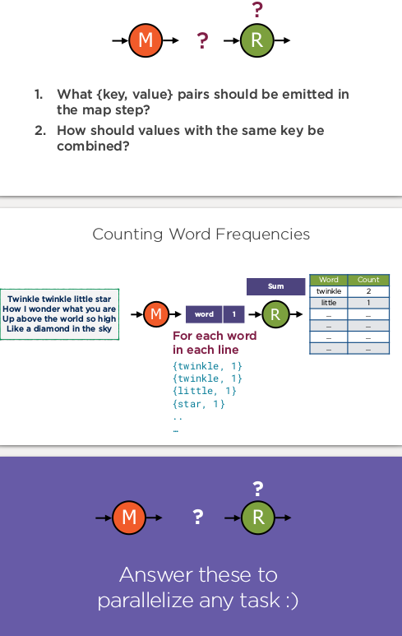
2) MapReduce Implementing in Java
- 3 classes are there as below :
- Map :
  - A class where the map logic is implemented
- Reduce :
  - A class where the reduce logic is implemented
- Main :
  - A driver program that sets up the job
- Map Step :
  - The map logic is implemented in a class that extends the Mapper Class
  - It is a generic class, with 4 type parameters as below:
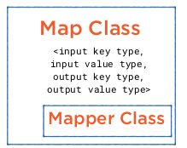
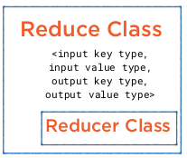

- Reduce Step :
  - The reduce logic is implemented in a class that extends the Reducer Class
  - It is a generic class, with 4 type parameters as above.
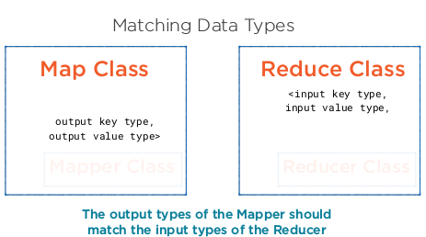

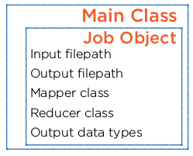
- Setting up the Job :
  - The Mapper and Reducer classes are used by a Job that is configured in the Main Class
  - The Job has a bunch of properties that need to be configured
- >hadoop jar wordcountdemo.jar WordCountJob /user/hduser/wordcount/input /user/hduser/wordcount/output
- > hadoop jar wordcountdemo.jar WordCountJob -D WordCountMapper.job.queuename=prod /user/hduser/wordcount/input /user/hduser/wordcount/output4

