Ch : 5 – Scheduling and managing Tasks with YARN

- YARN - Yet Another Resource Negotiator
- hadoop mapReduce is devided in 2 part :
  - MapReduce – perform operation
  - YARN – to run and schedule operations (processes).
- Co-ordinates tasks running on the cluster
- Assigns new nodes in case of failure
- Yarn is madeup from 2 componenets
  - 1) Resource Manager – Master processes
    - Runs on a single master node
    - Schedules tasks across nodes
  - 2) Node manager – Slave process
    - Run on all other nodes
    - Manages tasks on the individual node
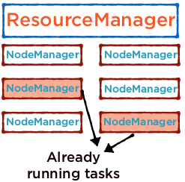
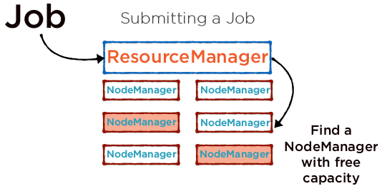
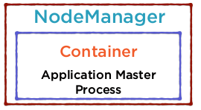
- All processes on a node are run within a container
- This is the logical unit for resources the process needs - memory, CPU etc
- A container executes a specific application
- 1 NodeManager can have multiple containers
- The ResourceManager starts off the Application Master within the Container
- Performs the computation required for the task
- If additional resources are required, the ApplicationMaster makes the request

- .

- .

