**1. What is SDLC?**

SDLC means software development life cycle is a structure imposed on software Development that define process planning, analyse, testing, implementation, deployment and maintenance.

**2. What is agile methodology?**

It is a combination of iterative and incremental model process model focus

On process adaptability and customer satisfaction by rapid delivery of working software product.

**3. What is SRS?**

Software requirement specification is complete describe specification of behaviour of system to be developed.

**4. What is oops?**

Object oriented programing system is to identify the object and object can communicate with other objects

-Object- object is represent the entity or unit of class.

-Class- class is a collection of data member and member function.

-Encapsulation-encapsulation means wrapping data of an object into single class.

-Inheritance- one class extend into sub class.

-Polymorphism- take one name have many form

-Abstraction- abstraction means abstract only those relevant data to currently perspective.

**5. Write Basic Concepts of oops**

**-**Object oriented programming is derive from abstract data type.it is used to identify the object.

**6. What is encapsulation?**

Encapsulation means hiding data & exposed only relevant data and private the data member and member function.

**7. What is inheritance?**

Inheritance means properties of main class is extend into sub class and main purposed is reusability and extendibility.

**8. What is polymorphism?**

Polymorphism means ability take one name have many forms. There are two type

1) Compile time Polymorphism

2) Run time Polymorphism

**9. What is RDBMS?**

-relational database management system is a collection of programs and capabilities that enable IT teams and others to create, update, administer and otherwise interact with a relational database. RDBMS store data in the form of tables (Rows and columns)

**10. What is SQL?**

SQL is structure query language, which is a computer language for storing, manipulating and retrieving data from relational database.

**11. Write SQL Commands**

There are 4 type.

**1) DDL**- data defining language

-in DDL there are 3 command CREATE, ALTER, DROP.

**2) DML**- data manipulating language

- In DML there are 3 command INSERT command is to create a record,

UPDATE command modify the records, DELETE command delete records,

**3) DCL**- data control language

-there are 2 command GRANT gives privilege to user, REVOKE privilege granted from user.

**4) DQL-** data query language

-DQL have 1 command SELECT is which is retrieve certain record from one or more table.

**12. Draw Use case on online book shopping** 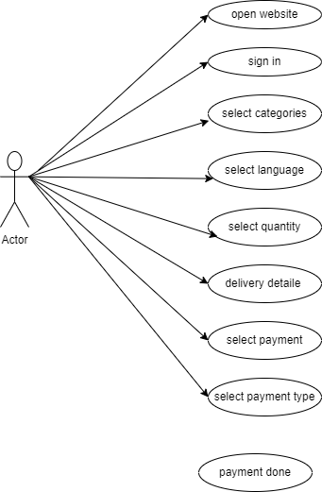

**13. Draw Use case on online bill payment system (paytm)**

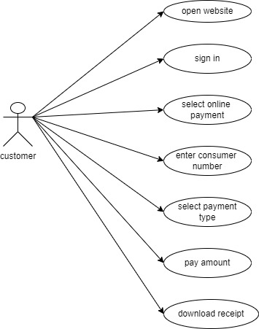

`

**14. Write SDLC phases with basic introduction**

-There are 6 phases

**1) Requirement gathering**

- Requirement gathering establish customer needs, features and functional and non-fun requirement is change. There are 3 type of problem can arise lack of clarity, requirement confusion, requirement amalgation.

**2) Analysis phase**

- The analysis phase defines the requirement of the system, independent of hoe these requirement will be accomplished.

**3) Design phase**

-the design team can expand the information establish in requirement. In this phase the team can design diagram for specify module, analysis critical priority and solution of specific requirement.

**4) Implementation phase**

- In this construct a solution in software and this phase is deal with quality and performance.

**5) Testing phase**

-In this phase validate the solution against requirement .it is a separated phase which is perform by different team after the implementation completed.

6) Maintenance phase

-this phase is repair defect and adapt the solution to the new requirement. Software maintenance is the process of enhancing and optimizing deployed software, as well as fixing defect.

**15. Explain Phases of the waterfall model**

Waterfall model is also known as classical software cycle which is performed by step by step between the various development phases.

1) Requirement collection-in this phase requirement is must be needed by the customer. Requirement is clearly define and stable and requirement re not ambiguous.

2) analysis-in this phases developed team analysis the specific model of criteria, budget and also analysis how to fulfil requirement.

3) Design –in this phase after completion of analysis phase is done then team can design the architecture diagram of that model and also analysis critical priority and performance plan.

4) Implementation –in this phase design phase is done then construct solution in software. he team build exactly what has been requested the requirement.

5) testing-in this phase the team validate the solution

6) maintenance-in this phase repair defect and update all analysis, design and document.

**16. Write phases of spiral model**

1) Planning – first planning of this phase is that how to fulfil requirement, quality and performance. Also determine objectives, alternatives and constraint.

2) Risk analysis – risk analysis is more important so firstly find risk and resolve the risk. Sometime of the project may not be known which a risk is then project is delay or increase cost.

3) Engineering –in this phase tam can build the solution of that model.

4) Customer evaluation – after completion of above 3 phases the customer evaluate the the result of engineering, quality of product.

**17. Write agile manifesto principles**

**-individual and interactions:** in agile development, self-organisation and motivation are important, as are interaction like co-location and pair programming.

**-working software:** demo working software is consider the best means of communication with the customer to understand their requirement instead of just depending on documentation.

**-customer collaboration:** as the requirement cannot be gathered completely in the beginning of the project due to various factor , continuous customer interaction is very important to get proper product requirement.

**-responding to change:** agile development is focused on quick responses to change and continuous development.

**18. What is join?**

- Join is used to combine rows from two or more table. Based on the elated column between them.

**19. Write type of joins.**

-there are 4 type of join

1) **INNER JOIN**- return rows when there is a match in both table.

2) **LEFT JOIN**- return all rows from the left table, even if there are no match in right table.

3) **RIGHT JOIN**- return all rows from the right table, even if there are no match in left table.

4) **FULL JOIN**-return rows when there is a match in one table.

**20. Explain working methodology of agile model and also write pros and con**

Agile is a combination of iterative and incremental model which is focus on process adaptability and customer satisfaction by rapidly working of software product.in this model collect all requirement then analysis all requirement which is fix, project budget, project completion duration time and also analysis how to fulfil all requirement .in design phase design the solution of requirement then construct in solution in software. After that in testing phase validation is check against the solution.in this model we can accommodate the requirement.

Pros:

-promotes team work and training

-easy to manage and flexibility to developers.

-functionality can be developed rapidly

-suitable for fixed or changing requirement

-good model for environment that change steadily

-Minimum resource require

Cons:

-Not suitable for handling complex dependencies.

-more risk of sustainability, maintainability and extensibility.

-depends on customer interaction and if customer is not clear then team can be driven in wrong direction.

**21. Draw use case on Online shopping product using COD.**

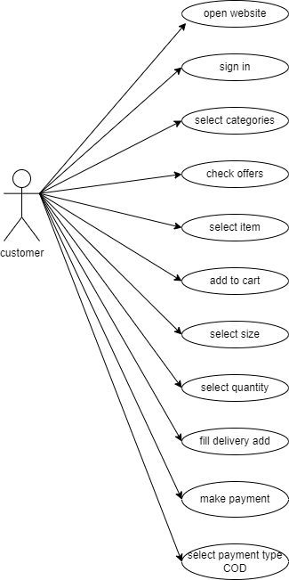

**22. Draw use case on Online shopping product using payment gateway.**

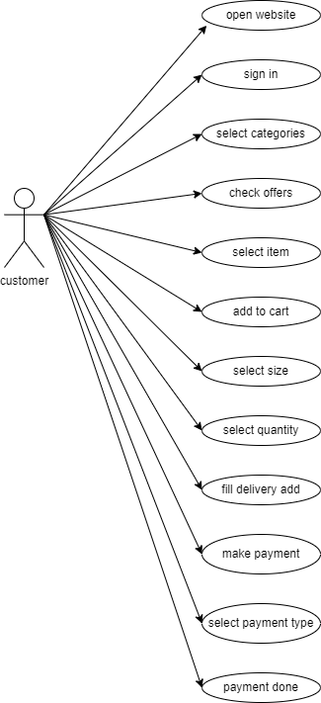

**HLR link https://github.com/SonalLad28/TopsAssignment/blob/main/HLR.xlsx**