**FSA IN MARATHI LANGUAGE**

**First I have written the lexicon alongwith their english meaning**

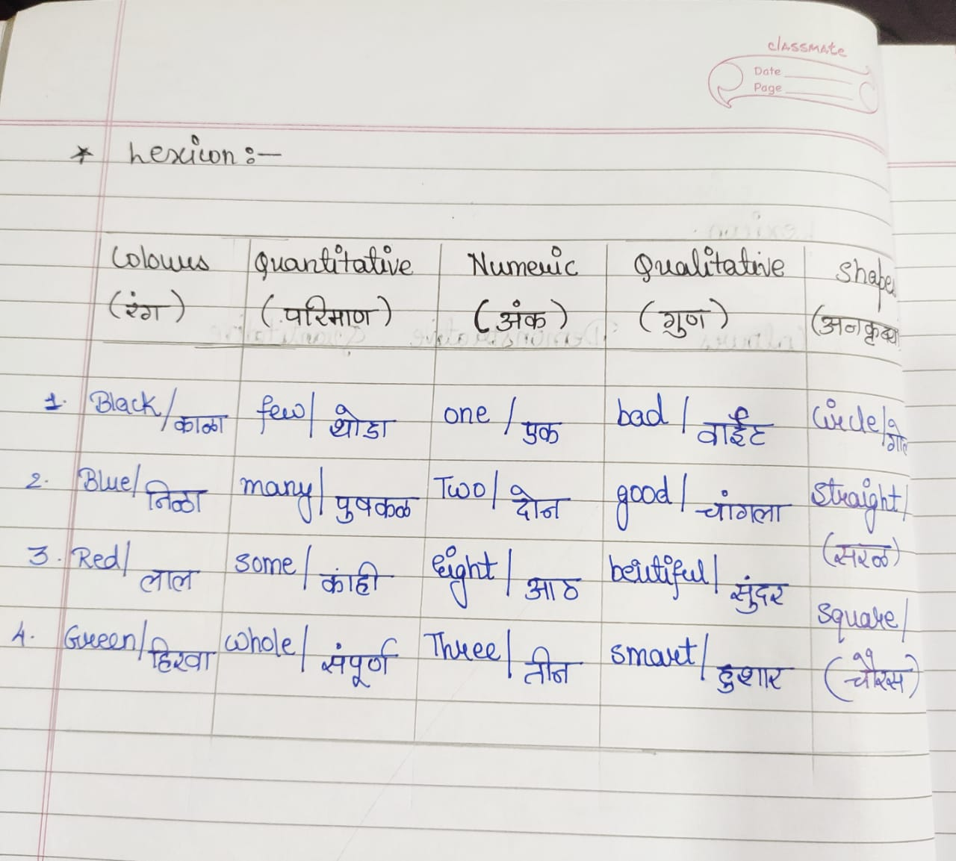

**Then tried designing its fsa with examples provided that fullfills the fsa**

