ASSESSMENT 1

**Objective:**

1. To explore more about python functionalities like lists, tuples, dictionaries .
2. To explore how to use strings and retrieve single line string, multiple line strings using single quotes and multi-quotes .

1. **Use of double quotes**

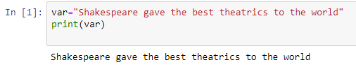

**Observation**: How to assign the single sentence into a variable and retrieve it using double quotes .

1. **Use of one single and one double quote**

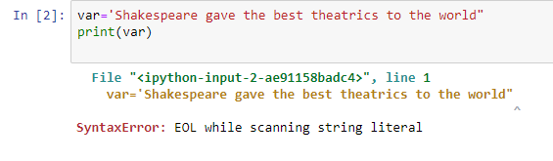

**Observation:** It gives syntax error as it isnot allowed to retrieve a string using different types of quotes.

1. **Use of triple quotes for long sentence**

value="""Shakespeare was born and raised in Stratford-upon-Avon, Warwickshire. At the age of 18, he married Anne Hathaway, with whom he had three children: Susanna and twins Hamnet and Judith. Sometime between 1585 and 1592, he began a successful career in London as an actor, writer, and part-owner of a playing company called the Lord Chamberlain's Men, later known as the King's Men. At age 49 (around 1613), he appears to have retired to Stratford, where he died three years later. Few records of Shakespeare's private life survive; this has stimulated considerable speculation about such matters as """

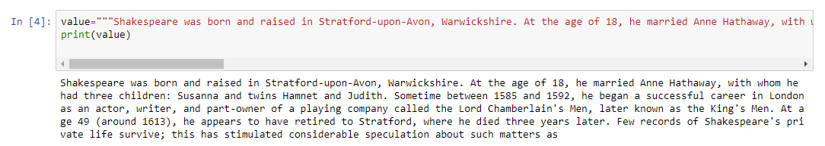

**Observation:** Triple quotes are used to retrieve longer sentences **.**

1. **To retrieve string of 2-3 paragraphs**

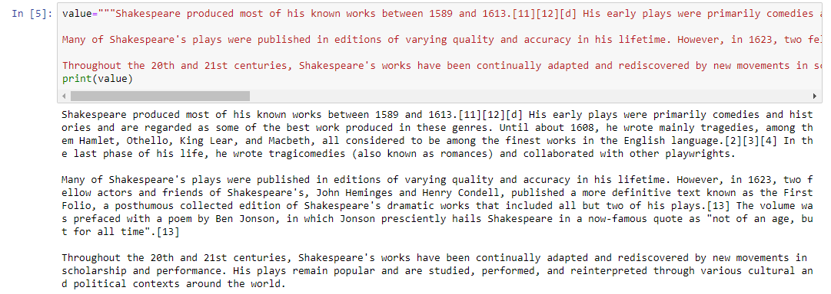

**Observation:** Strings of larger length such as of 2-3 paragraphs or even more can also be retrieved using triple quotes.

1. **To retrieve string containing 10-15 words each in every line**

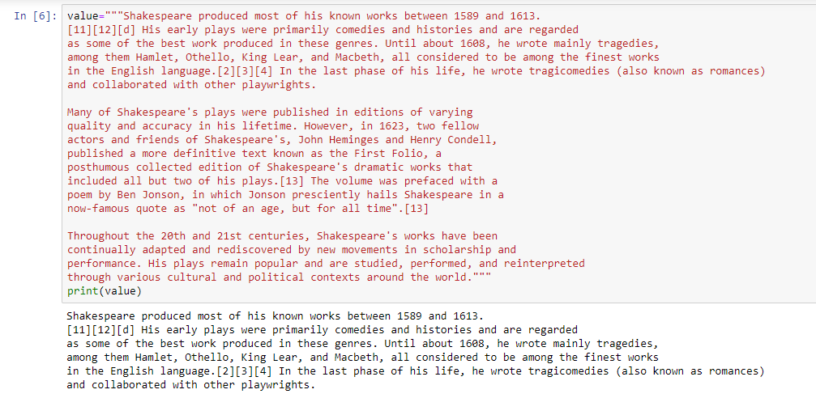

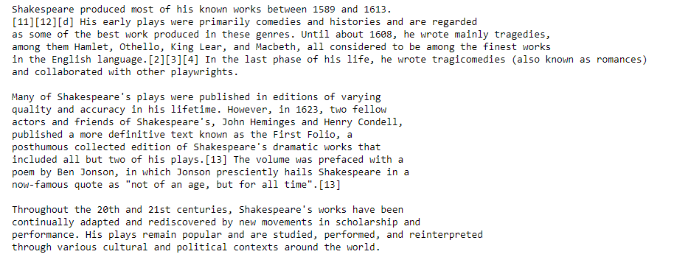

**Observation:** It was observed that even we keep 10-15 words in every line and press enter and end it with triple quotes the sentences gets successfully retrieved.

1. **What happens when we use single quotes in middle of word like “don’t”**

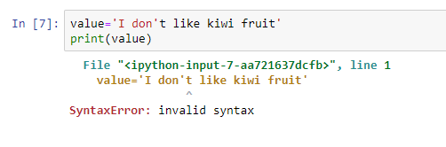

**Observation:** It was observed that when we use single quote in middle of any word and we start with single quote , software assumes it to the end of the sentence ignoring the rest of the sentence. Hence it gives syntax error

1. **To correct the error of single quotes**

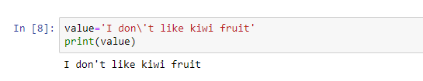

**Observation:** The above error can be resolved using slash(\) in between before single quotes.

1. **Use of Lists**

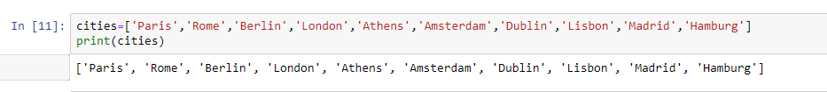

**Observation:** In python, lists are used to store values of different datatypes and enclosed in square brackets. The values are stored in single quotes and separated by comma.

1. **Adding value in list**

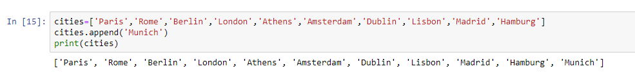

**Observation:** Values can be added in the list using the function “append” and hence can be added and retrieved.

1. **Removing value in list**

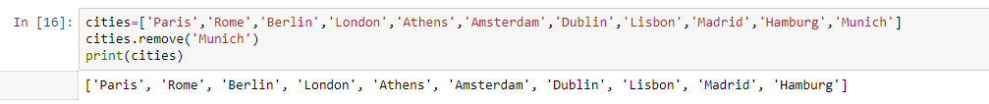

**Observation:** A value can be removed from the list using the function called “remove” and can be successfully removed.

1. **Accessing values in list**

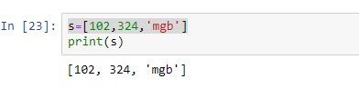

**Observation:** It can contain different values having different datatypes.

1. **Use of tuples**

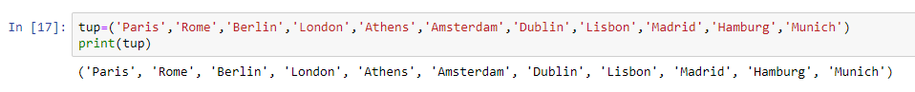

**Observation:** It was observed that tuples are similar to list with only difference as they cannot be changed like list and are enclosed in parentheses. They are also separated by a comma.

1. **Trying to append in tuple**

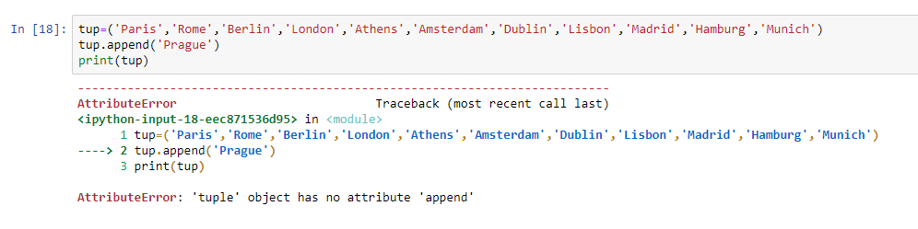

**Observation:** Tuple do not allow to change the values . It cannot be changed .

1. **Accessing values in tuple**

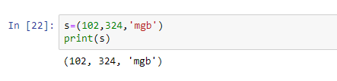

**Observation:** Tuple can also access values of different datatypes only difference is that it cannot be changed .

1. **Use of dictionaries**

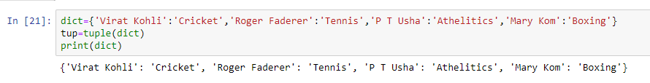

**Observation:** Dictionaries are collection of items having key-value pair and can be accessed with curly brackets. It is unordered , changeable, indexed.

1. **Accessing dictionary**

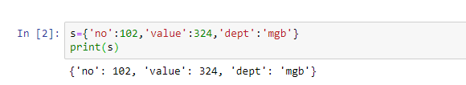

**Observation:** It can be observed that dictionaries can contain key-value pair of different datatypes.