ASSESSMENT 2

**Objective:**

1. To explore more about python functionalities like range, syntax of for, syntax of while, syntax of function and also the comparison between execution of program in for and while loop .
2. To explore how to import inbuilt math function and also to use its methods.

1. **Use of range with single parameter**

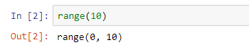

**Observation**: How to use range function. There are different types of range function differing in parameters passed. One of them is simply put limiting value. It tells that it will include numbers from 0 to 10 excluding 10.

1. **Use of range with multiple parameters**

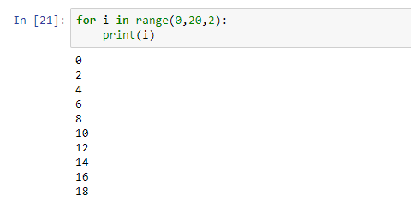

**Observation:** It includes 3 parameters which has syntax as **range(start, end, step).** In above example, numbers start from 0 and ends till 20 excluding 20 with an increment of 2 each as step value is 2.

1. **Use of for loop for printing cube of numbers**

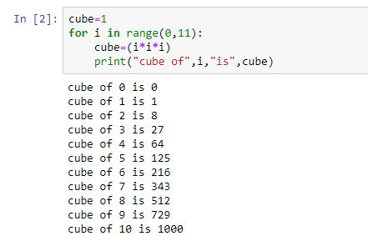

**Observation:** Syntax of for loop is given as above **.** It is necessary to give semicolon after every for loop . In this example, I goes from 0 to 10 excluding 11 and prints cube of those numbers.

1. **Use of while loop for printing cube of numbers**

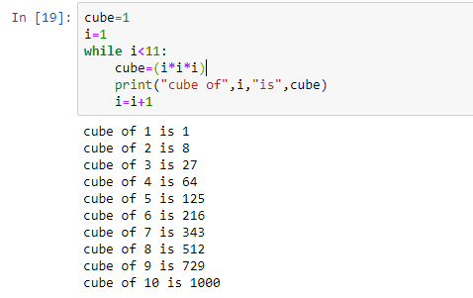

**Observation:** Syntax of while loop is as given above. In this example, first initialization was done then the cube of numbers will be found until it satisfies the condition. After every successful execution of loop condition it increments value and prints the value.

1. **To compare the time required to execute same program using for and while loop using “time”**

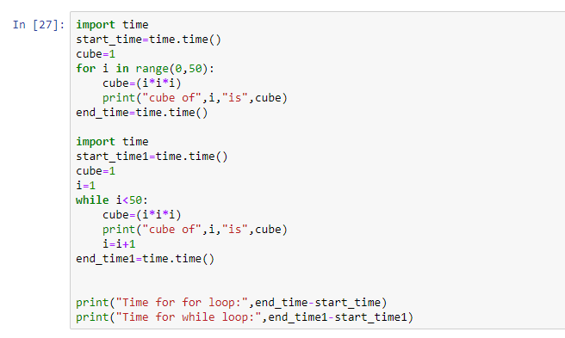

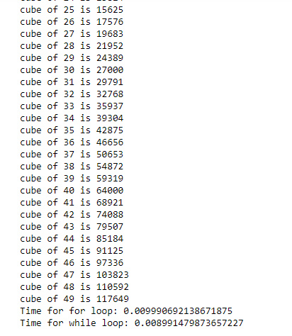

**Observation:** It was observed that for 50 numbers , while loop proved to be more efficient as it took less time as compared to for loop.

1. **Use of function for finding cube of number**

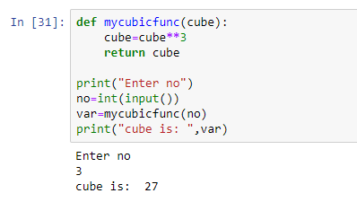

**Observation:** Function was defined to find cube of a number. Number was taken from user and its value was provided to the function. After function execution the value was returned.

1. **Use of math function**



**Observation:** The above is the syntax to import anything in python . Here we imported math function and renamed it as m.

1. **Using of math methods without importing it**

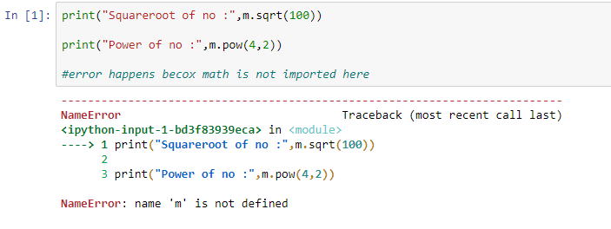

**Observation:** In python, it is not allowed to import function in one and use method in others. Because once we logout , its scope gets over and it is no longer into that scope. Like in this case, we performed logout and then restarted so we got the error as undefined symbol as there was no import written in it.

1. **Methods in math function**

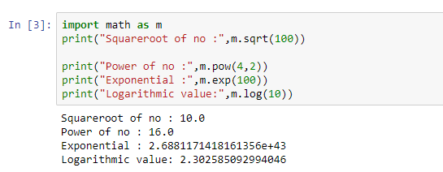

**Observation:** Above are some of the methods used in math library . They can be accessed using “m.method_name”. Sqrt method finds the squareroot of the particular number. Similarly power, exponential and logarithmic methods are used.