**Assignment: - 5**

**Sonalben Chauhan**

**8626672**

**Task1**

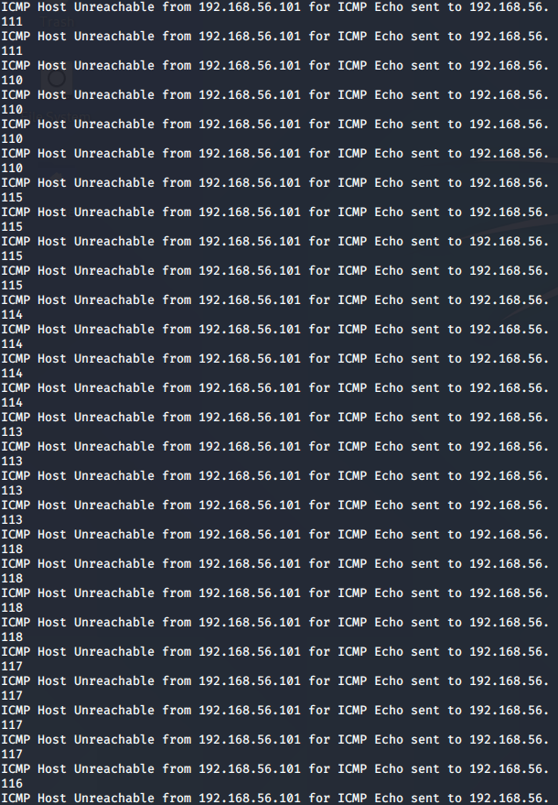

**Task1 2nd Question**

**Task2 1st Question**

**Task2 2nd Question**

