Group Members

Kavitha Vijayan

Sonalben Chauhan

Surbhi Gajjar

Rajwinder Kaur

  DATE [14/08/2020]

Assignment #3

# Health App

We have created an application to track calorie intake and daily water intake. Also, by using this app users can calculate their ideal weight. By using this application, users can get COVID 19 information and also, can find the nearest gym.

Use of GUI

We have used more than 6 gui controls. Here are 6 controls we used in the assignment:

* UIImageView
* UITextView
* Label
* UITextField
* Button
* PickerView

Internationalization

We have option to change language in the Fitness Screen. We can change the language to Spanish and swich it back to English.

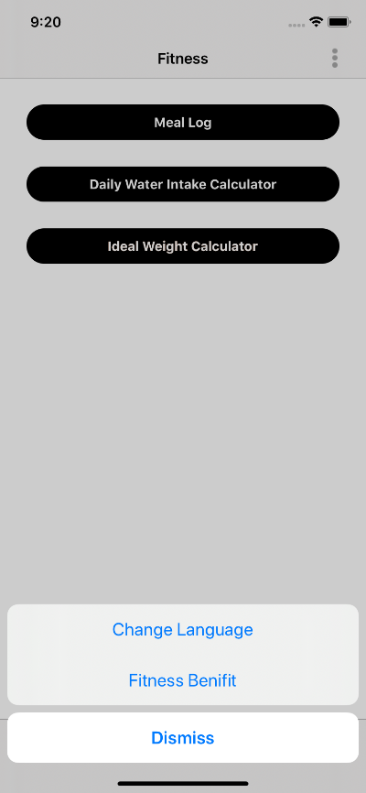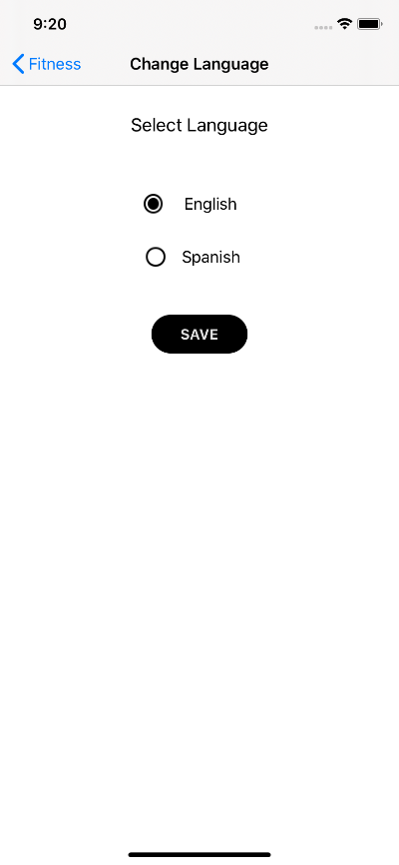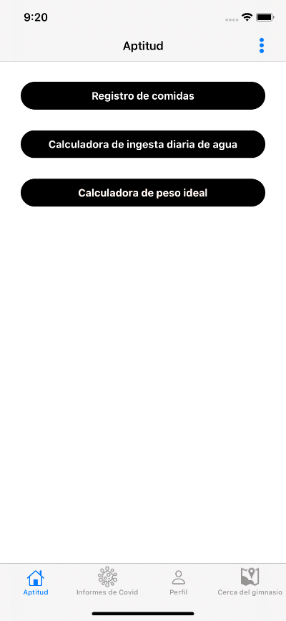

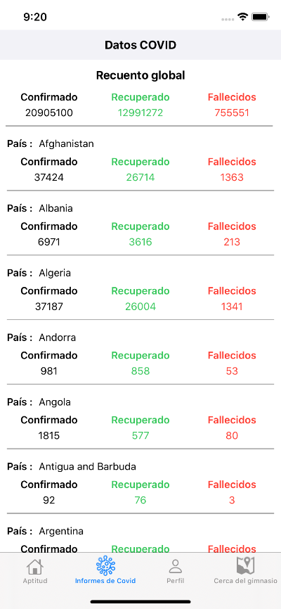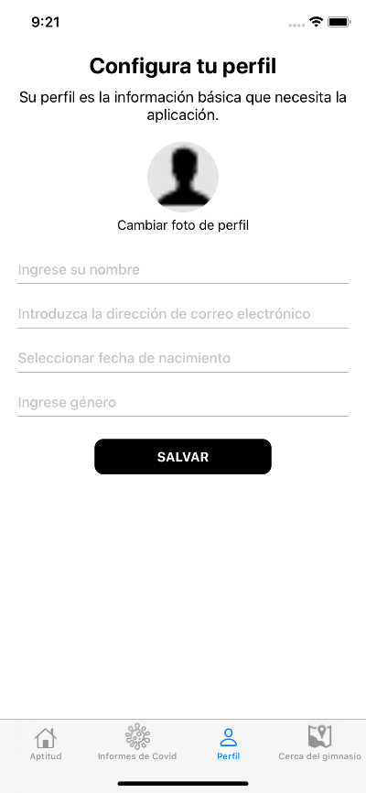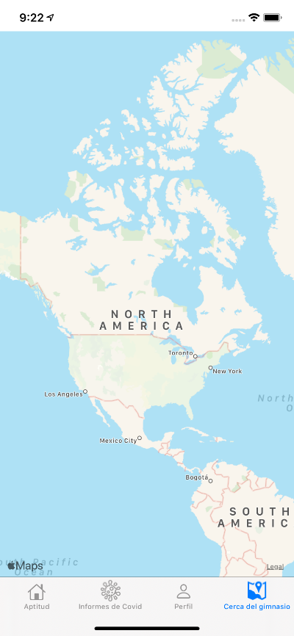

Use of Layouts

We are using three layouts here:

* StackView -> Fitness View Controller



* CollectionView -> On Boarding View Controller

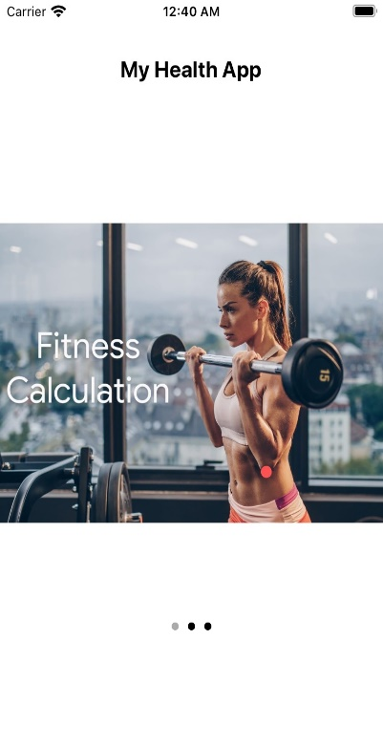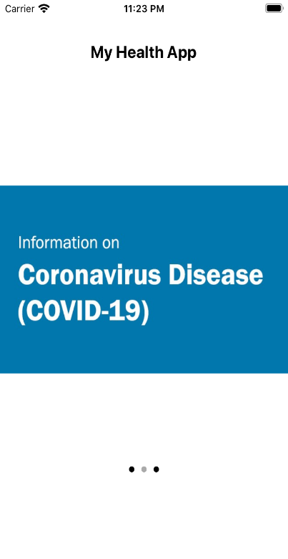

* TableView

Daily calorie intake Controller

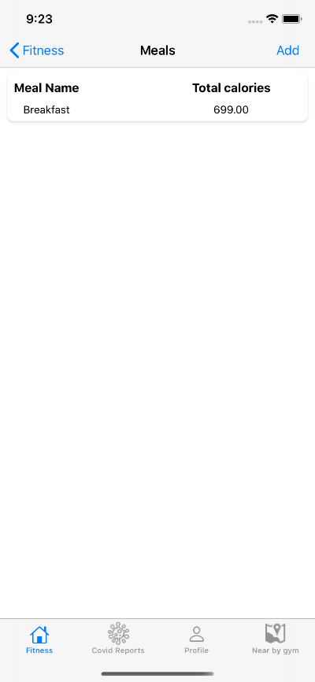

Use of Menus

We have used menus in textboxes in both the water intake screen and weight calculator screen.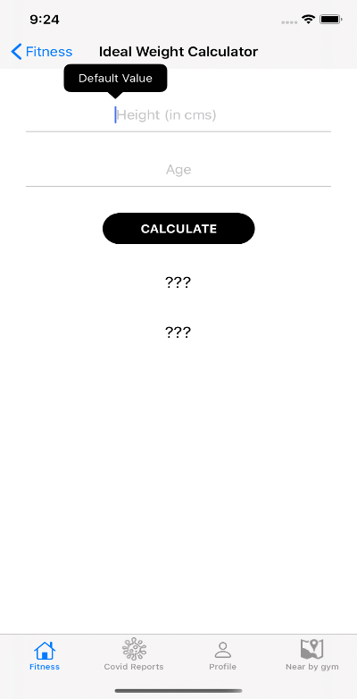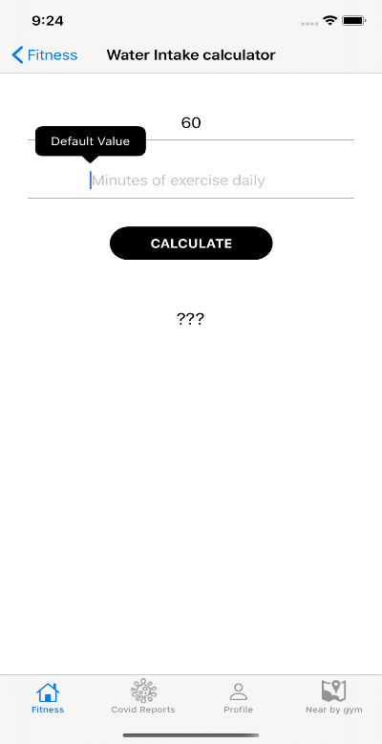

Keyboard and Gesture Recognizers

Our application makes use of gesture recognizers. Also, keyboard appears and disappears according to gestures

Navigation controller

We have added navigation controller in the Meals page. It returns to the meals page which have the options to select calculators.

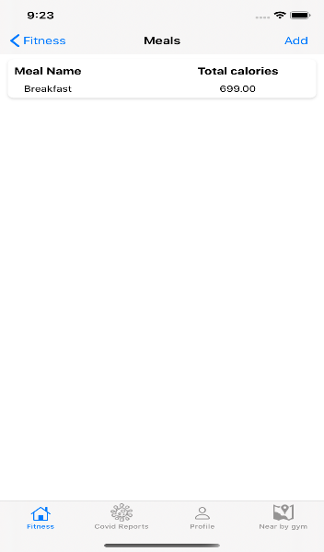

Use of Core Data

We are using Core Data to save meal details, to update meal details and delete meal details.

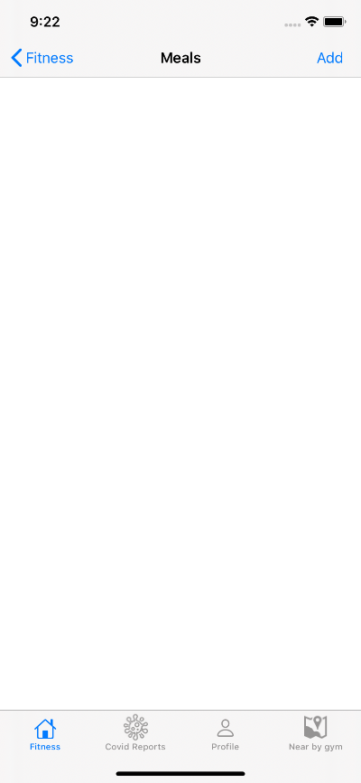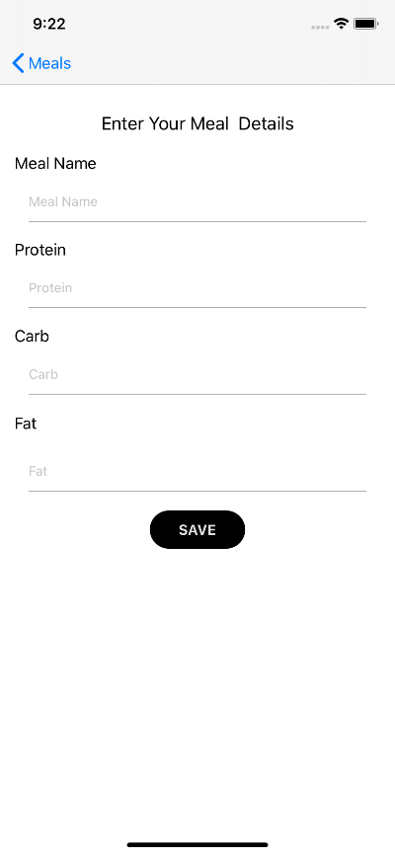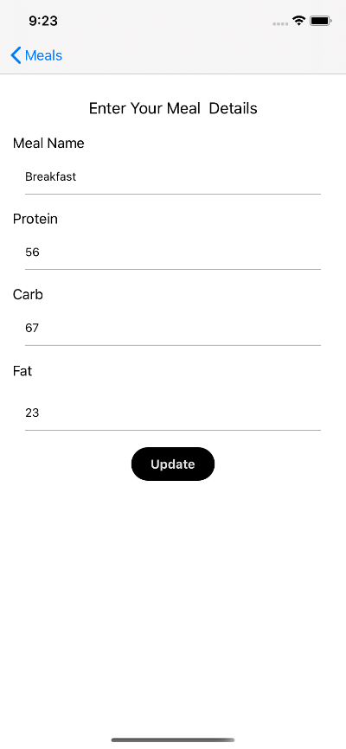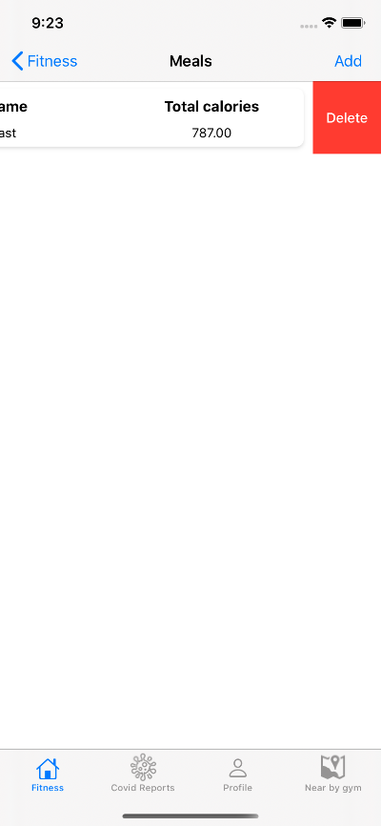

Application Working

Our application is working without any bugs. Did validations in every text fields.

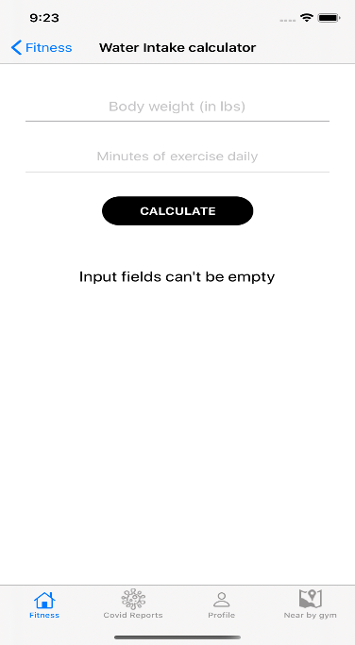

Code appearance

We have created a structured and formatted code. Comments and exception handling are in place in every files.

Use of services

We have used API for getting the covid 19 information and showing it in a screen.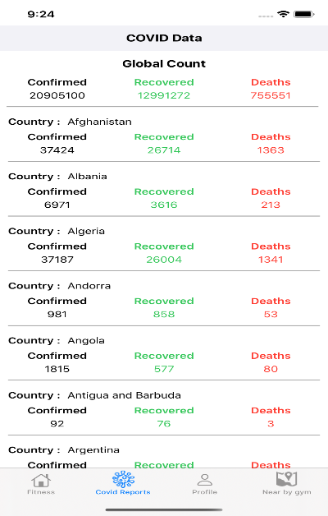

Use of maps and cameras

We are using map to get the location of the nearest gym.

We are using the camera to get the profile picture. Also, you can upload picture from your photo library.

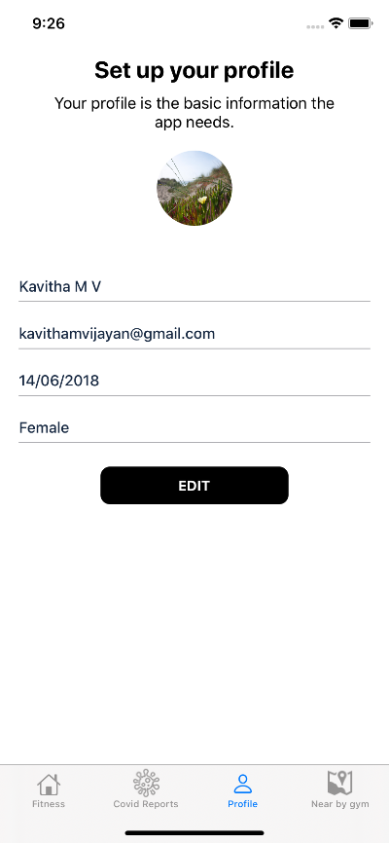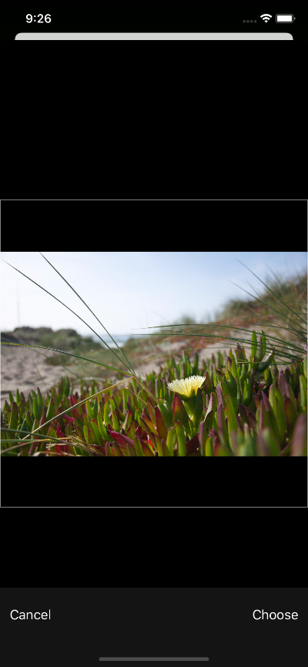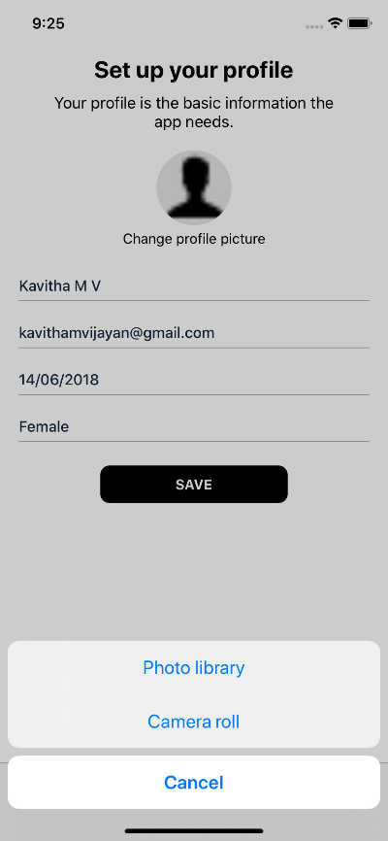

Assignment Contributions

|  |  |
| --- | --- |
| Use of maps and Cameras | Surbhi |
| Use of Services | Rajwinder |
| Core Data | Kavitha |
| Internationalization | Sonal |
| Layouts | Kavitha, Sonal |
| Keyboard and Gesture recognizes | Sonal |
| Navigation Controllers | Kavitha |
| Menus | Rajwinder |
| GUI controls | Kavitha |
| Validations | Surbhi |