PROG8170

Software Quality Assurance Techniques

**Fall 2019 - Final Examination**

**30% (75 marks) - Time: 2h:00m**

|  |  |
| --- | --- |
| **firstName:** | **Sonalben** |
| **lastName:** | **Chauhan** |
| **studentID:** | **8626672** |

**Aids Allowed:** One 8.5” x 11” single-sided, handwritten cheat sheet allowed

**Please stay in your seat and raise your hand if you have a question.**

**By writing this exam, you agree to the terms stated in the Examination Protocol (as found in eConestoga).**

|  |  |  |  |
| --- | --- | --- | --- |
| **Section** | **# of Questions** | **Total Marks** | **Marks Achieved** |
| 1 – Multiple Choice | 15 | 15 |  |
| 2 – Matching of Terms | 7 | 10 |  |
| 3 – Performance | 1 | 7 |  |
| 4 – Finite State Machine | 1 | 23 |  |
| 5 – Decision Tables | 1 | 20 |  |
|  |  | **Total** | **75** |

***Section 1: Multiple Choice*** ***– {15 Marks}***– select the *most correct* option by writing your answer (i.e. A, B, C or D) in the box provided. Please use only CAPITAL letters when denoting your answer. Each correct answer is worth 1 mark. Writing more than one answer in the box will invalidate the question and will result in a zero for that question.

**Question 1.1**

|  |  |
| --- | --- |
| **A database application accepts two inputs. The first input only accepts the values 1 through 10, inclusive. The second input only accepts the numbers 11 through 20, inclusive. The input space of this program would be**: | **Answer:** |
| 1. 20 |
| 1. 100 |
| 1. 20 * (the number of database states) |
| 1. 100 * (the number of database states) |

**Question 1.2**

|  |  |
| --- | --- |
| **Which of the following statements are TRUE about regression testing?**   1. **Regression testing and re-testing are one of the same;** 2. **Regression tests show that all failures have been resolved;** 3. **Regression tests are good candidates for automation testing;** 4. **Regression tests are performed to uncover defects as a result of changes in the software;** 5. **Regression tests should not be performed during integration testing.** | **Answer:** |
| 1. 1 and 2 are true |
| 1. 1, 3 and 5 are true |
| 1. 3 and 4 are true |
| 1. 2, 4 and 5 are true |

**Question 1.3**

|  |  |
| --- | --- |
| **What are the common approaches to performing Integration Testing?** | **Answer:** |
| 1. Incremental, Top-Down, Bottom-Up, Sandwich, Big-Bang |
| 1. Incremental, Top-Down, Bottom-Up, Regression, Big-Bang |
| 1. Pairwise, Inter-System, Intra-System, Regression |
| 1. Pairwise, Interface, Inter-System, Intra-System |

**Question 1.4**

|  |  |
| --- | --- |
| **Functional testing involves…** | **Answer:** |
| 1. Creating databases to be used for testing later on |
| 1. Executing the test cases with the highest priority |
| 1. Preparing test cases |
| 1. Identifying how a functionality is expected to behave |

**Question 1.5**

|  |  |
| --- | --- |
| **Pairwise testing involves…** | **Answer:** |
| 1. Testing each possible combination of values for every pair of input variables. |
| 1. Testing the application under test by two testers at the same time. |
| 1. Testing the application using a combination of pears. |
| 1. Testing applications using each input value doubled in value. |

**Question 1.6**

|  |  |
| --- | --- |
| **System Testing (also known as testing of a complete application to ensure that all of its software components properly function together)…** | **Answer:** |
| 1. Takes a long time to execute and requires deployment of the entire system |
| 1. Takes a short time to execute and requires deployment of the entire system |
| 1. Takes a long time to execute and does not require deployment of any databases |
| 1. Takes a short time to execute and requires deployment of a database |

**Question 1.7**

|  |  |
| --- | --- |
| **When performing Integration Testing, what are the most common types of Interface Errors that could be encountered?** | **Answer:** |
| 1. Constriction, Timing / performance problems, loopholes |
| 1. Construction, Inadequate functionality, Misunderstanding of interface |
| 1. Constriction, Inadequate functionality, Misunderstanding of interface |
| 1. Construction, Timing / performance problems, Error processing |

**Question 1.08**

|  |  |
| --- | --- |
| **System Tests are different than Unit Tests in that…** | **Answer:** |
| 1. System Tests can simulate infrequent errors easier than Unit Tests. |
| 1. It is preferable to execute System Tests earlier than Unit Tests in the software development life cycle. |
| 1. System Tests are unable to cover paths in the program logic but Unit Tests can indeed cover every path in the application’s business logic. |
| 1. System Tests are able to cover paths in the program logic but Unit Tests can also cover every path in the application’s business logic but only in more detail. |

**Question 1.09**

|  |  |
| --- | --- |
| **Performance Testing typically measures…** | **Answer:** |
| 1. Response time, environment usage and peak times. |
| 1. Response time and /or throughput requirements as well as system resource usage. |
| 1. Response time, overall functionality and correct module cohesion. |
| 1. Response time, software usage patterns and load characteristics. |

**Question 1.10**

|  |  |
| --- | --- |
| **A Finite State Machine is:** | **Answer:** |
| 1. A test driver in an integration testing framework |
| 1. A stub in a unit testing framework |
| 1. A computer program that simulates the various tests that can be performed on another software |
| 1. A mathematical logic model that determines that “State” of a particular logical sequence |

**Question 1.11**

|  |  |
| --- | --- |
| **Given that Vehicle = {car, truck, motorcycle}, the items [car] and [skateboard] are (respectively):** | **Answer:** |
| 1. Valid equivalence class and Valid equivalence class |
| 1. Valid equivalence class and Invalid equivalence class |
| 1. Invalid equivalence class and Invalid equivalence class |
| 1. Invalid equivalence class and Valid equivalence class |

**Question 1.12**

|  |  |
| --- | --- |
| **Given that an Isosceles triangle with sides a, b and c are to be in the range [1-20], what are the valid boundary values for this triangle that should be tested:** | **Answer:** |
| 1. 2, 3, 20, 29, -1, 4 |
| 1. 1, 21, 20, 19, 18, 17 |
| 1. 1, 20, -1, 0, 2, 3 |
| 1. 1, 20, 0, 2, 19, 21 |

**Question 1.13**

|  |  |
| --- | --- |
| **Acceptance testing (generally) is…** | **Answer:** |
| 1. A formal test procedure conducted to determine whether a system can be accepted for further testing by the development team. |
| 1. A formal test procedure conducted to determine whether a system satisfies its acceptance criteria (normally defined by the client / customer). |
| 1. An informal test procedure conducted to determine whether a system can be accepted for customer testing. |
| 1. An informal test procedure conducted to determine whether a system can be accepted for further testing by the testing team. |

**Question 1.14**

|  |  |
| --- | --- |
| **The Selenium testing framework does not automate…** | **Answer:** |
| 1. Unit tests |
| 1. System tests |
| 1. performance tests |
| 1. Acceptance tests |

**Question 1.15**

|  |  |
| --- | --- |
| **Performance testing can be used to determine if there are bottlenecks in the application such as (but not limited to):** | **Answer:** |
| 1. Disk usage, CPU usage, inadequate network bandwidth, inadequate memory; |
| 1. Disk contention, inadequate CPU, inadequate network bandwidth, inadequate memory; |
| 1. Disk fragmentation, inadequate CPU, inadequate network bandwidth, inadequate memory; |
| 1. Disk contention, inadequate CPU, inadequate network collisions, inadequate memory. |

***Question 2 – Matching of Terms – {10 Marks}***

Match the terms below to their definitions by inserting the letter identifier of the best definition that matches the term on the left. Place only one letter for each term (Yes! There are more Definitions than Terms 😊).

|  |  |  |  |
| --- | --- | --- | --- |
| **Term** | **Letter** |  | **Definition** |
|  |  |  | **A** – A testing process that relies on the ability to exploit a module's source code |
| Regression testing |  |  | **B** – A testing approach that relies on rigorous source code analysis without test execution |
| System testing |  |  | **C** – Testing performed periodically, once software has been released, to ensure that maintenance changes have not introduced new problems. |
| Static unit testing |  |  | **D** – A method of testing applied by a test engineer and that deals only with a software module's transformation of its inputs to its outputs |
| Dynamic testing |  |  | **E** – A testing principle whereby each Unit Under Test (UUT) is treated as an opaque object |
|  |  |  |  |
|  |  |  | **G** – The process of testing a complete system implementation by the system's end users. |
| White box testing |  |  | **H** – The process of testing individual modules by a software developer |
| Black box testing |  |  |  |
| Acceptance testing |  |  | **J** – A testing approach designed to ensure that each line of source code is executed during dynamic unit testing |
|  |  |  | **K** – The testing of a complete application to ensure that all of its software components properly function together |
|  |  |  | **L** – The process of testing software by executing it. |

***.0.0….3 – Performance Testing - {7 Marks}***

Assuming that you have administrator access to the web server for the following website, outline how you would go about performance testing this website (www.google.ca). Be sure to outline the procedure you would use as well as what metrics you would measure and how you would determine if the website is performing adequately. Trace the graph of Through put in the function of users (use different number of users to show your point)- This is a theory question and you don’t need to use the website of google (the method is the same for any website)

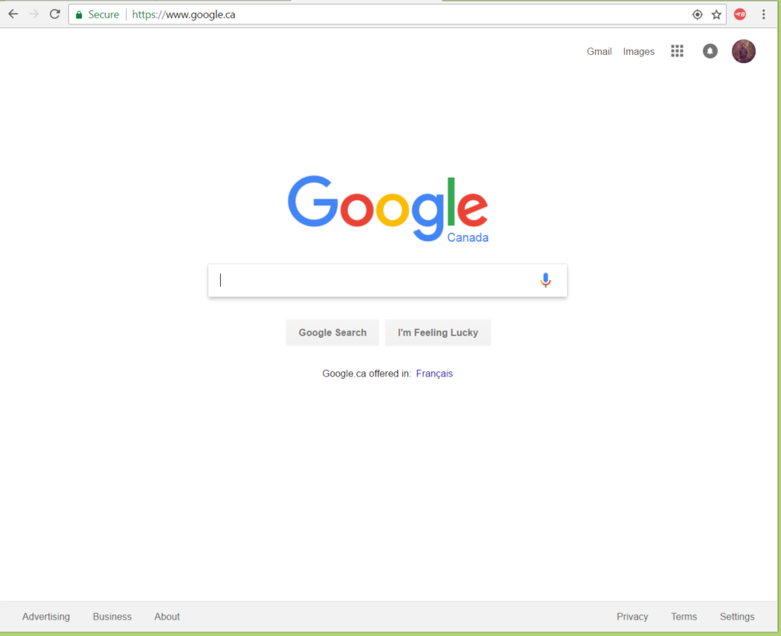

(You may use this space to answer Question 3)

**Question 4 – *Finite State Machines – {20 Marks}***

1. Develop the Finite State Machine for a very simple elevator in the space below. This elevator is the one you have in your build ing, It goes up and down, 4th floor is top floor and 1st is bottom floor, show me a diagram in circles and arrows only and write the label of each state and each transition
2. The tests (showing the Test Title, Test Steps and Expected Results) for testing this elevator
3. What is Acceptance testing, who runs it and when do we run it (when in the Software Life Cycle), choose one of your test cases as your acceptance test and just write the test case number or title you chose for your acceptance test.

|  |  |  |
| --- | --- | --- |
| **Test Title** | **Test Steps** | **Expected Results** |
|  |  |  |
|  |  |  |
|  |  |  |
|  |  |  |
|  |  |  |
|  |  |  |
|  |  |  |
|  |  |  |

**(Note:** the number of cells in the above graph do not necessarily indicate the number of responses required**).**

**Question 5 – *Decision Table - {20 Marks}***

Suppose you are a customer at a bank and you want to open a credit card account. There are three conditions at the time of your application:

* First, you will get a 15% discount on all your purchases today if you are a new customer;
* Second, if you are an existing customer and you hold a loyalty card, you get a 10% discount and
* Third, if you have a coupon, you can get 20% off (but it can’t be used with the ‘new customer’ discount).

Discount amounts are added, if applicable.

Develop the Decision Tables for this situation - remember to reduce it as much as possible and then derive the Test Cases and the Expected Results. You may use the blank space below and / or the graph(s) on the following pages to answer this question.

|  |  |  |  |  |  |  |  |  |  |
| --- | --- | --- | --- | --- | --- | --- | --- | --- | --- |
|  |  |  |  |  |  |  |  |  |  |
|  |  |  |  |  |  |  |  |  |  |
|  |  |  |  |  |  |  |  |  |  |
|  |  |  |  |  |  |  |  |  |  |
|  |  |  |  |  |  |  |  |  |  |
|  |  |  |  |  |  |  |  |  |  |
|  |  |  |  |  |  |  |  |  |  |
|  |  |  |  |  |  |  |  |  |  |
|  |  |  |  |  |  |  |  |  |  |
|  |  |  |  |  |  |  |  |  |  |
|  |  |  |  |  |  |  |  |  |  |
|  |  |  |  |  |  |  |  |  |  |
|  |  |  |  |  |  |  |  |  |  |
|  |  |  |  |  |  |  |  |  |  |
|  |  |  |  |  |  |  |  |  |  |
|  |  |  |  |  |  |  |  |  |  |
|  |  |  |  |  |  |  |  |  |  |

**(Note:** the number of cells in the above graph do not necessarily indicate the number of responses required**).**

|  |  |  |
| --- | --- | --- |
| **Test Title** | **Test Steps** | **Expected Results** |
|  |  |  |
|  |  |  |
|  |  |  |
|  |  |  |
|  |  |  |
|  |  |  |
|  |  |  |
|  |  |  |

**(Note:** the number of cells in the above graph do not necessarily indicate the number of responses required**).**

**(this is the last page of the examination and is intentionally left blank, but can be used for your rough work or to provide a solution to a previous question)**

**Remember to hand in your Cheat Sheet along with this examination – otherwise, a zero will be provided.**