OPERATIONS HANDBOOK
Odoo 17 Manufacturing
Step-by-Step User Manual
LEGACY MANUFACTURERS LIMITED
Validated against: odoo17_legacy_masterdata_dev
Covers master data setup, packaging recipes, custom multi-output manufacturing, reconciliation, work orders, Shop Floor, planning, and reporting.
Version 1.0 | 3 August 2026
How to Use This Manual
Follow the sections in sequence for setup; use the later checklists during daily production.
SCOPE This guide documents the Manufacturing and Shop Floor interfaces visible in the Legacy development master-data database. It uses the configured TSP production line and packaging recipe as examples. Screen labels may vary slightly by user access rights.

Contents
Section | Topic
1 | Access and navigation
2 | Manufacturing process at a glance
3 | Master-data setup sequence
4 | Create and maintain packaging recipes
5 | Create a custom multi-output Bill of Materials
6 | Create a manufacturing order
7 | Plan finished outputs and packaging
8 | Confirm and execute production
9 | Reconcile output, loss, and packaging
10 | Complete, scrap, unbuild, and correct
11 | Planning and reporting
12 | Daily checklists and troubleshooting

TEST DATABASE The database displays a neutralization banner. Treat it as a test environment; repeat approved steps in production only after validation and authorization.
1. Access and Navigation
Log in to the correct database and open the Manufacturing workspace.
STEP 1 Open the Odoo database
Browse to http://localhost:8077/web?db=odoo17_legacy_masterdata_dev.
STEP 2 Sign in
Enter your assigned Odoo email or username and password, then select Log in. The administrator account was used only to validate this manual.
STEP 3 Open Manufacturing
From the application launcher, select Manufacturing. The landing page is the Work Centers Overview.
STEP 4 Use the main menus
Use Operations for Manufacturing Orders and Work Orders; Planning for schedules; Products for products and Bills of Materials; Reporting for analysis; and Configuration for packaging recipes, work centers, and operations.
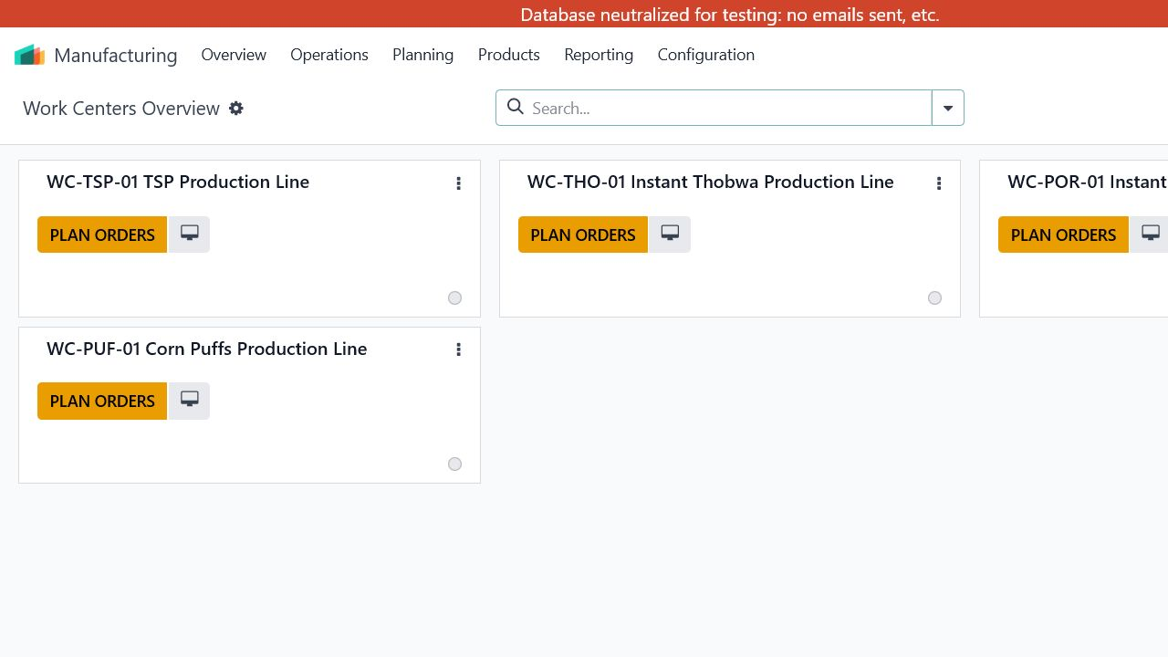
Figure 1. Manufacturing Work Centers Overview in the Legacy database.
ACCESS NOTE If a menu described in this manual is missing, request the appropriate Manufacturing, Inventory, or Shop Floor access group. Do not use the administrator account for routine production work.
2. Manufacturing Process at a Glance
Legacy custom manufacturing links bulk production, packaged finished goods, and packaging-material reconciliation.
Stage | Action | Primary result
1 | Maintain master data | Products, work centers, operations, packaging materials
2 | Define packaging recipes | Finished pack, base quantity, recipe version, material quantities, waste and rounding
3 | Build the BoM | Bulk/WIP product, raw materials, Custom Multi-Output workflow, process type, operations
4 | Create the MO | Select product, quantity, BoM, dates, responsible person, finished-output plan
5 | Confirm and execute | Reserve components, perform work orders, record output and packaging consumption
6 | Reconcile and close | Review usable output, loss, packaged equivalent, balance/variance, lots, and completion

CONTROL POINT Do not confirm an MO until the selected BoM, packaging recipes, output quantities, and scheduled date have been reviewed. Confirmation creates operational demand and work orders.

Custom workflow choices
- Custom Multi-Output: enables the Legacy output-plan, packaging-consumption, and reconciliation controls.
- Integrated Production and Packaging: use when bulk production and final packaging are controlled in one manufacturing order.
- Multi-Variant Packaging: use when one bulk output is packed into more than one finished-product variant.
3. Master Data Setup Sequence
Create records in dependency order to avoid missing selections and calculation errors.
Order | Record | Menu path | What to verify
1 | Products / Product Variants | Products > Products | Create raw materials, WIP/bulk items, packaging items, and finished packaged goods with correct UoM and tracking.
2 | Work Centers | Configuration > Work Centers | Set the production line, capacity, calendar, efficiency, and costing settings.
3 | Operations | Configuration > Operations | Create the production steps and assign each to the correct work center.
4 | Packaging Recipes | Configuration > Packaging Recipes | Define materials and quantities required for each finished package.
5 | Bills of Materials | Products > Bills of Materials | Link raw materials, workflow, process type, and ordered operations.

Product-code conventions observed in the database
Prefix | Observed use and example
RM- | Raw material, for example [RM-SOYA-BEANS].
WIP- | Bulk or work-in-process material, for example [WIP-BULK-TSP].
PKG- | Packaging material, for example [PKG-INNER-PACKAGING-700G].
FG- | Finished packaged product, for example [FG-TSP-CASE-10-X-700G].

UNIT-OF-MEASURE CHECK Keep mass, units, and pack conversions consistent. The configured TSP example manufactures 7.00000 kg of bulk TSP and uses a finished case packaging recipe with unit-based packaging materials.
4. Create and Maintain Packaging Recipes
Menu: Manufacturing > Configuration > Packaging Recipes
STEP 1 Select New
Create one active recipe for each packaged finished product and recipe version.
STEP 2 Complete the recipe header
Enter Name, Code, Product, Base Qty and UoM, Version, Company, Valid From/To, Active, Operation, and Workcenter.
STEP 3 Add packaging materials
On Packaging Materials, select Add a line for each item. Enter Packaging Product, Qty Per Base, Product UoM, Wastage Percentage, Rounding Method, Operation, and whether manual adjustment is allowed.
STEP 4 Add notes and validate
Use Notes for instructions or assumptions. Confirm that the recipe is active and its validity dates cover the planned production date.
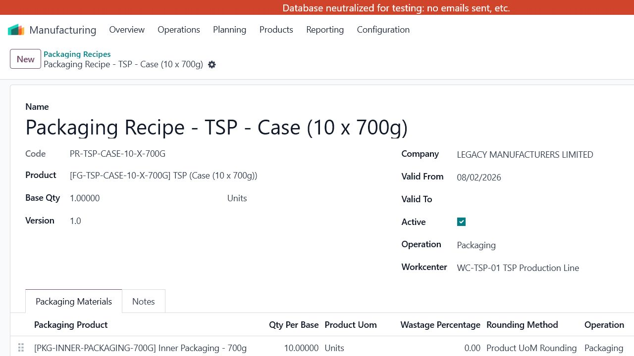
Figure 2. Configured TSP case packaging recipe and packaging-material lines.

Configured example
Field | Configured value
Recipe | PR-TSP-CASE-10-X-700G
Finished product | [FG-TSP-CASE-10-X-700G] TSP (Case (10 x 700g))
Base | 1.00000 Units, version 1.0
Inner packaging | [PKG-INNER-PACKAGING-700G] - 10.00000 Units
Outer packaging | [PKG-OUTER-PACKAGING-700G] - 1.00000 Units
Operation / work center | Packaging / WC-TSP-01 TSP Production Line

VERSIONING When material content or consumption rules change, close the old validity period and create a new version. Avoid overwriting a recipe that has already supported completed production.
5. Create a Custom Multi-Output Bill of Materials
Menu: Manufacturing > Products > Bills of Materials
STEP 1 Select New
Choose the bulk/WIP product and product variant that will be produced before or during packaging.
STEP 2 Enter quantity and reference
Set the base manufacturing quantity and UoM. Use a clear reference such as LEGACY-TSP-CASE-10-X-700G.
STEP 3 Select the workflow
Set Manufacturing Workflow to Custom Multi-Output. Choose Integrated Production and Packaging or Multi-Variant Packaging as required.
STEP 4 Set the BoM type
Use Manufacture this product for production BoMs. Use Kit only when the business process genuinely requires a kit.
STEP 5 Add components
On Components, enter the raw materials and quantities required for the BoM base quantity.
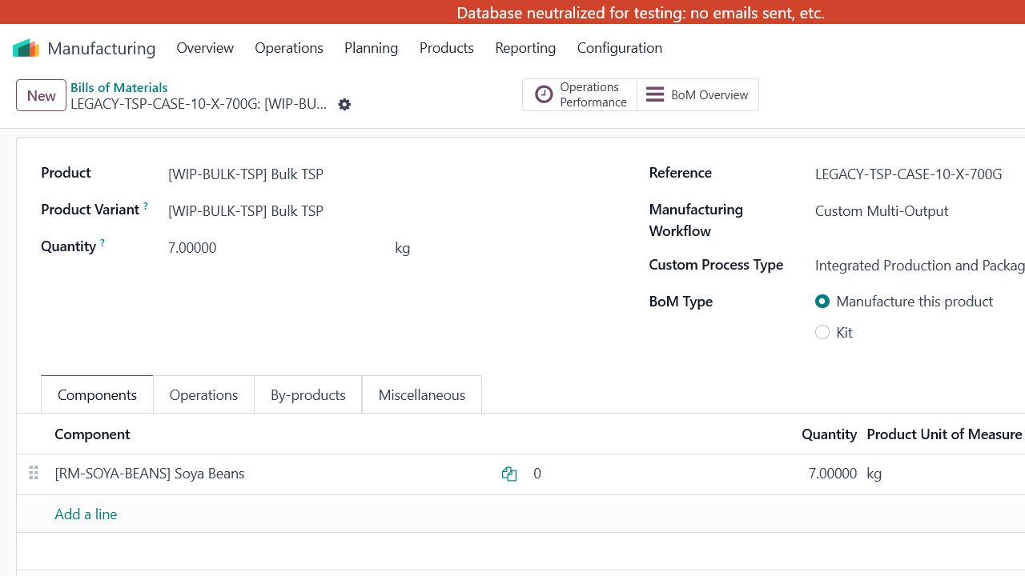
Figure 3. TSP custom multi-output BoM header and component setup.
EXAMPLE The configured TSP BoM produces 7.00000 kg of [WIP-BULK-TSP] from 7.00000 kg of [RM-SOYA-BEANS]. Verify real yields and losses with the production owner before using a BoM operationally.
5.1 Configure BoM Operations
Operations define the ordered work that appears on Manufacturing Orders and Shop Floor.
STEP 1 Open the Operations tab
Select Add a line to create a new operation or Copy Existing Operations to reuse validated operations.
STEP 2 Assign each operation
Set the operation name, work center, duration method, duration, and instructions.
STEP 3 Place operations in production order
Drag the row handles so the list matches the actual routing. Dependencies determine whether a work order is Ready or Waiting for another WO.
STEP 4 Review outputs
Use By-products only for genuine secondary outputs. The Legacy Finished Output Plan is handled on the MO when Custom Multi-Output is selected.
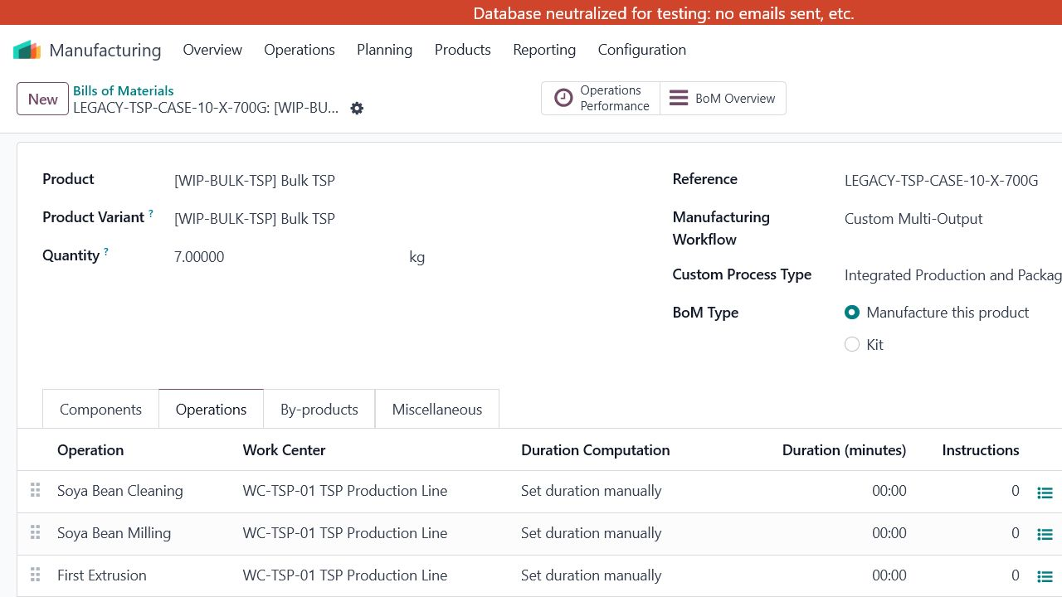
Figure 4. TSP BoM operations assigned to the TSP production line.
DURATION The configured example displays manual durations of 00:00. Enter realistic expected durations before relying on capacity planning or OEE analysis.
6. Create a Manufacturing Order
Menu: Manufacturing > Operations > Manufacturing Orders
STEP 1 Select New
The MO opens in Draft status. Do not confirm until all planning fields are complete.
STEP 2 Select product and quantity
Choose the bulk/WIP product to manufacture and enter the planned quantity and UoM.
STEP 3 Select the BoM
Choose the matching, approved BoM. Confirm that its workflow is Custom Multi-Output and its process type is correct.
STEP 4 Set schedule and owner
Enter Scheduled Date and review the calculated End date. Assign the Responsible user.
STEP 5 Load packaging logic
Use Reload Packaging Recipes after selecting/changing outputs or recipes. Use Recalculate Outputs after quantity or actual-output changes.
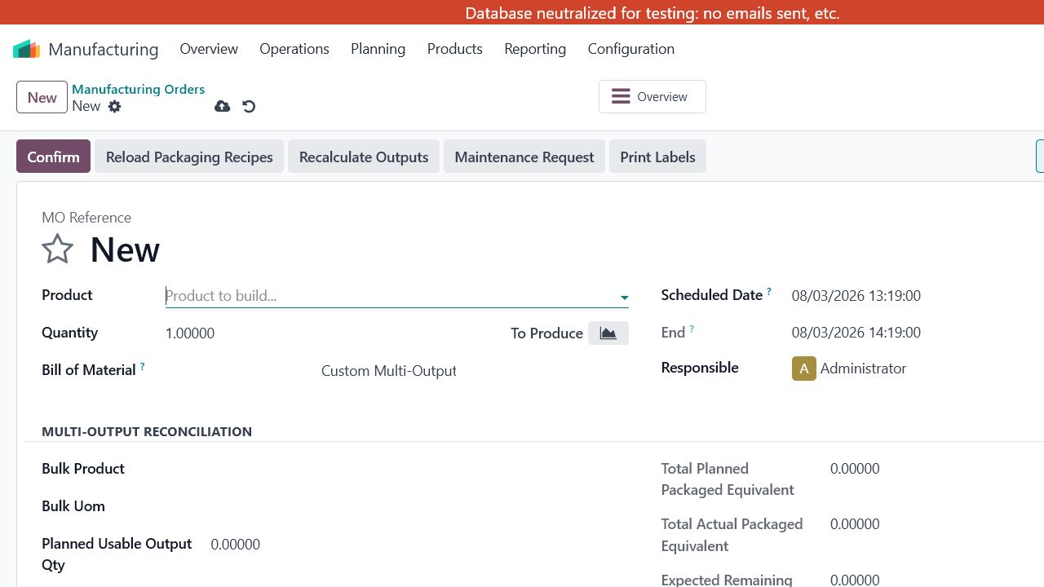
Figure 5. New MO with Custom Multi-Output reconciliation controls enabled.
DO NOT SAVE TEST DATA This manual used an unsaved draft only to inspect fields; the draft was discarded. In live use, save and confirm only genuine, authorized production orders.
7. Plan Finished Outputs and Packaging
Complete the output plan before confirmation so material demand and reconciliation have a reliable baseline.

Finished Output Plan tab
Field | How to use it
Product | Finished packaged product to receive into stock.
Output Classification | Select the classification required by the configured workflow.
Planned Qty | Planned number of finished units or packs.
Actual Qty | Enter after production; do not use planned quantity as a substitute.
Net Content Qty / UoM | Bulk content represented by one finished unit.
Equivalent Bulk Qty | Calculated/controlled bulk equivalent of the output.
Packaging Recipe / Version | Recipe that determines packaging-material demand.
Lot | Finished-output lot or serial reference when tracking is enabled.

Packaging Consumption tab
- Review Finished Product, Packaging Product, Qty Per Unit, Planned Output Qty, and Planned Packaging Qty.
- After production, review Actual Output Qty, Expected Actual Packaging Qty, and Actual Consumed Qty.
- Investigate Variance Qty and Variance Percentage. Enter a specific Variance Reason when consumption differs from expectation.
- Confirm the linked Stock Move and Operation are correct before completion.
RECALCULATE Run Recalculate Outputs whenever output quantities, recipes, or actual quantities change. Then re-check packaging consumption and reconciliation totals.
8. Confirm and Execute Production
Confirmation activates component demand and generates work orders from the BoM routing.
STEP 1 Review components
On Components, confirm the products, source locations, quantities to consume, UoMs, and availability. Resolve shortages before starting affected work.
STEP 2 Select Confirm
The MO moves from Draft to Confirmed. Work orders become Pending, Waiting, Ready, or In Progress according to availability and dependencies.
STEP 3 Open Work Orders or Shop Floor
Use Manufacturing > Operations > Work Orders for a list view, or open the Shop Floor application for operator execution.
STEP 4 Assign the station and operator
In Shop Floor, select the relevant Legacy work center and operator. Use All MO or My WO to control the display.
STEP 5 Run the operation
Start the ready work order, follow instructions, record consumed quantities and lots, pause when work stops, use Block for a genuine constraint, and select Done when the operation is completed.
STEP 6 Register production
Use Register Production for produced quantity and tracked lots. Close Production only after production and quality entries are complete.
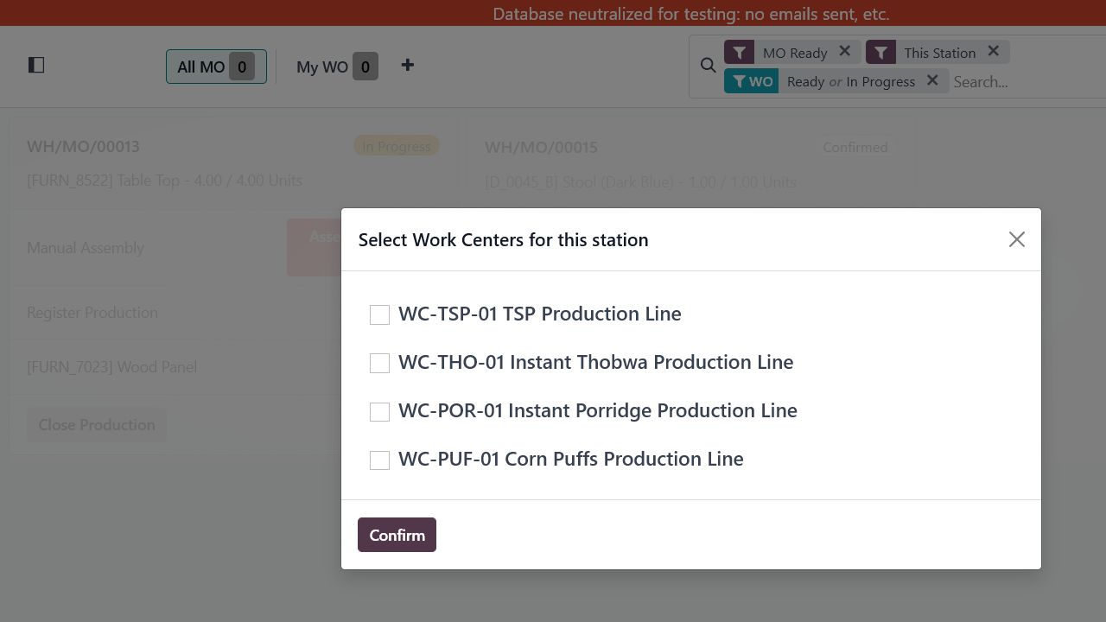
Figure 6. Shop Floor station selection for the four Legacy production lines.
STATUS GUIDE Waiting for components means required material is unavailable; Waiting for another WO means an earlier operation must finish; Ready means the work may start; In Progress means time is being recorded; Finished means the work order is complete.
9. Reconcile Output, Loss, and Packaging
The MO should explain where planned bulk material went before it is closed.
Control | Required review
Planned Usable Output Qty | Expected usable bulk output.
Actual Usable Output Qty | Measured usable bulk output after processing.
Planned Process Loss Qty | Expected production loss.
Process Loss Qty | Actual measured production loss.
Total Planned Packaged Equivalent | Planned bulk represented by finished-output lines.
Total Actual Packaged Equivalent | Actual bulk represented by actual finished output.
Expected / Remaining Bulk Qty | Bulk expected to remain and the actual remainder.
Reconciliation Difference | Unexplained difference after outputs, losses, and remainder.
Reconciliation Status | Balanced when the configured reconciliation equation is satisfied.
Variance Reason / Approved | Document and authorize accepted variance according to policy.

Recommended close sequence
- Enter actual usable output and actual process loss.
- Enter actual finished quantities and lots on Finished Output Plan.
- Record actual packaging consumption and variance reasons.
- Select Recalculate Outputs.
- Confirm packaged equivalents, remaining bulk, and difference.
- Resolve the difference or document and obtain variance approval.
- Complete remaining work orders and mark the MO Done.
BALANCE RULE Do not approve a variance merely to force closure. The approver should be independent of the data entry where practical and should confirm physical quantities, stock moves, and supporting notes.
10. Completion, Scrap, Unbuild, and Corrections
Use the transaction that matches the physical event and preserve traceability.
Action | Where | When to use
Finish the MO | MO form | Use when all components, outputs, work orders, lots, and reconciliation are complete.
Scrap | Operations > Scrap | Use for material or output that is physically lost, damaged, contaminated, or otherwise unusable. Select product, quantity, UoM, source, scrap location, and lot where required.
Unbuild | Operations > Unbuild Orders | Use to reverse a manufactured product into components when the physical operation and accounting treatment require it.
Cancel | MO action, subject to state | Use only for an order that will not be executed. Review reservations and related moves.
Correct actuals | MO / stock moves | Correct before closure where possible. After closure, follow the approved inventory/accounting correction process instead of silently changing history.

TRACEABILITY Use lot/serial tracking consistently for raw materials, bulk output, and finished products whenever configured. Attach supporting records or log a note when correcting a significant variance.
11. Planning and Reporting
Use planning to sequence work and reporting to monitor duration, productivity, and equipment effectiveness.
View | Menu path | Purpose
Planning by Production | Planning > Planning by Production | Review and schedule work by manufacturing order.
Planning by Workcenter | Planning > Planning by Workcenter | Balance work across the TSP, Thobwa, Porridge, and Corn Puffs lines.
Master Production Schedule | Planning > Master Production Schedule | Plan demand-driven production when the MPS process is in use.
Work Orders | Reporting > Work Orders | Compare expected and real operation performance.
Overall Equipment Effectiveness | Reporting > Overall Equipment Effectiveness | Review availability, performance, and quality-related equipment effectiveness.
Production Analysis | Reporting > Production Analysis | Analyze manufacturing quantities, timing, products, and other available measures.

Planning discipline
[ ] | Maintain realistic operation durations and work-center calendars; otherwise capacity and OEE results will be misleading.
[ ] | Plan by work center when competing orders use the same production line.
[ ] | Review late, blocked, and waiting work orders daily and assign an owner for each constraint.
[ ] | Use the same filters and date basis when comparing reports between periods.

12. Daily Operating Checklists
Use these checks at handover, before confirmation, and before closure.

Planner / production supervisor - before confirmation
[ ] | Correct bulk/WIP product, quantity, UoM, and BoM selected.
[ ] | Custom Multi-Output and the correct process type selected.
[ ] | Scheduled date, end date, responsible person, and work center are realistic.
[ ] | Finished Output Plan matches the approved production plan.
[ ] | Packaging recipes are active, within validity dates, and at the correct version.
[ ] | Components and packaging materials are available or have an approved shortage plan.
[ ] | Reload Packaging Recipes and Recalculate Outputs completed after changes.

Operator - during production
[ ] | Correct station, work order, operator, and product confirmed.
[ ] | Work started only when status is Ready and safety/quality prerequisites are met.
[ ] | Actual consumption, quantities, lots, scrap, downtime, and blocks recorded promptly.
[ ] | Work paused when production stops and marked Done only when the operation is complete.

Supervisor / approver - before MO completion
[ ] | All work orders complete and no unexplained block remains.
[ ] | Actual usable output, process loss, packaged outputs, and lots entered.
[ ] | Actual packaging consumption recorded and variances explained.
[ ] | Recalculate Outputs completed; remaining bulk verified physically.
[ ] | Reconciliation is Balanced, or variance is supported and properly approved.
[ ] | Stock moves and destination locations are correct before marking Done.

12.1 Troubleshooting
Use the symptom to identify the first control to check.
Symptom | Likely cause | First action
Packaging recipe not available | Recipe inactive, outside validity date, wrong company/product, or wrong version | Check recipe header, dates, product, company, and Active; then Reload Packaging Recipes.
Packaging demand is wrong | Base quantity, Qty Per Base, waste, rounding, output quantity, or recipe version is wrong | Correct the recipe/output plan and run Recalculate Outputs.
Work order is waiting | Component shortage or preceding operation incomplete | Review status, availability, reservations, and operation sequence.
Reconciliation is not balanced | Actual output, loss, remainder, finished quantities, packaging consumption, or UoM conversion is incomplete/wrong | Verify physical counts and each actual field, then recalculate. Do not approve until the cause is documented.
Cannot complete MO | Open work order, missing lot, insufficient consumption/output entry, or unresolved validation | Read the validation message; complete the relevant tab or work order and retry.
Planning is unrealistic | Operation durations, calendars, capacities, or work-center assignments are incomplete | Correct master data and reschedule; do not treat inaccurate plan output as a production commitment.
Menu or button is missing | Insufficient user access or feature configuration | Ask the system administrator to review access groups and Manufacturing settings.

ESCALATE Escalate repeated calculation differences, unexpected stock moves, access-control failures, or posting errors to the Odoo support/development team with the MO reference, product, date/time, user, screenshots, and exact error message.

