DecodeLabs — Data Analytics Internship
Project 2: Exploratory Data Analysis (EDA)
E-Commerce Order Dataset — Diagnostic Report
1,200 orders | Jan 2023 – Jun 2025 | 14 fields, fully cleaned

1. Problem Statement
DecodeLabs' e-commerce order data was cleaned in Project 1. This report performs the discovery phase: exploring the cleaned dataset to surface patterns, trends and outliers before any dashboarding or predictive modeling is attempted.
Core question: What is actually happening in our order pipeline — where is revenue concentrated, where is it leaking, and which relationships in the data are worth acting on?

2. Methodology
Dataset: Cleaned_Dataset_Project1_dl.xlsx, sheet 'Cleaned_Data' — 1,200 rows × 14 columns, zero missing values (confirmed against the Project 1 Data Quality Audit sheet).
- Descriptive statistics (mean, median, std, min/max) for all numeric fields.
- Categorical frequency breakdowns for Product, Payment Method, Order Status, Coupon Code and Referral Source.
- Outlier detection using the IQR method (Q1 − 1.5×IQR, Q3 + 1.5×IQR) on all numeric columns.
- Pearson correlation analysis across Quantity, Unit Price, Items in Cart and Total Price.
- Time-series aggregation of revenue by month to detect seasonality or trend.
- Revenue cuts by Product, Order Status, Payment Method, Coupon Code and Referral Source to connect statistics to business impact.

3. Dataset Overview
Field | Type | Notes
OrderID / TrackingNumber | Text | Unique per order — identifiers only
Date | Date | Jan 4, 2023 – Jun 30, 2025
CustomerID | Text | 1,189 unique customers across 1,200 orders
Product | Category | 7 products: Printer, Tablet, Chair, Laptop, Desk, Monitor, Phone
Quantity | Numeric | 1–5 units per order
UnitPrice | Numeric | $11.39 – $699.93
ItemsInCart | Numeric | 1–10 items
PaymentMethod | Category | 5 methods, evenly split (~230–258 orders each)
OrderStatus | Category | 5 statuses: Delivered, Shipped, Pending, Cancelled, Returned
CouponCode | Category | FREESHIP, SAVE10, WINTER15, No Coupon
ReferralSource | Category | Instagram, Email, Google, Facebook, Referral
TotalPrice | Numeric | $11.39 – $3,456.40 (Quantity × UnitPrice)

4. Univariate Analysis — Central Tendency & Spread
Metric | Quantity | Unit Price ($) | Items in Cart | Total Price ($)
Mean | 2.95 | 356.41 | 5.49 | 1,053.97
Median | 3.00 | 364.21 | 5.00 | 823.62
Std Dev | 1.41 | 197.18 | 2.28 | 819.86
Min | 1 | 11.39 | 1 | 11.39
Max | 5 | 699.93 | 10 | 3,456.40

Total Price has mean ($1,053.97) noticeably above its median ($823.62) — a classic right-skew signature. A handful of high-value orders (large quantity × high unit price) pull the average upward, so the median is the more honest "typical order value" for this business.
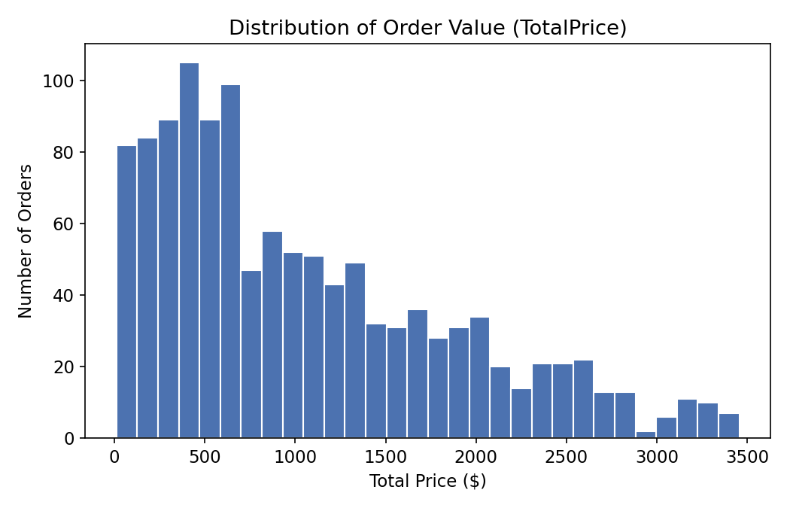
The histogram confirms the right skew directly: most orders cluster under $1,000, with a long tail of larger transactions stretching to ~$3,450.

5. Outlier Detection
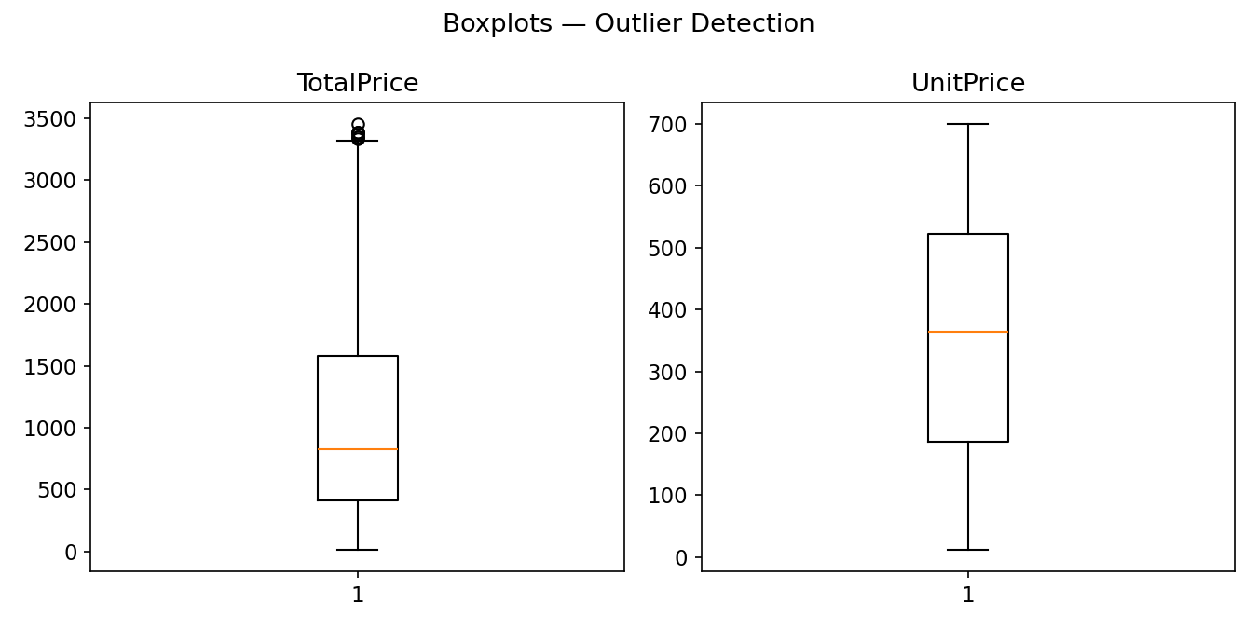
Applying the IQR rule (flagging values beyond Q3 + 1.5×IQR = $1,024.83 for Total Price) surfaces 8 orders above $3,330 — all of them orders for 5 units (the maximum allowed quantity) of a higher-priced item. None show data-entry irregularities (odd decimals, mismatched math, etc.).
Diagnosis: these are signal, not noise. They represent legitimate bulk purchases rather than cleaning errors, and are spread across Printers, Laptops, Tablets, Chairs and Monitors — not concentrated in one product, payment method or referral source. No further cleaning action is required; they're worth flagging to the business as a natural "large order" segment rather than removing them.

6. Correlation Analysis
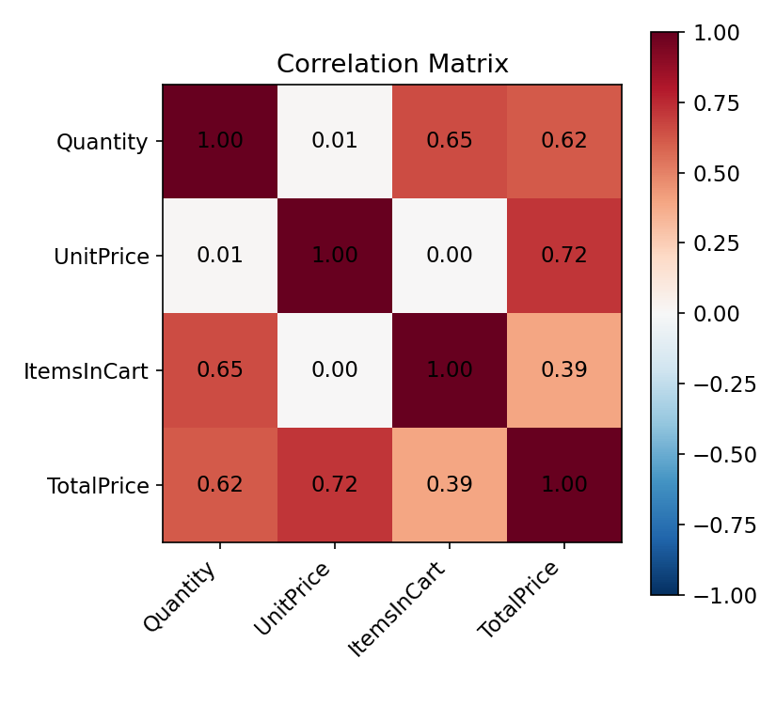
- Unit Price ↔ Total Price: r = 0.72 — the strongest driver of order value, as expected.
- Quantity ↔ Total Price: r = 0.62 — quantity matters, but less than price per unit.
- Quantity ↔ Items in Cart: r = 0.65 — customers who order more units also tend to have larger, fuller carts.
- Unit Price ↔ Quantity: r ≈ 0.01 (no relationship) — customers do not systematically buy more units of cheaper items or vice versa.
Reminder: correlation is a clue, not a verdict. These relationships describe the data as recorded; they don't establish that raising unit prices would proportionally raise revenue, since other factors (demand elasticity, product mix) aren't captured here.

7. Trend Analysis — Revenue Over Time
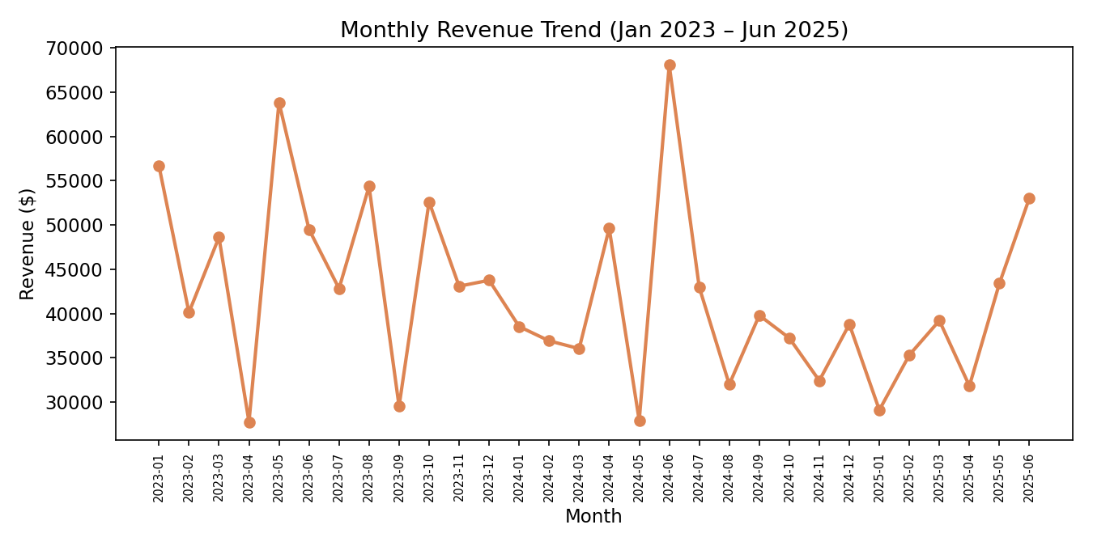
Monthly revenue fluctuates between roughly $27,700 and $68,100 with no strong sustained upward or downward trend across the 30-month window — it reads as noisy but stationary rather than growing or declining. Notable peaks appear in May 2023 ($63,800) and June 2024 ($68,100); the softest months are April 2024 and January/May 2025 (all under $32,000). This is worth flagging for a follow-up seasonality study, since no obvious calendar pattern (e.g. consistent Q4 spike) repeats cleanly year-over-year in this sample.

8. Business Breakdowns

8.1 Revenue by Product
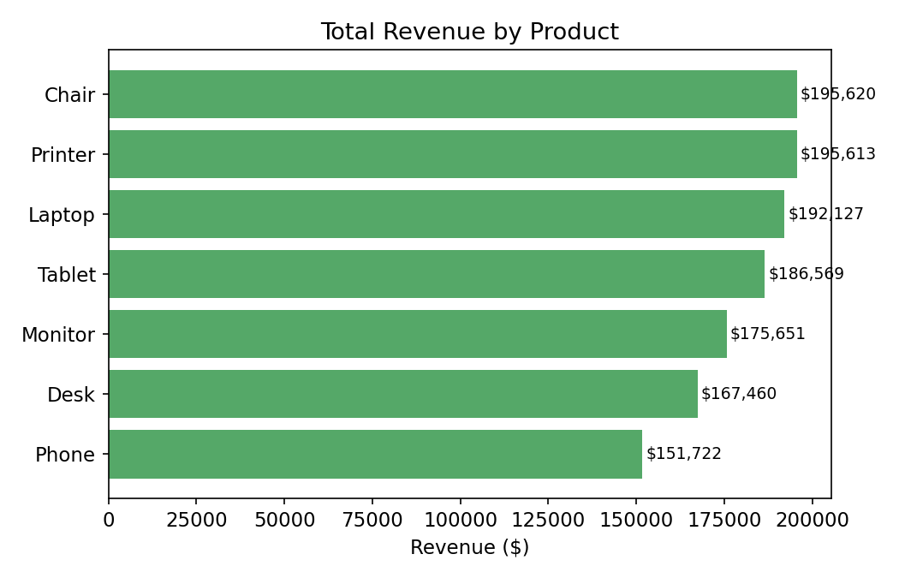
Revenue is close to evenly split across the 7 products (Chair and Printer lead at ~$195,600 each; Phone trails at ~$151,700), but Phone actually has the highest average unit price ($375). Its lower total revenue comes from having the fewest orders (156, the lowest of any product) — a volume gap rather than a pricing one.

8.2 Revenue at Risk — Order Status
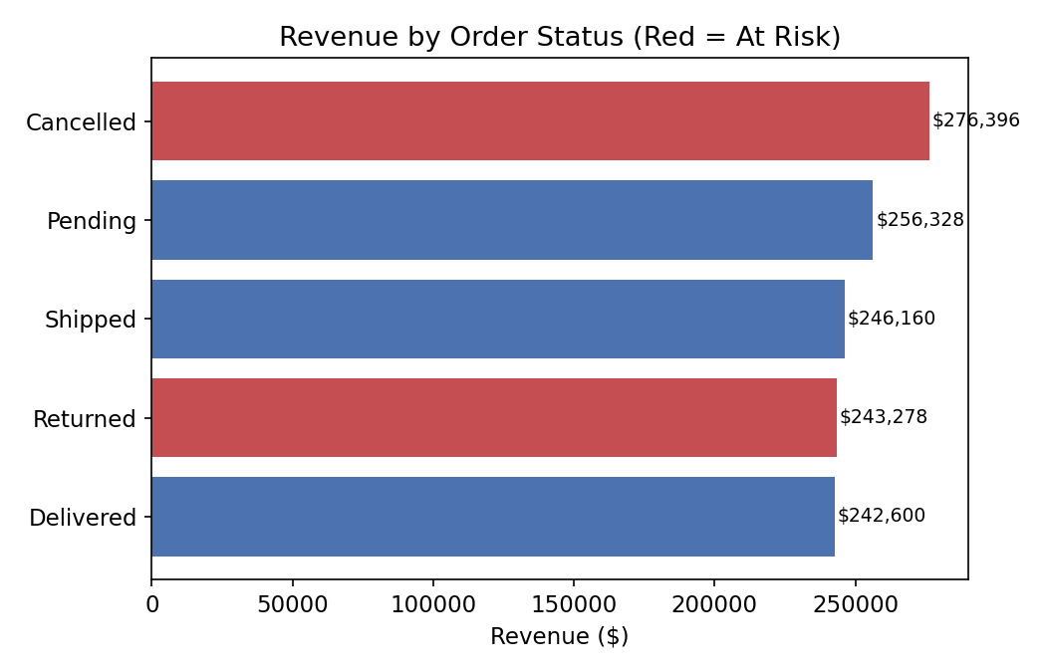
This is the most actionable finding in the dataset: Cancelled and Returned orders together account for $519,674 of the $1,264,762 total recorded revenue — 41.1%. Cancelled orders alone ($276,396, 250 orders) are the single largest status group, larger than Delivered. Nearly two in five recorded dollars never convert into fulfilled revenue.

8.3 Payment Method, Coupons & Referral Source
- Payment methods are evenly used (Online 258 orders, Cash 246, Credit Card 234, Debit Card 232, Gift Card 230) with no method standing out on revenue share — average order value ranges narrowly from $1,002 (Debit Card) to $1,128 (Credit Card).
- Coupon usage: orders with no coupon actually carry a similar average value (~$1,043) to discounted orders — coupons in this dataset don't show a clear trade-down effect on order size.
- Referral sources are balanced (Instagram 259, Email 250, Google 241, Facebook 228, Referral 222), with Instagram contributing the most total revenue ($275,285) mainly through order volume rather than a higher average order value.

9. Executive Summary

Key Findings
- Order values are right-skewed — use the median ($823.62), not the mean ($1,053.97), as the "typical order" benchmark.
- 8 high-value orders (>$3,330) are legitimate large purchases, not data errors — a natural bulk-order segment.
- Unit Price is the strongest driver of Total Price (r = 0.72); Quantity is the second strongest (r = 0.62).
- Monthly revenue is noisy but roughly stable over 2.5 years — no clear long-term growth or decline.
- 41.1% of all recorded revenue sits in Cancelled or Returned orders — the largest single opportunity in this dataset.
- Product, payment method and referral source revenue are all fairly evenly distributed — no single channel dominates.

Recommendations
- Investigate why Cancelled is the single largest order-status group — this is the highest-leverage question raised by this analysis and merits a root-cause follow-up (e.g., by product, payment method or shipping region).
- Report order value using the median going forward to avoid the mean being inflated by the bulk-order tail.
- Treat the 8 large orders as a segment to study, not clean away — e.g., are these repeat customers who could be targeted for a wholesale/bulk program?
- Run a dedicated seasonality study (year-over-year, same-month comparison) before assuming any month-to-month swing is meaningful.
Prepared as part of the DecodeLabs Data Analytics Internship — Project 2 (EDA).

