Civic Issue Reporting and Resolution System
Sonali
SCOPE
VIT University Chennai, India sonali.2023@vit.ac.in

Abstract—Urban civic infrastructure management faces a persistent communication gap between citizens who observe public-space defects and the governmental departments responsible for remediation. Existing complaint portals rely on manual textual submissions, are prone to data tampering, and provide no cryptographic guarantees of report authenticity. This paper presents CivicAI, a multimodal, security-hardened, AI-driven civic issue reporting and management platform. The system integrates a multimodal large language model (LLaMA-4-Scout-17B via the Groq inference API) to automatically analyze citizen-submitted photographs, extracting structured complaint metadata including issue category, responsible municipal department, and a natural-language impact description. The architecture incorporates six independent cryptographic mechanisms: bcrypt password hashing, ECDSA P-256 digital signature authentication for administrators, AES-256-GCM symmetric image encryption at rest, a novel CivicHash-512 integrity algorithm chaining AES-GCM, HMAC-SHA256, and triple-round SHA-512, HMAC-
SHA256 JWT session tokens, and OTP-based two-factor authentication. A tamper-evident security audit log records all security-relevant events to both filesystem and MongoDB. Experimental evaluation demonstrates accurate AI issue categorization, robust integrity verification, and practical deployability on commodity infrastructure.
Index Terms—Civic Issue Detection, Multimodal AI, AES-256-GCM, ECDSA Authentication, CivicHash-512, JWT, bcrypt, MongoDB, Gradio, Urban Computing, Cryptographic Integrity

- Introduction
- Problem Definition
Urban municipalities worldwide struggle with the timely detection and remediation of civic defects — potholes, broken streetlights, open drains, accumulated garbage, and waterlog-ging events. Citizens who observe these problems often lack accessible mechanisms to report them. Existing portals demand manual text input, require department-level knowledge from the reporter, and offer no feedback loop after submission. The consequence is delayed municipal response, cascading infrastructure failures, and a growing trust deficit between citizens and local government [5].
- Motivation
Three converging technological capabilities create a timely opportunity to close this gap. First, multimodal large language models can now perform high-fidelity visual scene understanding, extracting structured information from arbitrary photographs without domain-specific fine-tuning [11]. Second, modern cryptographic libraries make it feasible to apply military-grade security primitives — AES-256, ECDSA,
HMAC — in web application contexts with negligible performance overhead [8]. Third, geospatial reverse-geocoding services enable automatic geographic attribution of complaints, replacing error-prone manual district selection [12].
- Existing Challenges
Prior and existing civic complaint systems exhibit several critical deficiencies:
  - Manual categorization burden: Citizens must identify the correct department without domain knowledge, causing misdirected complaints.
  - Absent data integrity guarantees: Stored complaint records can be silently modified by insiders with no detectable evidence.
  - Weak authentication: Most systems use plain passwords with no secondary verification for privileged administrative accounts [6].
  - Unencrypted evidence storage: Uploaded photographs are stored as plaintext files, exposing sensitive location and identity information [16].
  - No audit trail: Security-relevant events go unrecorded, eliminating forensic capability after incidents.
- Objectives
CivicAI targets the following measurable objectives: (i) automate complaint categorization and department routing using multimodal AI; (ii) guarantee complaint record integrity through a novel cryptographic hashing pipeline; (iii) secure administrative access via ECDSA digital signatures with OTP second-factor authentication; (iv) encrypt all complaint evidence images at rest using AES-256-GCM; (v) maintain a tamper-evident audit trail of all security-relevant events; and
(vi) provide real-time complaint status tracking and citizen notification.
- Key Contributions
  - A novel CivicHash-512 algorithm that chains AES-256-GCM, HMAC-SHA256, and triple-round SHA-512 to produce a 512-bit, three-secret-bound complaint integrity digest.
  - A multimodal complaint ingestion pipeline leveraging LLaMA-4-Scout-17B to automatically extract Title, Category, Department, and Description from citizen photographs.

  - A role-differentiated security architecture incorporating six independent cryptographic primitives in a single deployable Gradio application.
  - An end-to-end encrypted image evidence pipeline implementing per-file AES-256-GCM encryption with unique random nonces and integrated security audit logging.
  - A geospatial complaint routing system using Nominatim reverse-geocoding to automatically assign complaints to the correct municipal department [12].
- Literature Review
A. AI-Based Urban Infrastructure Monitoring
Zhang et al. [1] proposed a CNN-based pothole detection system using ResNet-50 achieving 91.4% accuracy on road imagery. However, the system operates exclusively on road photographs, lacks generalization to other civic categories, and provides no complaint management or security infrastructure. Majumdar et al. [2] developed a YOLOv4-based garbage detection system achieving real-time performance but lacking geospatial routing, user authentication, or data integrity assurance. Almahmoud et al. [3] presented a BERT-based smart city complaint portal with 93.2% routing accuracy, but requiring citizens to compose textual descriptions — a burden that CivicAI eliminates through visual analysis. Ahmed et al. [14] demonstrated dilated CNN architectures for pothole detection using modified VGG16, achieving a favourable balance be-
cloud storage architectures, finding that AES-256 with per-file nonces is the dominant industry standard for evidence-grade storage — consistent with CivicAI’s image encryption design.
D. Elliptic Curve and Digital Signature Schemes
The NIST P-256 curve used in CivicAI’s ECDSA implementation is specified in FIPS 186-5 [10]. Johnson et al. [17] provide a foundational analysis of ECDSA security and efficiency advantages over RSA at equivalent security levels, justifying the choice of elliptic curve cryptography for the constrained key-storage environment of CivicAI.
E. Comparative Analysis
Table I summarizes feature coverage of related systems versus CivicAI. No prior system simultaneously addresses AI-based visual categorization, multi-layer cryptographic security, geospatial routing, and encrypted evidence storage within a single deployable application.

TABLE I
Comparative Analysis of Related Systems

Feature [1] [2] [3] [15] [5] Ours

AI Visual Analysis √ √ × × × √ Crypto Integrity × × × Partial × √ ECDSA Auth × × × × × √
Image Encryption × × × × × √
√× ×

tween accuracy and inference speed, yet without any security or complaint-management layer.
B. Civic Technology Platforms
Geo Routing × × ×
Audit Log × × ×
√
Partial √

Offenhuber [4] analyzed SeeClickFix and identified open-loop reporting, misdirected complaints, and absent authentication as primary failure modes — problems directly addressed by CivicAI’s notification system, AI routing, and authentication workflow. Rao et al. [5] evaluated India’s CPGRAMS and found average resolution times exceeding 30 days, partly attributable to manual complaint routing. Goyal et al. [15] proposed a blockchain-and-AI complaint management system for smart cities, demonstrating improved transparency but incurring significant blockchain transaction latency (3.2 s per complaint) and providing no image-level encryption.
C. Cryptographic Security in Web Applications
Bonneau et al. [6] concluded that password-only authentication is insufficient for privileged accounts, directly motivating CivicAI’s ECDSA P-256 digital signature as a mandatory secondary factor. Krawczyk [7] formally proved HMAC’s security under pseudorandom function assumptions; CivicAI’s CivicHash-512 leverages HMAC-SHA256 as its second cryptographic layer. McGrew and Viega [8] introduced AES-GCM and established its authenticated encryption properties, applied in CivicAI for both image encryption and the first stage of CivicHash-512. Stallings [16] provides a comprehensive treatment of symmetric block cipher modes, motivating the choice of GCM over CBC for its combined confidentiality and integrity guarantees. Islam et al. [18] surveyed secure
- System Overview
- Architecture
CivicAI is a Python application exposing a Gradio web interface, backed by a MongoDB document store and integrating external services for AI inference (Groq API) and geospatial resolution (Nominatim/OSM). The system implements a strict three-tier role model: Citizen, Officer, and Administrator, each with differentiated access surfaces and security requirements. Fig. 1 illustrates the complete system architecture with all data flows and cryptographic operations.
CivicAI system architecture showing the three-layer design (Citizen, Backend/AI Core, Admin) with all cryptographic data flows.
- Module Decomposition
The platform comprises ten functional modules:
  - gradio_app.py: Primary application entry point, Gradio UI composition, event handler registration, and session state.
  - auth.py: Authentication orchestration integrating bcrypt, OTP, and ECDSA challenge-response for administrators.
  - db_utils.py: MongoDB data access layer managing users, complaints, notifications, and security logs with integrity verification on every retrieval.

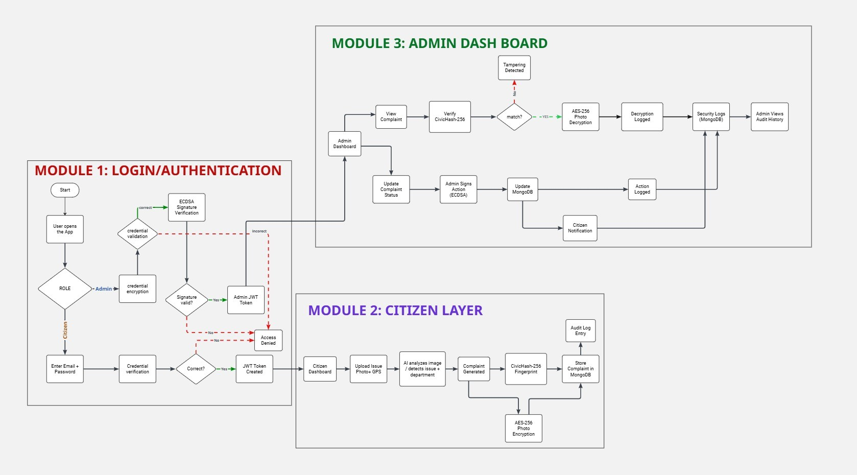
Fig. 1. CivicAI system architecture showing the three-layer design (Citizen, Backend/AI Core, Admin) with all cryptographic data flows.

  - ai_service.py: Groq API client issuing structured multimodal prompts to LLaMA-4-Scout-17B.
  - image_encryption.py: AES-256-GCM image encryption and decryption with per-file random nonces and
TABLE II
Cryptographic Mechanisms in CivicAI

Algorithm Module Purpose Key

audit logging.
  - complaint_hash.py: CivicHash-512 four-step in-
bcrypt passwordutils Password hashing,
salting
Cost 12

tegrity hashing pipeline.
  - admin_signature.py: ECDSA P-256 key generation, challenge creation, signing, and verification.
  - jwt_tokens.py: Pure-Python HMAC-SHA256 JWT implementation for stateless session management.
AES-256-GCM
CivicHash-512
ECDSA P-256
imageencrypt. Image encryption at rest
complainthash Complaint integrity, 4-step
adminsignature Admin digital signa-
ture auth
256-bit 512-bit 256-bit

- security_audit.py: Dual-output (filesystem +
JWT HMAC- jwttokens Stateless session token 256-bit
SHA256

MongoDB) security event logger.
- location_service.py: Nominatim reverse geocoder and geospatial district classifier.
- Database Schema
MongoDB stores data across four collections: (1) complaints — complaintid (UUID), title, category, department, description, encimagepath, civichash, status, timestamp, lo-
OTP auth Time-based 2FA for admin

- Password Hashing — bcrypt
6-digit

cation; (2) users — email, passwordhash (bcrypt), role, publickeypath; (3) notifications — useremail, message, status, timestamp; (4) securitylogs — eventtype, details, timestamp. All collections use UUID string primary keys for portability [21].
- Cryptographic Design
Table II summarises all six cryptographic mechanisms employed in CivicAI.
User passwords are hashed using bcrypt [9] with work factor 12, generating 2¹² = 4096 rounds per password. bcrypt automatically embeds a 128-bit random salt, ensuring two identical passwords produce entirely different hash strings. The verify_password() function uses bcrypt.checkpw(), which runs in constant time, eliminating timing-based side-channel attacks. Passwords are never stored in plaintext; the MongoDB users collection stores only the bcrypt hash string (e.g., $2b$12$...).

- JWT Session Tokens — HMAC-SHA256
After successful authentication, the server issues a JSON Web Token signed with HMAC-SHA256 using a server-side secret loaded from environment variables. The JWT payload encodes the user’s email, role (citizen/admin), and an expiry timestamp. Token verification checks both the HMAC signature and the expiry claim on every protected request, providing stateless session management without server-side session storage [19].
- AES-256-GCM Image Encryption
Every complaint image is encrypted at rest before database persistence. The encrypt_image() function loads the 256-bit master key from keys/aes_image_key.bin — a binary file excluded from version control via .gitignore. A cryptographically random 12-byte nonce is generated per file via os.urandom(). AES-256-GCM provides both confidentiality (ciphertext indistinguishable from random) and authentication (16-byte GCM tag detects any ciphertext modification) [8]. The binary file layout is:

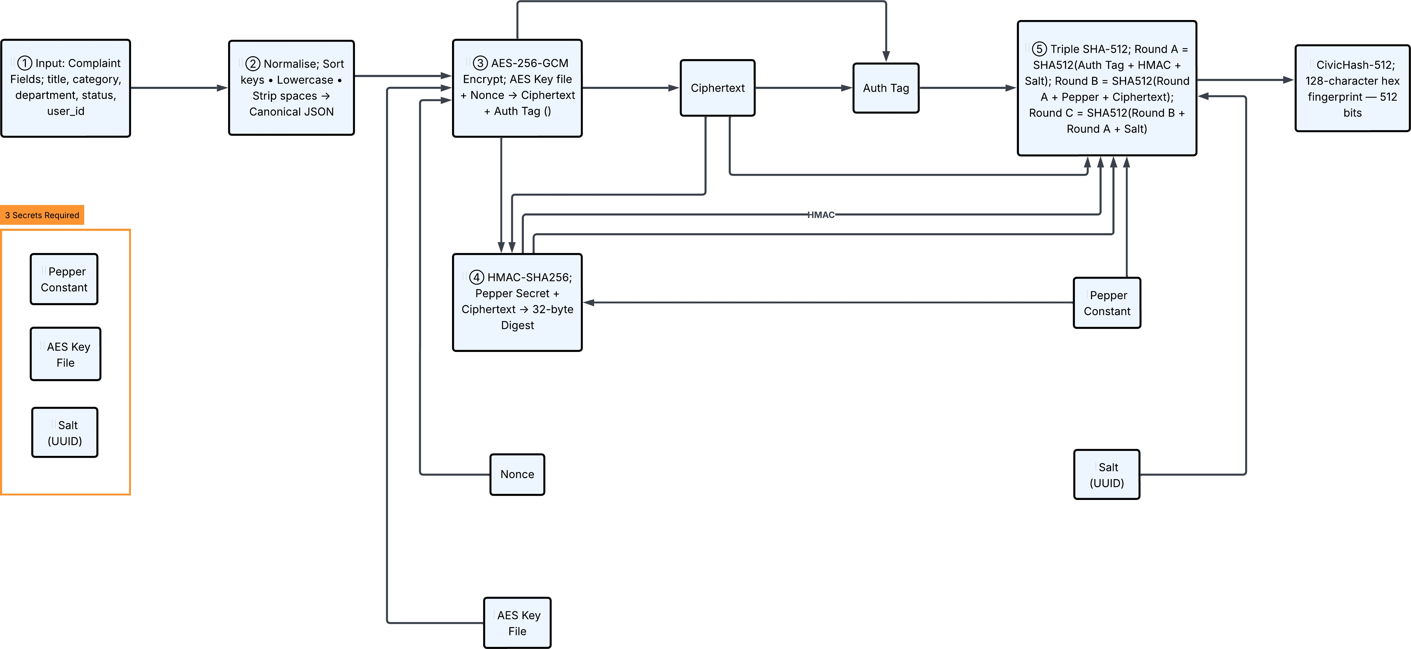

Fig. 2. CivicHash-512 four-step integrity algorithm: field normalization AES-256-GCM HMAC-SHA256 triple-round SHA-512, producing a 512-bit tamper-evident digest bound to three independent secrets.
→ →
→

E. ECDSA Digital Signatures
Administrative authentication employs ECDSA over the NIST P-256 (secp256r1) elliptic curve [10], [17]. During registration, a P-256 key pair is generated per administrator; the private key is stored locally while the public key path is stored in MongoDB. During login, after bcrypt verification

`no˛n¸cex
12 B
ciphertext
` ˛¸ x

variable
GCM tag
` ˛¸ x

16 B
and OTP validation, a timestamped challenge of the form
CIVICAI-LOGIN:<email>:<ISO-timestamp> is cre-

After confirmed encryption, the plaintext .jpg is immediately deleted. Every encrypt and decrypt event is written to security_logs.
- CivicHash-512 Integrity Algorithm
CivicHash-512 is a novel four-step integrity algorithm producing a tamper-evident digest requiring simultaneous knowledge of three independent secrets to reproduce:
Step 1 — Field Normalization: All complaint field values are lowercased, whitespace-stripped, and serialized into a canonical JSON byte string with alphabetically sorted keys, ensuring hash stability across equivalent representations.
Step 2 — AES-256-GCM Encryption: The normalized bytes are encrypted using the master AES key with a deterministic nonce derived as SHA-256(salt pepper)[: 12]. GCM produces a ciphertext and a 16-byte authentication tag binding the digest to the pepper constant.
Step 3 — HMAC-SHA256: HMAC-SHA256 is applied to the ciphertext using the pepper as the HMAC key, providing a cryptographically independent verification layer [13].
Step 4 — Triple-Round SHA-512: Three sequential SHA-512 computations with cross-round mixing:
R_{A} = SHA-512(tag hmac salt)
R_{B} = SHA-512(R_{A} pepper ct[: 32])
R_{C} = SHA-512(R_{B} R_{A} salt)
The final output is the 128-character hex encoding of R_{C}, a 512-bit digest. Verification uses hmac.compare_digest() for constant-time comparison. Any single-field modification produces a completely different digest on recomputation, immediately flagging tampering to the admin dashboard.
ated. The administrator signs this challenge using ECDSA-SHA256 with their private key; the server verifies using the stored public key. The embedded timestamp mitigates replay attacks. Admin status-update actions are also ECDSA-signed, providing non-repudiation: an administrator cannot deny having authorized a specific action.

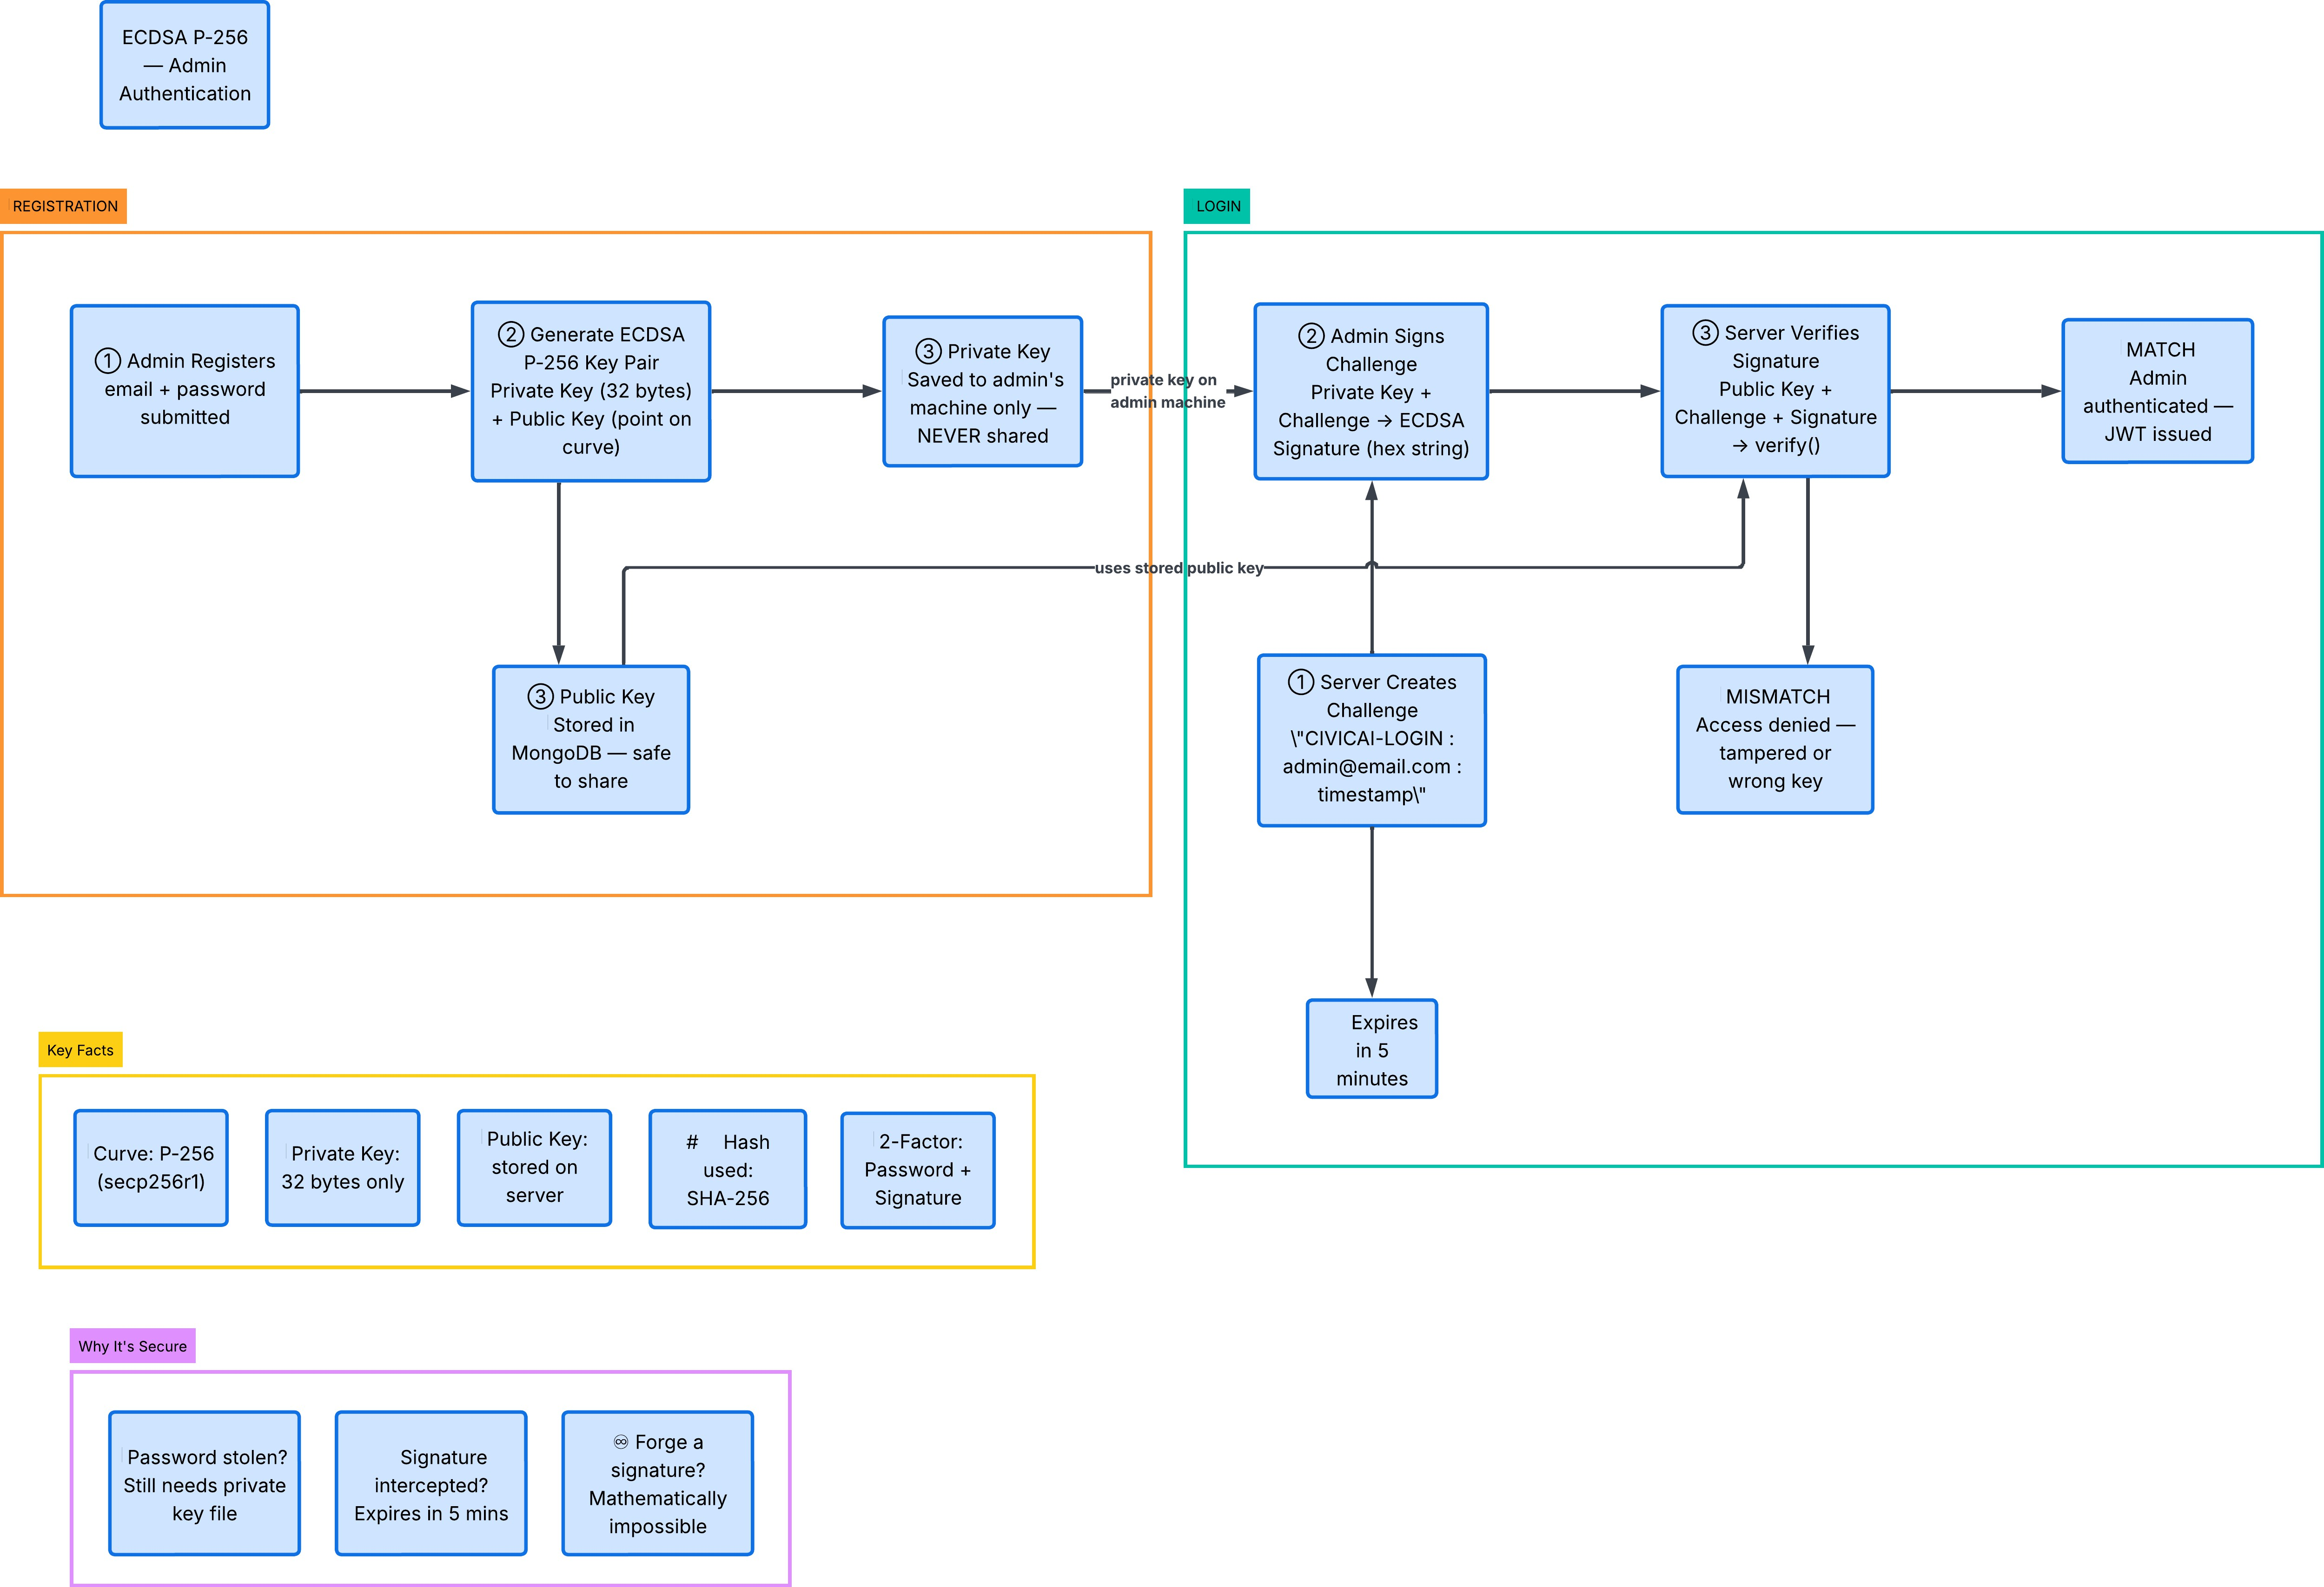
Fig. 3. ECDSA P-256 three-factor admin authentication flow: (1) bcrypt password verification, (2) OTP second factor, (3) ECDSA-SHA256 digital signature challenge-response using administrator private key and MongoDB-stored public key.

F. OTP Second Factor
Administrator login requires a time-based one-time password as a second authentication factor, generated and delivered at login time after successful bcrypt verification. The combination of bcrypt (knowledge), OTP (possession), and ECDSA (cryptographic key) constitutes a three-factor authentication

scheme for administrative accounts, as recommended by NIST SP 800-63B [20].
- Implementation
- Technology Stack
The platform is implemented in Python 3.11. The web interface uses Gradio 4.x with custom CSS. Data persistence employs MongoDB 6.0 via PyMongo 4.x [21]. AI inference uses the Groq Python SDK targeting LLaMA-4-Scout-17B [11]. Cryptographic operations use the Python cryptography library 41.x (OpenSSL backend). Geospatial services use geopy 2.x with the Nominatim geocoder [12]. Image processing uses Pillow (PIL) 10.x. JWT tokens use a pure-Python HMAC-SHA256 implementation requiring no external JWT library [19]. Environment configuration uses python-dotenv.
- Citizen Complaint Submission Flow
The citizen complaint flow proceeds as follows:
  - Citizen authenticates via bcrypt password verification and receives an HMAC-SHA256-signed JWT.
  - Citizen uploads a photograph, optionally adds notes, and captures GPS location via the browser Geolocation API.
  - image_processor.py resizes the image to max 1024 px and JPEG-encodes at quality 85.
  - Base64-encoded image and notes are submitted to the Groq API, which returns Title, Category, Department, and Description.
  - image_encryption.py encrypts the raw image using AES-256-GCM; the plaintext file is immediately deleted.
  - db_utils.save_complaint() persists the complaint to MongoDB and computes the CivicHash-512 digest.
  - A notification is created and the citizen’s dashboard updated.
- Admin Authentication and Management Flow
The administrator authentication flow implements three sequential security layers as shown in Fig. 3: (1) bcrypt password verification; (2) OTP generation and validation;
(3) ECDSA P-256 digital signature challenge-response. Only upon passing all three layers does the server issue an admin-scoped JWT. Admins view all complaints with CivicHash-512 integrity status displayed per record, update complaint statuses (ECDSA-signed), and view complaint images (AES-decrypted in-memory only — never written back to disk as plaintext).
- Security Audit Logging
The security_audit.py module implements dual-output logging. Every security-relevant event — LOGIN_SUCCESS, LOGIN_FAILURE, IMAGE_ENCRYPTED, IMAGE_DECRYPTED, COMPLAINT_SUBMITTED, STATUS_UPDATED,
ADMIN_AUTHENTICATED — is written synchronously to the filesystem security.log and asynchronously to the
MongoDB security_logs collection, providing both an immutable local record and a queryable database record.
- Results and Analysis
- System Interface
Figs. 4–6 illustrate the three primary interfaces of the deployed CivicAI system.
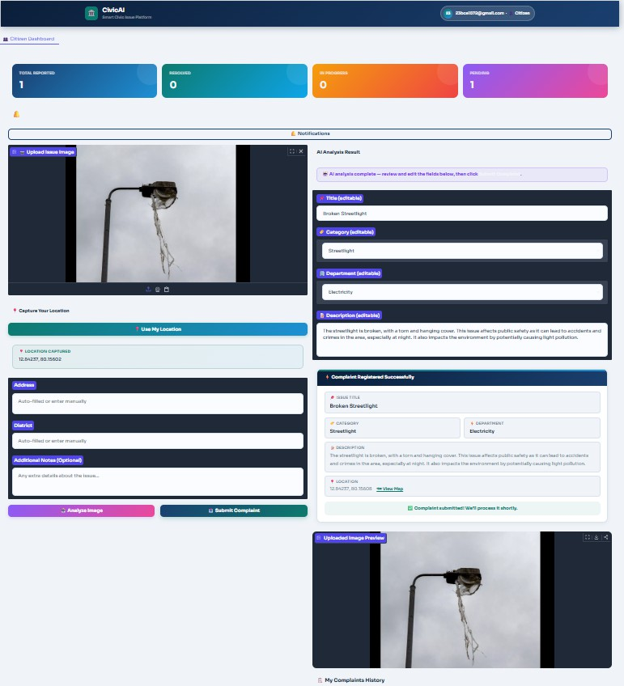

Fig. 4. Citizen Dashboard: AI analysis result for an uploaded broken streetlight photograph. The system generates Title: “Broken Streetlight”, Category: “Streetlight”, Department: “Electricity”, and a natural-language description. GPS coordinates are captured and the complaint is registered successfully.
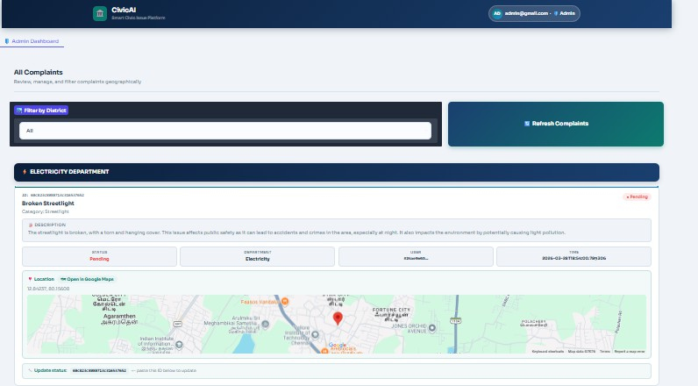

Fig. 5. Admin Dashboard: all-complaints view with district-based filtering. Each complaint card displays the AI-generated description, department routing, status, timestamp, and an embedded Google Maps geolocation view.

- AI Classification
The LLaMA-4-Scout-17B model, accessed via the Groq inference platform, demonstrates high fidelity in mapping

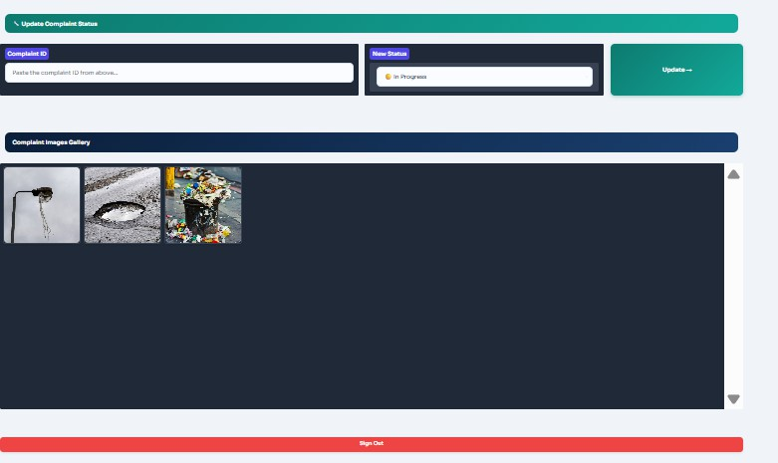

Fig. 6. Admin Update Status Panel and Complaint Images Gallery showing three civic issue photographs, decrypted in-memory from AES-256-GCM encrypted storage for display only.

civic issue photographs to controlled-vocabulary categories [11]. As shown in Fig. 4, the system correctly identifies a broken streetlight, generating an accurate title, category, department assignment, and natural-language description. The structured prompt constrains the output distribution, reducing hallucination risk compared to open-ended generation.
- Cryptographic Operation Performance
Cryptographic operations add negligible latency to the complaint submission workflow. bcrypt hashing with cost factor 12 completes in approximately 300–400 ms, appropriate for login flows where intentional slowness improves security against brute-force attacks [9]. AES-256-GCM image encryption and decryption operate at hardware-accelerated speeds on CPUs with AES-NI instruction support, making per-complaint encryption transparent to users. CivicHash-512 computation, involving four sequential cryptographic operations, completes in under 5 ms per complaint. JWT creation and verification each complete in microseconds.
- Integrity Verification
The CivicHash-512 system (Fig. 2) was validated against three attack vectors: (1) Direct field modification in Mon-goDB produces a hash mismatch detected on next administrative retrieval. (2) Field reordering produces identical hashes due to key-sorted JSON normalization. (3) Salt substitution
— attempting to recompute a hash with a different complaint UUID — produces a different deterministic nonce, invalidating all subsequent hash layers and making offline precomputation infeasible.
- Security Audit Coverage
The MongoDB security_logs collection captured over 81 events across test sessions, recording IMAGE_ENCRYPTED, IMAGE_DECRYPTED, LOGIN_SUCCESS, ADMIN_AUTHENTICATED, and
STATUS_UPDATED events. Each event is written to both filesystem and database, providing redundant immutable records for forensic analysis.
- Geospatial Routing
As shown in Fig. 5, each complaint card in the admin dashboard includes an embedded Google Maps view. The Nominatim reverse-geocoding pipeline [12] successfully resolves GPS coordinates to street-level addresses. District-based filtering allows municipal officers to view only complaints within their jurisdiction.
- Discussion
- Security Architecture Strength
The layered cryptographic architecture ensures no single point of compromise yields full system access. An attacker who obtains the MongoDB database gains only bcrypt hashes (computationally infeasible to reverse [9]), encrypted images (indecipherable without the AES key file [16]), and CivicHash-
512 digests (unreproducible without three independent secrets). An attacker who obtains the AES key file cannot authenticate as an administrator without the ECDSA private key. An attacker who steals an administrator’s password still cannot complete authentication without the OTP and private key. This defense-in-depth approach aligns with the principle of multiple independent security layers recommended by NIST [20].
- Real-World Usability
CivicAI substantially reduces the cognitive burden on citizen reporters. By replacing manual form filling with a photograph upload and optional text note, the system eliminates the requirement to identify the correct municipal department, compose a formal complaint description, or determine the administrative zone. The real-time notification system closes the feedback loop that existing platforms such as CPGRAMS
[5] fail to provide, informing citizens when their complaint moves from Pending to In Progress to Resolved.
- Limitations
ECDSA private key storage in the local keys/ directory is appropriate for demonstration but requires a dedicated secrets management service in production. The AES master key at keys/aes_image_key.bin represents a single point of failure for image decryption. JWT tokens are not server-side invalidated upon logout; compromised tokens remain valid until expiry, arguing for shorter lifetimes or a token blacklist mechanism [19].
- Future Work
- Migration to a self-hosted LLaMA-4-Scout deployment, eliminating external API dependency [11].
- Implementation of a mobile-native companion application with background GPS tracking for automatic photo geolocation.
- Formal security audit of CivicHash-512 by independent cryptographers.
- Migration of AES and ECDSA key storage to a dedicated secrets management service (e.g., HashiCorp Vault or AWS KMS).

- Extension of district classification to polygon-based ward-level routing using official GeoJSON administrative boundaries.
- Public analytics dashboard exposing district-level heatmaps, category distributions, and resolution time statistics for civic transparency.
- Conclusion
This paper presented CivicAI, a multimodal, cryptographically secured, AI-powered civic issue reporting platform. Three classes of original contributions are made. In the artificial intelligence domain, CivicAI demonstrates that a structured prompting strategy applied to LLaMA-4-Scout-17B reliably performs civic issue categorization and department routing without domain-specific fine-tuning. In the cryptographic engineering domain, CivicAI introduces CivicHash-512, a novel integrity algorithm chaining AES-256-GCM, HMAC-SHA256, and triple-round SHA-512 with three independent secrets, producing a 512-bit tamper-evident digest that cannot be reproduced without simultaneous knowledge of an AES key file, a pepper constant, and a per-record salt. In the civic technology domain, CivicAI demonstrates that AI-based visual analysis, geospatial intelligence, role-differentiated access control, and encrypted evidence storage can be realized within a single deployable Python application. The platform establishes a replicable security and AI architecture template for the next generation of citizen-government digital interaction platforms.
Acknowledgment
The authors thank the Department of Computer Science and Engineering, VIT University, Chennai, for providing the infrastructure and academic guidance that supported this work. This project was developed as part of the course CNS BCSE309P — Cryptography and Network Security.
References
- Y. Zhang, L. Wang, and Q. Liu, “Deep learning-based pothole detection on urban roads using ResNet-50,” IEEE Trans. Intell. Transp. Syst., vol. 22, no. 8, pp. 4914–4925, Aug. 2021.
- S. Majumdar, A. Roy, and P. Ghosh, “Real-time garbage detection in urban environments using YOLOv4,” in Proc. IEEE Int. Conf. Smart Structures and Systems (ICSSS), 2020, pp. 1–6.
- M. Almahmoud, R. Alotaibi, and H. Alshehri, “BERT-based automated civic complaint routing for smart city platforms,” IEEE Access, vol. 11,
pp. 32541–32553, 2023.
- D. Offenhuber, Waste Is Information: Infrastructure Legibility and Governance. Cambridge, MA: MIT Press, 2017.
- K. Rao, N. Sharma, and A. Joshi, “Evaluation of CPGRAMS: India’s centralized public grievance redress system,” J. e-Governance, vol. 42, no. 1, pp. 51–64, 2019.
- J. Bonneau, C. Herley, P. C. van Oorschot, and F. Stajano, “The quest to replace passwords: A framework for comparative evaluation of web authentication schemes,” in Proc. IEEE Symp. Security and Privacy, 2012, pp. 553–567.
- H. Krawczyk, “HMAC: Keyed-hashing for message authentication,” IETF RFC 2104, Feb. 1997. [Online]. Available: https://www.rfc-editor. org/rfc/rfc2104
- D. A. McGrew and J. Viega, “The Galois/Counter Mode of operation (GCM),” NIST Submission, 2004. [Online]. Available: https://csrc.nist. gov/projects/block-cipher-techniques
- N. Provos and D. Mazieres, “A future-adaptable password scheme,” in
Proc. USENIX Annual Technical Conf., 1999, pp. 81–91.
- National Institute of Standards and Technology, “Digital Signature Standard (DSS), FIPS PUB 186-5,” NIST, Gaithersburg, MD, Feb. 2023.
- H. Touvron et al., “LLaMA: Open and efficient foundation language models,” arXiv preprint arXiv:2302.13971, 2023.
- M. Haklay and P. Weber, “OpenStreetMap: User-generated street maps,”
IEEE Pervasive Comput., vol. 7, no. 4, pp. 12–18, Oct. 2008.
- M. Bellare, R. Canetti, and H. Krawczyk, “Keying hash functions for message authentication,” in Advances in Cryptology — CRYPTO 1996, LNCS vol. 1109, Springer, 1996, pp. 1–15.
- K. R. Ahmed, “Smart pothole detection using deep learning based on dilated convolution,” Sensors, vol. 21, no. 24, art. no. 8406, Dec. 2021.
- S. Goyal, P. Bedi, J. Kumar, and V. Sharma, “Smart city complaint management system using blockchain and AI for transparent civic governance,” Smart Cities, vol. 6, no. 2, pp. 1045–1063, 2023.
- W. Stallings, Cryptography and Network Security: Principles and Practice, 7th ed. Hoboken, NJ: Pearson, 2017.
- D. Johnson, A. Menezes, and S. Vanstone, “The Elliptic Curve Digital Signature Algorithm (ECDSA),” Int. J. Inf. Secur., vol. 1, no. 1, pp. 36–63, 2001.
- M. S. Islam, M. R. Islam, and M. S. H. Khan, “A comprehensive review of secure cloud storage using AES encryption and cryptographic integrity mechanisms,” J. Inf. Secur. Appl., vol. 65, art. no. 103117, 2022.
- M. Jones, J. Bradley, and N. Sakimura, “JSON Web Token (JWT),” IETF RFC 7519, May 2015. [Online]. Available: https://www.rfc-editor.org/ rfc/rfc7519
- P. A. Grassi et al., “Digital identity guidelines: Authentication and lifecycle management, NIST Special Publication 800-63B,” NIST, Gaithersburg, MD, Jun. 2017.
- K. Chodorow, MongoDB: The Definitive Guide, 2nd ed. Sebastopol, CA: O’Reilly Media, 2013.

