

DEPARTMENT OF COMPUTER SCIENCE AND ENGINEERING
COLLEGE OF ENGINEERING GUINDY
ANNA UNIVERSITY, CHENNAI – 25.

LAB RECORD
CS6301 – MACHINE LEARNING

PREDICTION OF PTSD SEVERITY IN VETERANS

TEAM MEMBERS:
1. VISHRUTHI 2022103022
2. SONALI SHRUTHI 2022103510
3. SARASHIVASRI 2022103520

PROJECT GUIDE
Dr. Mohamed Fathimal,
Department of Computer Science and Engineering,
College of Engineering Guindy,
Anna University, Chennai – 25.

Prediction of PTSD Severity in Veterans

Project Guide Dr. Mohamed Fathimal P
Asst.Professor, DCSE,
College of Engineering,
Guindy Anna University.

Vishruthi A- 2022103022, Sonali Shruthi A- 2022103510, Sarashivasri S- 2022103520

Abstract—Veterans are particularly vulnerable to developing Post-Traumatic Stress Disorder (PTSD), a complex and debilitating condition that, if left undiagnosed or untreated, can lead to severe psychological, social, and physical health issues over the long term. Early intervention for veterans in crisis represents a crucial area of study to reduce the psychological and health burdens for this population. Traumatic experiences associated with military service are associated with drug and alcohol abuse, suicidality, anger, and disrupted work and family relationships This project applies machine learning to predict PTSD severity in veterans by analyzing diverse data sources, including medical records, psychological assessments, wearable data, and self-reported symptoms. By identifying key patterns and risk factors associated with PTSD, the model enables early detection of high-risk individuals. This approach supports timely, personalized interventions, improving care quality and recovery outcomes for veterans.

Index Terms—PTSD, Veterans, Trauma, Mental health, Diagnosis, Machine Learning

INTRODUCTION
In order to develop and implement a machine learning model that accurately predicts the severity of Post-Traumatic Stress Disorder (PTSD) in veterans, we have analysed diverse data sources such as medical records, psychological assessments, wearable device data, and self-reported symptoms. This prediction will enable healthcare providers to identify high-risk individuals early, facilitate timely intervention, and enhance personalized treatment plans, ultimately improving the recovery outcomes and quality of life for veterans. Post-Traumatic Stress Disorder (PTSD) is a pervasive mental health issue affecting a significant number of veterans, often leading to severe emotional, social, and physical challenges.

Traditional diagnostic methods rely heavily on self-reporting and clinical evaluations, which can be limited by subjective biases, inconsistent data, and delayed detection. These limitations hinder timely intervention and effective treatment, increasing the risk of long-term consequences for those affected. The challenge lies in developing an accurate, data-driven approach that can integrate diverse data types, such as clinical records, behavioural assessments, wearable sensor data, and self-reported symptoms, to identify veterans at high risk of PTSD earlier. Addressing this problem is crucial to providing early, personalized care and reducing the overall burden of PTSD among veterans. Veterans are at significant risk of developing Post-Traumatic Stress Disorder (PTSD) due to their exposure to traumatic events during military service.

This report discusses the use of machine learning (ML) algorithms to predict the severity of Post-Traumatic Stress Disorder (PTSD) in veterans, emphasizing the importance of high-accuracy models for early and reliable detection. Among the algorithms assessed, Random Forest and CatBoost achieved the highest accuracy at 98%, showcasing their robustness and effectiveness in managing complex, multidimensional datasets related to PTSD. The Random Forest algorithm is particularly effective at reducing overfitting through ensemble learning, which combines multiple decision trees to produce accurate and stable predictions. Likewise, CatBoost, a gradient boosting algorithm tailored for categorical data, is noted for its speed, scalability, and efficiency in handling imbalanced datasets and non-linear relationships, making it well-suited for predicting PTSD severity.

Other strong-performing algorithms include XGBoost and Gradient Boosting, both reaching 97% accuracy. These models utilize boosting techniques to focus on misclassified instances iteratively, thereby enhancing overall performance. XGBoost is especially appreciated for its computational efficiency and capability to manage large datasets, while Gradient Boosting strikes a balance between predictive power and interpretability. The Extremely Randomized Trees algorithm also showed good performance, achieving an accuracy of 88% by leveraging increased randomness to improve generalization and reduce overfitting.

Boosting methods like AdaBoost, which reached 83% accuracy, illustrate their potential to enhance weaker learners by iteratively combining their predictions. Although slightly lower-performing algorithms such as Logistic Regression (78%) and Support Vector Machines (SVM) (73%) serve as baseline comparisons, their inclusion offers valuable insights into linear modelling.

Early detection is crucial to prevent this condition's long-term psychological and physical effects. This project aims to utilize machine learning techniques to predict the severity of PTSD in veterans by analysing a range of data sources, including medical records, psychological evaluations, data from wearable devices, and self-reported symptoms. By identifying critical patterns and risk factors, the machine learning model can detect individuals at high risk of PTSD early on, enabling targeted interventions. This approach offers the potential to enhance the quality of care, promote faster recovery, and improve overall outcomes for veterans affected by PTSD.

LITERATURE REVIEW
Natasha Biscoe et.al[1] proposed a study to investigate the relationship between complex PTSD symptom clusters and executive function in UK Armed Forces veterans. A dataset consisting of veterans diagnosed with complex PTSD was utilized, with participants recruited from veteran support services. Assessments included the PTSD Symptom Inventory to gauge symptom severity and various executive function tests, such as the Wisconsin Card Sorting Test and the Stroop Test. Statistical methods, including regression analysis and correlation coefficients, were employed to examine the relationships between PTSD symptoms and executive function performance. Key performance metrics included correlation coefficients to measure associations and regression analysis to evaluate predictive relationships. Results indicated significant correlations between the severity of PTSD symptoms and deficits in executive function. Notably, emotional dysregulation symptoms were strongly negatively correlated with cognitive flexibility, while higher levels of avoidance symptoms were linked to impaired inhibition and problem-solving abilities. Veterans with complex PTSD exhibited considerable cognitive deficits, particularly in executive function tasks. The study concluded that complex PTSD symptom clusters significantly impair executive function in veterans, underscoring the need for comprehensive assessments that include cognitive functioning in treatment plans. It emphasized integrating cognitive rehabilitation strategies into PTSD treatments to enhance overall functioning and quality of life and recommended further longitudinal studies to explore causal relationships and targeted interventions.

Scott et.al[2] proposed a meta-analysis to systematically evaluate the impact of posttraumatic stress disorder (PTSD) on neurocognitive functioning, focusing on the extent and nature of cognitive deficits associated with the disorder. The dataset included peer-reviewed studies that quantitatively assessed cognitive performance in individuals diagnosed with PTSD compared to control groups, utilizing various cognitive assessments across domains such as attention, memory, executive function, and processing speed. Statistical methods employed included the calculation of standardized mean differences (SMD) to quantify cognitive deficits and a random effects model to accommodate variability among studies. Key performance metrics included effect sizes, confidence intervals, and heterogeneity analysis using the I² statistic. The results demonstrated significant cognitive deficits in individuals with PTSD, particularly in memory and attention, with moderate effect sizes reported. Specific findings revealed substantial impairments in both verbal and non-verbal memory tasks, sustained attention, and processing speed, with variable deficits in executive function. Observations highlighted the pervasive nature of cognitive impairments in PTSD, affecting daily functioning, and noted a correlation between the severity of PTSD symptoms and cognitive deficits. The authors concluded that PTSD significantly impairs neurocognitive functioning, particularly in memory and attention, emphasizing the need to consider these cognitive deficits in treatment and assessment. They recommended further research to explore the mechanisms underlying these impairments and their implications for effective treatment strategies.

Murphy et.al[3] proposed an article to explore the unique needs and challenges faced by veterans seeking mental health support, identifying barriers to care and the types of assistance required to effectively address their mental health difficulties. The dataset consisted of a review of literature and qualitative studies focusing on veterans' experiences with mental health services, incorporating interviews, surveys, and observational analyses. While the article primarily serves as a literature review, it employs qualitative and thematic analysis to synthesize findings regarding veterans' mental health needs. Key performance metrics evaluated included access to care and veterans’ satisfaction levels with mental health support. The evaluation revealed significant barriers to accessing mental health services, including stigma, lack of awareness, and logistical challenges. Many veterans expressed a preference for peer-led support tailored to their unique experiences. Findings emphasized the necessity for targeted mental health interventions that consider these specific needs and advocate for increased awareness and education about available resources. In conclusion, the authors emphasized that understanding veterans' needs is crucial for improving mental health services. By addressing barriers to care and enhancing the availability of tailored, peer-supported interventions, better mental health outcomes can be achieved. The study calls for further research and policy initiatives focused on veterans' mental health needs to ensure comprehensive support.

Murphy et.al[4] proposed a study aimed to investigate the prevalence of ICD-11 PTSD and complex PTSD (CPTSD) among treatment-seeking veterans, focusing on associated risk factors and comorbid conditions to inform improved treatment strategies. The dataset comprised veterans diagnosed with PTSD and CPTSD, with data collected through structured clinical interviews and standardized assessment tools. The analysis utilized descriptive statistics to determine prevalence rates and logistic regression to identify significant risk factors and comorbidities. Key performance metrics included prevalence rates, odds ratios (OR) for risk factor associations, and rates of co-occurring mental health conditions. Results indicated a notable prevalence of both PTSD and CPTSD in the treatment-seeking veteran population. Significant risk factors included high levels of trauma exposure, prior mental health issues, and specific demographic characteristics. Comorbidity was prevalent, with many veterans exhibiting symptoms of depression, anxiety, and substance use disorders alongside PTSD and CPTSD. The findings highlighted the complexities of PTSD and CPTSD, suggesting that CPTSD may necessitate different treatment approaches due to its additional symptomatology. The authors emphasized the need to recognize and address comorbid conditions to enhance treatment outcomes for veterans. In conclusion, the study advocates for integrated treatment approaches that consider the complexities of PTSD and CPTSD in veterans, calling for further research into effective interventions tailored to their unique needs.

David E. Reed et.al[5] proposed a study aimed to examine the prevalence and correlation of co-occurring chronic pain and post-traumatic stress disorder (PTSD) among U.S. military veterans, as well as how this co-occurrence impacts veterans' functioning. The dataset comprised veterans from the National Health Study for a New Generation of U.S. Veterans, utilizing standardized assessments to measure chronic pain, PTSD symptoms, and functional impairment. Statistical analyses were conducted, including descriptive statistics to assess prevalence rates and multivariate analyses such as logistic regression to identify correlates associated with chronic pain and PTSD. Key performance metrics included prevalence rates, odds ratios (OR) to assess associations, and functional outcomes measuring daily functioning and quality of life. Results indicated a significant prevalence of co-occurring chronic pain and PTSD among veterans, with findings showing that younger age and higher psychological distress were associated with this co-occurrence. Veterans experiencing both conditions reported greater functional impairment compared to those with only one condition. The study highlighted the importance of integrated treatment approaches, as the co-occurrence of chronic pain and PTSD negatively impacts functioning. In conclusion, the authors called for increased awareness and targeted interventions, emphasizing the need for integrated care strategies that address both chronic pain and PTSD to enhance veterans' quality of life.

Amanda M. Raines et.al[6] proposed a meta-analytic review to evaluate the efficacy of Cognitive Processing Therapy (CPT) in treating PTSD among veterans and military personnel. By synthesizing existing literature, the authors aimed to determine CPT's effectiveness in reducing PTSD symptoms and improving mental health outcomes in this population. The dataset consisted of peer-reviewed studies, including randomized controlled trials (RCTs) and quasi-experimental designs, that assessed PTSD symptomatology before and after CPT interventions. The analysis utilized meta-analytic techniques, including standardized mean differences (SMD) to measure treatment effects and a random effects model to account for variability across studies. Key performance metrics included SMD for effect size, confidence intervals (CI) for precision estimates, and heterogeneity statistics (I²) to assess variability among study results. The evaluation involved systematic data extraction and quality assessment of included studies, using the Cochrane Risk of Bias tool. Results indicated that CPT significantly reduced PTSD symptoms among veterans and military personnel, with a large overall effect size demonstrating substantial symptom reduction post-CPT. Additionally, evidence showed sustained improvements over time, although effectiveness varied based on delivery format (individual vs. group therapy) and comorbid conditions. The review concluded that CPT is a highly effective treatment for PTSD within military populations, advocating for its integration into clinical practice to enhance mental health outcomes. The authors called for further research to investigate long-term effects and the impact of varying treatment modalities within CPT.

Cloitre et.al[7] proposed a study to develop and validate the International Trauma Questionnaire (ITQ), a self-report measure for assessing the diagnostic criteria of post-traumatic stress disorder (PTSD) and complex PTSD (CPTSD) as defined by the ICD-11. The dataset included diverse trauma-exposed populations, with data collected through pilot studies that involved the ITQ alongside established PTSD measures. The authors employed factor analysis and reliability testing, including Cronbach's alpha, to evaluate the ITQ's psychometric properties. Key performance metrics included construct validity and diagnostic accuracy in classifying individuals according to ICD-11 criteria. The evaluation demonstrated that the ITQ is a reliable and valid instrument, with a clear factor structure supporting the distinction between PTSD and CPTSD symptoms. Strong correlations with established PTSD measures confirmed good convergent validity. The findings highlight the ITQ's importance as a standardized, culturally sensitive tool for both research and clinical practice. It offers a robust method for assessing PTSD and CPTSD among trauma-exposed individuals, facilitating improved understanding and treatment of these disorders. The authors concluded that the ITQ represents a significant advancement in the assessment of PTSD and CPTSD, supporting the integration of this measure into clinical settings.

J. Sveen et.al[8] proposed a study to examine the psychometric properties of the PTSD Checklist for DSM-5 (PCL-5), focusing on its reliability, validity, and factor structure. The study used a pilot dataset of trauma-exposed individuals to evaluate the tool's capacity to detect PTSD symptoms in alignment with DSM-5 criteria. Utilizing established psychometric algorithms, the authors analyzed the PCL-5's internal consistency, convergent validity with other PTSD measures, and its alignment with proposed DSM-5 factor models. Performance metrics such as Cronbach’s alpha and model fit indices were applied to assess reliability and factor structure. Results highlighted strong internal consistency and support for the four-factor DSM-5 PTSD model (re-experiencing, avoidance, negative alterations in cognition/mood, and hyperarousal). Observations suggested that while the PCL-5 effectively differentiates PTSD symptoms, its use in diverse clinical populations requires further validation. The authors concluded that the PCL-5 demonstrates solid psychometric properties, supporting its use as a reliable and valid tool for assessing PTSD symptoms in trauma-exposed individuals.

Novaco et.al[9] proposed a study to explore the complex relationship between combat-related posttraumatic stress disorder (PTSD), anger, and violence among veterans. Utilizing data from the National Vietnam Veterans Readjustment Study (NVVRS), the study examined two cohorts: 1,200 male combat veterans from the main survey and 259 from the clinical interview component. Anger indices were constructed based on NVVRS variables, while PTSD was assessed through continuous symptom scores and diagnostic criteria. The authors proposed that PTSD activates threat-related cognitive networks, amplifying anger through a positive feedback loop, which can override inhibitory controls on aggression. Their findings revealed that PTSD alone was not directly linked to violence; however, when PTSD co-occurred with high levels of anger, there was a significant increase in violent behaviors. This result remained consistent across multiple measures of PTSD and anger in both study components. The study underscores the pivotal role of anger as a mediating factor in the PTSD-violence relationship and highlights the importance of incorporating anger assessment and management into PTSD treatment programs for veterans. The authors conclude that anger should be recognized not only as a symptom but also as a critical target for intervention to reduce violence risk, suggesting that anger management provides an effective entry point for therapeutic efforts.

Kang et.al[10] proposed a study to conduct an in-depth analysis of suicide risk among veterans who served in Operation Enduring Freedom (OEF), Operation Iraqi Freedom (OIF), and Operation New Dawn (OND). Using mortality data from the VA/DoD Mortality Data Repository (MDR), the research included over 1.3 million veterans and identified 4,618 suicides, yielding a crude suicide rate of 31.87 per 100,000 person-years. Key risk factors included service in active duty components, exposure to combat as indicated by service in the Army or Marines, being single at separation, and demographic variables such as age, sex, and race. Statistical methods like standardized mortality ratios (SMRs) and Cox proportional hazards models showed that suicide rates among veterans were elevated compared to the general U.S. population, with active duty veterans facing higher risks than those in reserve or National Guard components. Temporal analyses revealed that suicide rates were highest in the early years post-separation, with annual percent changes assessed using Joinpoint regression. The study emphasized the need for targeted suicide prevention programs focusing on high-risk subgroups, particularly those exposed to combat trauma or with limited social support, and recommended addressing these vulnerabilities through tailored interventions.

Cynthia A Stappenbeck et.al[11] proposed a study aimed to elucidate the complex relationships between alcohol use problems, PTSD symptoms, and combat exposure in predicting aggressive behaviours among veterans. The research utilized a dataset obtained through structured interviews and validated self-report questionnaires, focusing on veterans' histories of alcohol misuse, PTSD symptomatology, and experiences of combat. To analyse these interrelationships, the researchers employed regression analyses, allowing them to quantify the effects of each variable on both nonphysical and physical aggression. Performance metrics included effect sizes and significance levels to assess the strength and reliability of the findings. The results revealed that alcohol problems were significantly associated with increased levels of both forms of aggression, while PTSD symptoms, particularly emotional dysregulation and hyperarousal, contributed notably to aggressive behaviours. Additionally, combat exposure was found to exacerbate these effects, suggesting a multifaceted interplay where alcohol misuse amplifies aggression through its impact on PTSD symptom severity. The study underscores the necessity for integrated treatment approaches that concurrently address alcohol use, PTSD, and aggression in veterans, thereby aiming to improve mental health outcomes and reduce aggressive tendencies in this vulnerable population. Overall, the findings highlight the importance of understanding the co-occurring issues faced by veterans and advocate for targeted interventions to enhance their well-being.

I. Burnett-Zeigler et.al[12] proposed a study aimed at assessing the prevalence of alcohol misuse among veterans returning from Iraq and Afghanistan and to identify associated demographic, psychological, and situational correlates. The researchers utilized a dataset derived from surveys conducted with veterans, focusing on their alcohol consumption patterns, mental health status, and social support systems. They employed various statistical analyses, including logistic regression, to evaluate the relationships between alcohol misuse and potential correlates. Performance metrics included odds ratios to quantify the strength of associations and confidence intervals for reliability. The evaluation revealed that a significant portion of the veterans reported alcohol misuse, with factors such as PTSD symptoms, depression, and lower levels of social support being strongly correlated with increased risk of alcohol problems. The study concluded that targeted interventions are necessary to address the mental health needs of returning veterans, as the high prevalence of alcohol misuse poses significant risks to their overall well-being. The findings highlight the importance of understanding the complex factors contributing to alcohol misuse in this population and suggest that improving social support networks could play a critical role in reducing alcohol-related issues among veterans.

J. M. Brown et.al[13] proposed a study to investigate the relationships among post deployment alcohol use, aggressive behaviours, and PTSD symptoms among military personnel. The objective was to understand how these factors interact and contribute to veterans' behavioural health outcomes after returning from deployment. The dataset used in the study comprised survey responses from military service members, which included measures of alcohol consumption, self-reported aggression, and PTSD symptom severity. The researchers employed statistical methods, particularly regression analyses, to examine the associations among these variables. Performance metrics included odds ratios and significance levels to assess the strength and reliability of the relationships identified. The evaluation found that higher levels of post deployment alcohol use were significantly associated with increased aggression and more severe PTSD symptoms. Additionally, the results indicated that aggression acted as a mediating factor, whereby alcohol use heightened aggressive tendencies, which in turn were influenced by PTSD symptoms. The study concluded that addressing alcohol misuse among veterans is critical, as it not only impacts their mental health but also contributes to aggressive behaviours. The findings underscore the importance of implementing targeted interventions that consider the interconnections between alcohol use, PTSD, and aggression to improve overall behavioural health outcomes for military personnel.

Strom et.al[14] proposed a study to investigate the relationship between risk-taking behaviours and the severity of PTSD symptoms in veterans. The primary objective was to explore how different levels of PTSD symptomatology correlate with various forms of risk-taking behaviours, providing insights into behavioural health challenges faced by veterans. The dataset consisted of responses from a sample of veterans, gathered through self-reported questionnaires assessing PTSD symptoms and risk-taking tendencies across multiple domains, such as health, social, and financial risks. The researchers utilized statistical analyses, including correlation and regression techniques, to evaluate the relationships between PTSD severity and risk-taking behaviours. Performance metrics included correlation coefficients and significance levels to measure the strength and reliability of the associations found. The evaluation revealed a significant positive correlation between higher PTSD symptom severity and increased engagement in risk-taking behaviours. Veterans with more severe PTSD symptoms were more likely to exhibit impulsivity and engage in hazardous activities, suggesting a potential coping mechanism or maladaptive response to trauma. The study concluded that understanding the link between PTSD and risk-taking behaviours is crucial for developing targeted interventions aimed at improving behavioural health outcomes for veterans. By addressing these risk behaviours, mental health practitioners can better support veterans in managing PTSD symptoms and enhancing their overall well-being.

Wortmann et.al[15] proposed a study aimed to evaluate the psychometric properties of the PTSD Checklist for DSM-5 (PCL-5) within a population of military service members seeking treatment for PTSD. The objective was to assess the reliability and validity of the PCL-5 as a screening tool for PTSD symptoms in this specific demographic. The dataset comprised responses from military service members who presented for mental health treatment, with the PCL-5 used to measure their PTSD symptoms. The researchers employed various statistical methods, including confirmatory factor analysis (CFA) and reliability analyses, to evaluate the scale's structural integrity and internal consistency. Performance metrics included Cronbach's alpha for internal consistency and fit indices (such as CFI and RMSEA) to assess model fit in CFA. The evaluation found that the PCL-5 demonstrated strong internal consistency (high Cronbach's alpha) and a good fit for the factor structure consistent with the DSM-5 criteria. The results indicated that the PCL-5 is a valid and reliable instrument for assessing PTSD symptoms in treatment-seeking military personnel. The study concluded that the PCL-5 is an effective tool for both clinical assessment and research in this population, emphasizing its utility in identifying and addressing PTSD among military service members. The findings support the continued use of the PCL-5 in mental health settings to facilitate appropriate interventions for those affected by PTSD.

A. Minassian et.al[16] proposed a study to investigate the potential link between predeployment heart rate variability (HRV) and the risk of developing PTSD after deployment among active-duty Marines. The objective was to determine whether lower HRV, a marker of autonomic nervous system function and stress resilience, could predict the onset of PTSD symptoms postdeployment. The dataset included physiological data collected from Marines before deployment, alongside follow-up assessments of PTSD symptoms using validated measures after their return. The researchers utilized statistical techniques, including logistic regression, to analyse the relationship between predeployment HRV and subsequent PTSD risk. Performance metrics included odds ratios and confidence intervals to quantify the predictive capacity of HRV for PTSD outcomes. The evaluation revealed that lower predeployment HRV was significantly associated with a higher risk of developing PTSD symptoms after deployment. Specifically, Marines with the lowest HRV levels showed a markedly increased likelihood of PTSD diagnosis. The study concluded that predeployment HRV may serve as a useful biomarker for identifying Marines at elevated risk for PTSD, suggesting that interventions aimed at enhancing resilience prior to deployment could be beneficial. The findings highlight the importance of monitoring physiological indicators to inform preventive strategies in military populations at risk for PTSD.

K. Possemato et.al[17] proposed a study aimed at investigating the dynamic relationship between PTSD symptoms and alcohol use among combat veterans using ecological momentary assessment (EMA) techniques. The objective was to capture real-time data on PTSD symptoms and alcohol consumption to better understand how these variables fluctuate over time in daily life. The dataset consisted of self-reported data collected from veterans through mobile applications, enabling frequent assessments of their current PTSD symptoms and alcohol use patterns over a specified period. The researchers employed statistical analyses, including mixed-effects models, to evaluate the associations between momentary PTSD symptoms and alcohol use. Performance metrics included effect sizes and significance levels to assess the strength and reliability of the observed relationships. The evaluation revealed a significant and positive correlation between heightened PTSD symptoms and increased alcohol use, suggesting that periods of intensified PTSD may trigger higher alcohol consumption as a coping mechanism. Additionally, the results indicated that veterans with more severe PTSD symptoms were more likely to engage in alcohol use on days when they experienced higher distress. The study concluded that EMA provides valuable insights into the temporal dynamics of PTSD and alcohol use, highlighting the need for interventions that address these co-occurring issues in a real-world context. The findings emphasize the importance of developing targeted strategies to support veterans in managing their symptoms and reducing alcohol use, particularly during high-stress periods.

D. Conybeare et.al[18] proposed a study to investigate the psychometric properties of the PTSD Checklist-Civilian Version (PCL-C) within a nonclinical population. The primary objective was to evaluate the reliability, validity, and factor structure of the PCL-C to determine its effectiveness as a screening tool for PTSD symptoms in individuals without a formal PTSD diagnosis. The dataset included responses from a diverse sample of adults who completed the PCL-C, alongside additional measures to assess related constructs such as anxiety and depression. The researchers utilized statistical methods, including exploratory and confirmatory factor analyses, to assess the factor structure of the PCL-C. Performance metrics included Cronbach's alpha for internal consistency, along with correlations with other validated measures to evaluate convergent validity. The evaluation revealed that the PCL-C demonstrated strong internal consistency and a valid factor structure consistent with the DSM-IV criteria for PTSD. Results indicated that the PCL-C effectively distinguishes between individuals with varying levels of PTSD symptoms and correlates positively with measures of anxiety and depression, confirming its validity. The study concluded that the PCL-C is a reliable and valid instrument for assessing PTSD symptoms in nonclinical populations, supporting its use in both research and clinical settings for identifying individuals who may benefit from further evaluation or intervention. The findings underscore the importance of accessible screening tools for PTSD in diverse populations.

S. I. Omurca et.al[19] proposed a study exploring the application of machine learning techniques to evaluate and predict post-traumatic stress disorder (PTSD) symptoms. The primary objective was to develop an innovative approach to assess PTSD by leveraging various machine learning algorithms, potentially improving diagnostic accuracy and treatment strategies. The dataset utilized for this research included clinical assessments and self-reported questionnaires from individuals diagnosed with PTSD, encompassing a range of features related to their symptoms and demographics. The researchers employed several machine learning algorithms, including decision trees, support vector machines (SVM), and random forests, to analyse the data and predict PTSD symptom severity. Performance metrics such as accuracy, precision, recall, and F1-score were used to evaluate the effectiveness of each model. The evaluation revealed that machine learning algorithms, particularly random forests, demonstrated high accuracy and robustness in predicting PTSD symptoms based on the available features. The results indicated that these algorithms could effectively classify individuals with varying levels of PTSD severity, highlighting the potential of machine learning methods to enhance traditional assessment techniques. The study concluded that integrating machine learning approaches into PTSD evaluation processes could lead to more precise and individualized assessments, ultimately improving treatment outcomes for those affected by the disorder. This innovative approach emphasizes the importance of utilizing advanced analytical techniques in mental health research to better understand and address PTSD.

The report from the National Center for Children in Poverty[20] aimed to examine the prevalence and contributing factors of violence and unintentional injuries among adolescents in the U.S. The primary objective is to provide a comprehensive overview of the impact of these issues on youth, with a focus on identifying key risk factors and suggesting effective prevention strategies. The dataset used in this analysis includes national surveys, health records, and crime statistics that capture incidents of violence and injuries among adolescents. Although specific algorithms are not detailed in the report, statistical methods are likely employed to analyse the data and identify trends and correlations. The evaluation of the data reveals alarming statistics regarding the rates of violence and unintentional injuries among adolescents, indicating that these issues significantly affect their well-being and development. The report highlights the role of various risk factors, such as socio-economic status, access to mental health resources, and community violence, in contributing to these outcomes. The results underscore the need for targeted interventions that address these risk factors, emphasizing comprehensive strategies involving schools, families, and communities. The conclusion advocates for policy changes and community programs aimed at reducing violence and promoting safe environments for adolescents, ultimately aiming to decrease the incidence of both violent behaviour and unintentional injuries. The report serves as a crucial resource for stakeholders seeking to improve adolescent health and safety in the U.S.

PROPOSED WORK

Dataset Description
The US Veteran dataset comprises a diverse range of features relevant to PTSD studies and outcomes, focusing on clinical and diagnostic attributes. The dataset used in this study comprises various clinical and diagnostic variables collected from multiple PTSD-related studies. It includes comprehensive information on the study design, treatment interventions, outcome assessments, and diagnostic measures, which are key to predicting PTSD severity. A brief description of the dataset's columns:

1. Study Class: This column specifies the type of intervention in the study, such as psychotherapy, pharmacotherapy, or a combination of therapies. It helps to understand the therapeutic approach used for PTSD treatment in each study.

2. Treatment Focus (Study Level): This column identifies the treatment focus of the study, distinguishing between PTSD alone and PTSD with co-occurring conditions such as Substance Use Disorder (SUD). It provides insight into the complexity of treatment approaches used in the studies.

3. Clinical Setting: The clinical setting describes the environment in which the PTSD treatment was administered, including outpatient clinics, inpatient settings, or residential treatment facilities. This variable helps assess the impact of different clinical environments on treatment outcomes.

4. Study Design: This column includes information about the study design, such as randomized controlled trials (RCTs), cohort studies, and other types of clinical studies. The study design is critical for understanding the research methodology and its impact on the reliability of the findings.

5. Subscale/Symptom Cluster Data: This column includes data related to specific symptom clusters or subscales used to assess PTSD severity, such as intrusion, avoidance, and hyperarousal symptoms. It provides detailed information about the severity of PTSD symptoms in each study participant.

6. Subgroup Analysis: This variable includes whether the study included subgroup analyses based on factors such as age, gender, or comorbid conditions. It helps to understand how different population subsets were considered in the analysis.

7. Allowed PTSD Psychotherapy Co-Intervention: This column indicates whether other psychotherapy interventions were allowed alongside PTSD treatments, which might affect the outcomes measured in the study.

8. Allowed Other Psychotherapy Co-Intervention: Similar to the above, this variable specifies whether other non-PTSD-focused psychotherapies were permitted during the study.

9. Allowed Psychotropic Med Co-Intervention: This column shows whether psychotropic medications, such as antidepressants or anxiolytics, were allowed as co-interventions during the PTSD treatment.

10. Diagnosis Assessment Type: The type of diagnostic assessment used to determine PTSD status is recorded here. This includes tools such as interviews, self-report questionnaires, or clinician-administered assessments.

11. Diagnostic Measure: This column includes the specific diagnostic tool used to assess PTSD, such as the Clinician-Administered PTSD Scale (CAPS), Structured Clinical Interviews (SCID), or other diagnostic instruments. It helps to categorize studies based on the tools used for diagnosing PTSD.

12. Diagnostic Measure Detail: Further details about the diagnostic measure used in the study are provided in this column, such as the version of the diagnostic tool or specific criteria used.

13. Depression Outcome Assessed: This column indicates whether depression outcomes were assessed in the study, providing insight into the comorbidity of PTSD with depression.

14. Anxiety Outcome Assessed: Similar to depression, this column indicates whether anxiety outcomes were measured during the study, reflecting comorbid anxiety disorders often associated with PTSD.

15. Sleep Outcome Assessed: This column indicates whether sleep disturbances, a common symptom of PTSD, were evaluated as part of the study’s outcomes.

16. Anger Outcome Assessed: This column shows whether anger, which is often associated with PTSD, was assessed as an outcome in the study.

17. Functioning Outcome Assessed: This column tracks whether functional outcomes, such as social, occupational, and daily functioning, were assessed as part of the study.

18. Substance Use Outcome Assessed: This variable indicates whether substance use outcomes were evaluated, especially given the high comorbidity of PTSD and substance use disorders.

19. Quality of Life Outcome Assessed: This column specifies whether the study assessed the quality of life of participants, a key outcome in evaluating the impact of PTSD treatments.

20. Suicide or Self-Harm Related Outcomes: This column indicates whether outcomes related to suicide or self-harm were measured in the study, given the increased risk of these outcomes in individuals with PTSD.

21. Serious Harms Assessed: This column includes whether the study measured any serious harms, such as adverse effects of treatment or unintended consequences, during the course of the study.

22. Risk of Bias Rating: The risk of bias in the study’s methodology is recorded here, which can provide context to the quality and reliability of the findings.

23. Patients with Suicidality Excluded: This column indicates whether patients with a history of suicidality were excluded from the study, which could affect the generalizability of the findings.

24. Suicide and Self-Directed Violence Related Inclusion and Exclusion Criteria: This column describes the criteria used to include or exclude participants based on suicide risk or self-directed violence, helping to define the population studied.

25. Psychotic Disorder and Symptom Related Inclusion and Exclusion Criteria: This variable indicates whether individuals with psychotic disorders or related symptoms were excluded from the study, influencing the sample population.

26. Trauma Type: This column includes the type of trauma experienced by the participants, such as military combat, sexual assault, or childhood abuse, which can influence PTSD severity and treatment response.

27. Trauma Detail: Further details about the trauma, such as the nature, duration, or context of the traumatic event, are provided in this column, which can offer deeper insights into how trauma impacts PTSD severity.

This dataset offers a comprehensive view of the complexities associated with PTSD research, making it ideal for a machine learning model predicting PTSD Severity.

Categorical to Numerical Values
The process involves converting categorical data in a dataset into numerical formats to facilitate analysis and machine learning.

Encoding Diagnostic Measures: The Diagnostic Measure column, which lists various PTSD assessment tools (e.g., CAPS, SCID, PCL), was encoded using a custom ranking system. The ranking was based on the perceived significance and frequency of use of each diagnostic method in PTSD research and clinical practice. The diagnostic measures were assigned numerical values according to a predefined ranking dictionary. For example: CAPS (Clinician-Administered PTSD Scale) was ranked 1, as it is a widely used and comprehensive diagnostic tool for assessing PTSD. SCID (Structured Clinical Interview for DSM Disorders) was assigned a rank of 2. Diagnostic methods that combine multiple instruments, such as CAPS and DSM, were given higher ranks to reflect their robustness in diagnosing PTSD. The mapping was implemented using a dictionary where each diagnostic measure was associated with a numerical rank based on its perceived relevance and common usage in PTSD diagnosis. This encoded data was stored in a new column called Encoded Diagnostic Measure.

Encoding Treatment Focus (Study Level): The Treatment Focus (Study level) column, which differentiates between PTSD and PTSD with co-occurring Substance Use Disorder (SUD), was also encoded numerically. A custom ranking was used to assign the value 0 for PTSD alone and 1 for PTSD+SUD. This transformation allowed the study to distinguish between the treatment focuses in subsequent analysis.

Study Class Encoding: The Study Class column, which represents the type of intervention (e.g., psychotherapy, pharmacotherapy, or combined therapies), was encoded using a custom ranking system. A higher rank was given to therapies considered more comprehensive or widely used. For instance: Psychotherapy & pharmacotherapy was ranked highest (0) due to its proven effectiveness in treating PTSD. Other approaches such as CIH (Complementary and Integrative Health) or Psychotherapy were assigned higher numerical values to distinguish them based on their therapeutic approach.

Clinical Setting Encoding: The Clinical Setting column, representing different environments where PTSD treatments are administered (e.g., outpatient clinics, residential inpatient facilities), was encoded similarly using a predefined ranking. This ranking accounted for the nature of each setting, prioritizing more controlled or specialized environments: Other (home) was ranked 1, representing home-based interventions. More structured environments, such as Outpatient clinics and Primary care clinics, were ranked progressively higher. Other varied or less structured settings, such as Mobile applications or Internet-based interventions, received higher ranks to reflect their less standardized nature.

Final Encoding of Diagnostic Measures: A final encoding step for the Diagnostic Measure column was performed using a more granular ranking system. This ranking incorporated various diagnostic tools and their combinations based on their prominence in PTSD diagnosis. Tools combining multiple diagnostic methods were ranked higher to reflect their greater diagnostic accuracy and comprehensiveness-: CAPS and DSM was ranked the highest (1), indicating its high reliability and thoroughness in PTSD diagnosis. SCID and CAPS and CAPS and PCL followed closely, reflecting their frequent use in combination for diagnosing PTSD. Other single diagnostic tools like MINI, PCL, and IES were ranked lower, based on their less comprehensive nature in comparison to more combined methods.

Each of these transformations was conducted to standardize the dataset, ensuring that all categorical variables were represented numerically for machine learning model input. The encoding allowed the dataset to be processed efficiently by algorithms such as decision trees, random forests, or neural networks. The updated dataset, now containing numerical values for all categorical variables, is saved to a new CSV file for future analysis or modeling.

Normalization
We import the US Veteran dataset from a CSV file, detect the numeric columns, and perform Min-Max normalization to adjust the values of these columns to a range between 0 and 1.

Formula:
Normalized value= (X−Xmin)
(Xmax −Xmin)

Normalizing numeric features is essential to ensure they are on a similar scale, which is especially important for machine learning algorithms that are sensitive to feature magnitudes. By normalizing the values, we prevent any bias that might arise from features with larger ranges overshadowing the model. After normalization, the values in each numeric column are constrained between 0 and 1, preparing them for further analysis or modeling. Finally, the normalized dataset is saved to a new CSV file. This normalization process is vital to ensure that the model treats all features fairly, avoiding any disproportionate emphasis on certain features due to their magnitude, which leads to a more balanced and equitable analysis.

D. Feature Engineering
In this study, KMeans clustering was utilized during the feature engineering phase to classify PTSD severity into three distinct categories: High, Medium, and Low. The dataset, which encompasses a diverse range of sociodemographic, psychological, and behavioural characteristics, was analysed using this unsupervised learning algorithm to reveal hidden patterns and organize the data accordingly. The selection of KMeans was based on its capability to group data according to feature similarities, eliminating the need for pre-labelled data. This method differs from earlier research that only identified individuals at risk, and not at risk of PTSD. By employing KMeans clustering, this study refines the classification of PTSD severity into more detailed levels, offering a richer and more meaningful set of labels. The resulting severity clusters can serve as target variables for predictive modelling, thereby enhancing the potential for early intervention and personalized care.

The PTSD Severity column was a key feature in predicting the severity of PTSD. This column was encoded with numerical values corresponding to three levels of severity: High severity was mapped to the value 0. Medium severity was mapped to the value 1. Low severity was mapped to the value 2. This encoding allowed the model to treat PTSD severity as an ordinal variable, with values that reflect increasing severity levels. Additionally, like other features, the "PTSD Severity" feature is normalized to ensure all input variables are on the same scale, optimizing the model's performance.

E. Feature Selection
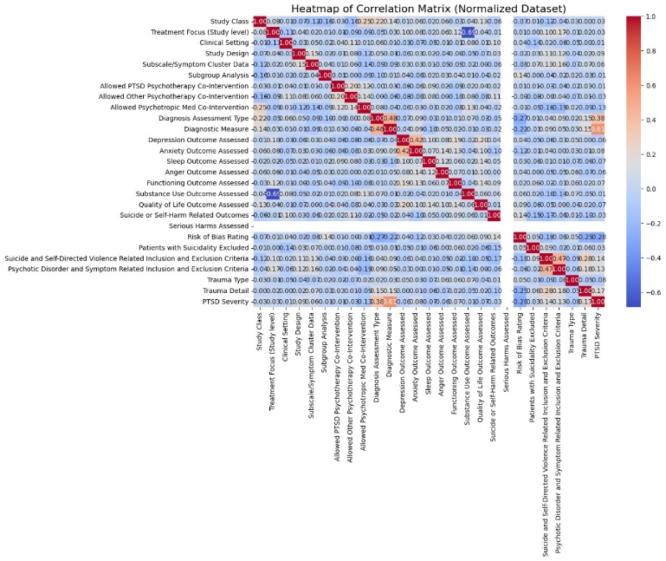
Figure 1. Correlation Matrix- Heatmap

F. Algorithms Used
“Decision tree” like a tree structure of nodes and branches created by partitioning data into subsets according to feature values. Each split maximizes information gain or minimizes impurity, for example, Gini or entropy. The process stops if the data is pure or a depth limit is met. Decision trees are interpretable, can take both numeric and categoric inputs, and do not need much pre-processing. They suffer from overfitting and are unstable with even minor data changes. Pruning and the setting of constraints enhance the capability to generalize.

“Random Forest” is basically an ensemble of decision trees that are learned from different yet random subsets of data and features. All the trees' outputs (voting or averaging) are combined to improve the accuracy and reduce overfitting. The randomness lowers the correlation among trees, thus the model is robust against the noise. It treats missing data and works pretty well with high-dimensional datasets. It's computationally intensive and much less interpretable than a single tree. Hyperparameters (for instance, how many trees to use, and also the maximum depth) affect performance.

“SVM” classifies data by finding a hyperplane to maximise the separation between classes. A linear kernel is required for separable data, whereas polynomial and RBF kernels transform data when the pattern is non-linear. SVM is known for their performance on small, high-dimensional datasets with good protection against overfitting. Its main drawbacks are sensitivity to parameter tuning (e.g., kernel choice, C, gamma) and computational power needs when dealing with large datasets. In particular RBF is considered to be effective in complex, non-linear problems.

“KNN” is a simple, non-parametric algorithm that classifies points based on the majority class of their k nearest neighbors. It relies upon distance metrics such as Euclidean or Manhattan to find neighbors. KNN does not have a training phase and thus it is memory-intensive and sensitive towards noisy data. It is more successful with a small, well-separated dataset. However, it does not act well for high-dimensional or imbalanced data. Scaling and feature selection significantly improves its performance.

“AdaBoost” combines multiple weak classifiers like decision stumps into a strong classifier. It does this by iteratively focusing attention on samples that were misclassified. Challenging samples are given high weights such that future classifiers improve upon them. The final prediction is a weighted vote across all classifiers. AdaBoost effectively works on binary and multi-class problems, especially with clean, well-structured data. However, it is sensitive to noise and outliers since these can dominate the learning process.

“ANN” attempts to mimic brain-like structures with interconnected layers of neurons. Data flows through layers: input, hidden, and output. The weights are adjusted using backpropagation to minimize the error. ANNs are absolutely excellent at capturing complex patterns; they are well-used for tasks like image recognition, NLP, and time-series prediction. They require large datasets, high computational powers, and careful tuning of hyperparameters like learning rate and architecture. Overfitting is controlled with techniques like regularization and dropout.

“Naive Bayes” is a machine learning algorithm based on Bayes' theorem, which applies the assumption that features are independent given the class label. It calculates the probability of each class given the input features and selects the class with the highest probability. The algorithm is simple, efficient, and works well with large datasets. Despite its simplicity, it often performs well, even with the "naive" assumption of feature independence. Naive Bayes can be used for both classification and regression tasks.

“Logistic regression” predicts the probabilities for binary classification by a sigmoid function. It applies a linear combination of inputs to model the relationship between features and class labels. The algorithm is interpretable, efficient, and it works well with linearly separable data. It can be extended towards multi-class problems using methods like one-vs-rest. Regularization techniques that include L1 and L2 prevent overfitting. Logistic regression shows weakness in the classification when a nonlinear pattern exists unless the feature set is transformed.

“XGBoost” is an optimized gradient boosting algorithm meant for speed and performance. It constructs sequential decision trees by learning from errors of previous ones in minimizing a loss function. It includes advanced forms of regularization, such as L1 and L2, and allows parallel processing to increase efficiency. It excels at handling missing values, big data, and variety-rich data. But it demands tuning hyperparameters, and thus it can be very computationally expensive. It's widely used in competitions.

“Gradient Boosting” focuses on building an ensemble of trees sequentially, where each tree corrects the errors of its predecessor. It uses gradient descent in minimizing a loss function and is known to be powerful for complex patterns. The flexibility of the algorithm can be used with different kinds of data as well as loss functions. However, it is very prone to overfitting and is slower than random forests. Regularization techniques and learning rate tuning improve its generalization and stability.

“LDA” is a subspace projection algorithm that reduces the dimensionality and classifies using just the data in the linear subspace maximized for class separability. It assumes that features are normally distributed and classes have the same covariance matrix. LDA is computationally efficient and performs well when the data is linearly separable. It is applied very often as an individual step for visualization or used in classification tasks. However, it fails with non-linear relationship and overlap of classes.

“QDA” is the extension of LDA but allows each class to have its own covariance matrix so that it can formulate quadratic decision boundaries. It is useful where class distributions diverge significantly in terms of shape or orientation. QDA assumes feature normally distribution but is sensitive to small sample sizes, resulting in instability. It can handle non-linear separations much better than LDA but at the cost of more parameters, so it tends to overfit.

“CatBoost” is one such gradient boosting algorithm, optimized especially for categorical data. It uses an innovative approach with ordered boosting and feature combination which are seen to prevent overfitting and increase precision. Minimal preprocessing is required since it can take care of the categorical features directly. Thus, CatBoost is effective with structured data though heavy on computation. However, it gives very high performance and fewer parameters to tune; hence less prone to overfitting and potent for imbalanced datasets.

“SGD” is an optimization algorithm that involves continuously minimizing a loss function by updating a weights iteratively with small, random batches of data. It's far faster and much more scalable compared to traditional gradient descent, especially for large datasets. SGD works well for linear models and neural networks but it's sensitive to learning rates and noisy updates. Techniques like momentum, learning rate decay, and mini-batching improve its convergence and stability.

“Extra Trees” is an ensemble method similar to Random Forest but introducing more randomness by selection splits randomly instead of their optimization. This reduces variance and accelerates training while remaining high accuracy. Extra Trees work well if the data are very high-dimensional, and the size of the data might be big. However, in some cases, they are a bit worse than Random Forest, and they can't be interpreted as good as Random Forest. Optimal results come only from proper hyperparameter tuning.

EXPERIMENTAL ANALYSIS

Performance Metrics
A PTSD severity prediction algorithm should be tested fully to determine its performance. Thus, in this work, several algorithms were tested using standard metrics and evaluation processes on the US Veteran dataset. The following metrics were calculated for all algorithms to provide consistency and comparability.

“Accuracy” is the ratio of the number of the correct classifications of instances (both normal and malicious) to the total instances. It provides a general view about the capability of the model.

Formula:
Accuracy = True Positives + True Negatives
Total Instances

“Precision” is the ratio of true positive predictions to the number of all positive predictions that the model has made. High precision means that fewer misclassifications are being made.

Formula:
Precision = True Positives
True Positives + False Positives

“Training time” is the amount of time it took for the model to fit to the training dataset. This is a crucial metric as time delays delay speedy treatment for suffering veterans.

“Recall”, or respectively, sensitivity measures the ability of the model to detect correctly actual positive instances (for example, intrusions). It ensures that the model captures the vast majority of attacks and does not miss important ones.

Formula:
Recall = True Positives
True Positives + False Negatives

“F1-score” is a harmonic mean of precision and recall, balancing the trade-off between both. The score can be extremely helpful in class-imbalanced datasets as it provides an overall measure of both precision and recall in one score.

Formula:
F1-Score = 2 * Precision * Recall
Precision + Recall

Evaluation Procedure
For all algorithms, following was performed in the evaluation procedure:

Model Training- The training time was counted for the model using Python's module time. For every model, it had been trained on the training split of the US Veteran dataset (x_train, y_train).

Prediction- Test on test dataset x_test and the results were stored.

Confusion Matrix- Its computation is intended to assess the number of true positives, false positives, true negatives, and false negatives.

Metric Extraction- All the main metrics such as accuracy, precision, recall, F1-score are drawn out from the classification report to compare amongst models.

Performance Chart/Table
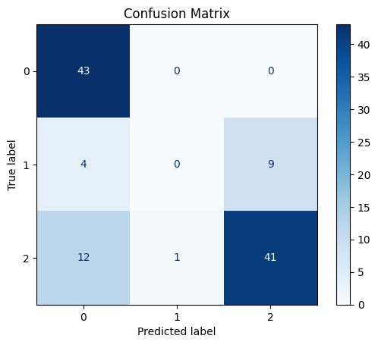
(a)

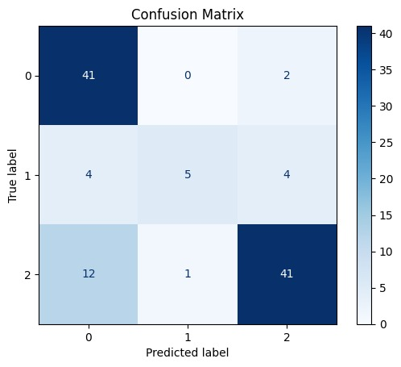

(b)

Figure 2. a) Confusion matrix for SVM using RBF; b) Confusion matrix for SVM using polynomial kernel

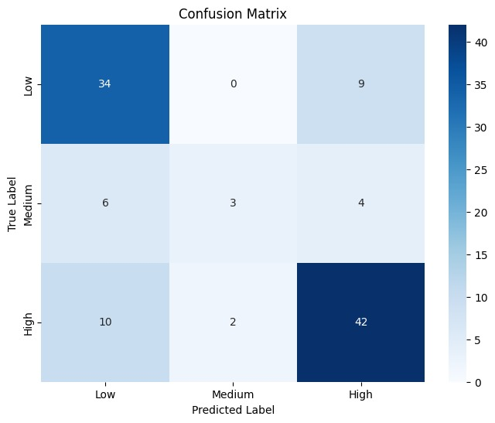

Figure 3. Confusion matrix for KNN

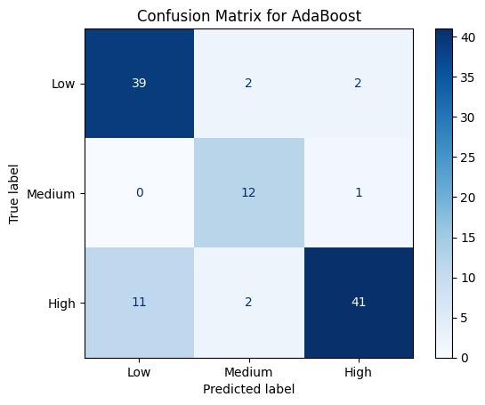

Figure 4. Confusion matrix for AdaBoost

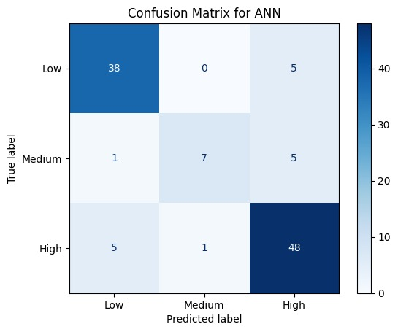

Figure 5. Confusion matrix for ANN

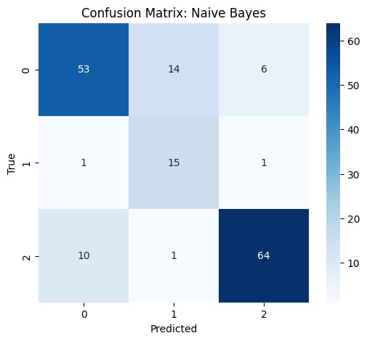

Figure 6. Confusion matrix for Naive Bayes

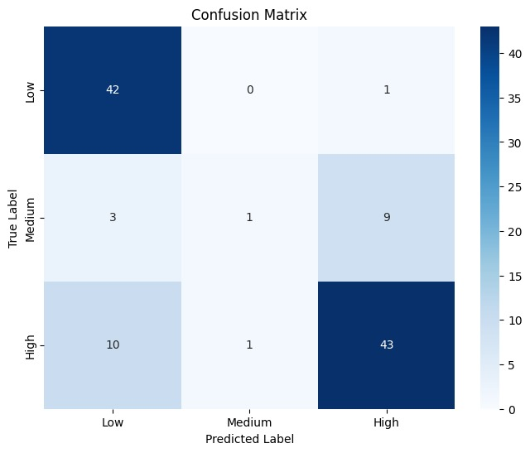

Figure 7. Confusion matrix for Logistic Regression

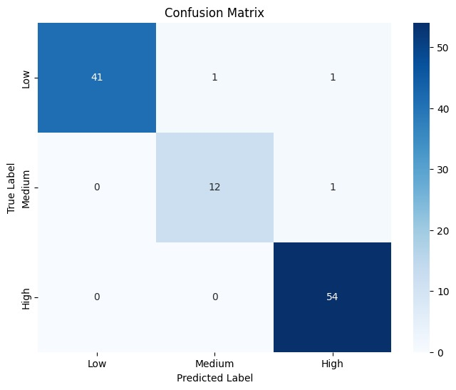

Figure 8. Confusion matrix for XGBoost

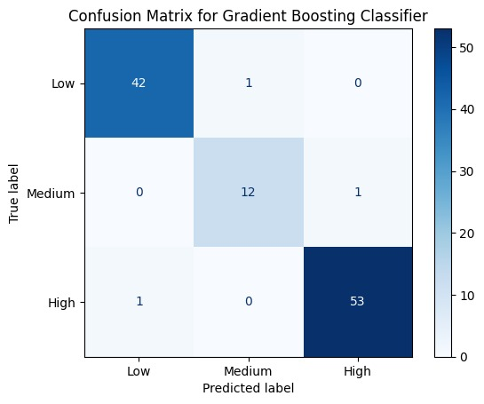

Figure 9. Confusion matrix for Gradient Boosting

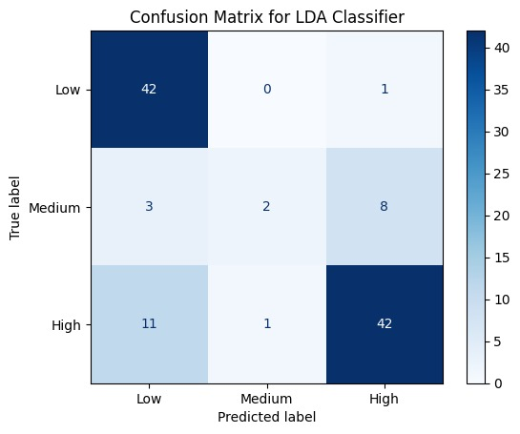

Figure 10. Confusion matrix for LDA

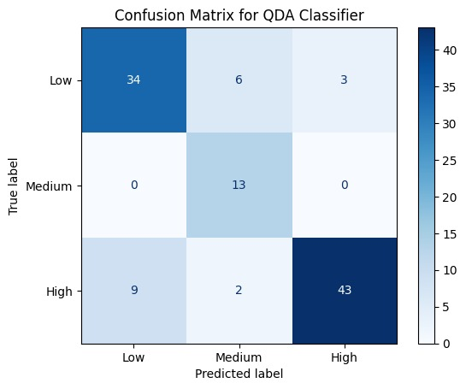

Figure 11. Confusion matrix for QDA

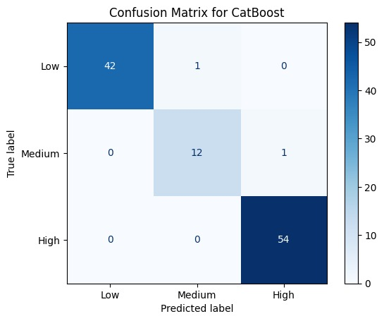

Figure 12. Confusion matrix for CatBoost

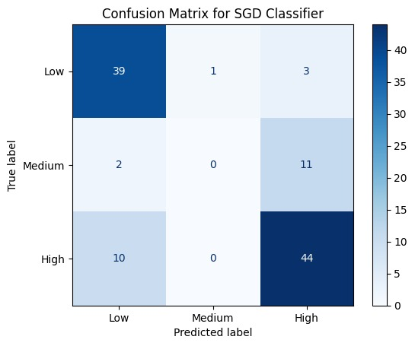

Figure 13. Confusion matrix for SGD

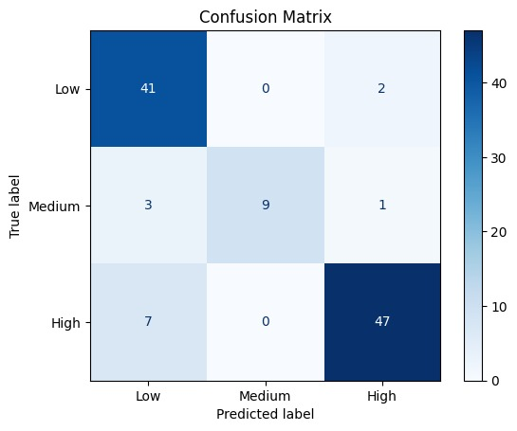

Figure 14. Confusion matrix for Extra Trees

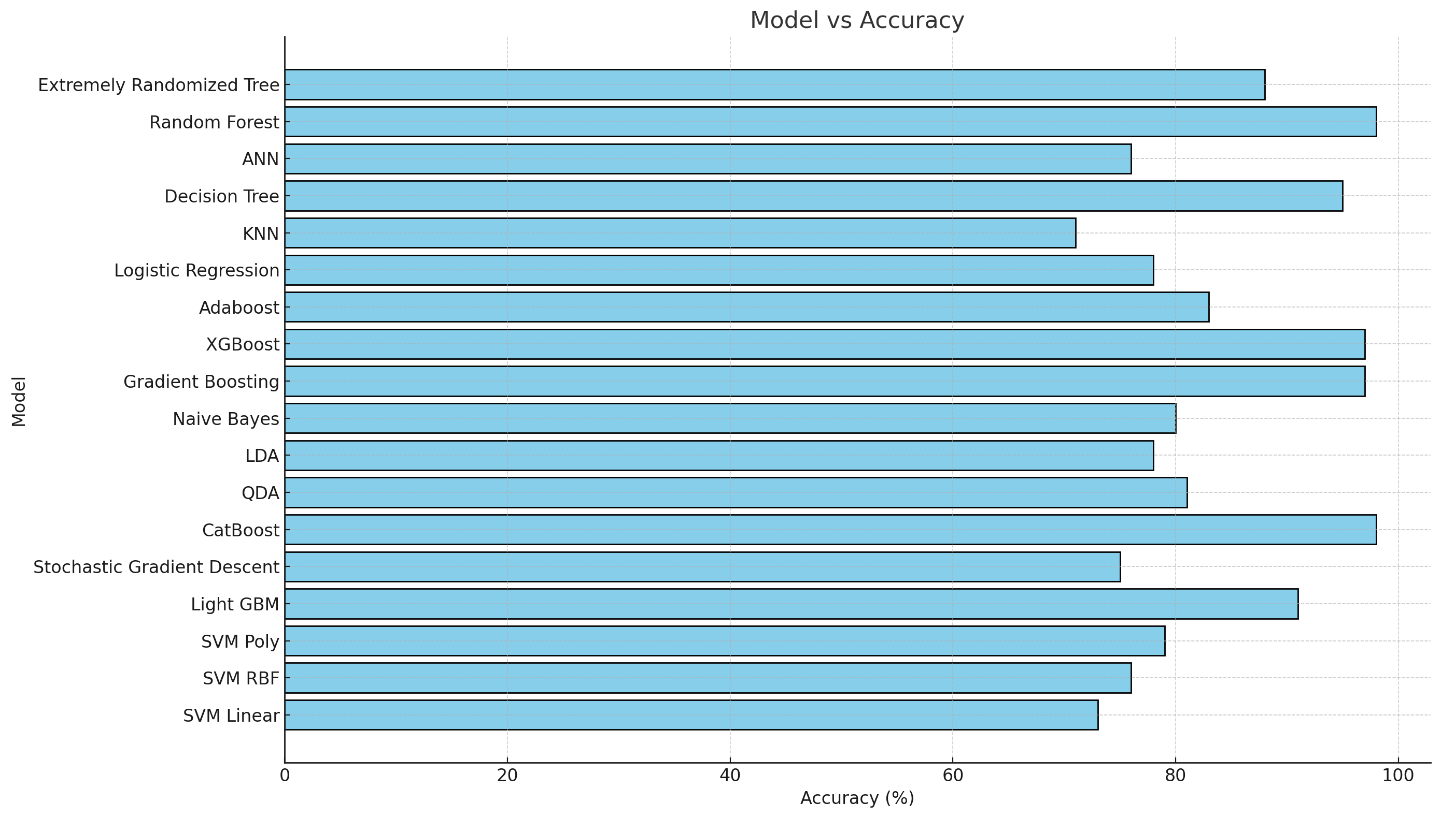
(a)

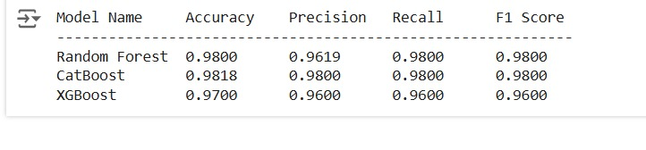 (b)
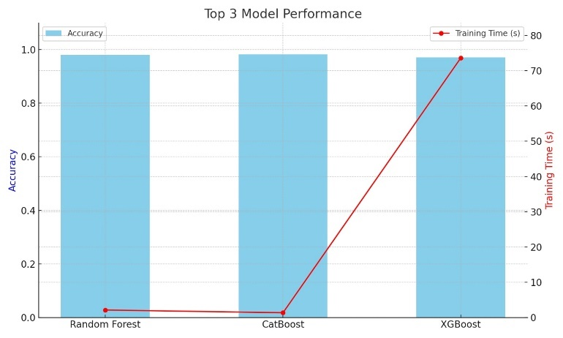
(c)
Figure 15. a) Model Accuracy Comparison; b) Top 3 models and their scores; c) Top 3 model performance

CONCLUSION
Evaluation on the PTSD dataset for veterans with diverse machine learning algorithms delivers crucial insight into their predictability. Random Forest, CatBoost, XGBoost, and Gradient Boosting are models tested and proven as the best predictors of accuracy with 98%, 98%, 97%, and 97% respectively. These ensemble-based techniques utilize diverse decision trees, which makes them highly reliable in capturing complex patterns in data for this problem domain.

Others, such as AdaBoost at 83% and Extremely Randomized Trees at 88%, performed well; however, the simplicity of models like Logistic Regression at 78%, Naive Bayes at 80%, and KNN at 71% has provided relatively lower accuracy, indicating that perhaps these approaches cannot handle the complex relationships and interactions between features within the data.

Ironically, the SVM model achieved modest accuracy of 73%, reasonable for the linear and kernel-based models but perhaps not robust enough to capture the nature of non-linear relationships in the dataset.

These results further emphasize the fact that for predicting PTSD severity, high-end ensemble techniques have a necessity to be used since they performed well compared to standard algorithms. This is because PTSD data always involves subtle and complex interactions between features such as depression, anxiety, etc. Psychological variables concerned. The highest accuracy obtained by the top models underscores the potential of such models for real-world deployment in clinical settings, where accurate predictions can guide personalized treatment and intervention strategies for veterans.

Some of the future work may lie in further fine-tuning these high-performing models, showing hybrid approaches or incorporating domain knowledge to enhance interpretability and reliability. Their deployment in a production environment would likely involve incorporate explainability techniques to make clinicians and stakeholders trust their decisions.

References
[1] Biscoe, N., New, E. & Murphy, D. Complex PTSD symptom clusters and executive function in UK Armed Forces veterans: a cross-sectional study. BMC Psychol 12, 209 (2024). https://doi.org/10.1186/s40359-024-01713-w

[2] Scott JC, Matt GE, Wrocklage KM, Crnich C, Jordan J, Southwick SM, et al. A quantitative meta-analysis of neurocognitive functioning in posttraumatic stress disorder. Psychol Bull. 2015;141(1):105–40.

[3] Murphy D, Busuttil W. Understanding the needs of veterans seeking support for mental health difficulties. BMJ Mil Health. 2020 Aug;166(4):211-213. doi: 10.1136/jramc-2019-001204. Epub 2019 Apr 29. PMID: 31036746.

[4] Murphy D, Karatzias T, Busuttil W, Greenberg N, Shevlin M. ICD-11 posttrau-matic stress disorder (PTSD) and complex PTSD (CPTSD) in treatment seeking veterans: risk factors and comorbidity. Soc Psychiatry Psychiatr Epidemiol. 2021;56(7):1289–98.

[5] Reed DE 2nd, Fischer IC, Williams RM, Na PJ, Pietrzak RH. Co-occurring Chronic Pain and PTSD Among US Military Veterans: Prevalence, Correlates, and Functioning. J Gen Intern Med. 2024 Aug;39(11):2009-2016. doi: 10.1007/s11606-024-08803-w. Epub 2024 May 23. PMID: 38780882; PMCID: PMC11306465.

[6] Raines, A.M., Clauss, K., Schafer, K.M. et al. Cognitive Processing Therapy: A Meta-analytic Review Among Veterans and Military Personnel with PTSD. Cogn Ther Res 48, 361–370(2024).https://doi.org/10.1007/s10608-023-10429-x

[7] Cloitre et al., 2018 M. Cloitre, M. Shevlin, C.R. Brewin, J.I. Bisson, N.P. Roberts, A. Maercker, T. Karatzias, P. Hyland The International Trauma Questionnaire: development of a self-report measure of ICD-11 PTSD and complex PTSD Acta Psychiatr. Scand., 138 (6) (2018), pp. 536-546, 10.1111/acps.12956

[8] J. Sveen, K. Bondjers, and M. Willebrand, “Psychometric
properties of the PTSD checklist for dsm-5: A pilot study,”
Eur. J. Psychotraumatol., vol. 7, 2016.

[9] Novaco, R. W., & Chemtob, C. M. (2015). Violence associated
with combat-related posttraumatic stress disorder: The
importance of anger. Psychological trauma: theory, research,
practice, and policy, 7(5), 485.

[10] Kang, H. K., Bullman, T. A., Smolenski, D. J., Skopp, N. A., Gahm, G. A., & Reger, M. A. (2015). Suicide risk among 1.3 million veterans who were on active duty during the Iraq and Afghanistan wars. Annals of epidemiology, 25(2), 96-100.Shneiderman, B. (1998) Designing the User Interface - Strategies for Effective Human-Computer Interaction, Addison-Wesley, Reading, MA.

[11] C. Stappenbeck, J. Hellmuth, T. Simpson and M. Jakupcak, "The effects of alcohol problems, PTSD, and combat exposure on nonphysical and physical aggression among Iraq and Afghanistan war veterans.", Psychological Trauma: Theory, Research, Practice, and Policy, vol. 6, no. 1, pp. 65-72, 2014. Available: 10.1037/a0031468.

[12] I. Burnett-Zeigler et al., “Prevalence and correlates of alcohol misuse among returning Afghanistan and Iraq Veterans,” Addict. Behav., vol. 36, no. 8, pp. 801–806, 2011.

[13] J. M. Brown, J. Williams, R. M. Bray, and L. Hourani, “Postdeployment Alcohol Use, Aggression, and PostTraumatic Stress Disorder,” Mil. Med., vol. 177, no. 10, pp. 1184–1190, 2012.

[14] Strom, Thad Q. et al. 2012. “An Exploratory Examination of Risk-Taking Behavior and PTSD Symptom Severity in a Veteran Sample.” Military Medicine 177(4): 390–96.

[15] Wortmann, Jennifer H. et al. 2016. “Psychometric Analysis of the PTSD Checklist-5 (PCL-5) among Treatment-Seeking Military Service Members.” Psychological Assessment 28(11): 1392–1403.

[16] A. Minassian et al., “Association of predeployment heart rate variability with risk of postdeployment posttraumatic stress disorder in active-duty marines,” JAMA Psychiatry, vol. 72, no. 10, pp. 979–986, Oct. 2015.

[17] K. Possemato et al., “Ecological Momentary Assessment of PTSD Symptoms and Alcohol Use in Combat Veterans,” Psychol. Addict. Behav., vol. 29, no. 4, pp. 894–905, 2015.

[18] D. Conybeare, E. Behar, A. Solomon, M. Newman and T. Borkovec, "The PTSD Checklist-Civilian Version: Reliability, Validity, and Factor Structure in a Nonclinical Sample", Journal of Clinical Psychology, vol. 68, no. 6, pp. 699-713, 2012.

[19] S. I. Omurca and E. Ekinci, “An alternative evaluation of post traumatic stress disorder with machine learning methods,” INISTA 2015 - 2015 Int. Symp. Innov. Intell. Syst. Appl. Proc., no. Ml, 2015.

[20] “NCCP | Adolescent Violence and Unintentional Injury in the United States.” [Online]. Available: http://www.nccp.org/publications/pub_890.html. [Accessed: 26-May-2020].

