# **NPM Assignment**

**Setup NODEjs environment in your machine**

-sudo apt install nodejs

-node -v

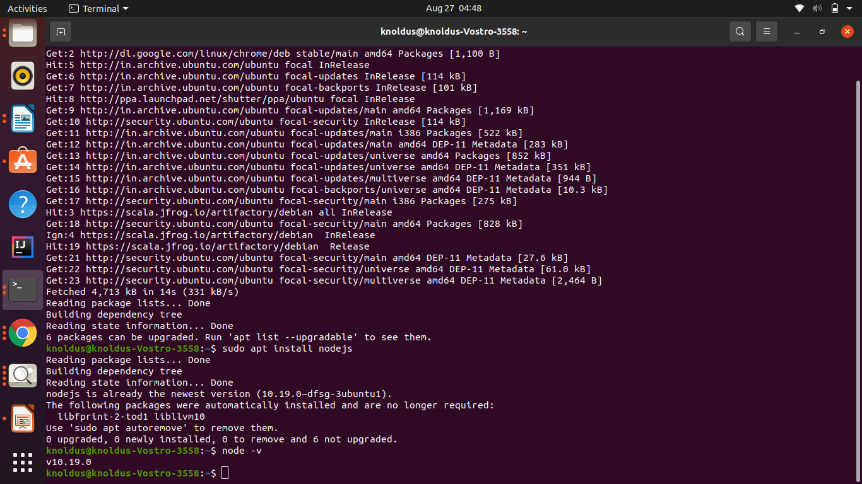

**install the following packages as global packages -**

**1. Angular**

sudo apt install npm

sudo apt install -g @angular/cling --version

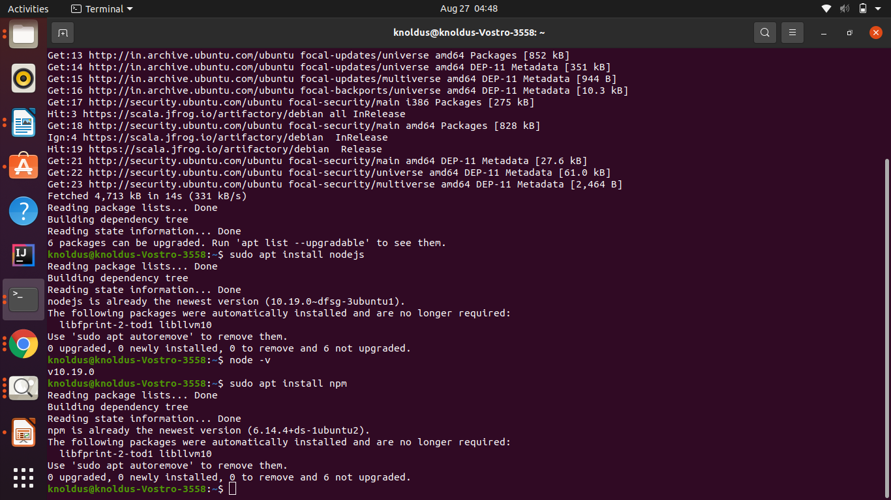

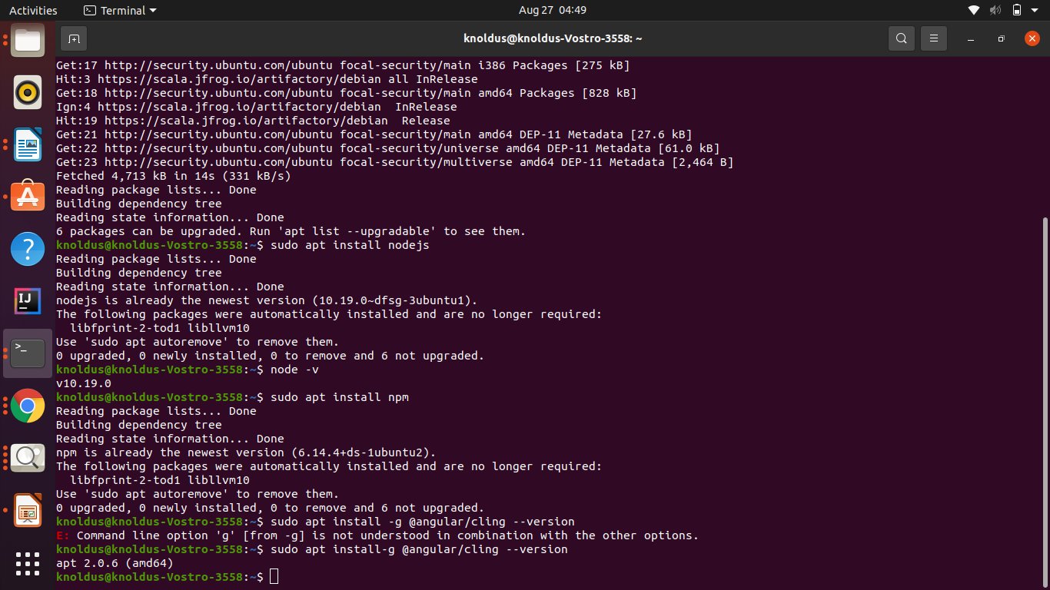

**2. React**

sudo npm -g install create-react-app create-react-app --version

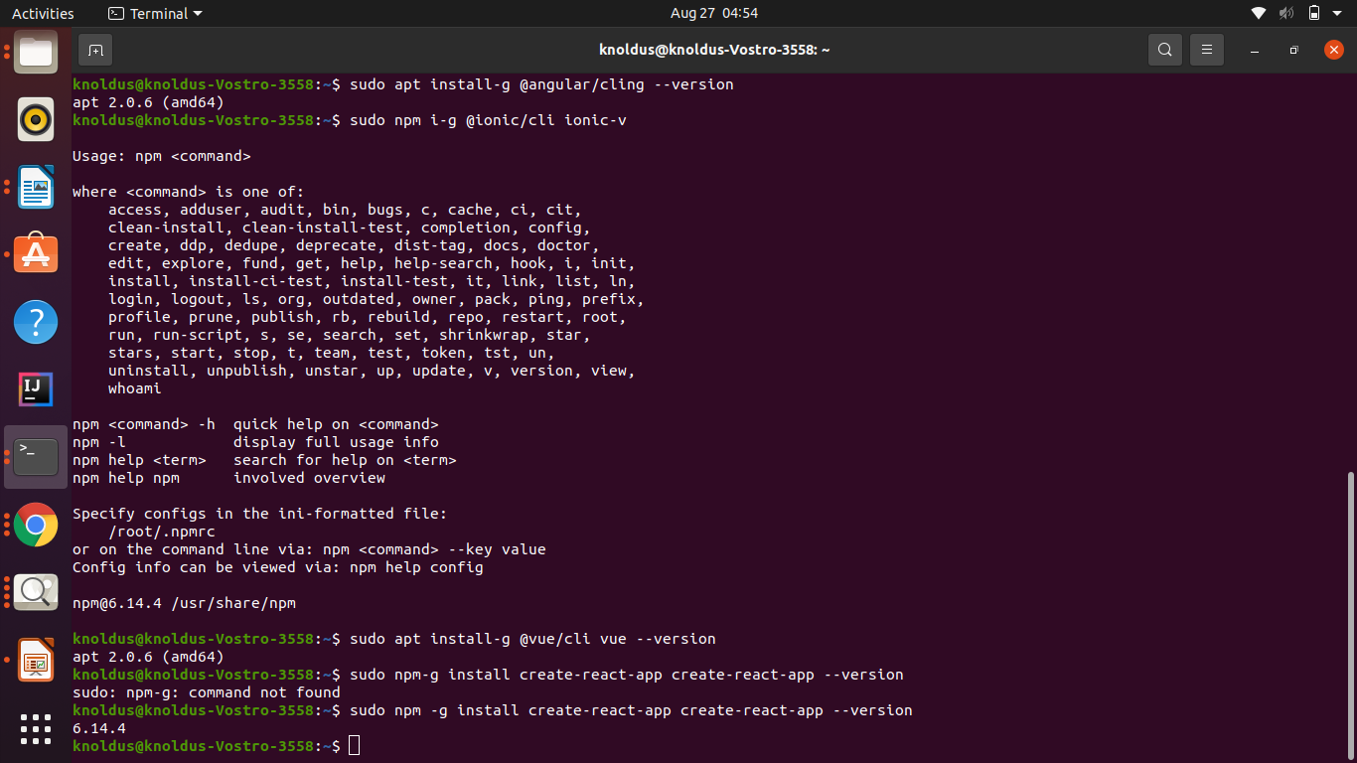

**3. Vue**

sudo apt install-g @vue/cli vue --version

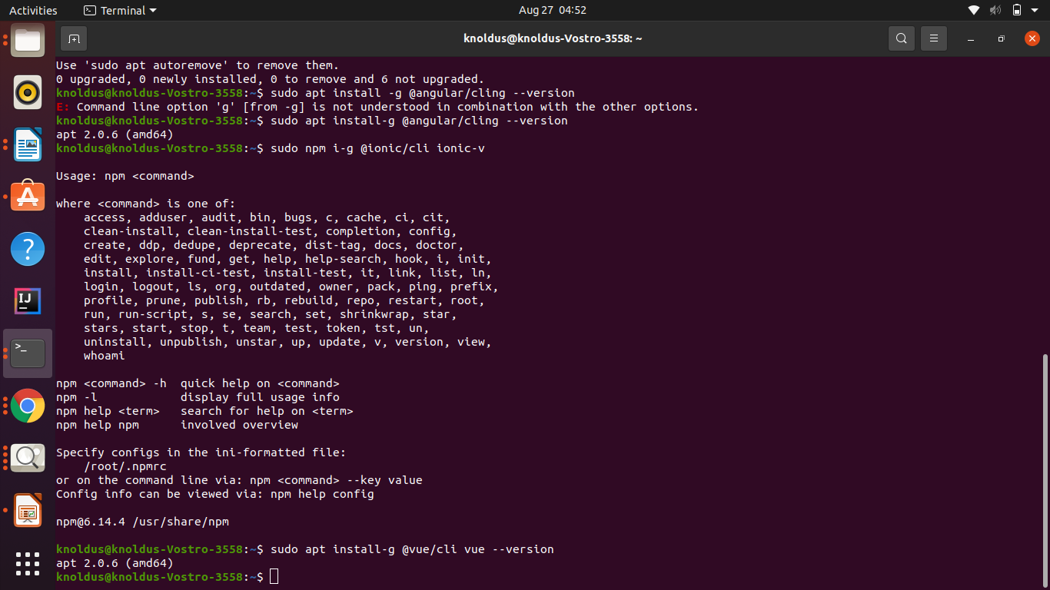

**4. Ionic**

sudo npm i-g @ionic/cli ionic-v

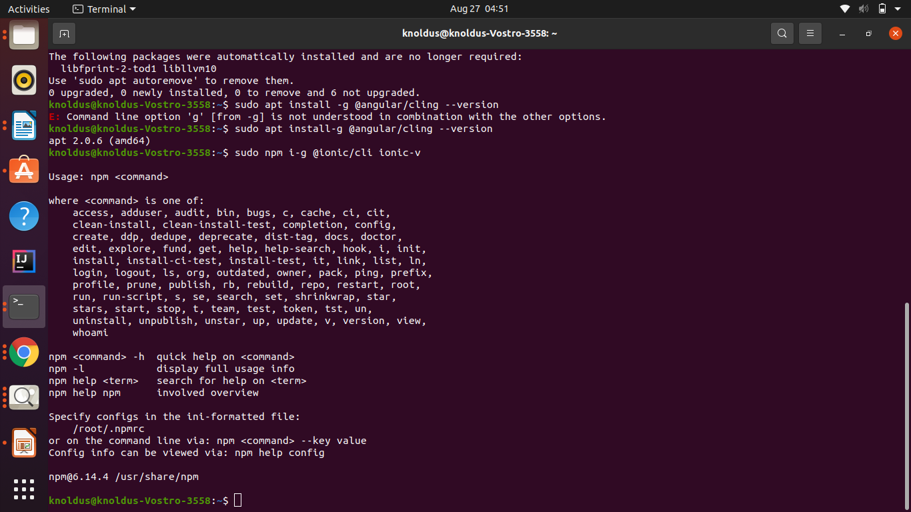

**By**

**-Sonali Kumari (1622)**