**Automatic Transmission Controller**

Name: Sonali Ravindra Buchade

Emp Id-214869

**Contents**

Introduction 3

Analysis of the system 4

Requirement 5

Equations Required 6

System 8

Output 9

Conclusion 11

Reference 11

**Introduction-**

This model shows how to model an automotive drivetrain with Simulink. State flow enhances the Simulink model with its representation of the transmission control logic. In this system, state flow shows its strength in this capacity by performing the function of gear selection in an automatic transmission. This function is combined with the drivetrain dynamics in a natural and intuitive manner by incorporating a state flow block in the Simulink block diagram.

**Analysis of the system-**

The block diagram below shows the power flow in a typical automotive drivetrain. Nonlinear ordinary differential equations model the engine, four-speed automatic transmission, and vehicle. This model directly implements the blocks from this diagram as modular Simulink subsystems.

On the other hand, the logic and decisions made in the Transmission Control Unit (TCU) do not lend themselves to well-formulated equations. TCU is better suited for a State flow representation. State flow monitors the events which correspond to important relationships within the system and takes the appropriate action as they occur.

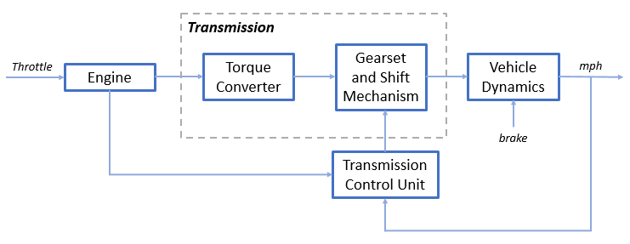

Fig. 1 Block Diagram of Automatic Transmission Controller

**Requirement-**

The system model programs the shift points for the transmission according to the schedule shown in the figure below. For a given throttle in a given gear, there is a unique vehicle speed at which an upshift takes place. The simulation operates similarly for a downshift.

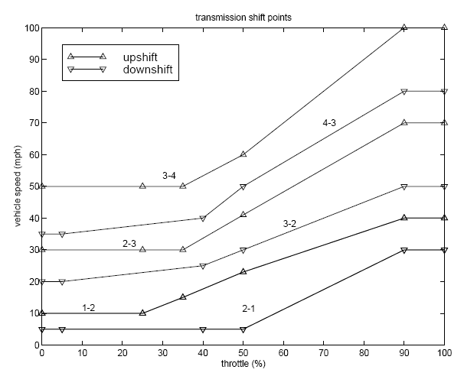

**Equations Required-**

The throttle opening is one of the inputs to the engine. The engine is connected to the impeller of the torque converter which couples it to the transmission (see Equation 1).

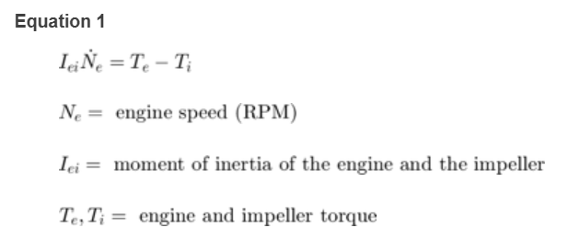

The input-output characteristics of the torque converter can be expressed as functions of the engine speed and the turbine speed. In this example, the direction of power flow is always assumed to be from the impeller to the turbine (see Equation 2).

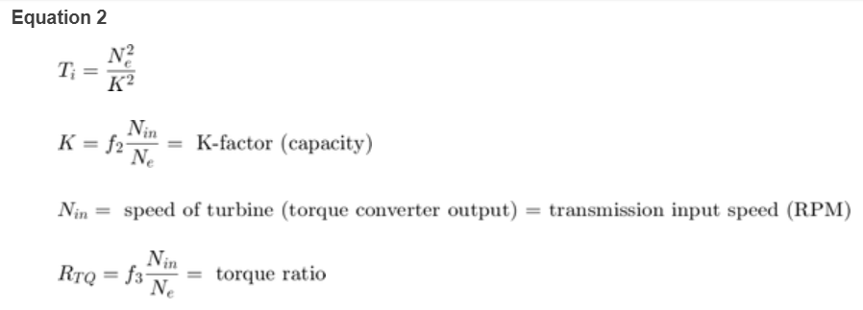

The transmission model is implemented via static gear ratios, assuming small shift times (see Equation 3). 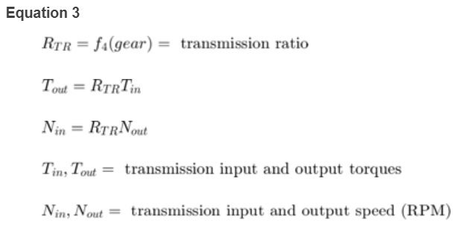

The final drive, inertia, and a dynamically varying load constitute the vehicle dynamics (see Equation 4)

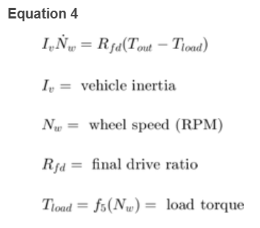

The load torque includes both the road load and brake torque. The road load is the sum of frictional and aerodynamic losses (see Eq. 5)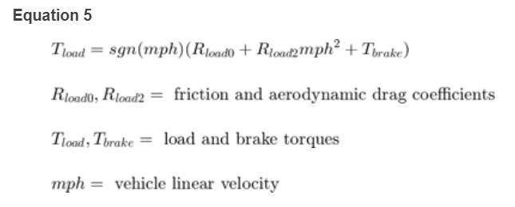.

**System Model-**

Used skills-

1. Callbacks- We used post load function to define parameters so that when anyone opens this Simulink model automatically all the parameters will get loaded in base workspace.

2. Data Inspector- We logged all the signals required to compare between different runs.

3. Solver Selection – We have selected fixed step ode5 solver to get best results

4. Simulink function block- We have used Simulink function block in shift logic to graphically design the computation of threshold.

5. Lookup Table- We have used 1 and 2 dimensional lookup table in engine, torque converter, transmission gear ratio and shift logic subsystems to reduce the computation hence complexity of system

6. Signal Builder Block- It is used to design throttle and break signals.

I) Throttle- which is input for engine and shift logic subsystem and

II) Brake- which is input for vehicle subsystem

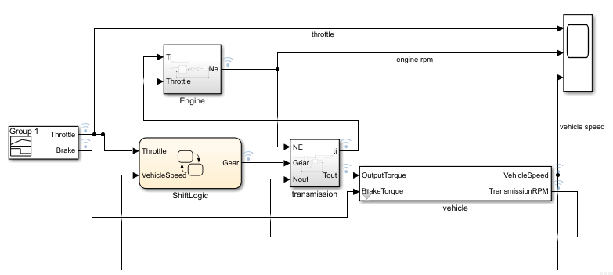

Fig. 2 Simulink model of Automatic transmission controller

**Output Results-**

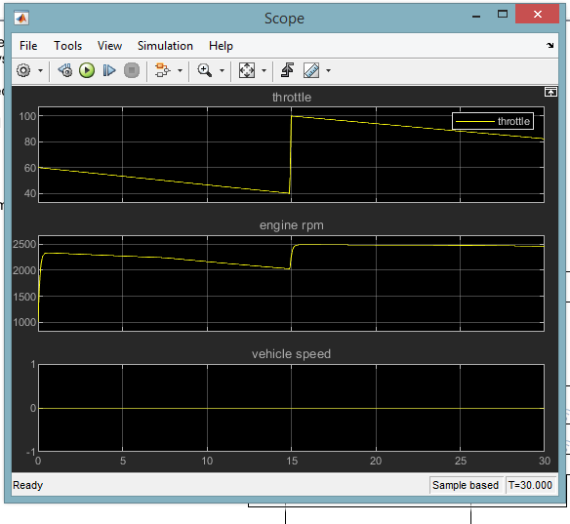

Fig.3 Scope Output

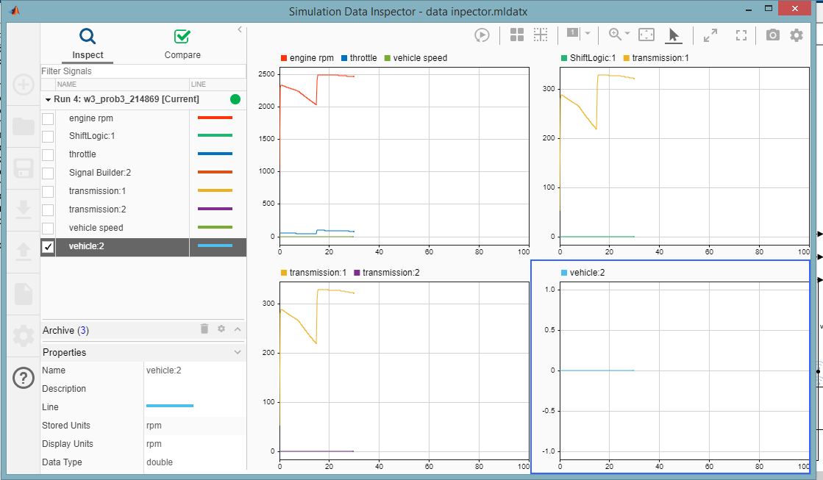

Fig. 4 Data Inspector Results

**Conclusion-**

The seamless integration of state flow control logic with Simulink signal processing enables the construction of a model that is efficient and visually intuitive. Study of call-backs, data inspector, solver selection, Simulink function block, lookup table and signal builder block is done in this project.

**Reference-**

<https://in.mathworks.com/help/simulink/slref/modeling-an-automatic-transmission-controller.html>