Part A: File and Directory Creation
- Create a regular file named example.txt in your home directory.
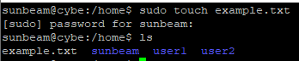
- Create a shell script file named script.sh .
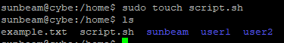

- Create another file named template.txt .
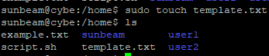
- Create a directory named docs .
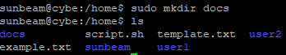
- List all created files and directories and verify their existence using appropriate commands
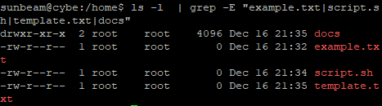
Part B: File Permission Tasks using chmod
- Change the permissions of the file example.txt so that:
- The owner has read and write permissions
- The group has read-only permission
- Others have no permissions
2. Add only execute permission to the file script.sh for:
- Owner
- Group
- Others
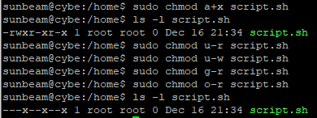
3. Remove the write permission from the file example.txt for:
- Group users
- Other users
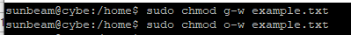
4. Change the permissions of the directory docs so that:
- The owner has read, write, and execute permissions
- The group has read and execute permissions
- Others have read-only permission
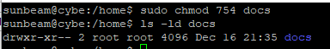
5.Set the permissions of example.txt to be exactly the same as the permissions of the file template.txt
