Q1: Basic Terminal Commands
Check the current working directory.

List all files and folders
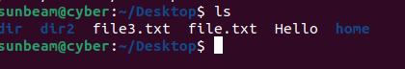
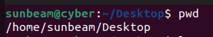

Display the current date and time. date
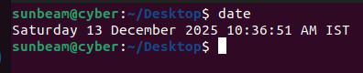

Q2: Directory Management
- Create a directory named linux_lab .
- Inside linux_lab , create two folders: docs and scripts .
- Navigate to the docs directory.
- Go back to the home directory.
- Remove the scripts directory.
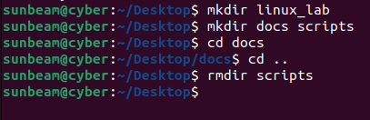

Q3: File Management
1. Create a file named test.txt .
2. Write your name inside the file.
3. Display the content of the file. cat
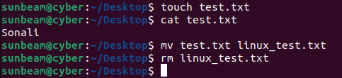
4. Rename test.txt to linux_test.txt .
5. Delete the file

Q4: Copy & Move
1. Create a directory called backup .
2. Copy any text file into the backup directory.
3. Move the file back to the home directory.
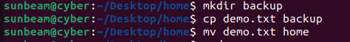

Q5: User & System Information
1. Display the current logged-in user.
2. Show system hostname.
3. Display Linux kernel version. uname -a
4. Check system uptime. uptime
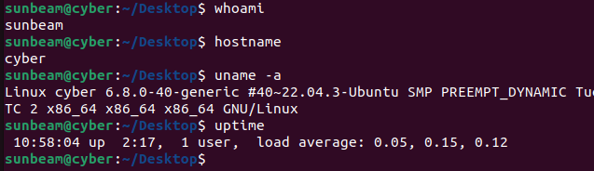

Q6: Package Management
1. Update the package list.
2. Install tree package.
3. Use tree command in home directory.
4. Remove the tree package.
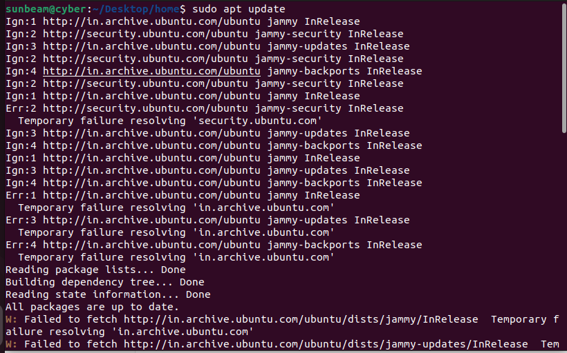
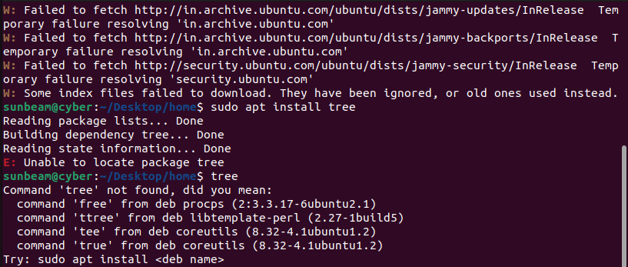

Q7: Networking Commands
1. Check IP address.
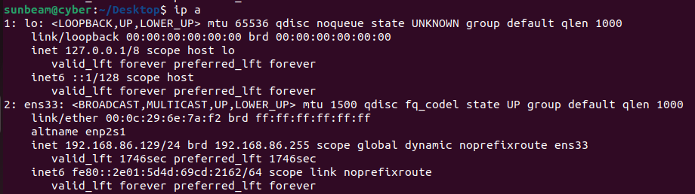
2. Check network interfaces
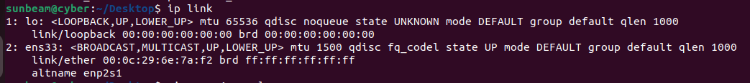
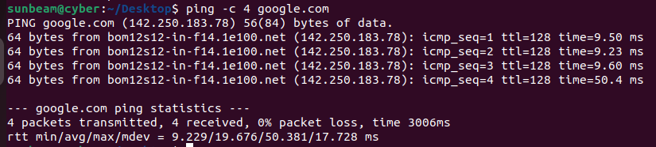
3. Ping Google (4 packets only)

