- Create a directory named my_files in your home directory.
- Inside the my_files directory, create three text files: file1.txt file2.txt file3.txt

- Create a directory named backup inside the my_files directory

- Use the cp command to create a backup of: file1.txt file2.txt inside the backup directory.
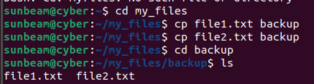

- Use the cp command to copy file3.txt to your Desktop.
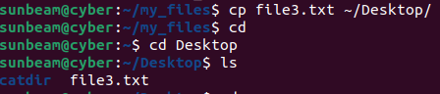

- Copy the entire my_files directory (inside home) with a new name my_old_files .
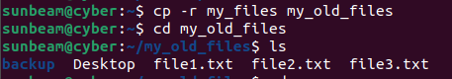

- Copy the backup directory to your home directory.
