Q1. Create a new file using nano
Create a new file named nano_practice.txt using the nano command.
Hint:
nano nano_practice.txt
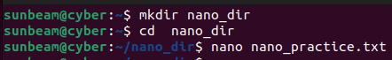
Q2. Write basic content in the file
Inside nano_practice.txt , write the following text:
Linux Nano Editor Practice
This file is created using nano.
Nano is a simple and user-friendly text editor.
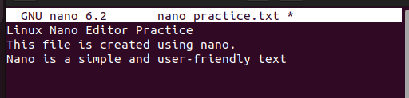
Q3. Save and exit nano
Save the file and exit the editor
Q4. Reopen the file and edit content
Reopen nano_practice.txt and add the following line at the end:
This line was added later using nano.
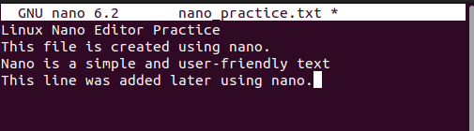

Q5. Search for a word
Inside the nano editor, search for the word “nano”
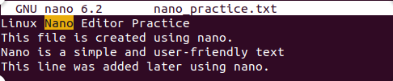
Q6. Cut and paste a line
Cut the last line Paste it at the top of the file
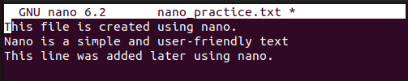
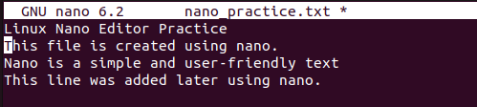
Q7. Undo and redo
Undo the last change Redo the change
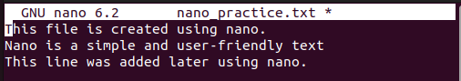
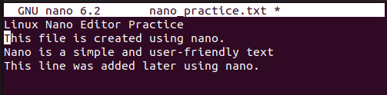

Q8. Enable line numbers
Open the file with line numbers enabled.
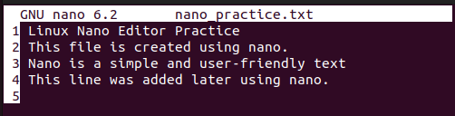

Q9. Replace a word
Replace the word “simple” with “powerful” in the file
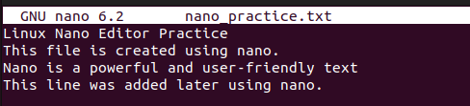
Q10. Create another file using nano
Create a new file named linux_commands.txt and write any 5 Linux commands with their purpose

