Part A: Directory and File Creation
- Create a main directory named SunBeam.
- Inside SunBeam, create three subdirectories: ground_floor, first_floor, second_floor.
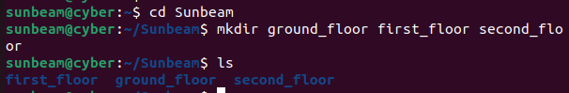
- In the ground_floor directory, create subdirectories KAVERI, KRISHNA, and VENNA.
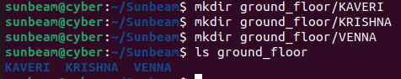
- In the first_floor directory, create subdirectories WARANA, NIRA, INDRAYANI, PURNA, PRAVARA,KOYANA.
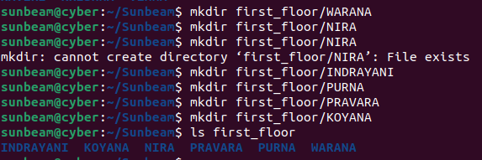

- In the second_floor directory, create subdirectories Library, CT-01, CT-02, and CT-03.
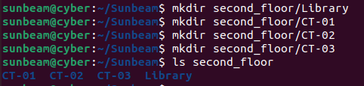
- In the KRISHNA hall, create a directory named DAC and inside it create 10 student files: d1, d2, …, d10.
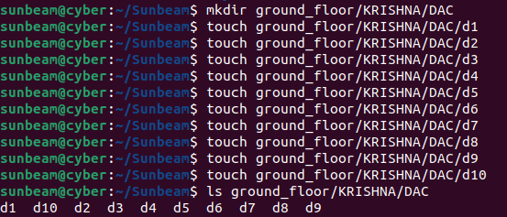
- In the NIRA hall, create a directory DESD with student files e1 to e10.
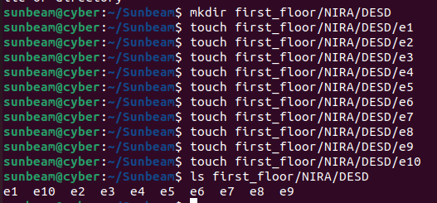
- In the PURNA hall, create a directory DITISS with student files c1 to c10.
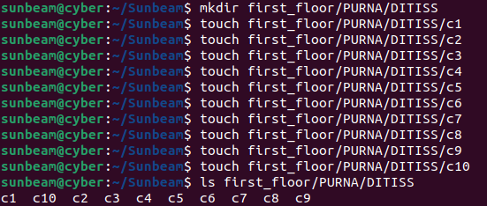

- In the PRAVARA hall, create a directory DBDA with student files b1 to b10.
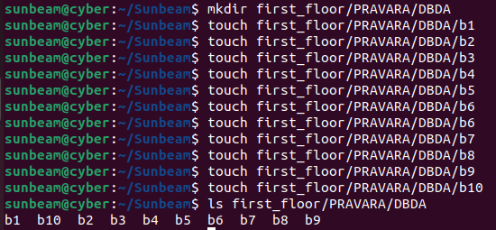
- In the WARANA hall, create a directory DMC with student files w1 to w10.
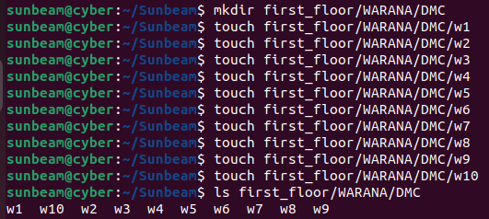

Part B: File and Directory Operations
Add the following students in each course:
student1 student2 student3 amit domnic keshav rudra bishop cyrus
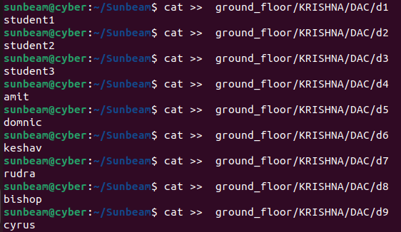
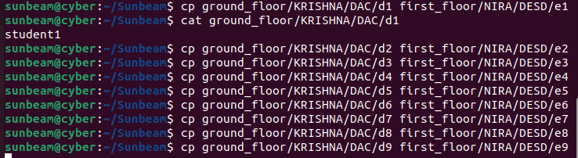
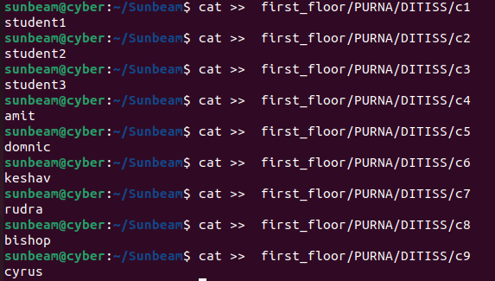
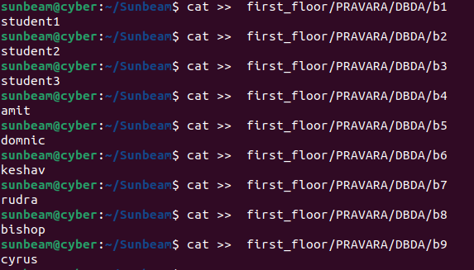
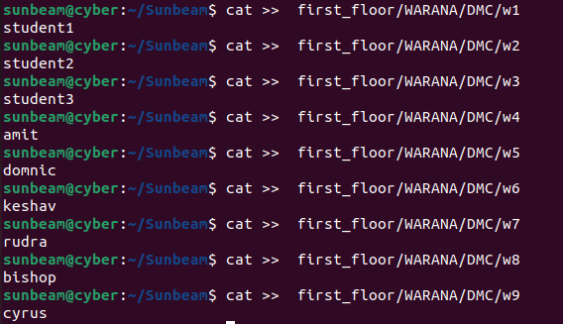
- Move student d5 from KRISHNA/DAC hall to NIRA/DESD.
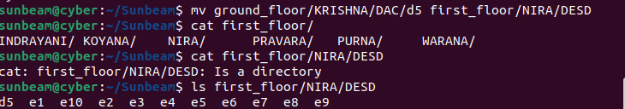
- Copy student c3 from PURNA/DITISS to PRAVARA/DBDA.
- Remove student e10 from NIRA/DESD.
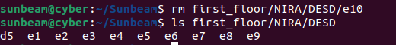
- Rename student w4 to w4_updated.
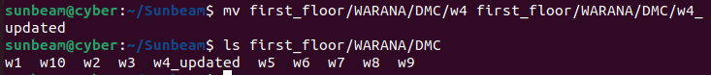
- Move the directory CT-02 into Library.

Part C: Listing and Viewing
- List all halls present in the First floor. (Use relative path).
- List all student files inside DAC sorted alphabetically in reverse order.
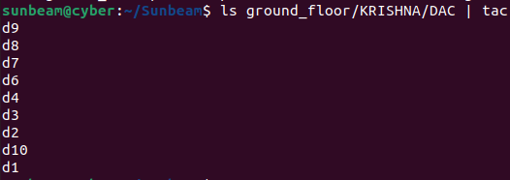
18. Create a file all_students.txt in the SunBeam directory which contains a list of all students from all
courses.
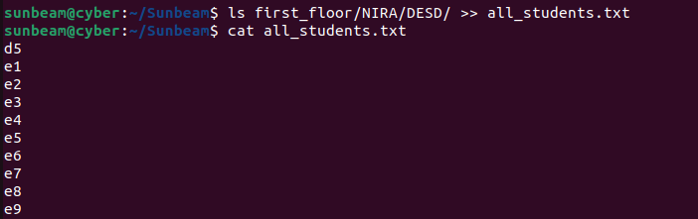
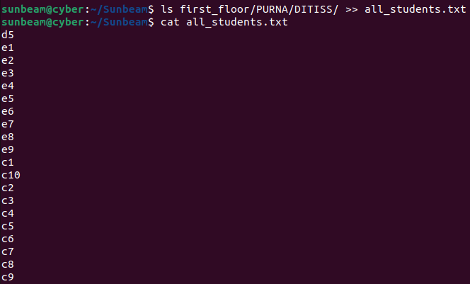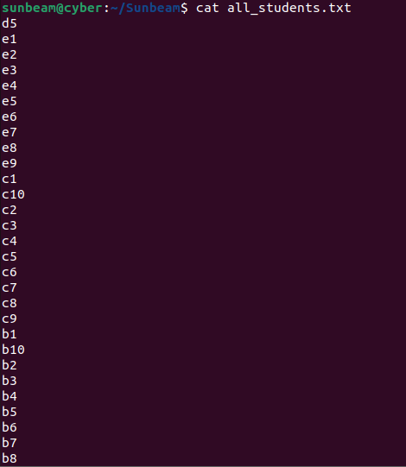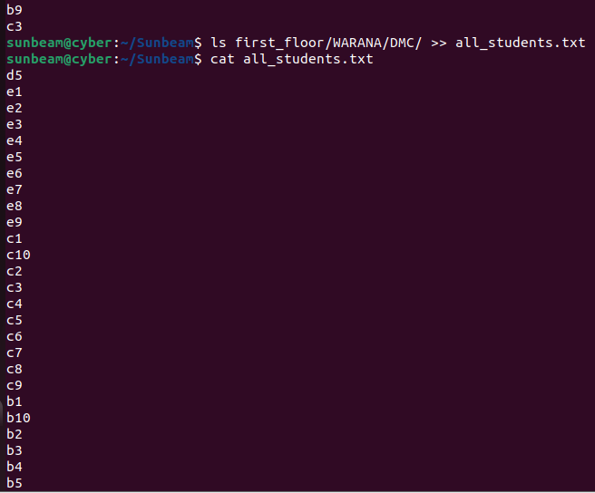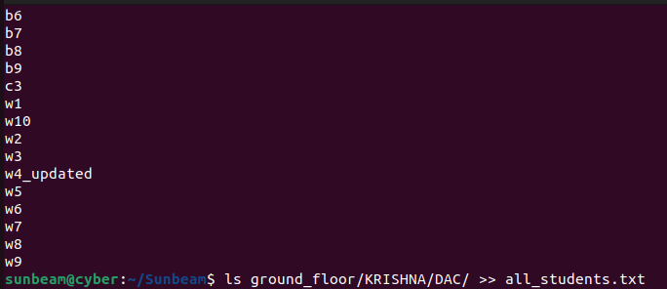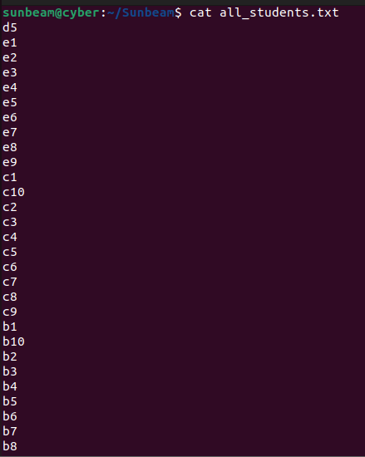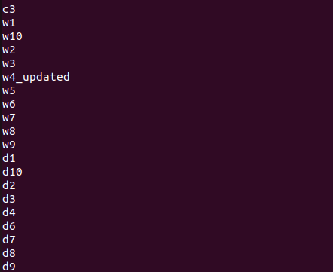

19. Display the content of all_students.txt using:
cat (normal order)
tac (reverse order)
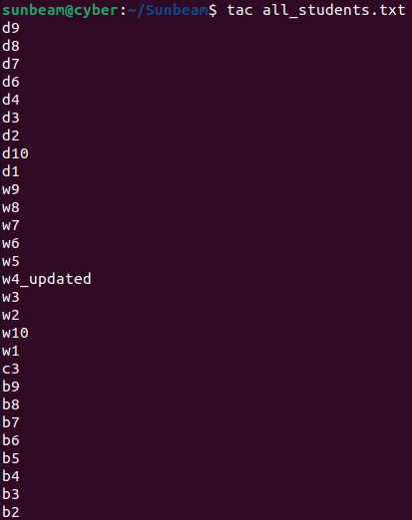
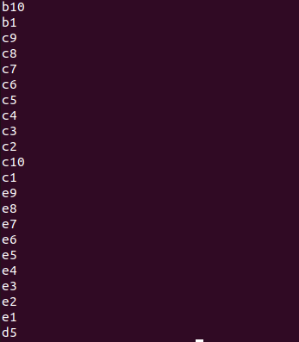
20. Display the unique list of student names from all_students.txt. 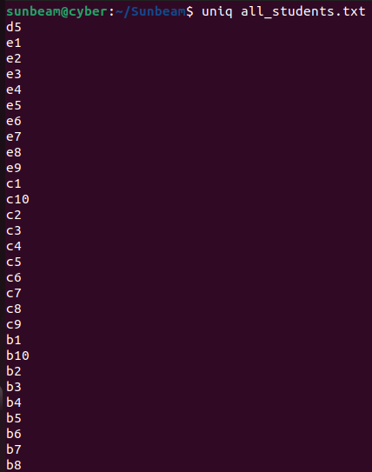
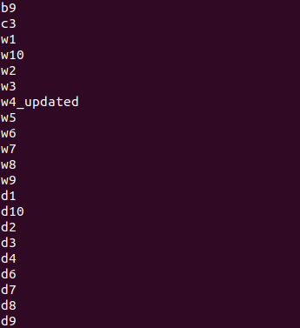
Part D: Path Practice
21. From your home directory, display the contents of the DBDA hall using absolute path.
22. From inside the NIRA/DESD directory, access students in DAC hall using relative path.
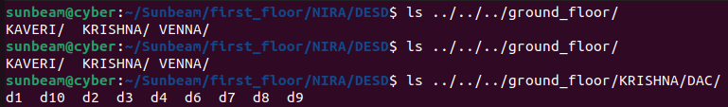
23. From inside the Ground directory, move VENNA hall to the Second floor using relative path.
24. From anywhere, remove the empty directory CT-03 using an absolute path.

Part E: Cleanup
25. Delete the entire SunBeam structure with one command when all tasks are verified.
