1. Open the Terminal on your Linux system.
2. Navigate to a directory that contains at least one text file.
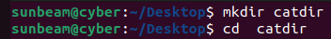
3. Use the cat command to display the contents of a file
4. Execute the following tasks and write down the commands you used:
a. Display the contents of a file named my_file.txt
b. Display the contents of my_other_file.txt and number all the lines
c. Display the contents of my_third_file.txt
5. Create a new file and use the cat command to add content to that file.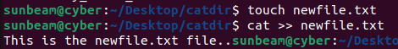
6. Practice the following cat command options:
- -n : Number all lines
- -b : Number only non-empty lines
- -s : Suppress repeated empty lines

