- Open the Terminal on your Linux system.
- Use the cd command to navigate to the directory where you want to create new directories
- Use the mkdir command to create directories.
- Perform the following directory creation tasks and write down the commands used
a. Create a directory named
b. Inside my_directory my_directory , create another directory named
c. Create a hidden directory named .new_directory
d. Create a directory named our_directory pictures with the following subdirectories
- vacation
- family
- friends
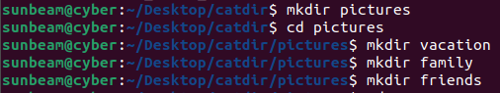
e. Create a directory named dir1
- Use the ls command to verify that all directories have been created successfully.
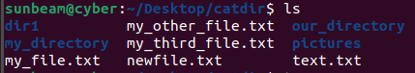

- Use the tree command to display the complete directory structure.
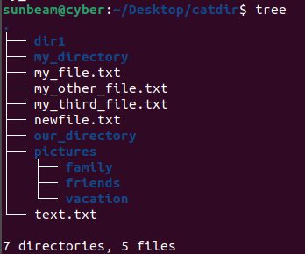
- Practice additional mkdir options:
- -p : Create parent directories if they do not exist
- -m : Set permissions while creating a directory
- -v : Show verbose output

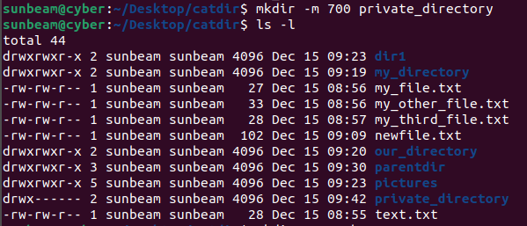

- Delete the directory named dir1

- Delete the directory named pictures (including its subdirectories)

