- Create a directory named my_music in your home directory.
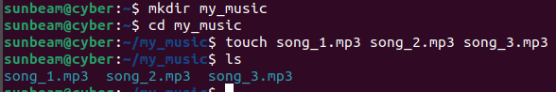
- Create the following files inside my_music : song_1.mp3 song_2.mp3 song_3.mp3

- Create a subdirectory named old_music inside the my_music directory.

- Move song_1.mp3 to the old_music directory using the mv command.
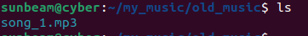

- Rename song_3.mp3 to new_song_3.mp3 using the mv command.
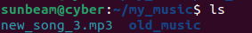

- Move song_2.mp3 to your Desktop.
