1. List all directories present in the root ( / ) directory.
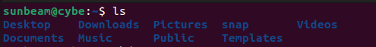
2. Identify and write the purpose of the following directories:
• /etc – Contains system configuration files and settings.
• /home – Stores personal files and folders of normal users.
• /var – Holds changing data like logs, emails, and cache files.
• /usr – Contains user applications, programs, and libraries.
• /bin – Stores basic commands used by all users (like ls, cp).
• /sbin – Stores system commands mainly used by the administrator.
• /tmp – Used to store temporary files; contents are deleted automatically.
3. Create the following directory structure:
/srv/files/public
/srv/files/private
/srv/files/backup
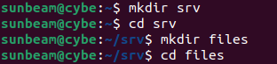
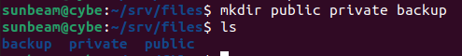
4. Create one file inside each directory
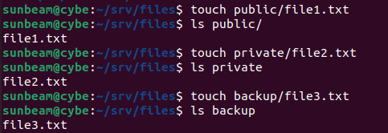
5. Display the complete directory structure using a single command.

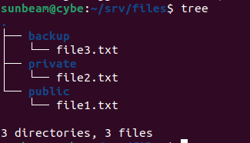

Q2: SSH Installation and Configuration
Objective : To configure SSH and test remote login.
Tasks : 1. Install the OpenSSH server package.
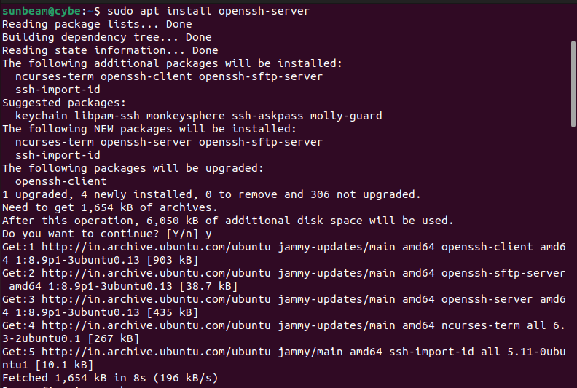

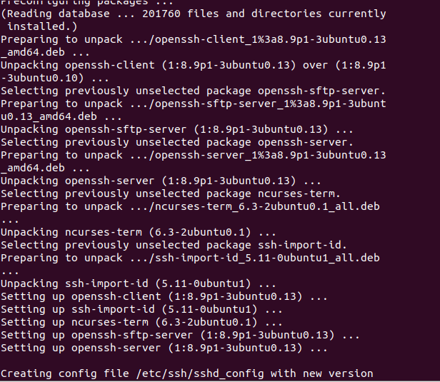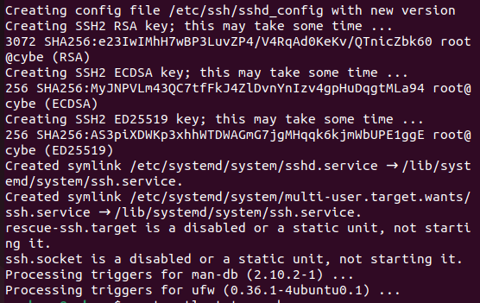

2. Verify whether SSH is running.
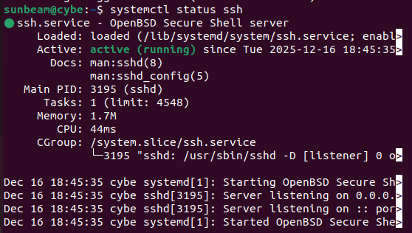
3. Find the IP address of your Ubuntu VM.
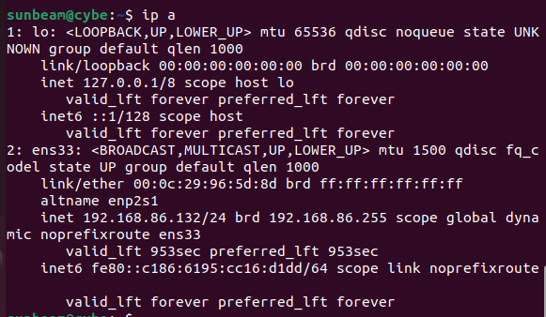

4. Connect to the Ubuntu VM using SSH from Putty or CMD.
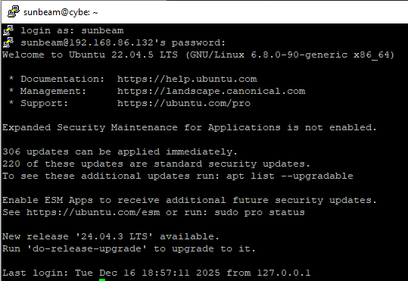
Questions
Why should root SSH login be disabled?
Ans. Root SSH login should be disabled because it prevents direct attacks on the most powerful account and makes the system more secure.

Q3: Linux Services Management
Objective : To understand Linux services and service management.
Tasks :

1. Check the status of the SSH service.
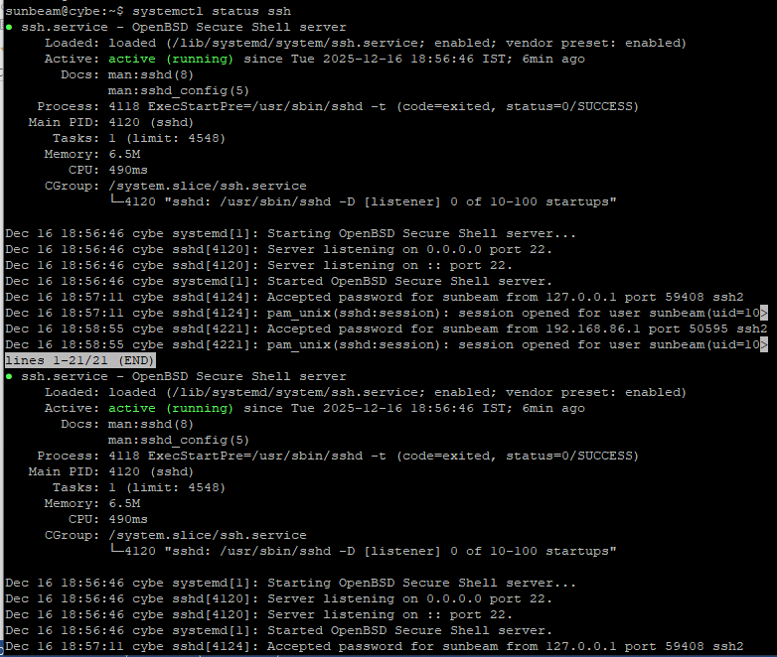

2. Stop the SSH service.
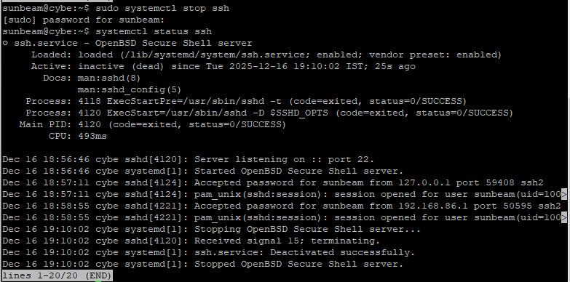
3. Start the SSH service again.
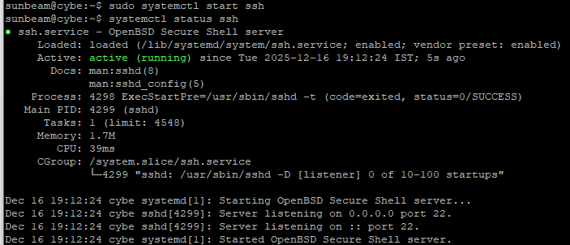

4. Restart the SSH service.
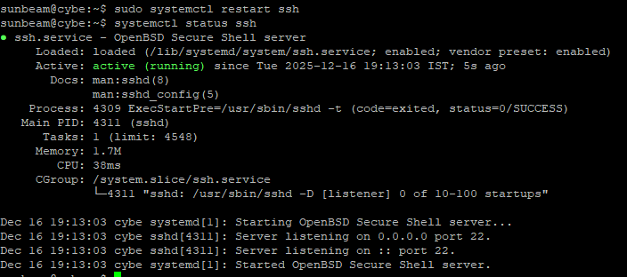
5. Enable the SSH service so that it starts automatically on boot.
6. List all active services running on the system.
Hint:
systemctl list-units --type=service
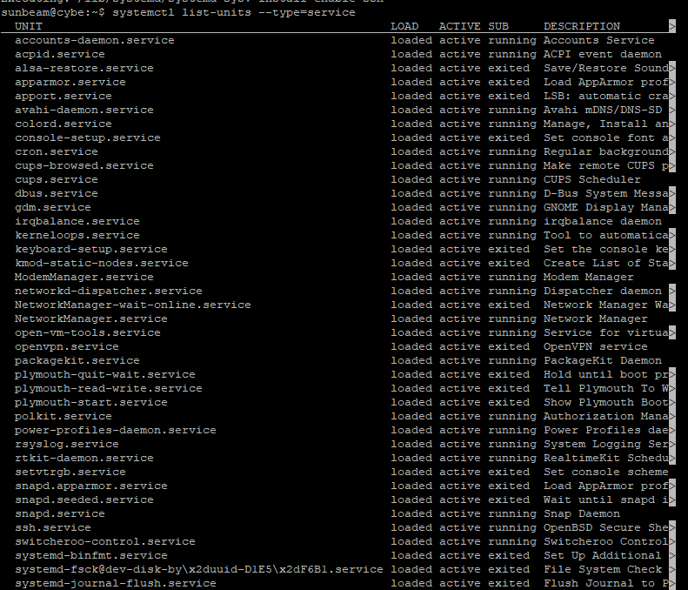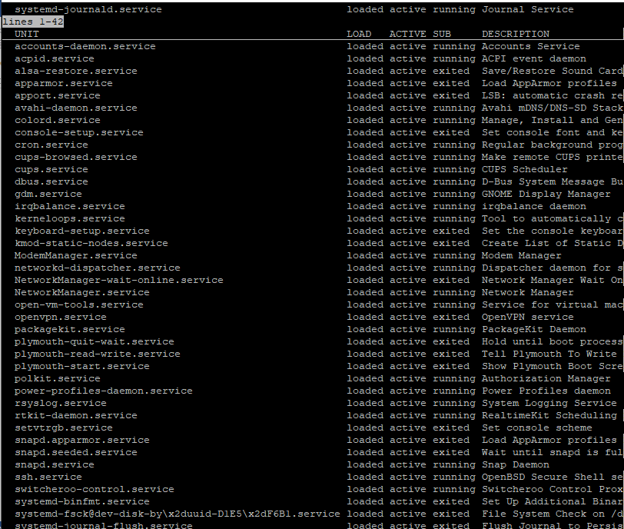
Questions
What is a service in Linux?
A service is a background program that runs automatically to provide system functions like networking, SSH, or web servers.
Difference between start and enable
• start → Runs the service immediately but only for the current session.
• enable → Makes the service start automatically every time the system boots.

Q4: Linux Users and Permissions
Objective : To understand Linux permission model and user access control.
Tasks
1. Create two users:
user1
user2
2. Set passwords for both users.
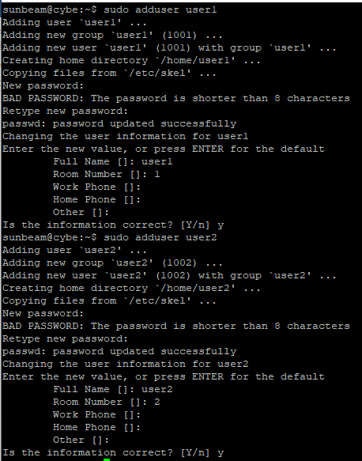
3. Create a directory named /shared .
4. Assign ownership of /shared to user1 .
5. Set permissions so that:
- Owner has full access
- Group has read & execute
- Others have no access
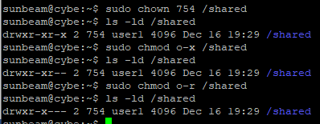
6. Login as
user2 and try to access /shared .
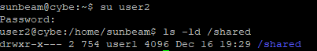
Questions
Explain r, w, x permissions:
- r (read): Allows viewing the file or listing a directory.
- w (write): Allows modifying the file or adding/deleting files in a directory.
- x (execute): Allows running a file or entering a directory.
What happens if permissions are set to 777?
- Everyone can read, write, and execute the file or directory.
- This is unsafe because anyone can change or delete the data.
How do permissions help in securing data?
- Permissions control who can access or modify files.
- They prevent unauthorized users from reading, changing, or executing important data.
- Q5: /etc/passwd File Analysis
Objective : To understand Linux user account information.
Tasks
- Open and view the /etc/passwd file. 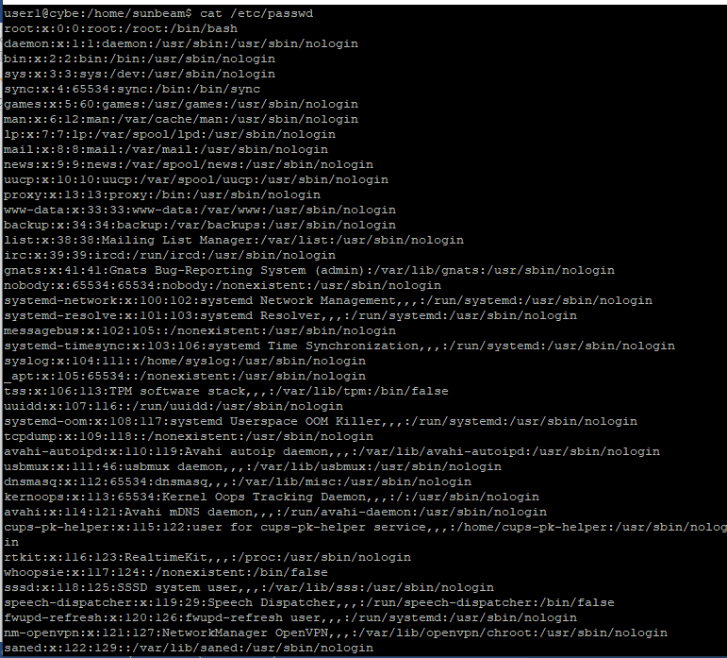
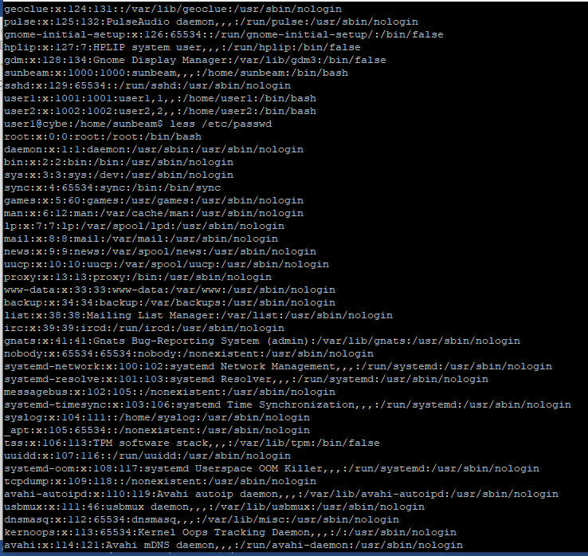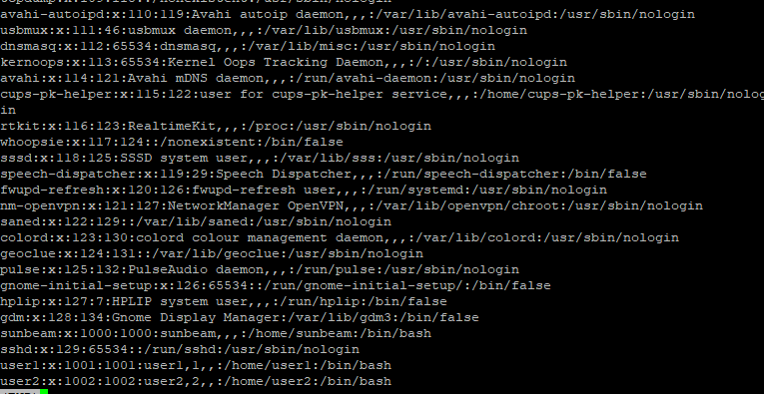
- Select any one normal user entry and note its fields.
- Identify the following from /etc/passwd :
Username : sunbeam
UID : 1000
GID : 1000
Home directory : /home/sunbeam
Login shell : /bin/bash

4.Find system users (UID less than 1000).
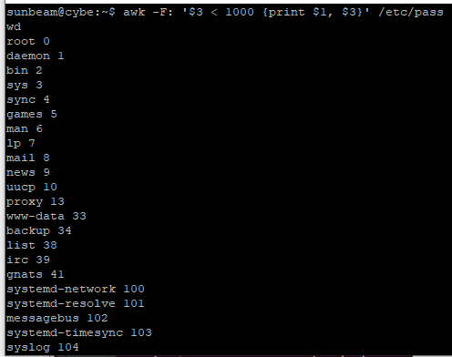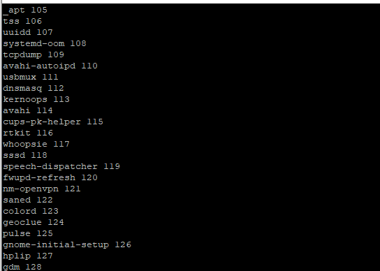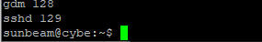
- Locate your own user entry.
- Questions
- What does the x field indicate?
Ans. The x means the user’s password is not stored in /etc/passwd. It tells the system to look for the encrypted password in another file.
- Why are passwords not stored in /etc/passwd
Because /etc/passwd can be read by everyone. Storing passwords there would be unsafe, so passwords are kept securely in /etc/shadow instead.

