MySQL Assignment
Task 1: Install MariaDB on Ubuntu
- Update the system packages.
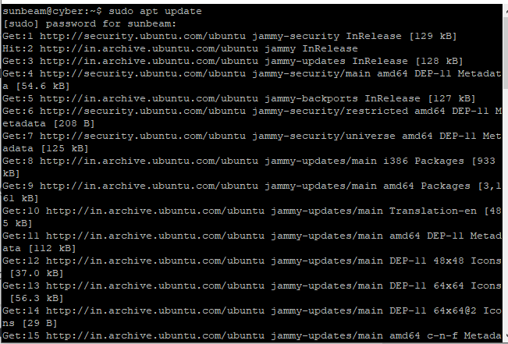
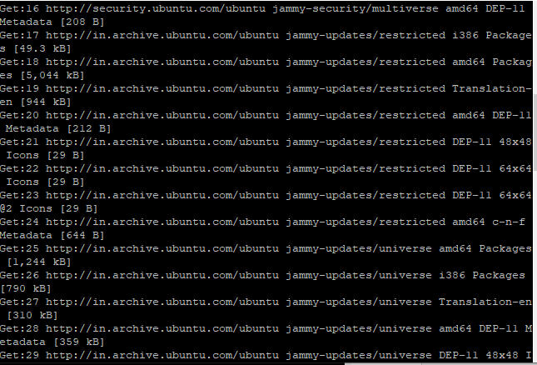
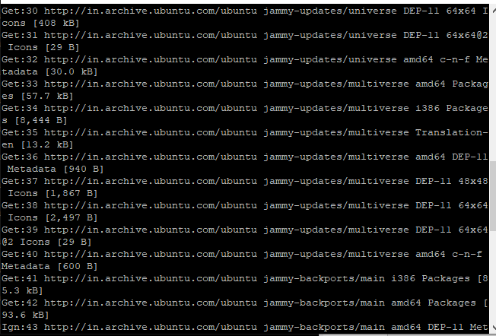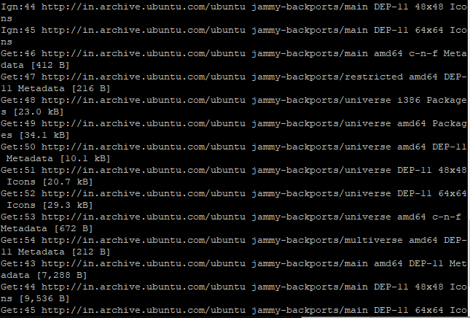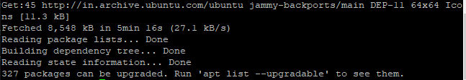
- Install the MariaDB Server package.
sudo apt install mariadb-server –y
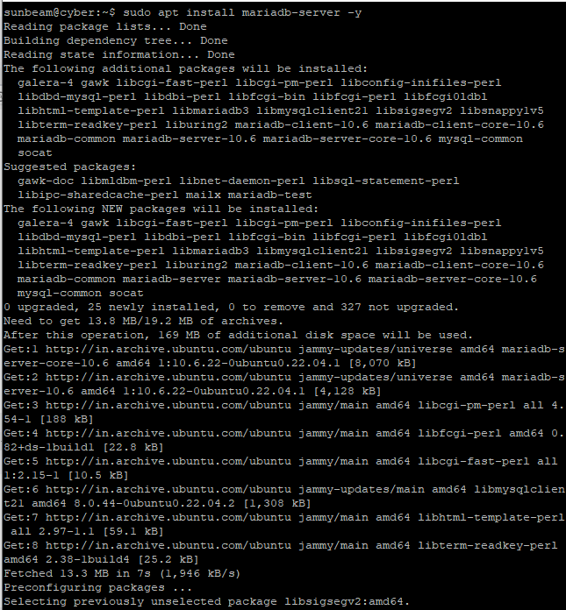

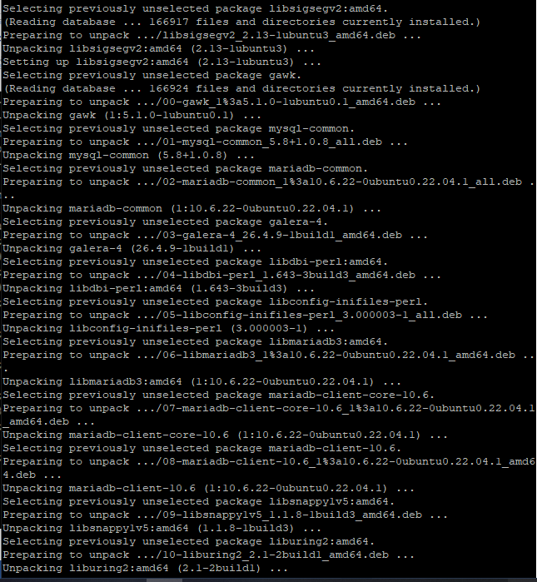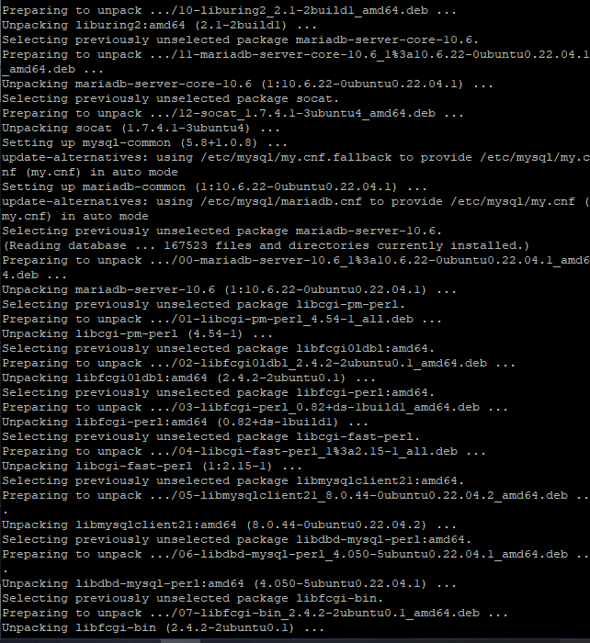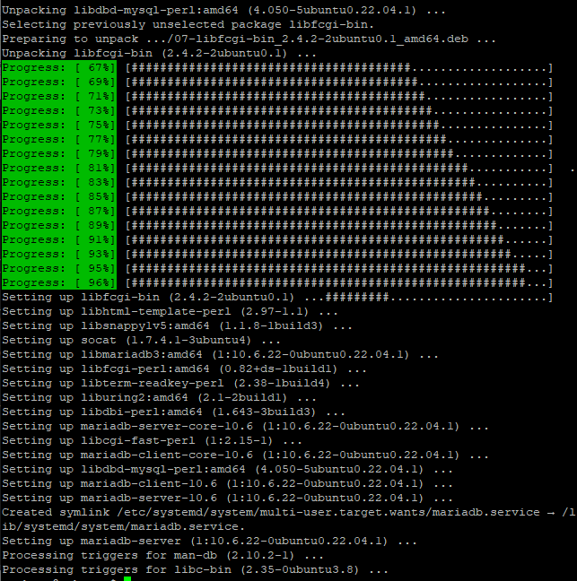

3. Check whether the MariaDB service is running.
sudo systemctl status mariadb
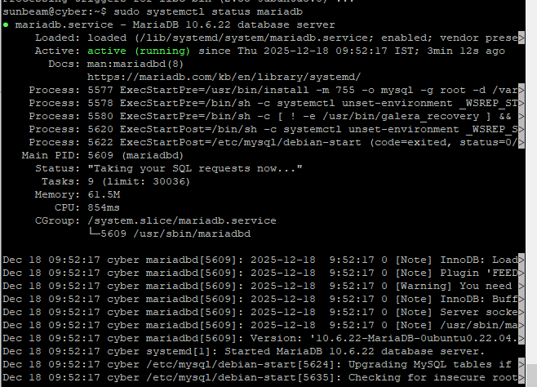
- Verify the installed MariaDB version.
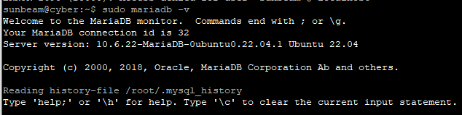

Task 2: Create a New Database User
- Login to mysql as root.
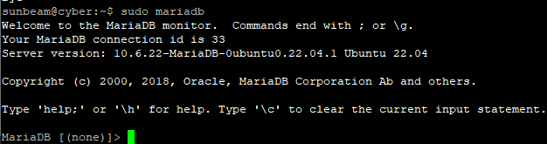
- Create a new database user.
- Set a password of your choice.

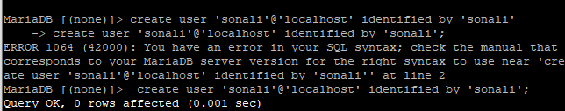
4. Verify that the user is created.
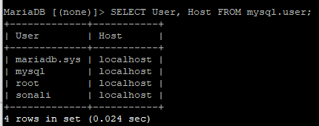

Task 3: Assign Permissions to the User
Grant only the following permissions to the newly created user:
- SELECT
- INSERT
- DELETE
- Assign the permissions.
- Apply the privilege changes.

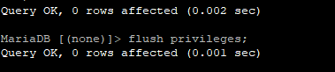
- Verify the granted privileges.
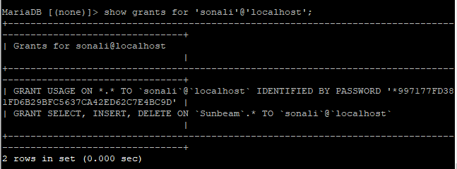

Task 4: Login Using the New User
1. Logout from the root user.
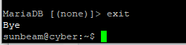
- Login using your own-name database user.
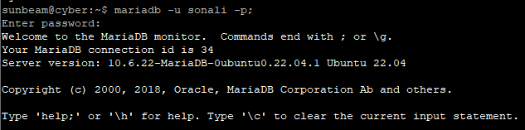
- Confirm successful login
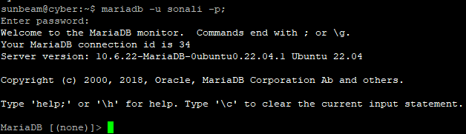

Task 5: Create Database
- Using the new user account, create a database, Sunbeam
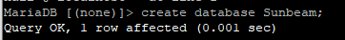
- Display the list of databases to confirm creation.
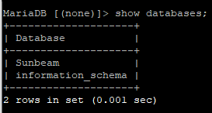

Task 6: Create Table
1. Select the Sunbeam database.
2. Create a table named cyber
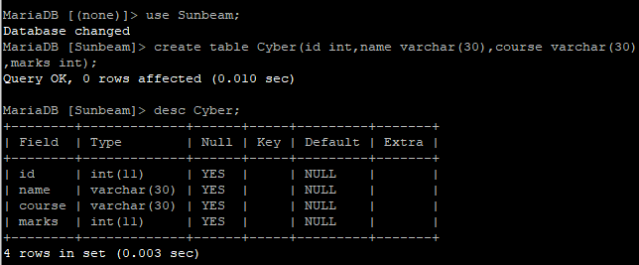

Task 7: Insert Data into Table
1. Insert all records
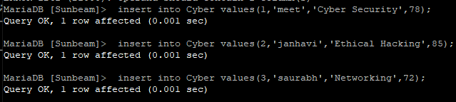
2. Display the table data.
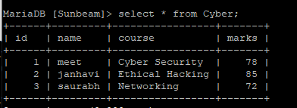

Task 8: Delete Data
- Delete the record where id = 3 .
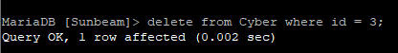
- Display the table again to confirm deletion.
