|  |  |  |  |  |  |
| --- | --- | --- | --- | --- | --- |
|  | 1 | Create table resource |  |  |  |
|  |  | id | int |  |  |
|  |  | Name | varchar(500) |  |  |
|  |  | Date_Of_Joining | date |  |  |
|  |  | Years_Of_Exp | int |  |  |
|  |  | Yash_EmpID | varchar(500) |  |  |
|  |  |  |  |  |  |
|  | 2 | Insert data into it | yyyy/mm/dd |  |  |
|  | id | Name | date_Of_Joining | Years_Of_Exp | yash_emp_id |
|  | 1 | Amol Nilkanth Bagal | 1/20/2014 | 1 | 1002899 |
|  | 2 | Manohar Singh | 9/10/2012 | 10 | 1001553 |
|  | 3 | Nitish Aggarwal | 3/28/2008 | 2 | 1000193 |
|  | 4 | Sonali Uttam Mane | 3/9/2015 | 3 | 1003719 |
|  | 5 | Ruchi Soni | 3/26/2015 | 4 | 1003813 |
|  | 6 | Kartik Dharmendra Jalgaonkar | 12/1/2014 | 8 | 1003549 |
|  | 7 | Charu Dubey | 3/13/2014 | 6 | 1003054 |
|  | 8 | Nikhil Bhagwantrao Raut | 5/19/2014 | 7 | 1003177 |
|  | 9 | Vishal Khandu Kumkar | 5/25/2012 | 5 | 1001285 |
|  | 10 | Isha Tiwari | 4/27/2015 | 2 | 1003927 |
|  | 11 | Dharmendra Biswal | 4/30/2015 | 5 | 1003999 |
|  |  |  |  |  |  |

**3.Update Years of exp Kartik to 8 from 10**

UPDATE resource SET Year_of_Exp = 10 WHERE Rname = 'Kartik Dharmendra Jalgaonkar';

**4.Delete record of Vishal**

DELETE FROM Resource WHERE Id=9;

**Q 5 : Alter table to add location column**

ALTER TABLE Resource

ADD Location VARCHAR(200);

**Q 6 : Make id as primary key.**

ALTER TABLE Resource ADD Primary key (Id);

**Q 7.Alter table to drop column years_of_exp ?**

ALTER TABLE Resource DROP COLUMN Year_of_Exp;

**Q 8.Alter table to change the datatype of primary key column to Bigint ?**

ALTER TABLE Resource MODIFY COLUMN Id BIGINT;

**Q 9. Write a select statement to view all the from the table created**

SELECT * FROM Resource ;

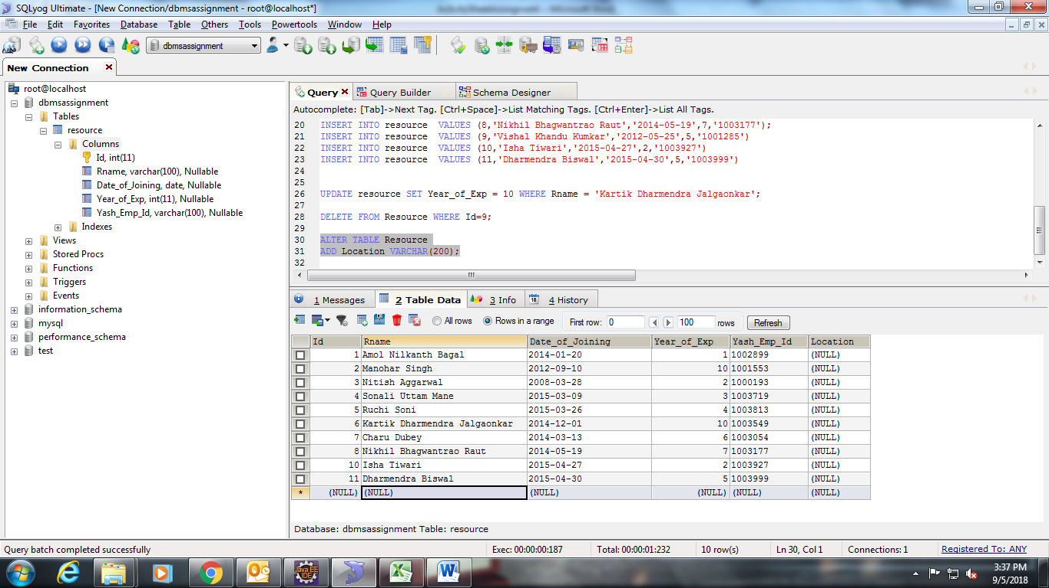

**Q 10 .Write a select statement to view data in the increasing and decreasing order of date_of_joining**

SELECT * FROM Resource ORDER BY Date_of_Joining DESC;

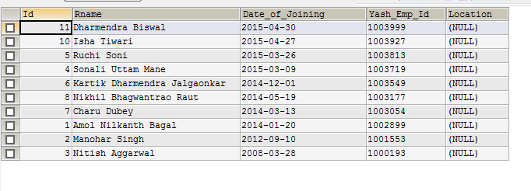

SELECT * FROM Resource ORDER BY Date_of_Joining ASC;

