**Activity1**

|  |  |  |  |  |  |  |  |
| --- | --- | --- | --- | --- | --- | --- | --- |
|  |  |  |  |  |  |  |  |
|  | **SALESPEOPLE** | |  |  |  |  | Primary Key |
|  | SNUM | SNAME | CITY | COMM |  |  | Foreign Key |
|  | 1001 | PEEL | LONDON | 12 |  |  |  |
|  | 1002 | SERRES | SANJOSE | 14 |  |  |  |
|  | 1003 | AXCELROD | NEW YORK | 10 |  |  |  |
|  | 1004 | MOTIKA | LONDON | 11 |  |  |  |
|  | 1005 | FRAN | LONDON | 26 |  |  |  |
|  | 1007 | RIKKLIN | BARCELONA | 21 |  |  |  |
|  |  |  |  |  |  |  |  |
|  |  |  |  |  |  |  |  |
|  | **CUSTOMER** | |  |  |  |  |  |
|  | CNUM | CNAME | CITY | SNUM | RATING |  |  |
|  | 2001 | KELVIN | SANJOSE | 1007 | 200 |  |  |
|  | 2002 | GIOVANNI | ROME | 1003 | 200 |  |  |
|  | 2003 | LIU | SANJOSE | 1002 | 200 |  |  |
|  | 2004 | GRASS | BARLIN | 1002 | 300 |  |  |
|  | 2006 | CLEMENS | LONDON | 1001 | 100 |  |  |
|  | 2007 | PEREIRA | ROME | 1004 | 100 |  |  |
|  | 2008 | CISNEROS | SANJOSE | 1007 | 300 |  |  |
|  |  |  |  |  |  |  |  |
|  | **ORDERS** |  |  |  |  |  |  |
|  | ONUM | AMT | SNUM | CNUM | ODATE |  |  |
|  | 3001 | 18.69 | 1007 | 2008 | 35134 |  |  |
|  | 3003 | 890 | 1001 | 2001 | 35134 |  |  |
|  | 3002 | 1900.1 | 1004 | 2007 | 35134 |  |  |
|  | 3005 | 5160.45 | 1002 | 2003 | 35134 |  |  |
|  | 3006 | 1098.16 | 1007 | 2008 | 35134 |  |  |
|  | 3009 | 1713.23 | 1003 | 2002 | 35165 |  |  |
|  | 3007 | 75.75 | 1003 | 2002 | 35165 |  |  |
|  | 3008 | 4723 | 1001 | 2006 | 35195 |  |  |
|  | 3010 | 1309.95 | 1002 | 2004 | 35226 |  |  |
|  | 3011 | 9891.8 | 1001 | 2006 | 35226 |  |  |
|  | CREATE TABLE SALESPEOPLE(  SNUM INT PRIMARY KEY,  SNAME VARCHAR(200),  city VARCHAR(200),  COMM INT  ); |  |  |  |  |  |  |

INSERT INTO SALESPEOPLE VALUE (1001,'PEEL','LONDON',12);

INSERT INTO SALESPEOPLE VALUE (1002,'SERRES','SANJOSE',14);

INSERT INTO SALESPEOPLE VALUE (1003,'AXCELROD','NEW YORK',10);

INSERT INTO SALESPEOPLE VALUE (1004,'MOTIKA','LONDON',11);

INSERT INTO SALESPEOPLE VALUE (1005,'FRAN','LONDON',26);

INSERT INTO SALESPEOPLE VALUE (1007,'RIKKLIN','BARCELONA',21);

CREATE TABLE **Customer**(

CNUM INT NOT NULL,

CNAME VARCHAR(200),

CITY VARCHAR(200),

SNUM INT,

RATING INT,

PRIMARY KEY (CNUM),

FOREIGN KEY (SNUM) REFERENCES SALESPEOPLE(SNUM)

);

INSERT INTO Customer VALUE (2001,'KELVIN','SANJOSE',1007,200);

INSERT INTO Customer VALUE (2002,'GIOVANNI','ROME',1003,200);

INSERT INTO Customer VALUE (2003,'LIU','SANJOSE',1002,200);

INSERT INTO Customer VALUE (2004,'GRASS','BARLIN',1002,300);

INSERT INTO Customer VALUE (2006,'CLEMENS','LONDON',1001,100);

INSERT INTO Customer VALUE (2007,'PEREIRA','ROME',1004,100);

INSERT INTO Customer VALUE (2008,'CISNEROS','SANJOSE',1007,300);

**Orders**

CREATE TABLE Orders(

ONUM INT NOT NULL,

AMT DECIMAL(10,2) DEFAULT NULL ,

SNUM INT,

CNUM INT,

ODATE INT,

PRIMARY KEY (ONUM),

FOREIGN KEY (SNUM) REFERENCES SALESPEOPLE(SNUM),

FOREIGN KEY (CNUM) REFERENCES Customer(CNUM)

);

INSERT INTO Orders VALUE (3001,18.69,1007,2008,35134);

INSERT INTO Orders VALUE (3003,890,1001,2001,35134);

INSERT INTO Orders VALUE (3002,1900.1,1004,2007,35134);

INSERT INTO Orders VALUE (3005,5160.45,1002,2003,35134);

INSERT INTO Orders VALUE (3006,1098.16,1007,2008,35134);

INSERT INTO Orders VALUE (3009,1713.23,1003,2002,35165);

INSERT INTO Orders VALUE (3007,75.75,1003,2002,35165);

INSERT INTO Orders VALUE (3008,4723,1001,2006,35195);

INSERT INTO Orders VALUE (3010,1309.95,1002,2004,35226);

INSERT INTO Orders VALUE (3011,9891.8,1001,2006,35226);

|  |  |
| --- | --- |
|  | **1.Count the number of Non NULL rating fields in the Customers table**  **(including repeats)** |
|  |  |

SELECT COUNT(*) FROM customer WHERE RATING IS NOT NULL;



|  |  |
| --- | --- |
|  | **2.Write a query that gives the names of both the salesperson and the customer for each**  **order after the order number.** |

SELECT ONUM,SNAME,CNAME FROM orders o,customer c,salespeople s WHERE o.SNUM=s.SNUM AND o.SNUM = c.SNUM;

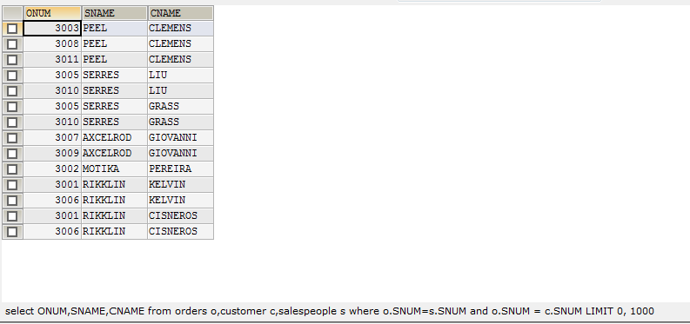

|  |  |
| --- | --- |
|  | **3.Count the number of Salespeople registering orders for each day.**  **(If a salespersons has more than one order on given day, he or she should be counted only once).**  SELECT odate, COUNT(DISTINCT(SNUM))FROM orders GROUP BY odate;    **4.Find all orders attributed to salespeople in London.**  SELECT * FROM orders o LEFT JOIN salespeople s ON s.SNUM = o.SNUM WHERE s.city = 'LONDON'; |

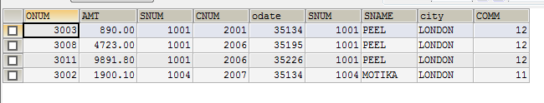

**5. Find all salespeople who have customers with more than one current order**

SELECT SNAME,COUNT(CNUM) AS Current_Order FROM salespeople s INNER JOIN orders o ON s.SNUM = o.SNUM GROUP BY o.CNUM HAVING Current_Order > 1 ;

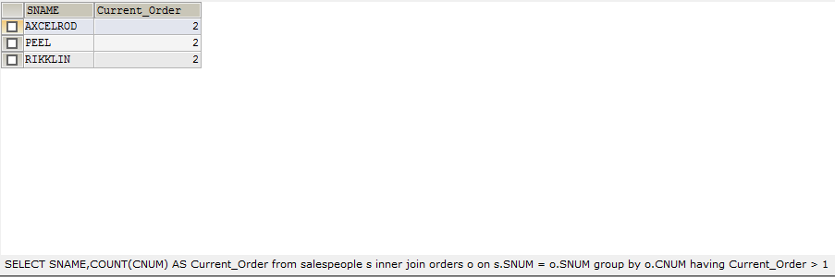

**6.Write a query that selects all customers whose names begins with ‘C’.**

SELECT CNAME FROM customer WHERE CNAME LIKE "c%" ;

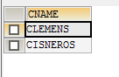

**7. Write a query on the Customers table that will find the highest rating in each city. Put the output in this form: for the City (city) the highest rating is: (rating).**

SELECT city ,MAX(RATING) FROM customer GROUP BY city ;

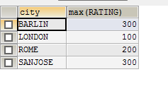

**8.  Write a query that selects each customer’s smallest order.**

SELECT c.CNUM,c.CNAME, MIN(AMT) FROM orders o LEFT JOIN customer c ON c.cnum = o.CNUM GROUP BY CNUM ;

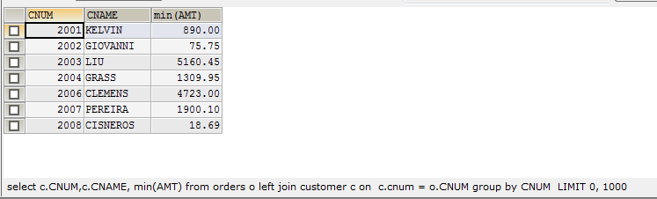

**9.Write a query that selects the first customer in alphabetical order whose name begins with G.**

SELECT CNAME FROM customer WHERE CNAME LIKE "G%" ORDER BY CNAME ASC LIMIT 1;

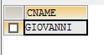

**10.** **Write a query that counts the number of different non NULL city values in the Customers table.**

SELECT COUNT(DISTINCT(city)) AS diff_City FROM customer;



**11.   Find the average amount from the Orders table.**

SELECT AVG(AMT) FROM orders;

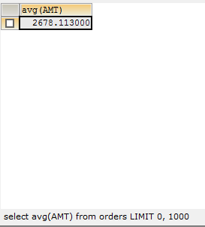

**12.**  **Find all customers who are not located in San Jose and whose rating is above 200.**

SELECT * FROM customer WHERE CITY <> 'sanjose' AND rating > 200;

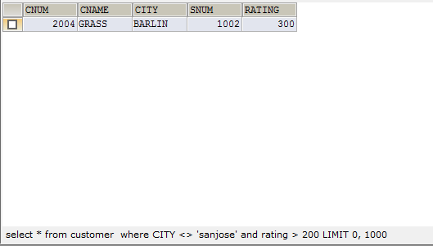

**13. Does the customer who has placed the maximum number of orders have the maximum rating?**

SELECT SNAME,COUNT(CNUM) AS Current_Order FROM salespeople s INNER JOIN orders o ON s.SNUM = o.SNUM GROUP BY o.CNUM HAVING Current_Order > 1 ;

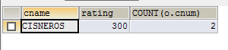

**OR**

SELECT c.cname,c.rating, COUNT(o.cnum) FROM customer c INNER JOIN orders o ON o.cnum=c.cnum

WHERE c.rating=(SELECT MAX(c.rating) FROM customer c) GROUP BY c.cname LIMIT 1;

SELECT CASE WHEN EE = dd THEN 'Y' ELSE 'N' END AS Result

FROM (

SELECT A.CNAME, A.RATING, COUNT(o.onum) AS dd,

(SELECT MAX(dd) FROM (

SELECT COUNT(ONUM) AS dd, CNUM FROM Orders

GROUP BY CNUM) a) AS EE

FROM Customer A

INNER JOIN Orders o

ON A.Cnum = O.Cnum

WHERE Rating = (SELECT MAX(rating) FROM Customer)

GROUP BY A.CNAME, A.RATING

ORDER BY dd DESC LIMIT 1) B



**14. Find all records in the Customer table with NULL values in the city column.**

SELECT * FROM customer WHERE CITY = NULL;

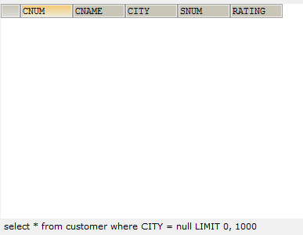

**15.** **Arrange the Orders table by descending customer number.**

SELECT * FROM orders ORDER BY CNUM DESC;

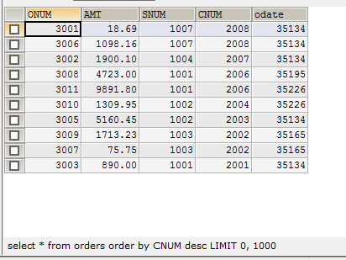

**16.Find which salespeople currently have orders in the Orders table.**

SELECT SNUM,SNAME

FROM salespeople

WHERE EXISTS

(SELECT SNUM FROM orders );

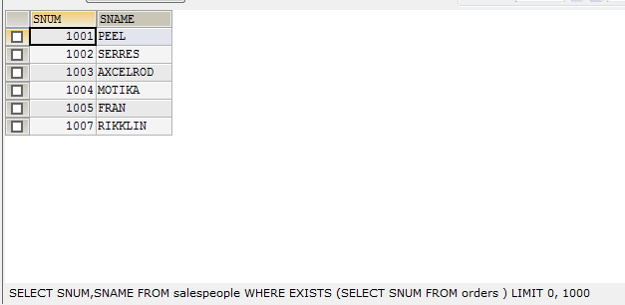

**17. Find the names and numbers of all salespeople who had more the one customer.**

SELECT SNUM ,SNAME FROM salespeople s WHERE (1< (SELECT COUNT(*) FROM customer WHERE SNUM = s.SNUM ));

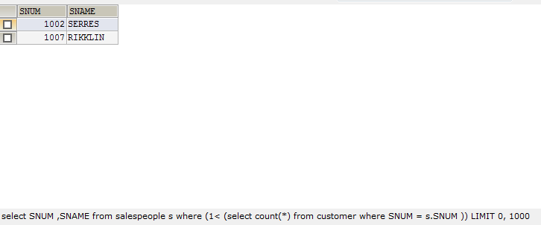

**18. Count the orders of each of the salespeople and output the results in descending order.**

SELECT SNAME,COUNT(ONUM) FROM orders o LEFT JOIN salespeople s ON o.SNUM= s.SNUM

GROUP BY SNAME ORDER BY COUNT(ONUM) DESC;

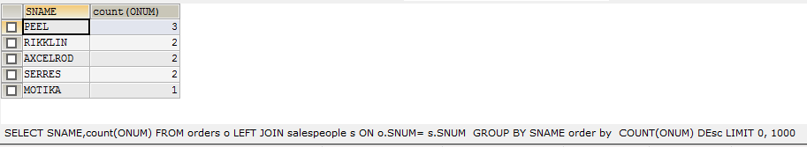

**19. List the Customer table if and only if one or more of the Customers in the Customer table are located in San Jose.**

SELECT * FROM customer WHERE CITY IN (SELECT CITY FROM customer WHERE CITY = ‘SANJOSE’);

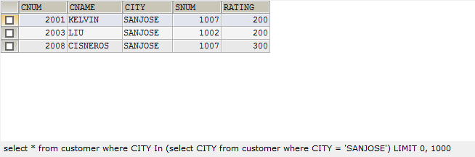

**20.Find the largest order taken by each salesperson.**

SELECT s.SNUM , MAX(AMT), s.SNAME FROM ORDERS o LEFT JOIN salespeople s ON o.SNUM = s.SNUM GROUP BY SNUM;

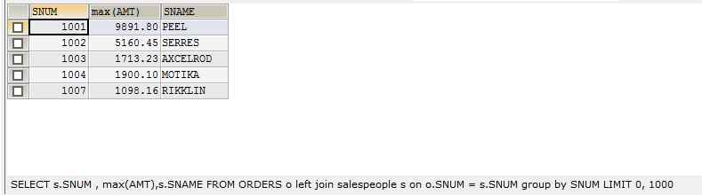

**21.Find customers in San Jose who have a rating above 200.**

SELECT * FROM customer WHERE CITY = 'SANJOSE' AND RATING > 200;



**22. List all the orders of salesperson Motika from the Orders table.**

SELECT * FROM ORDERS o LEFT JOIN salespeople s ON o.SNUM= s.SNUM WHERE SNAME = 'MOTIKA';



**23.Find salespeople who have multiple customers.**

SELECT SNUM ,SNAME FROM salespeople s WHERE (1< (SELECT COUNT(*) FROM customer WHERE SNUM = s.SNUM ));

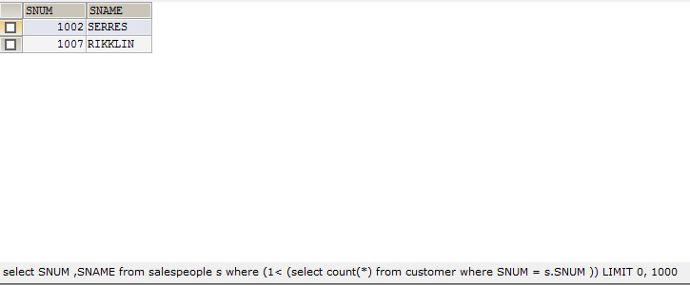

**24.Find salespeople with customers located in their city.**

SELECT s.SNUM ,s.SNAME,s.city FROM salespeople s LEFT JOIN customer c ON s.SNUM = c.SNUM WHERE s.SNUM NOT IN (SELECT snum FROM customer);



**25.Find the largest orders for serres and Rifkin.**

SELECT SNAME,MAX(AMT) FROM orders o LEFT JOIN salespeople s ON o.SNUM= s.SNUM

WHERE SNAME = 'SERRES' OR SNAME = 'RIKKLIN' GROUP BY SNAME;

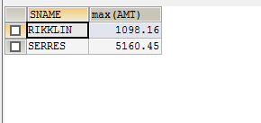

**26. Find all salespeople that are located in either Barcelona or London.**

SELECT SNUM,SNAME,CITY FROM salespeople WHERE city = 'BARCELONA' OR city = 'LONDON';

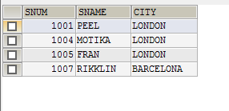

**27. Find all salespeople with only one customer.**

SELECT SNUM ,SNAME FROM salespeople s WHERE (1 = (SELECT COUNT(*) FROM customer WHERE SNUM = s.SNUM ));

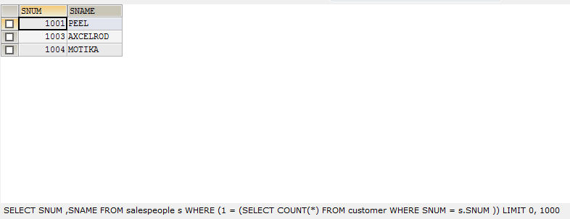

**28.Find salespeople whose sales is greater the avg sales.**

SELECT SNAME,COMM FROM salespeople WHERE COMM > (SELECT AVG(COMM) FROM salespeople );

