**Activity Sheet -2**

**Activity1**

|  |  |  |  |  |  |
| --- | --- | --- | --- | --- | --- |
|  |  |  |  |  |  |
| 1 | Modify table resource as per data below: | | | | |
|  |  |  |  |  |  |
| id | name | Date_of_joining | Years_Of_Exp | Yash_EmpID | location_id |
| 1 | Amol Nilkanth Bagal | 1/20/2014 | 1 | 1002899 | 1 |
| 2 | Manohar Singh | 9/10/2012 | 8 | 1003927 | 1 |
| 3 | Nitish Aggarwal | 3/28/2008 | 8 | 1001553 | 2 |
| 4 | Sonali Uttam Mane | 3/9/2015 | 2 | 1000193 | 3 |
| 5 | Ruchi Soni | 3/26/2015 | 3 | 1003719 | 1 |
| 6 | Kartik Dharmendra Jalgaonkar | 1/12/2014 | 4 | 1003813 | 2 |
| 7 | Charu Dubey | 3/13/2014 | 8 | 1003549 | 1 |
| 8 | Nikhil Bhagwantrao Raut | 5/19/2014 | 6 | 1003054 | 2 |
| 9 | Vishal Khandu Kumkar | 5/25/2012 | 7 | 1003177 | 1 |
| 10 | Isha Tiwari | 4/27/2015 | 2 | 1003927 | 3 |
| 11 | Dharmendra Biswal | 4/30/2015 | 5 | 1003999 | 2 |
|  |  |  |  |  |  |
|  |  |  |  |  |  |

CREATE TABLE Location

(Location_Id INTEGER PRIMARY KEY, Location_Name VARCHAR(200));

INSERT INTO Location VALUES(1,'Indore');

INSERT INTO Location VALUES(2,'Pune');

INSERT INTO Location VALUES(3,'Banglore');

INSERT INTO Location VALUES(4,'Mumbai');

ALTER TABLE Resource ADD Year_of_Exp INT;

SELECT * FROM Resource;

UPDATE Resource SET Year_of_Exp = 1,Location_Id = 1 WHERE Id = 1;

UPDATE Resource SET Year_of_Exp = 8,Location_Id = 1 WHERE Id = 2;

UPDATE Resource SET Year_of_Exp = 8 , Location_Id = 2 WHERE Id = 3;

UPDATE Resource SET Year_of_Exp = 2, Location_Id = 3 WHERE Id = 4;

UPDATE Resource SET Year_of_Exp = 3, Location_Id = 1 WHERE Id = 5;

UPDATE Resource SET Year_of_Exp = 4, Location_Id = 2 WHERE Id = 6;

UPDATE Resource SET Year_of_Exp = 8, Location_Id = 1 WHERE Id = 7;

UPDATE Resource SET Year_of_Exp = 6, Location_Id = 2 WHERE Id = 8;

UPDATE Resource SET Year_of_Exp = 7, Location_Id = 1 WHERE Id = 9;

UPDATE Resource SET Year_of_Exp = 2, Location_Id = 3 WHERE Id = 10;

UPDATE Resource SET Year_of_Exp = 5, Location_Id = 2 WHERE Id = 11;

|  |  |  |  |  |  |
| --- | --- | --- | --- | --- | --- |
| **3** | **Create table resource** | |  |  |  |
|  |  |  |  |  |  |
|  | resourcehrs_ID | resourceid | hours | week_endDate |  |
|  | 1 | 1 | 8 | 12/26/2014 |  |
|  | 2 | 2 | 9 | 12/26/2014 |  |
|  | 3 | 3 | 2 | 12/26/2014 |  |
|  | 4 | 4 | 3 | 12/26/2014 |  |
|  | 5 | 5 | 5 | 6/26/2015 |  |
|  | 6 | 2 | 8 | 6/26/2015 |  |
|  | 7 | 1 | 7 | 6/26/2015 |  |

CREATE TABLE ResourceHours(

ResourceHrs_Id INT NOT NULL,

Hours INT,

week_endDate DATE,

Resource_Id INT,

PRIMARY KEY (ResourceHrs_Id),

FOREIGN KEY (Resource_Id) REFERENCES Resource(Resource_Id)

);

INSERT INTO ResourceHours VALUES (1,8,'2014-12-26',1);

INSERT INTO ResourceHours VALUES (2,9,'2014-12-26',2);

INSERT INTO ResourceHours VALUES (3,2,'2014-12-26',3);

INSERT INTO ResourceHours VALUES (4,3,'2014-12-26',4);

INSERT INTO ResourceHours VALUES (5,5,'2015-06-26',5);

INSERT INTO ResourceHours VALUES (6,8,'2015-06-26',2);

INSERT INTO ResourceHours VALUES (7,7,'2015-06-26',1);

**4.Create table project**

CREATE TABLE Project(

Project_Id INT,

Project_Name VARCHAR(100),

Location_Id INT,

PRIMARY KEY (Project_Id),

FOREIGN KEY (Location_Id) REFERENCES Location(Location_Id));

INSERT INTO Project VALUES (1,'project1',1);

INSERT INTO Project VALUES (2,'project2',1);

INSERT INTO Project VALUES (3,'project3',3);

INSERT INTO Project VALUES (4,'project4',4);

|  |  |
| --- | --- |
| **1** | **List out resource name ,date_of_joining,location od resource whose years_of_exp is more than 2 years** |

SELECT Rname,Date_of_Joining FROM Resource WHERE Year_of_Exp >2;

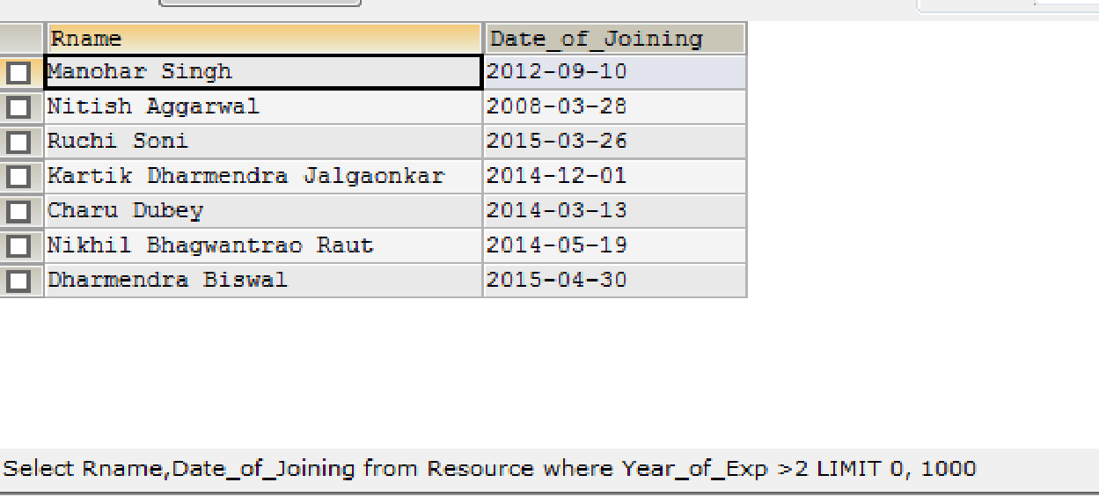

|  |  |
| --- | --- |
| **2** | **Find the employee which maximum experience** |

SELECT Rname,Year_of_Exp FROM Resource WHERE Year_of_Exp = (SELECT MAX(Year_of_Exp) FROM Resource);

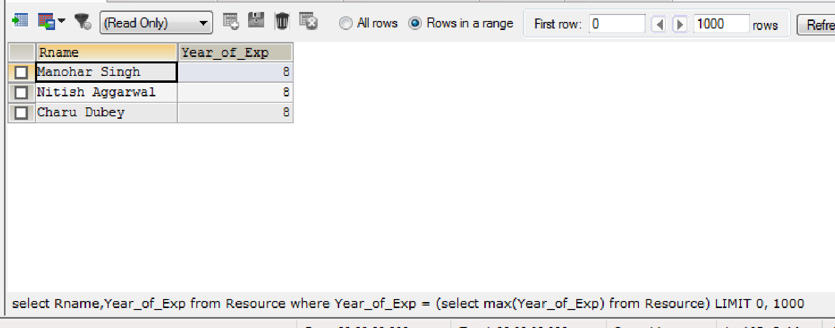

|  |  |
| --- | --- |
| **3** | **Find the resource with Indore location** |

SELECT * FROM Resource res LEFT JOIN Location loc ON res.Location_Id = loc.Location_Id WHERE Location_Name = 'Indore';

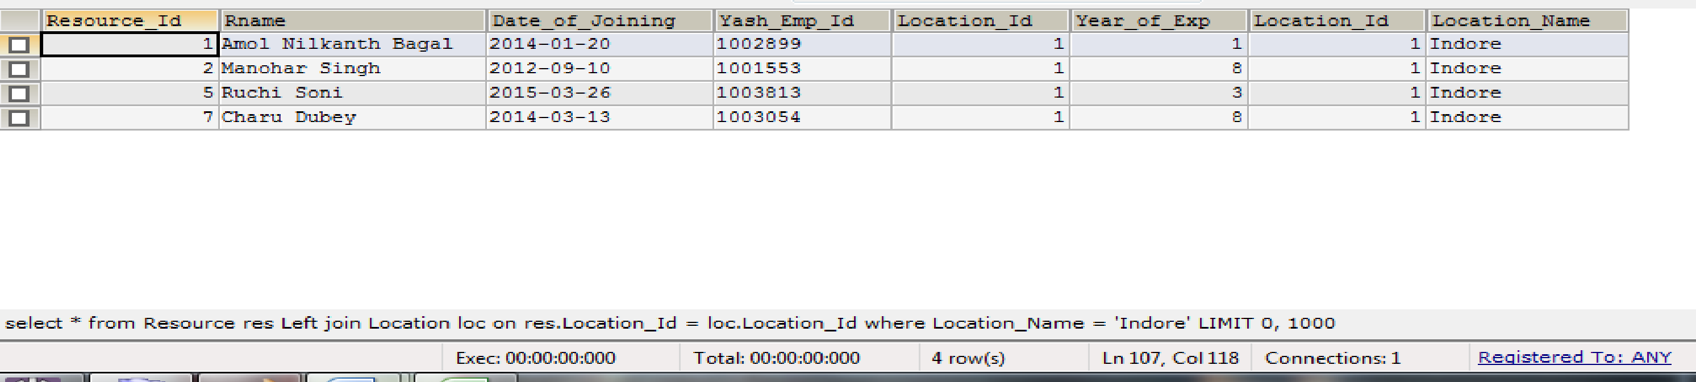

|  |  |
| --- | --- |
| **4** | **Find the resource name,hours ,location ,week_end_date .** |

SELECT res.Rname ,loc.Location_Name,resHr.Hours,resHr.week_endDate FROM Resource res

INNER JOIN ResourceHours resHr ON res.Resource_Id = resHr.Resource_Id

INNER JOIN Location loc ON res.Location_Id = loc.Location_Id;

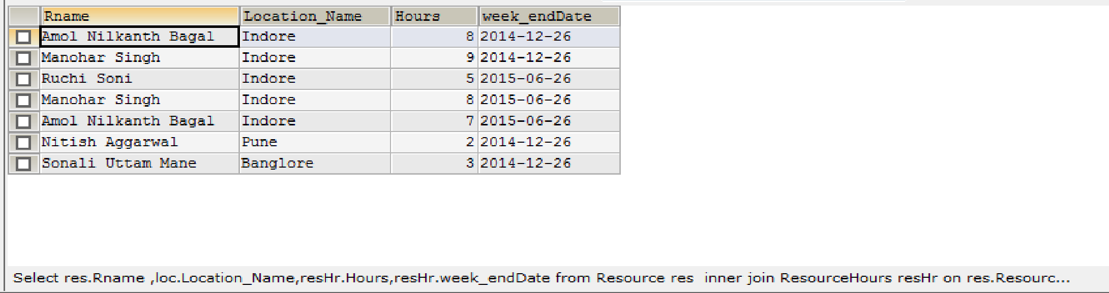

|  |  |
| --- | --- |
| **5** | **Delete record from location table with location name as Mumbai** |

DELETE FROM location WHERE Location_Name= 'Mumbai';

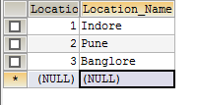

|  |  |
| --- | --- |
| **6** | **Make listing of all the records from all the tables using inner join** |

SELECT * FROM Resource res

INNER JOIN ResourceHours resHr ON res.Resource_Id = resHr.Resource_Id

INNER JOIN Location loc ON res.Location_Id = loc.Location_Id

INNER JOIN Project proj ON loc.Location_Id = proj.Location_Id;

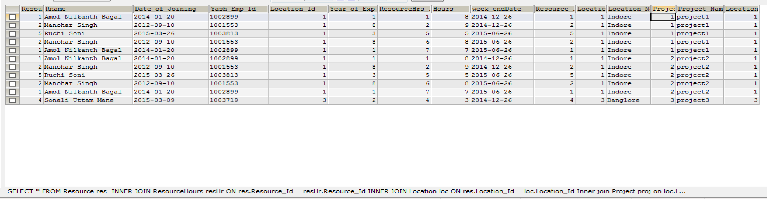

|  |  |
| --- | --- |
| **7** | **Drop primary key and foreign key constraint from project table (Drop constraint not the columns)** |

ALTER TABLE Project DROP PRIMARY KEY;

ALTER TABLE Project DROP FOREIGN KEY Location_Id;