ADVANCED PYTHON PROGRAMMING

NAME : R.SONALI

REG NO : 22MID0061

ERRORS:

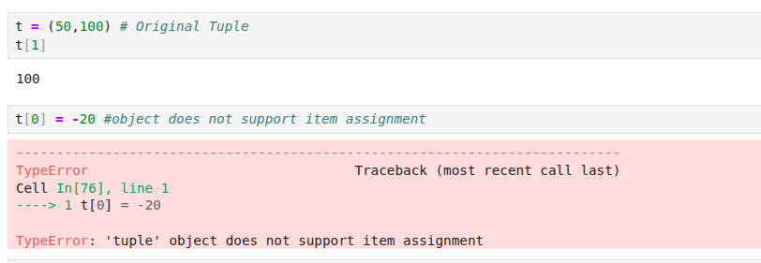

ERROR: Object not support item assignment

Solution : Tuple is Immutable