***SQL Pizza Project Queries***

KPI Queries:

1.Total Revenue:

Query: select sum(total_price) as Total_Revenue from pizza_sales

Output:

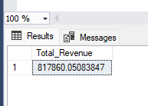

2.Average Order Value:

Query: select sum(total_price) / count(distinct order_id) as AverageOrderValue from pizza_sales

Output:

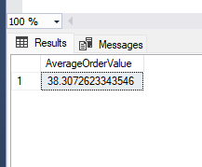

3.Total Pizzas Sold:

Query: select sum(quantity) as TotalPizzaSold from pizza_sales

Output:

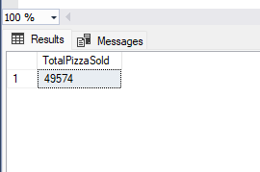

4.Total Orders:

Query: select count(distinct(order_id)) as TotalOrders from pizza_sales

Output:

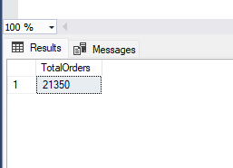

5.Average Pizzas Per order:

Query: select cast(cast(sum(quantity) as DECIMAL(10,2)) / cast (count(distinct(order_id)) as decimal(10,2)) as decimal(10,2))

as AveragePizzasPerOrder from pizza_sales

Output:

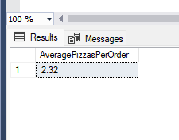

**Charts**

1.Daily Trend for Total Orders:

Query: select DATENAME(DW,order_date) as DayoftheWeek , COUNT(distinct order_id) as totalorders

from pizza_sales

group by DATENAME(DW,order_date)

Output:

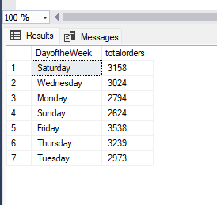

2.Monthly Trend for Total Orders:

Query: select Datename(MONTH,order_date) as Monthfortrend,count(distinct order_id) as totalorders

from pizza_sales

group by Datename(MONTH,order_date)

order by totalorders desc

Output:

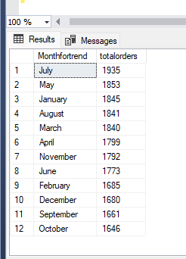

3.Percentage of sales By pizza category wise:

Query: select pizza_category,sum(total_price)*100 / (select sum(total_price) from pizza_sales) as percentagesales

from pizza_sales

group by pizza_category

Output:

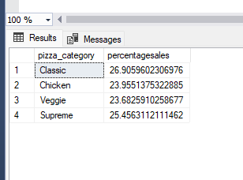

4.Sales of Percentage by Pizza Size:

Query:select pizza_size,sum(total_price)*100 / (select sum(total_price) from pizza_sales) as percentagesales from pizza_sales group by pizza_size

Output:

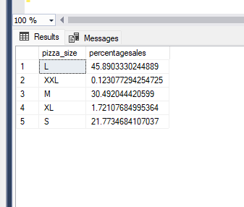

5.Total Pizza Sold By pizza Category:

Query: select pizza_category,sum(quantity) as TotalPizzasoldperCategory from pizza_sales

group by pizza_category

Output:

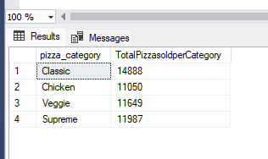

6.TOP 5 Best sellers By Revenue,Quantity and Orders:

Query: select top 5 pizza_name,sum(quantity) as TotalQuantity from pizza_sales

group by pizza_name

Order by TotalQuantity desc

Output:

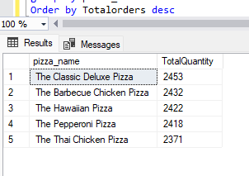

Query: select top 5 pizza_name,count(distinct order_id) as Totalorders from pizza_sales

group by pizza_name

Order by Totalorders desc

Output:

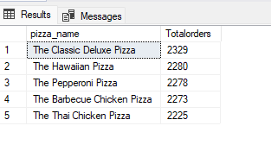

Query: select top 5 pizza_name,sum(total_price) as TotalRevenue from pizza_sales

group by pizza_name

Order by TotalRevenue desc

Output:

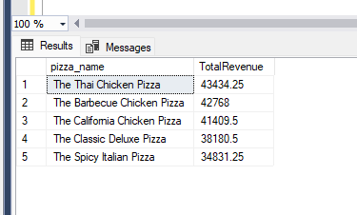

7.Bottom 5 Worst sellers By Revenue,Quantity and Orders:

Query: select top 5 pizza_name,sum(quantity) as TotalQuantity from pizza_sales

group by pizza_name

Order by TotalQuantity ASC

Output:

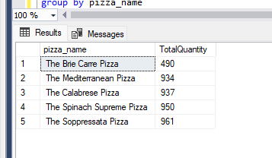

Query: select top 5 pizza_name,count(distinct order_id) as Totalorders from pizza_sales

group by pizza_name

Order by Totalorders ASC

Output:

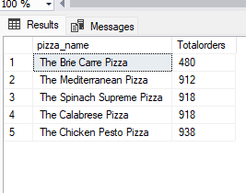

Query: select top 5 pizza_name,sum(total_price) as TotalRevenue from pizza_sales

group by pizza_name

Order by TotalRevenue ASC

Output:

