###### Contents

1. **INTRODUCTION 1** 
   1. Introduction
   2. Objective

1. **Literature Survey 3**

1. **System Development 6**

3.1 Working/Architecture

3.2 User Interface Design

3.3 Output

1. **Conclusion 7**

**REFERENCES**

**ACKNOWLEDGEMENT**

**1.INTRODUCTION**

One of the most consumed beverages in the world is coffee. Aside from water, some people assert that it is the liquid that is consumed the most globally. But coffee is more than just a drink. It is woven into our lives as a memory, an expectation, and a lifetime of solace-inducing moments of minor pleasure.

A website gives clients important details about your coffee business, serves as an online store for beans and other goods, and offers engaging informative and entertaining material to draw them into your brand. Coffee's popularity as a beverage is unquestionably due to the caffeine it contains as well as to its enjoyable taste. Coffee drinkers have come to link the richness and scent of the beverage with the energising boost that caffeine provides.

An establishment that specialises in serving coffee of all varieties, most notably espresso, latte, and cappuccino, is known as a coffeehouse, coffee shop, or café. There are several coffee shops that offer non-caffeinated drinks and cold drinks like iced coffee and iced tea. Cafés in continental Europe serve alcoholic beverages. 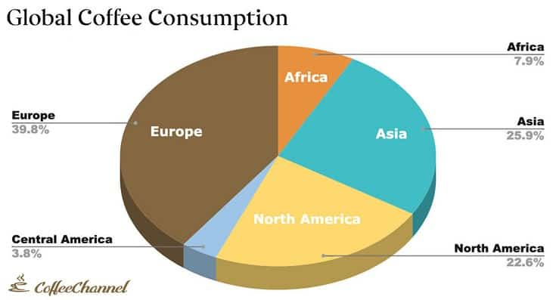

Figure 1.1 Statistical Data of coffee

Unroasted green coffee beans are created by separating the seeds from the fruits of the Coffea plant. A cup of coffee is made by first roasting the beans, then grinding them into tiny particles that are often soaked in hot water before being filtered out. Even though cooled or iced coffee is widespread, it is often served hot.

The Coffee Shop Management is based on a concept to maintain orders and management of a particular coffee shop. The administrator can handle the data and update information of the coffees. The Coffee Shop Management System is a web based project. The Aim of Coffee Shop Management is communication between rural area people and coffee shop management.

1.1 Introduction: -

The System “Coffee Shop Management” is an automated system. Coffee Shop Management is a web-based project. In this system Admin can handle data. In this System admin can handle data. The Customer can suggest the admin(distributor) to make any change in coffees. The administrator can add, update, delete any information about the system.

1.3Objective: -

• It takes the suggestion from the user.

• This system is helpful for rural area people.

• It takes less processing time.

• To provide the fresh coffee and healthy product to the people.

The Coffee Shop management help to manage and run the Cafe shop systematically. In this management system we will provide that can be used by café employee to take order. So that owner of shop can evaluate the whole system. Employee can take payment which will manage into the software. The administrator can handle all record like employee ,product ,customer ,order and bill

• This system is user friendly.

• It provides high security.

• It is flexible to user as compared to previous system.

• It contain all operation like delete, view, add.

• This system is transparent/clear to user as compared to previous system.

**2.Literature Survey**

To study any system the analyst needs to collect facts and all relevant information. The facts when expressed in quantitative form are termed as data. The success of any project depends upon the accuracy of available data. Accurate information can be collected with help of certain methods/ techniques. These specific methods for finding information of the system are termed as fact finding techniques. Interview, Questionnaire, Record Review and Observations are the different fact finding techniques used by the analyst. The analyst may use more than one technique for investigation.

The feasibility study is major factor, which contributes to the analysis and development of the system. The decision of the system analyst whether to design a particular system or not depends on its feasibility.

Operation Feasibility:

* No system user will be negatively impacted by the system's introduction. Any division of Starbucks Corporation administrator can benefit from using this solution.
* This system is incredibly user-friendly and adaptable.
* This system has a graphical user interface.

Technical Feasibility:

• This feasibility examines the system's technicality. This method is entirely automated, as opposed to manually storing Product & Employee data.

• To manage the system, no effective human resources are needed.

Economic Feasibility:

• The expenses incurred for the system's development and execution are the focus of this topic. On the other hand, the system's upkeep and the advantages that result from it. The system's effectiveness is determined by the cost-benefit analysis.

The project would be beneficial because it satisfies the objectives when developed and installed. All behavioural aspects are considered carefully and conclude that the project is behaviourally feasible.

Figure 2.1 Context Level Diagram

A literature review tries to examine the key aspects of the most recent research on a given subject. Therefore, the goal of the literature review is to locate, examine, and analyse any works or studies that are relevant to this system as well as do research on the current systems. Understanding every piece of information is crucial.

Before creating this system, they were thought about and related. To comprehend the idea and function of network management, programming languages, protocol languages, hardware and networking architecture, and existing systems that are connected to this project, some research has been done.

**2.1 Café Coffee Day Website**

In this website there are multiple running pictures in the home page itself, there are almost five different images/ screens. Which includes café menu, E-shop, order online, café finder/ café locator, Mobile app, or CCD mobile app. The red icon for Cafe Coffee Day may be seen at the top of the page. It denotes their own Brand's icon.

Many other features, such as changing each image individually, have been employed. The website also has the login, search, and notification bell icons. The Read Our Story page has been moved to the main page itself in order to increase access to it as more research is conducted on the website. The background graphic for the Read Our Story page was

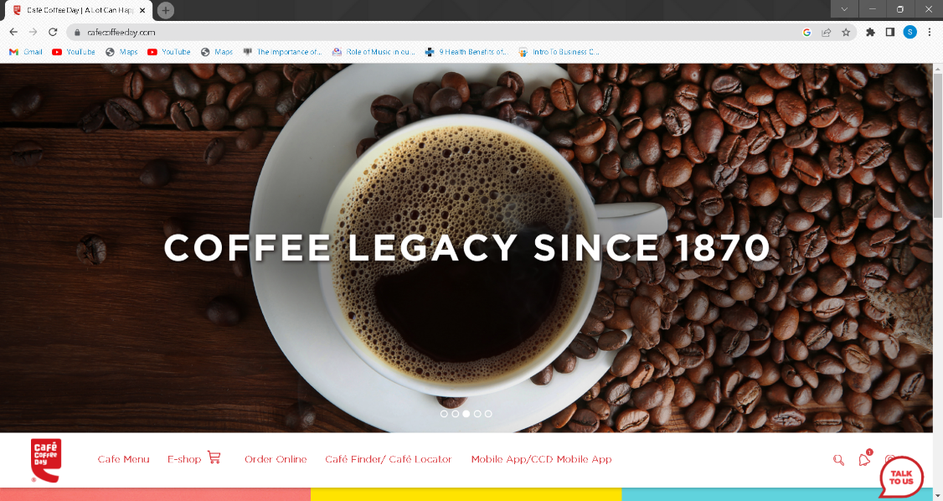

Figure 2.1 Café Coffee day (Home page)

completed before the Our Story button was made. Additionally, the about us page now includes more details thanks to the use of Java script. The Read Our Story button features a wonderful, straightforward visual along with a brief quotation.

Additionally, there are three links in the middle of the page that will take you to other pages that will help us discover what is new today. Additionally, it features a location map, which we can use to find nearby CCD cafes by typing in our zip code or city name. It is the most amazing feature I have ever seen on a website. The shop is the third and last feature right now. I believe it indicates that we can purchase coffee online. Hopefully!!

Every page has a talk to us button in the shape of a circular comment; by clicking on it, we are taken to the next page, where we can leave feedback or send messages regarding their service or anything else. However, no matter which page we visit, it will always follow us. This allows them to expand their network globally and link their Instagram, Facebook, YouTube, Twitter, and Linkedin profiles with their own icons. In this manner, the bottom of the home page seems more appealing.

**3.System Development**

3.1 Working / Architecture

An important step in the study of a system is the specification of the requirements. Designing a system that will function in the required environment is only achievable when the requisite specifications are properly provided. Since they are the ones who will really utilise the system, it is mostly up to the users of the current system to provide the requirement requirements. This is due to the fact that requirements must be known in the beginning phases in order for the system to be designed to meet those criteria. Once a system is designed, it is very difficult to change it; nonetheless, it is useless to design a system that does not meet the needs of the user.

Data structure, programme structure, and procedural details are developed, reviewed, and recorded as the design process progresses. System design can be regarded from a project management or technical perspective. Architectural design, data structure design, interface design, and procedural design are the four technical tasks that make up design.

3.2 User Interface

**Data Flow Diagram**

A data flow diagram is a visual tool for describing and examining how data moves through a system. These serve as the main resource and serve as the foundation for the creation of the other components. The logical transition of data from input to output through processing can be explained without reference to the system's physical components. The logical data flow diagrams are what these are called. The real tools and methods used to transfer data between individuals, offices, and workstations are depicted in the physical data flow diagrams. A collection of data flow diagrams serves as a complete explanation of a system.

Home page

The coffee icon, which was created by html, is located in the top left corner. The navigation bar is then located on the left side of the page. It includes the actual Home page, the Menu, the Gallery, the About us section, the Blog, and the Login section. The navigation bar's top points will then guide you to a specific page that has been designed for your usage. It is Visible and the right size. HTML and CSS are combined to accomplish this.

There is a background image in this with the appropriate Dark colour and coffee in it. The quotation is located on the image's shadow side.

Screenshot 3.2.1 Home Page

Then, at the bottom, are some coffee-related facts and quotes. With different fonts, it is in the page's centre. It is using the page in the right way. Then, below it, is a button for making a reservation for a table. this will take it to the page for booking a table.

Book a table includes a fantastic café backdrop as well as the customers' names, emails, dates, and times. in order for the consumer to reserve a table. so that they can sit at the reserved table when they arrive. so that they won't have to wait if the cafe is completely booked.

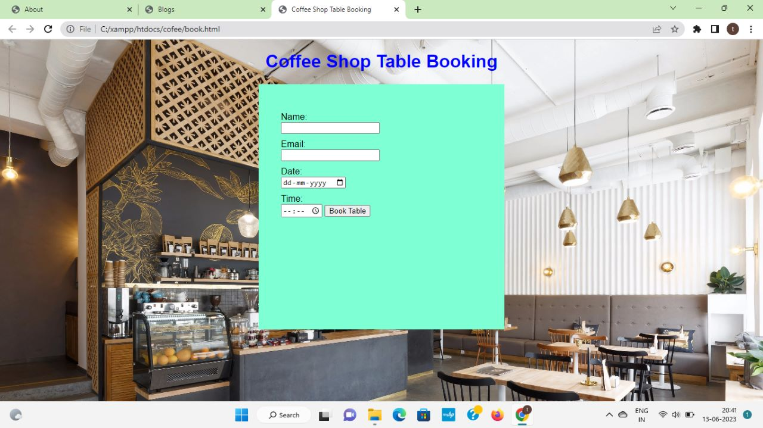

Screenshot 3.2.2 Book A Table

Menu page

We have a simple background image of a coffee on our website. This makes the background appear more appealing and simpler. The search bar is then located in the upper right corner, where we may type in the type of menu we wish to add to our cart. The heading is "Menu of Coffee Shop" after that.

On this page's menu, we've included various coffee varieties along with their unique names and the dollar amount they would cost in our shop. We created a grid for the coffee image thumbnails, and at the bottom, in blue, are the coffee's name and price, which are displayed in white. The CSS manages the entire mechanism.

The back button on it also serves as an indirect referral to the home page.

Screenshot 3.2.3 Menu Page

Gallery Page

The shop's gallery is characterised with several photographs of coffee along with their names, and the gallery's headline uses two different colour names. There are numerous varieties of coffee, each with a name. The page's background is not an image, but rather a wonderful colour combination. It makes the page appear more appealing.

There are several varieties of coffee that are particularly well-liked at certain cafes. Images of coffee are captured and placed in a grid with the name of the specific coffee at the bottom.

Additionally, there is a back button at the bottom of the page that will take you to the homepage.

Screenshot 3.2.4a Gallery page

Screenshot 3.2.4b Gallery page

Contact Page

Screenshot 3.2.5 Contact page

About Us Page

The read colour creates the headline for the "about us" page. The little quote that follows also adds to the page's appeal. When we click on or place our pointer in the image at the bottom, it grows thanks to CSS.

Information about our cafe is written on the right side. It has specific writing in the colour pink. The CSS also performs it. There is a read more button at the bottom of that paragraph, which suggests we can get more information about our cafe there. There is a read more option available for those who want to learn more about the cafe. Although this button was made using CSS, Java Script handled the information at its read more.

The back button on it also serves as an indirect referral to the home page.

Screenshot 3.2.6 About us page

Blog Page

Here are some blogs that people have written about our cafe or even about coffee. It was produced using HTML. The HTML for the Heading is used. Then on the negative side, there are informational photo grids.

35% of the grids are devoted to photographs and 65% to content. There are dates, which also indicate when a specific blog was written. It is a fantastic HTML and CSS mix.

The back button on it also serves as an indirect referral to the home page.

Screenshot 3.2.7 Blog page

Login Page

The login page on our website is created. so that the user or customer can access our website in a nice manner. You must enter your email address and password (not your mail password) on the login page before clicking the "Sign In" button. If you already have an account on our website but can't remember your password, there is also the option of forgetting the password.

In contrast, those wishing to log into our website will receive a brief and straightforward greeting. It improves the aesthetics of the page.

Login Diagram

Screenshot 3.2.8 Login page

Flowchart

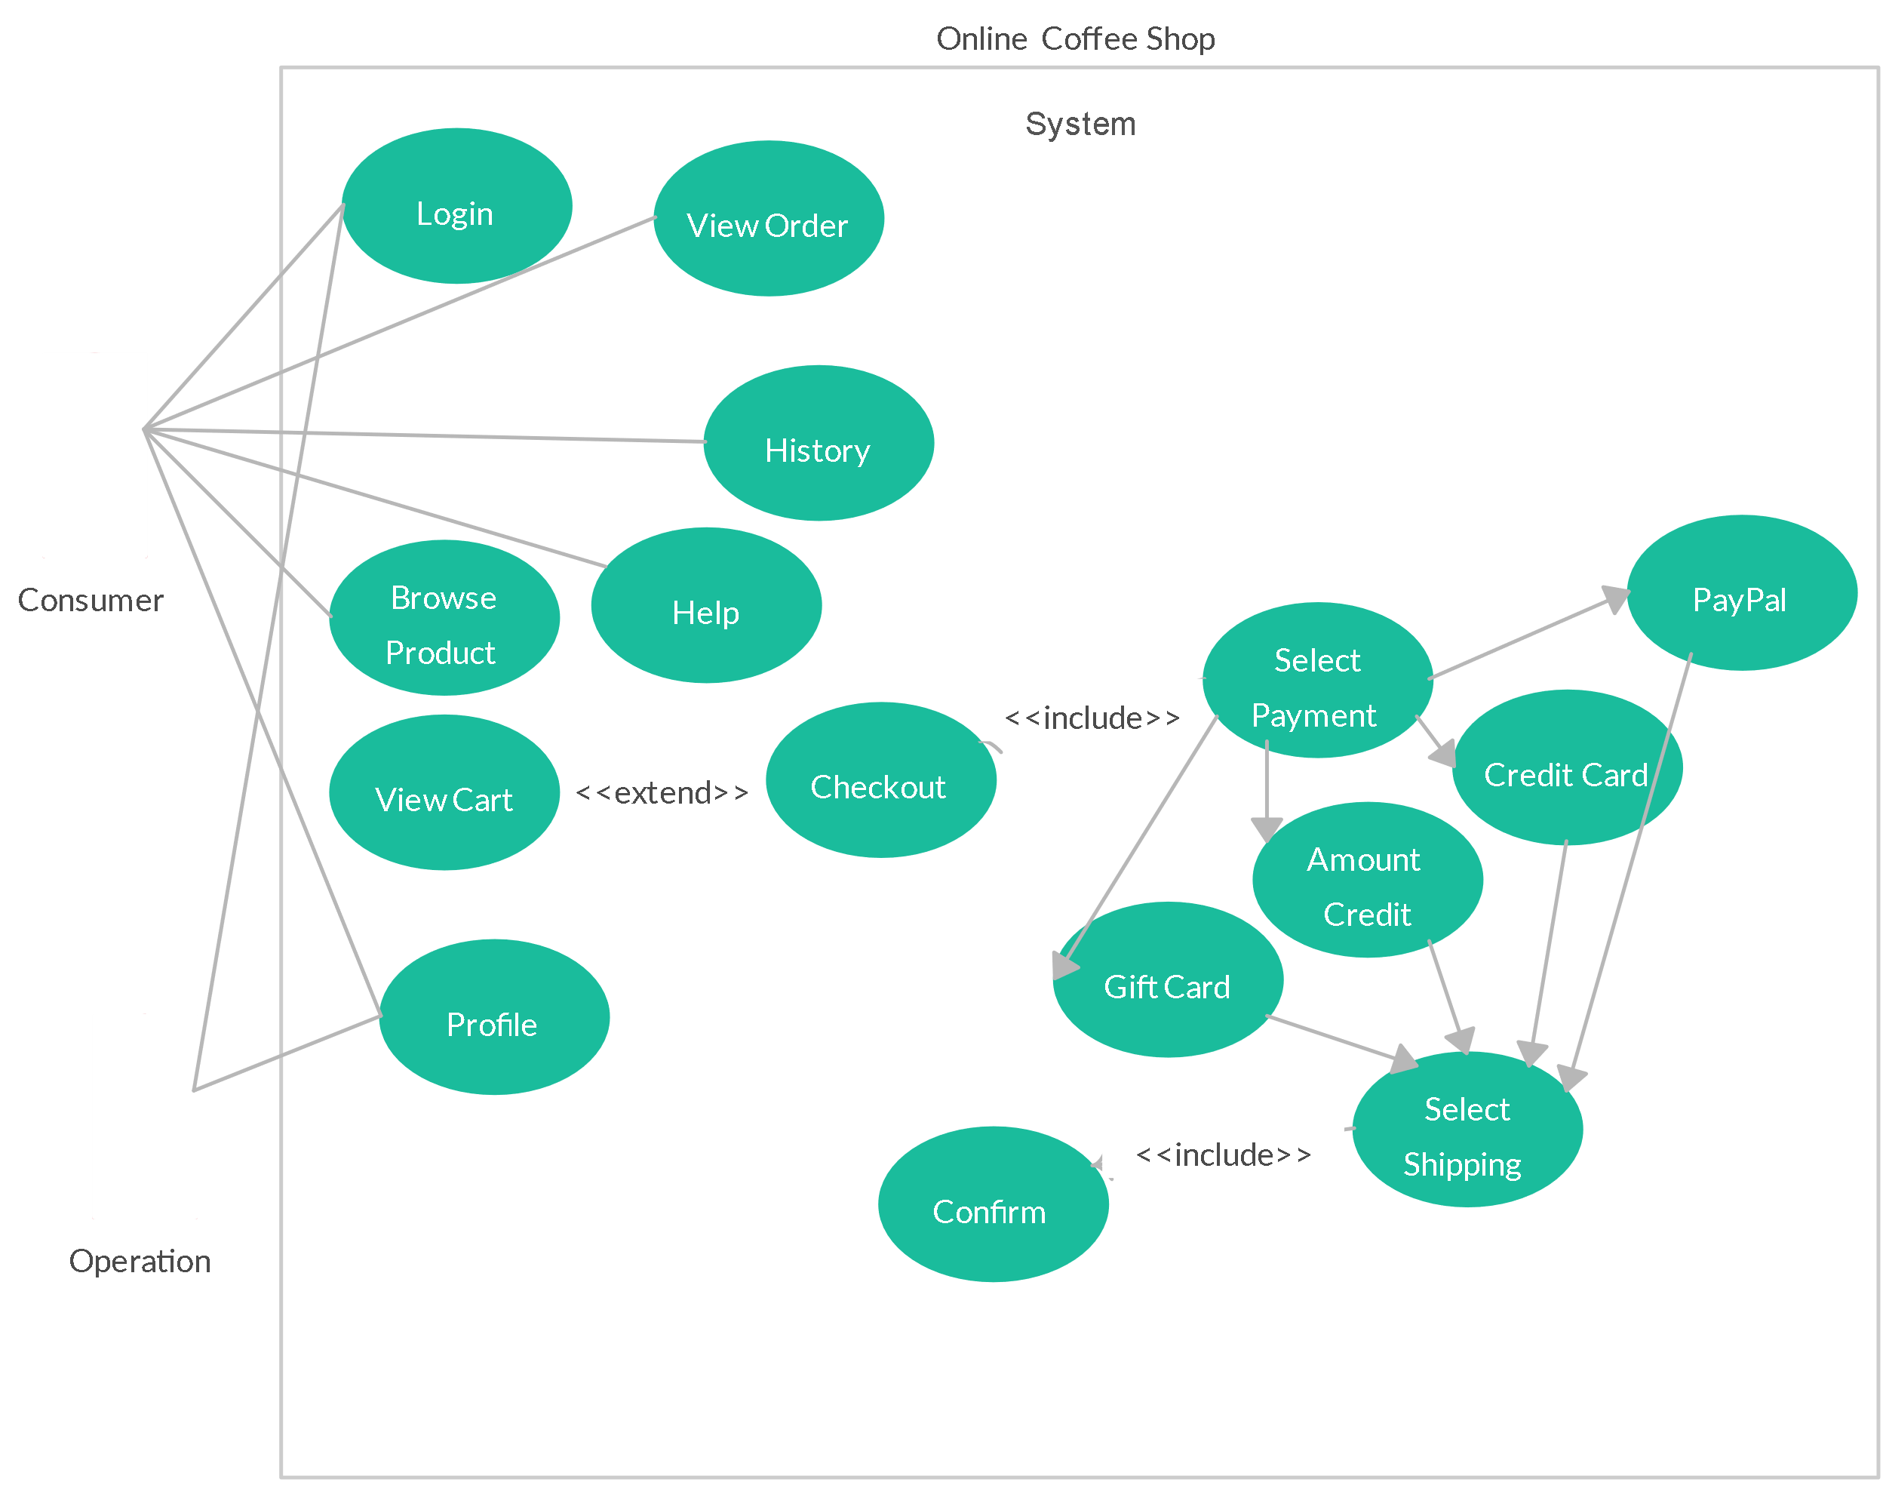

Figure 3.2.1 : Flowchart

**4.Conclusion**

* We have learned various things through this project. Such as HTML, CSS, JAVA SCRIPT, PHP, DATABASE CONNECIVITY etc
* A website gives clients important details about your coffee business, serves as an online store for beans and other goods, and offers engaging informative and entertaining material to draw them into your brand.
* Local entrepreneurs' small, independent coffee shops can have a very different impact. Their support of the neighbourhood generates employment possibilities and enables the promotion of local talent.