TestiGatherer– Project Progress Report 1

Table of Contents
- Introduction
- Problem Statement & Proposed Solution
2.1 Problem Statement
2.2 Proposed Solution
- Scope and Objectives
- Key Features
- Technology Stack
5.1 Frontend Technologies
5.2 Backend Technologies
5.3 Development Tools
5.4 Version Control
- Analysis Models
6.1 Use Case Diagram
- Design Models
7.1 System Architecture
- Data Models
8.1 Entity Relationship Diagram
- Project Status and Next Steps
- Upcoming Work

Introduction
TestiGatherer is a comprehensive full-stack web application designed to revolutionize how users create, manage, and share testimonials. The platform enables users to establish personalized testimonial spaces where they can collect feedback, ratings, and experiences from their audience in an organized and visually appealing manner.
Built with modern web technologies, TestiGatherer combines the power of React for dynamic frontend experiences with Express.js and Prisma ORM for robust backend operations. The application supports multiple authentication methods including local credentials and Google OAuth, ensuring flexibility and security for all users.
The platform focuses on delivering a user-centric design, scalable architecture, and secure authentication mechanisms.
- User-Centric Design: An intuitive interface that enables seamless testimonial management and space customization.
- Scalable Architecture: Designed to handle growing traffic and data efficiently using PostgreSQL and cloud-based infrastructure.
- Secure Authentication: JWT tokens and OAuth 2.0 integration ensure protected user sessions and secure access control.

Problem Statement & Proposed Solution
Organizations and individuals often struggle with collecting, organizing, and displaying testimonials effectively. Traditional methods lack centralized management and flexibility, making testimonial management inefficient.
Key challenges include:
- Lack of centralized systems to manage testimonials
- Limited customization options for different products or services
- Insecure or inefficient user authentication systems
- Lack of interactive features such as ratings and likes
- Difficulty scaling the system as user data grows
Existing solutions are often fragmented and require the use of multiple tools or platforms to perform basic testimonial management tasks.

Proposed Solution
TestiGatherer provides a unified platform that addresses these challenges through the following features:
- Unified Platform: A single application for creating, managing, and displaying testimonials.
- Customizable Spaces: Users can create personalized testimonial spaces with unique branding.
- Secure Access: The system supports multi-method authentication including JWT and Google OAuth.
- Interactive Features: Built-in engagement tools such as rating systems, likes, and user interaction.

Scope and Objectives

The TestiGatherer project aims to develop a complete testimonial management platform with strong scalability, usability, and security.
1. User Authentication and Management: Implement secure registration and login mechanisms using email/password authentication along with Google OAuth integration. The system will also support user profile management and role-based access control.
2. Space Creation and Customization: Allow users to create multiple testimonial spaces with customizable names, images, headers, and feedback questions to meet specific requirements.
3. Testimonial Submission: Enable users to submit testimonials containing text, images, and ratings. The system will also support moderation and approval workflows.
4. Interactive Features: Provide engagement tools such as like/unlike functionality, rating systems, and social sharing options.
5. API Development: Develop RESTful APIs that support all application operations and allow potential integration with external systems.
The primary goal is to simplify testimonial collection and management while ensuring flexibility, scalability, and enterprise-level security.

Key Features

- Multi-Method Authentication: Users can sign up and log in using either traditional credentials or Google OAuth 2.0. Authentication security is maintained using JWT tokens.
- Customizable Spaces: Users can create personalized testimonial spaces with custom names, logos, headers, and feedback questions to collect relevant information.
- Rich Testimonial Submission: Testimonials can include text content, images, and star ratings, enabling detailed feedback and social proof.
- Responsive Design: The interface is fully responsive and built using Tailwind CSS and Framer Motion to ensure smooth performance across desktop, tablet, and mobile devices.
- RESTful API: The system includes well-documented RESTful APIs for seamless integration with third-party systems and future expansion.

Technology Stack
TestiGatherer is built using modern industry-standard technologies that ensure scalability, performance, and maintainability.
Frontend Technologies
- React: A component-based JavaScript library used to build dynamic single-page applications.
- Tailwind CSS: A utility-first CSS framework that enables rapid development of responsive and customizable user interfaces.
- Framer Motion: An animation library used to create smooth transitions and engaging UI interactions.
- React Router: Provides client-side routing that allows seamless navigation without page reloads.

Backend Technologies
- Node.js and Express.js: A lightweight runtime and web framework used to develop server-side APIs efficiently.
- PostgreSQL: A reliable relational database system used for secure and scalable data storage.
- Prisma ORM: A type-safe database toolkit that simplifies database operations and migrations.
- JWT and OAuth 2.0: Used for secure authentication and authorization.

Development Tools
- Zod for schema validation
- CORS for cross-origin resource sharing
- Dotenv for environment variable management

Version Control
- Git for source code version control
- GitHub for project collaboration and repository management

Analysis Models
During the analysis phase, several models were created to understand system requirements, user interactions, and overall system behavior.
These models form the foundation for the system design and implementation.

Use Case Diagram
The use case diagram illustrates the interaction between users and the system. It includes functionalities such as user registration, login, space creation, testimonial submission, and testimonial management.

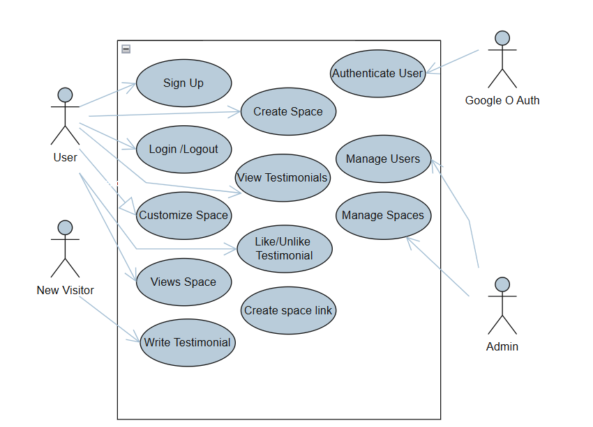

Design Models
The design phase converts analysis results into a structured system architecture.
System Architecture
The system follows a three-tier architecture consisting of:
- Presentation Layer: Handles user interaction and frontend components.
- Application Layer: Processes business logic, authentication, and API requests.
- Data Layer: Manages persistent storage using PostgreSQL and Prisma ORM.
This separation ensures modularity, maintainability, and scalability.
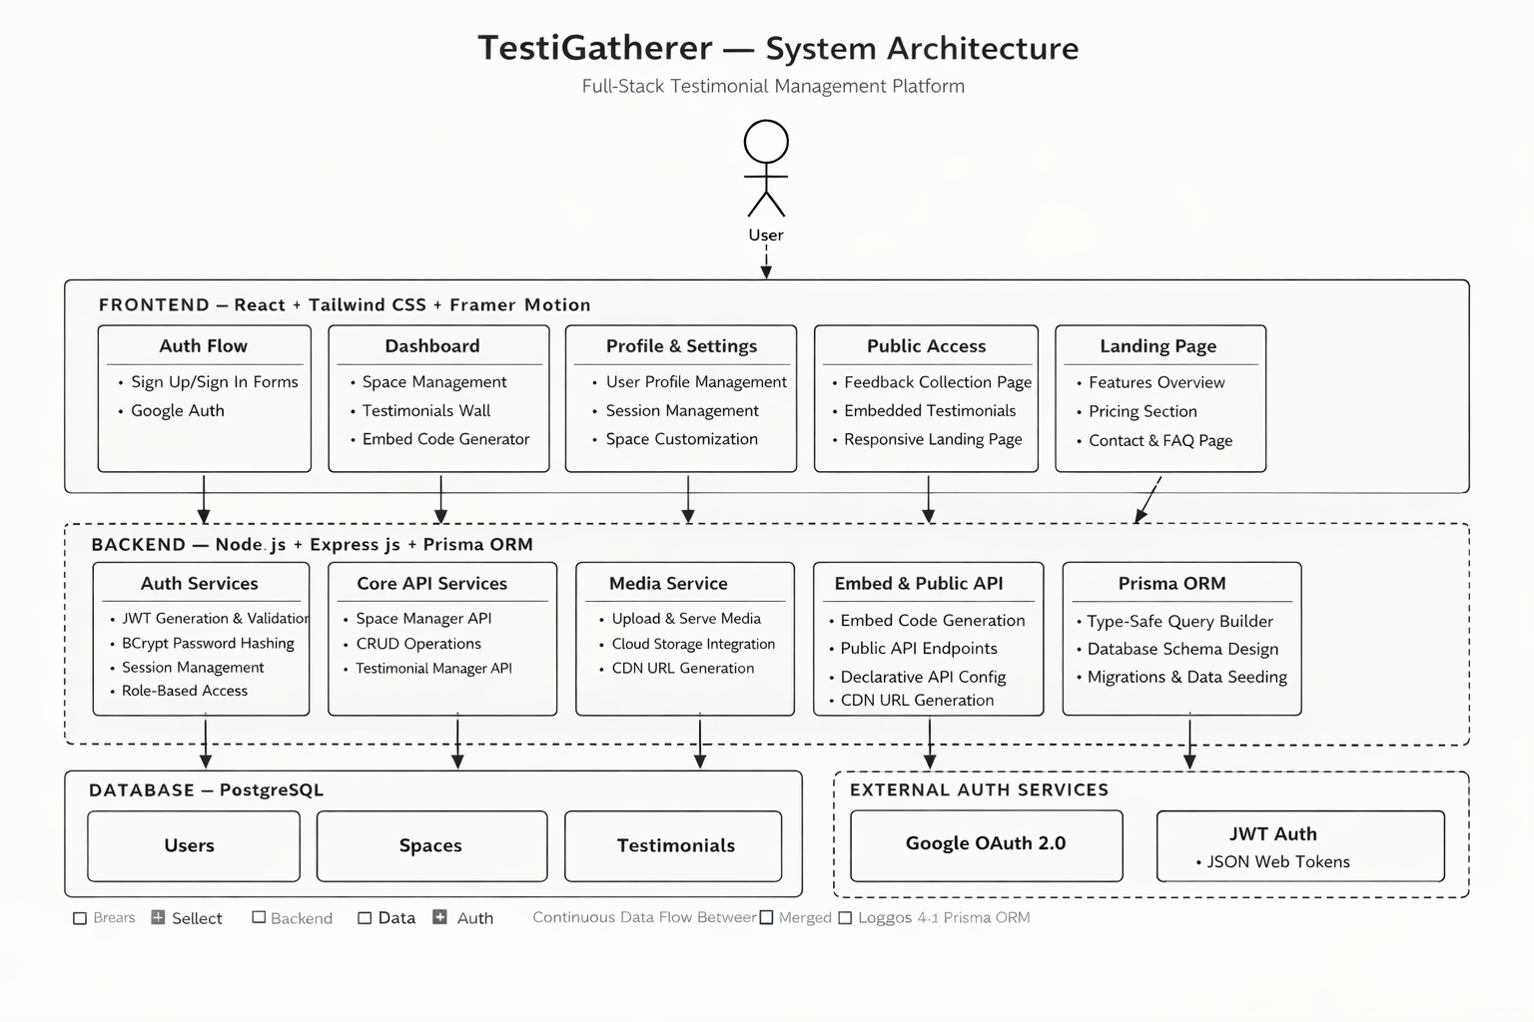

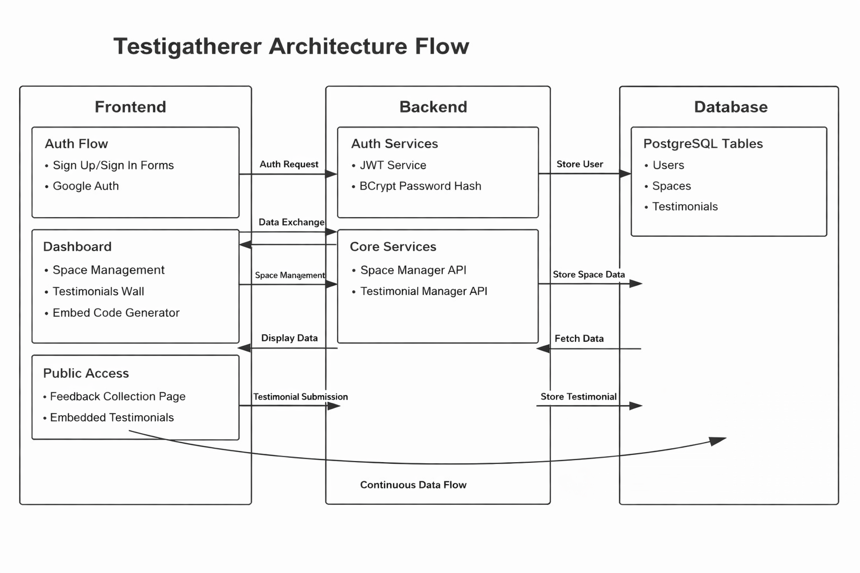
Data Models
Data models define how information is structured and stored in the database.
Entity Relationship Diagram
The ER diagram defines the relationships between major entities in the system.
- User Entity: Represents registered users who can create testimonial spaces and submit testimonials.
- Space Entity: Each user can create multiple testimonial spaces to collect feedback.
- Testimonial Entity: Testimonials belong to a specific space and can include ratings, images, and textual feedback.
The relationships establish clear ownership and organization of testimonial data.

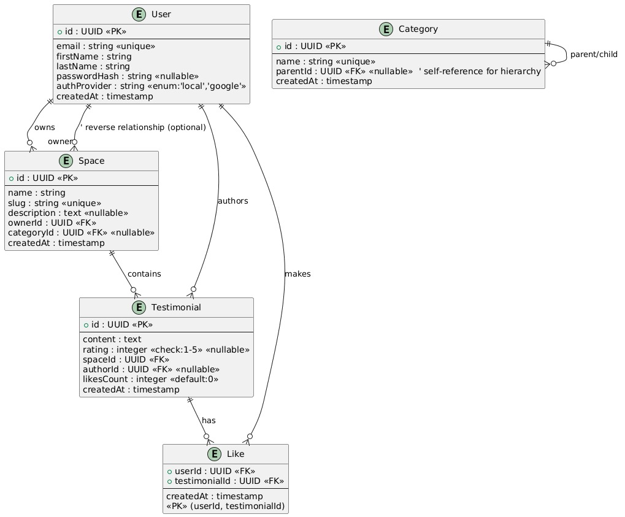

Project Status and Next Steps
This report summarizes the progress made in the initial phases of the TestiGatherer project.
Phase 1: Analysis (Completed)
Requirements gathering, use case modeling, and system analysis have been completed successfully.

Phase 2: Design (Completed)
System architecture design, database schema design, and sequence diagrams have been finalized.
Phase 3: Implementation (In Progress)
Backend API development, database setup, and frontend component implementation are currently underway.
Phase 4: Deployment (Upcoming)
The system will be deployed on cloud infrastructure for production use.

Upcoming Work
- Backend Development
Implementation of APIs and database integration.
- Frontend Development
Development of React components and user interface.
- Production Deployment
Deployment on cloud servers with performance optimization.

