**MACHINE LEARNING_IN CLASS PROGRAMMING ASSIGNMENT_3**

**Video:**

[**https://drive.google.com/file/d/1X2w9PBq_z1cVhp6vQXmq5W6eZC85dW7y/view**](https://drive.google.com/file/d/1X2w9PBq_z1cVhp6vQXmq5W6eZC85dW7y/view)

**Github Link:** [**https://github.com/Sonalika2229/ML-Assignment3**](https://github.com/Sonalika2229/ML-Assignment3)

**Sonalika**

**Venchiryala**

**700742916**

**Question1:**

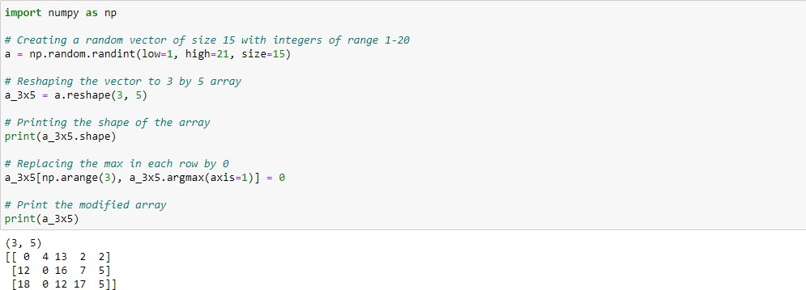**1**. Numpy: a. Using NumPy create random vector of size 15 having only Integers in the range 1-20. 1. Reshape the array to 3 by 5 2. Print array shape. 3. Replace the max in each row by 0

Imported the numpy library as np

Created a random vector a of size 15 with integers of range 1-20 Reshaped the vector to 3 by 5 using a.reshape()

a_3x5.argmax() finds the index of the maximum value in each row and sets the value at that index to 0.

**Create a 2-dimensional array of size 4 x 3 (composed of 4-byte integer elements), also print the shape, type and data type of the array.**

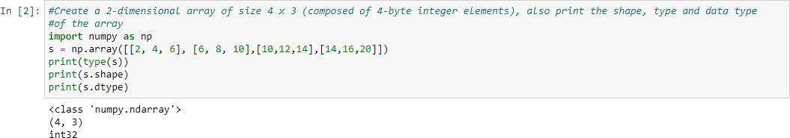

Created a 2-dimensional array of size 4 x 3 with 4-byte integer elements type(s) function is used to print the type of array

s.shape is used to print the shape of the array s.dtype is used to print the data type of the array.

1. Write a program to compute the eigenvalues and right eigenvectors of a given square array given below: [[ 3 -2] [ 1 0]]

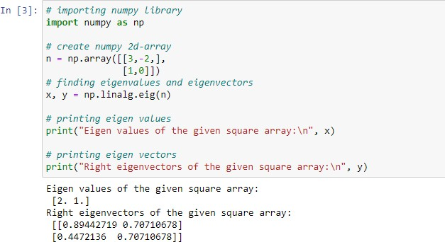

Created the 2-dimensional array

Np.linalg.eig(n) function is used to compute the eigenvalues and eigenvectors of a square array.

Printed the eigen vectors and eigen values

1. Compute the sum of the diagonal element of a given array. [[0 1 2] [3 4

5]]

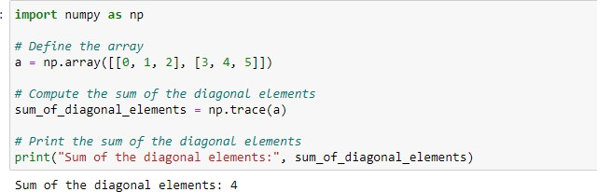

Defined the array

np.trace(a) function is used to compute the sum of diagonal elements. Printed the sum of elements.

1. Write a NumPy program to create a new shape to an array without changing its data. Reshape 3x2: [[1 2] [3 4] [5 6]] Reshape 2x3: [[1 2 3] [4 5 6]].

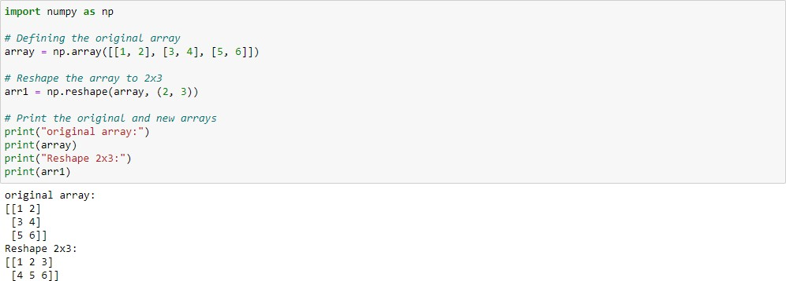

Defined the original array

The reshape() function returns the new array with the same data as the input array,but with the different shape. Here we reshape the 3x2 array into 2x3 array. **2.Matplotlib**

1. Write a Python programming to create a below chart of the popularity of programming Languages. 2. Sample data: Programming languages: Java, Python, PHP, JavaScript, C#, C++ Popularity: 22.2, 17.6, 8.8, 8, 7.7, 6.7

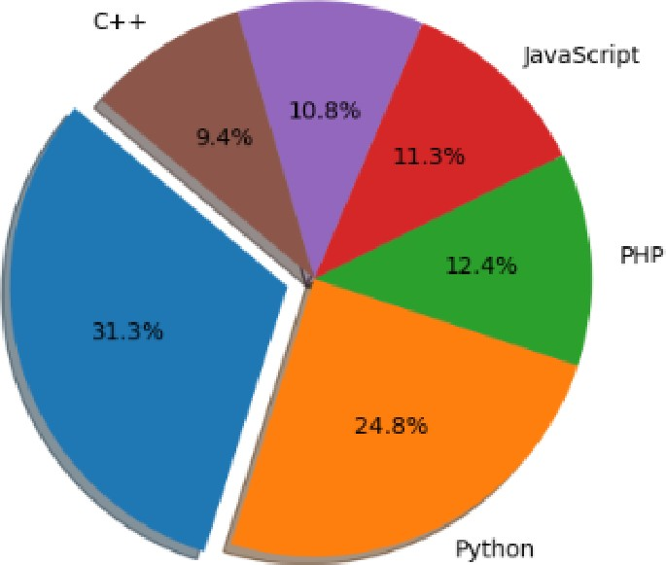

**In** [7 J: import matplotlib. pyplot •• plt

# *IJQta* to *plot*

**lang = 'Java"J 'Pythori'J 'PHl?'J 'JavaScript'., 'C.ft'., 'C++'**

**Popuratity = [22.2., 17.6., 8.8., &, 7.7., 6.7]**

**colors= ['"'IF1f77b4 ..:, "iffJ-0e"., "'#2cae2c", "'#cl62728"1 '"#'9467be"':i ":tt.8c564b"]**

# ***explode 1st st* tee**

**explcde = (0.1J e., 0, 0.,0,0)**

#- ***Plot***

**plt.,pie(Popuratity:i e:xplode=explode., labels=lang., color-s=Colcrs}**

autopct='%1.lf%%', **shadcw=True,** startaogle=l40)

plt.,axis( 'equal') plt.,shoe()

**C#**

**Java,**