ADTA 5560 Midterm
PART I: Learning Process in Neural Networks (20 Points)
SUBMISSION REQUIREMENT PART I:
Discuss the learning process of a neural network like Feedforward Neural Network (FFNN).
Answer: The feedforward neural network is inspired by human brain cell called neuron.
Perceptron is a simple single layer neural network. It is a fundamental unit of artificial neural network. It is a simple neural network that has a single layer of input neurons feeding forward to one output layer of McCulloch-Pitts neurons with full connectivity.
Overview- feedforward neural network:
Feedforward neural network is a biologically inspired artificial neural network (ANN). which consist of several simple artificial neurons processing units, arranged in layers. Each unit in a layer is connected with all the units in the previous layer.

The artificial neuron units in a neural network are called nodes. The links between neuron nodes are unequal with each link having a different strength or weight. The weights of these links represent the knowledge of the network. The data enters the network through the input layer and goes through the layers of the network to reach the output. There is no feedback between layers hence it is called feedforward neural network.
The figure below shows a feedforward neural network
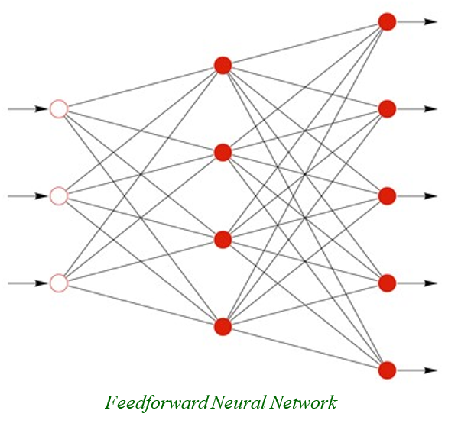
Figure: Feedforward Neural Network
Learning process of a neural network like Feedforward Neural Network (FFNN):
Gradient Based Learning:
- It is based on gradient descent optimization algorithm.
- A gradient measures how much the output of a function changes if you change the inputs a little bit. A gradient measures how much the output of a function changes if you change the inputs a little bit.
- A gradient measure the change in all weights with regards to the change in cost or error.
- Gradient is illustrated as the slope of the cost function.
- The higher the gradient the steeper the slope. The faster the model can run.
- The lower the gradient the less steep the slope and the slower the model.
- If the gradient is near zero or zero, then the model stops learning.
- The Feed Forward Neural networks are usually trained by using iterative, gradient-based optimizers that merely drive the cost function to a very low value. i.e., only as low as possible, not the minimum value as in the case of convex function.
- The below figure shows the gradient descent function.

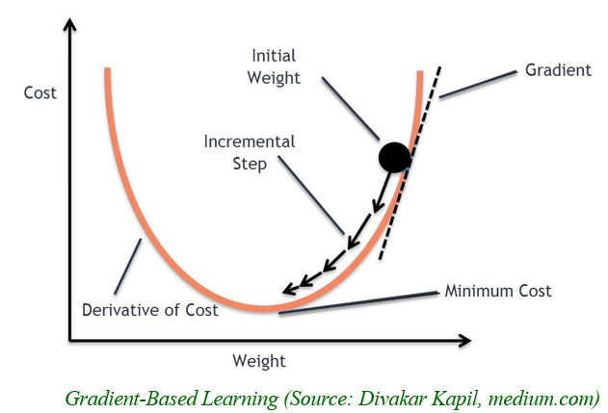

Cost function:
The cost function shows the difference between the approximation made by the model and the actual target value.
- The difference between the predicted output and the desired output (y’ - y) is considered as the cost or loss represented by the cost/loss function.
- The loss is high when the neural network makes a lot of mistakes. If the loss is low when it makes fewer mistakes.

Backpropagation Algorithm:
- The training for the FFNN is done by backpropagation algorithm.
- The algorithm iteratively passes the batches of data through network, updating the weights to decrease the error/loss function.
- The amount by which the weights are updated determined by a parameter called the Learning rate.

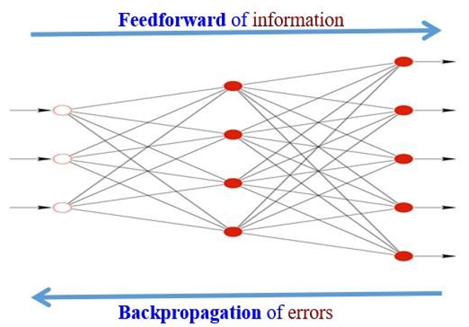
Figure: Backpropagation of a FFNNs

The below figure shows training a neural network using backpropagation.

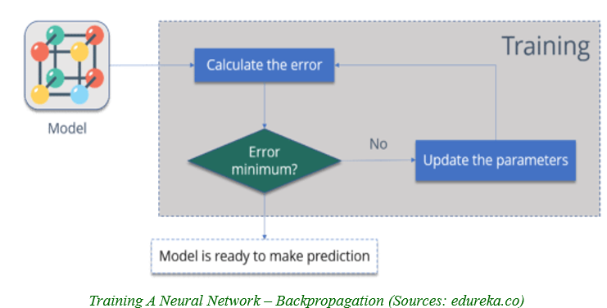
Figure: Training a neural network using backpropagation

PART II: Sequence Data and Memory (20 Points)
SUBMISSION REQUIREMENT PART II:
Question 2.1:
--) Discuss the special relationship between sequence data like language and memory
Answer: The relationship between sequence data and memory can be explained with the below mentioned details.
Sequence Data:
A sequence data can be described as an ordered list of symbol, things, events or values. The order can be established by positions in space or time. When the items in the sequence are ordered in time, it is called time series.
Example:
1,2,3, 4,5,6,7,8,9
A sentence spoken by a person.
Humans can persist the information their memory. This makes them different from machines. Due to persistence humans never have to think/learn from scratch. Humans use their previous memory for the current learning and future.
Memory:
Memory is the ability to store information and past experiences in the brain and recall them as necessary. Memory is the ability to use past experiences to influence present behaviour.
Relationship between sequence data like language and memory:
Memory is a mechanism that learns a representation of the past and help adapt to the present and determine the next word/phrase/number etc. With memory we can use the past learning/information to decide the current and next words in a language.
Question 2.2:
--) Discuss why the recurrent neural network is a good fit for processing sequence data like language
Answer: Recurrent neural network is a good fit for processing sequence data like language because it has a memory embedded vector or a hidden internal state that is updated as a sequence is processed. This enables it to remember information and pass the same to the next connected neuron. This stored information is used to determine the next element in the sequence. In case of language, the memory is used to determine the next word. This is important because language depends on previous context for meaning.
The below figure shows memory mechanism of RNN
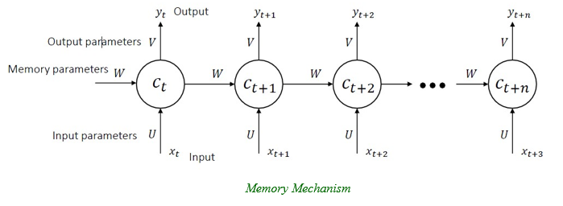
Figure: Memory mechanism of RNN
The below figure shows the mathematical model for RNN. With this we get a clear understanding of how it utilizes the old state to get the new state for sequential data like language.
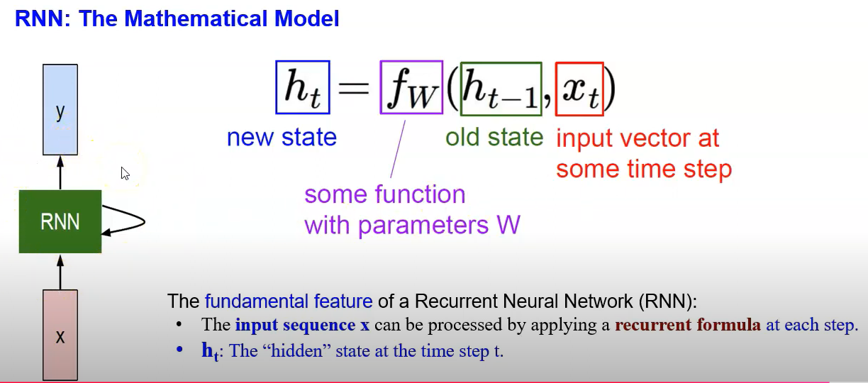
Figure: Mathematical model of RNN

PART III: Simple RNN Cell and McCulloch-Pitts Model (20 Points)
SUBMISSION REQUIREMENT PART III:
Question 3.1:
--) Discuss the Simple RNN Cell showing that it is a version of the McCulloch-Pitts model that is implemented in a real artificial neural network.
Answer: McCulloch-Pitts Model: The McCulloch Pitts model is the simplest single-layer neural network with more than one input and one output. It consists of a set of inputs, each input is multiplied with a weight, summation/ transfer function and activation function.
- Input
- Weight
- Transfer function/summation
- Activation function
The below diagrams show the Simple RNN Cell and McCulloch-Pitts model.
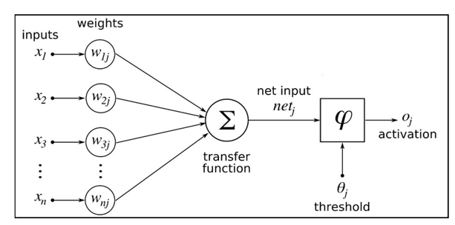
Figure: McCulloch-Pitts Neuron Model
Simple Neural Network: The state of a simple RNN consists of only one hidden vector h. This is a single layer neural network also called as Vanilla or Elman RNN.
- Input
- Weight (W)
- H: single hidden vector
- Whh: weight of the previous hidden layer
- Whx: weight of the current input
- tanh: activation function
- Why: weight of the output
- ht-1: previous hidden state
- ht: current hidden state
Like the McCulloch Pitts neuron Simple RNN also has inputs multiplied by the weights and summed up before it goes to the activation function and generate the output. With this we can establish that Simple RNN is a version of the McCulloch Pitts model. The below figure shows the components of a simple RNN.
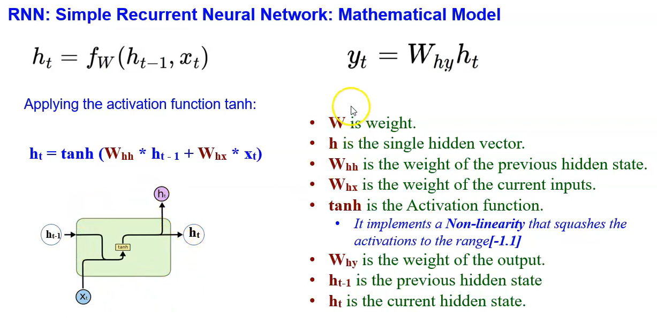
(Source: ann_rnn_recurrent_neural_networks_PART_II.pdf)
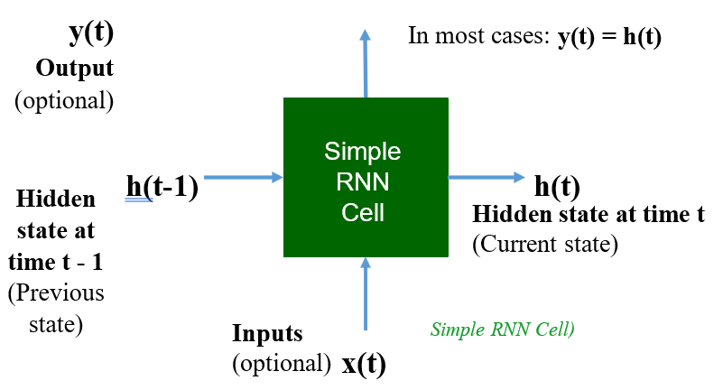
Figure: Simple RNN Cell (Source: ann_rnn_recurrent_neural_networks_PART_II.pdf)
Question 3.2:
--) Discuss and prove that the Simple RNN cell has computation power.
Answer: It is true that RNN has computation power it can be explained by the mathematical model of memory and how it s combined with non-linear transformations to achieve computation power.
Memory of Simple RNN:
Mathematical model of memory:
C_{t+1} = h_{θ} (x_{t+1} , C_{t}) → C_{t+1} = h_{θ} (C_{t} , x_{t+1}) → C_{t} = h_{θ} (C_{t - 1} , x_{t})
Mathematical model of simple recurrent neural networks, i.e., vanilla RNN:
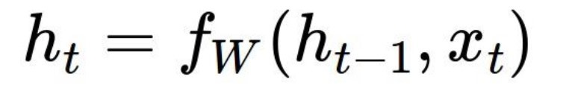
h_{t} = tanh (W_{hh} * h_{t - 1} + W_{hx} * x_{t})
With this we can establish that In recurrent neural networks, the hidden state h represents the memory of the network. The below figure represents the function and the anatomy of a simple RNN.
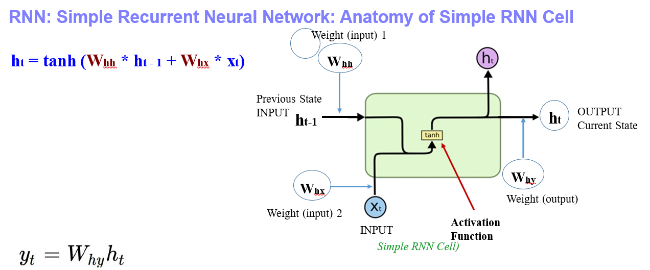
Figure: Anatomy of a Simple RNN
Computation Power: Simple RNN has a hidden state which has information from the previous steps. This hidden (internal) state is updated when a sequence is processed. This is used to model the complex relationship in a sequence.
Hence, we can state that RNN has a computation power with which a simple RNN combines non-linear transformation with memory to determine the next element in a sequence.
PART IV: Simple RNN with Sine Wave Data and Keras (20 Points)
TO-DO
Build, train, and evaluate a simple recurrent neural network (a complete simple RNN) that has two layers: a SimpleRNN and a fully-connected layer in Keras. The SimpleRNN layer has 64 neurons.
The training and testing the model are done on sine wave data belonging to a dataset generated by dividing the range 0 … 50 into 768 data points, including 0 and 50. All the tasks related to the project are done in Python using Jupyter Notebook.
SUBMISSION REQUIREMENT PART IV
--) Add one section to discuss the design of the neural network into the MS Word document,
“ADTA_5560_midterm.docx,” including the diagram of the neural network.
--) Add another section to include the report on the results of training and evaluating the model into the document: “ADTA_5560_midterm.docx,”
--) Submit all the code and the results of running the code in a Jupyter Notebook document (*.ipynb)
Answer:
Objective: In this part we have to design a simple recurrent neural network with two layers, a simple RNN and a fully connected layer using Keras. The simple RNN layer should have 64 neurons. The dataset will be generated from a sine wave of range 0… 50 with 768 data points.
Diagram: The below diagram shows the neural network with two layers with simple RNN and a fully connected layer.
Note: for the sake of simplicity, the number of neurons is reduced in the diagram, there should 64 neurons as per the design of the network.
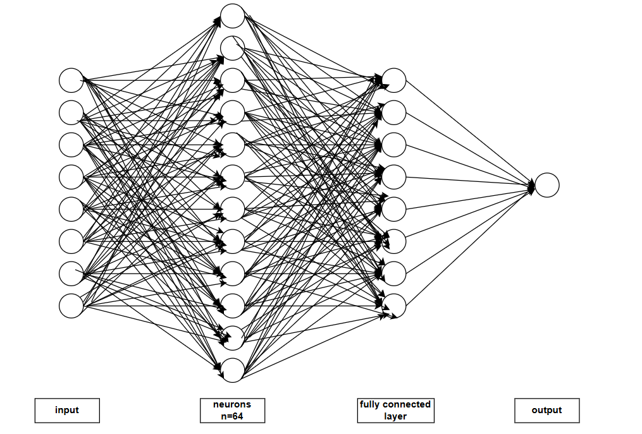
Figure: Neural network with simple RNN and fully connected layer
Report: The below mentioned steps were taken to build the simple recurrent neural network having an RNN and a FC layer.s
Steps:
- Importing libraries:
  - It is important to import the python libraries to successfully build the RNN
    - timeseries RNN neural network
    - basic libraries
    - keras: TimeseriesGenerator
    - keras: MinMax scalar
- Data Generation:
  - Used numpy to create a simple sine wave of range 0… 50 with 768 data points.
  - Plotted the sine wave as shown in the below figure:
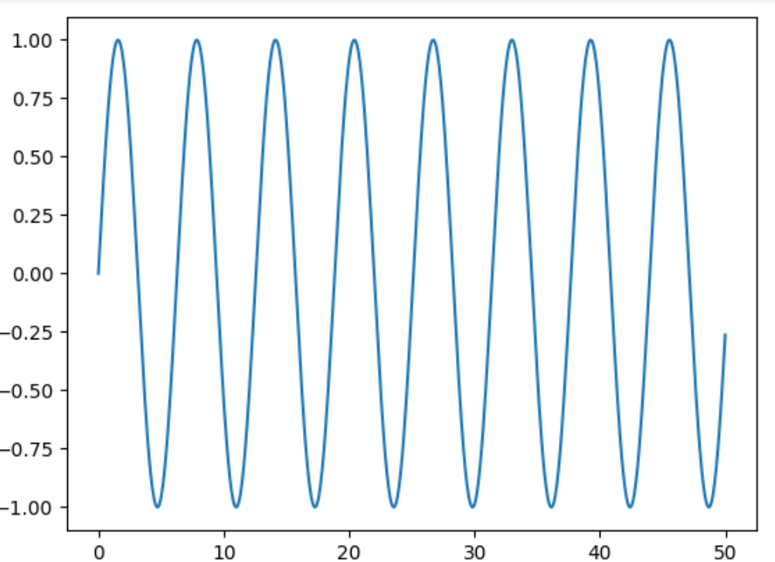

  - Loaded it into a pandas dataframe. This dataframe was used as an input data to the RNN.
- Split Train and Test Data:
  - The data is split into training and testing with test data set having 20% of the data and training dataset having 80% of the data.
- Normalize the data:
  - MinMaxScalar is used
  - We are scaling only the training data. We are not scaling the testing data.
  - Transformation is done for both training data and testing data.
- Create time series generator instance:
  - length of the input sequence is set as 50.
  - Batch size as 1.
  - TimeseriesGenerator method is used to create the time series.
  - This produces time series batches used to train the model.
- Build and Test Model:
  - The dataset has only one attribute: Sine values of index x. So only one feature is used to train the model.
  - The model is defined and a simple RNN layer with 64 neurons is added.
  - A fully connected layer for the final prediction with only one neuron is added.
- Compile the Model:
  - Use model.compile to compile the model.
  - The model summary is shown in the below table.
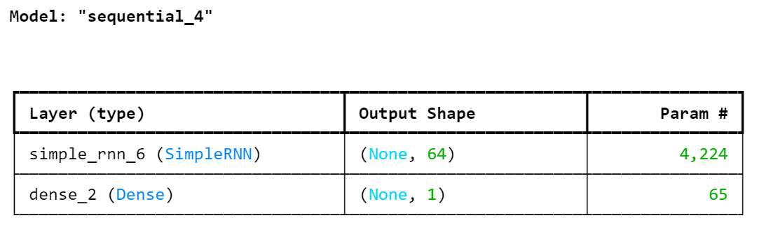
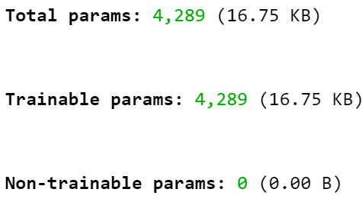
- Train the Model:
  - Fit the model using model.fit()/ model.fit_generator()
- Visualize model performance after training:
  - The loss data is loaded into a dataframe and ploted.
  - The figure below displays the plot.
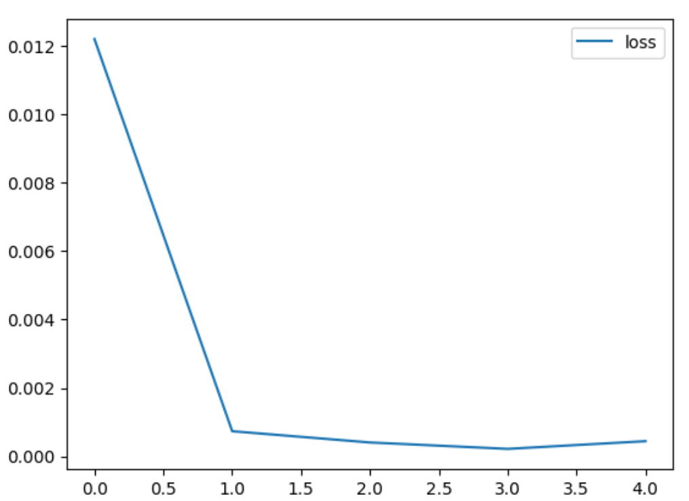
Evaluation of the Model’s performance on Tests Data
  - Store the predictions in a separate list
  - Make predictions for each batch and append it in the list.
  - The below screenshot shows the predictions made by the model.
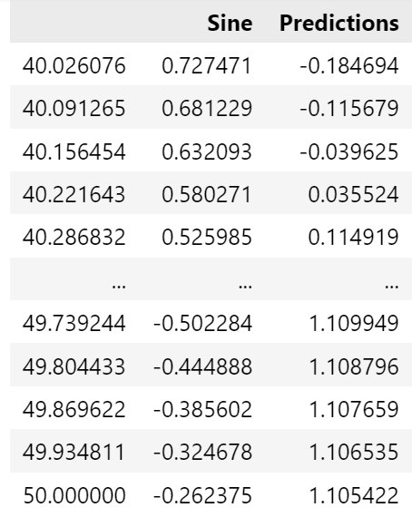
- Revert the scaled values back to real values
  - Use inverse transform to revert the scaled values to real values.
- Loss calculated
  - loss: 3.0165e-04
  - The below screenshot shows the loss calculations from the model
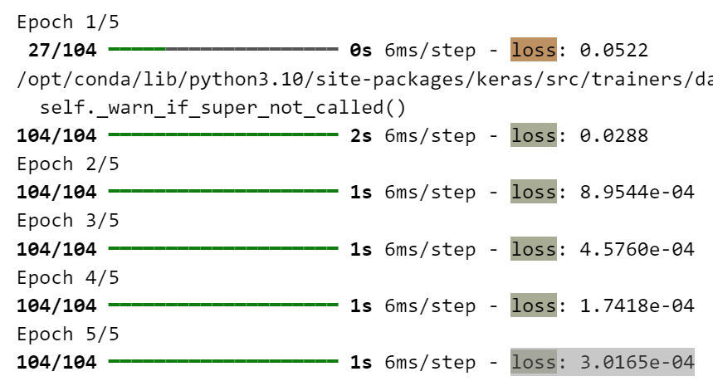
- Append the predictions list to the dataframe
  - Visualize the predicted sine wave and the original sine wave.
  - The below figure shows the same.
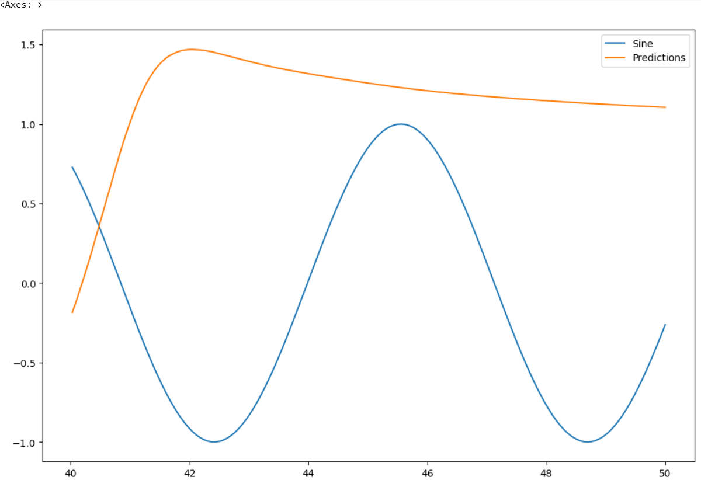
Conclusion: In this assignment we successfully created dataframe for a sine wave, split the generated dataset into training and testing dataset. We also normalized the data, built the model with adding hundred RNNs and trained the model, visualized the model’s performance and predicted the data. We also plotted the predicted and original data to understand the model’s performance.
Jupyter Notebook: ADTA5560midterm_Part4_64neurons.ipynb

PART V: Redesign Simple RNN (20 Points)

TO-DO
Redesign the simple recurrent neural network by changing the number of neurons of the SimpleRNN layer. The student can choose the number he/she wants.
--) Rebuild and retrain the new model using the Keras in another Jupyter Notebook document.
--) Run all the steps of the project in the Jupyter Notebook document to get the results of each step.
--) Evaluate the new model on the test data.
--) Write a report on these results.

SUBMISSION REQUIREMENT PART V:

--) To discuss the new design of the simple recurrent neural network, add one new section into the MS DOCS document above: “ADTA_5560_midterm.docx”. The discussion should include:
- The diagram of the redesigned neural network
- Discussion in detail of how the Simple RNN is redesigned
- Discussion in detail of why such a redesigned network can potentially produce improved performance, i.e., higher accuracy level.

Answer:

Objective: In this part we will redesign a simple recurrent neural network to improve performance of the recurrent neural network built in the previous section. We will be changing the number of neurons to achieve better accuracy.
Diagram of the redesigned neural network: The below diagram shows the redesigned neural network with two layers with simple RNN having 128 neurons and a fully connected layer.
Note: for the sake of simplicity, the number of neurons is reduced in the diagram, there should 128 neurons as per the design of the network.

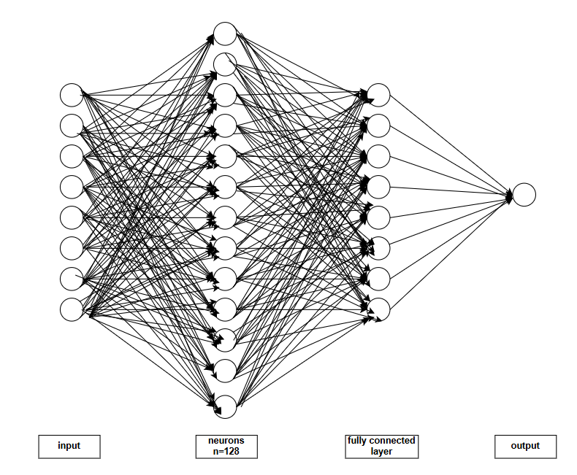
Figure: Neural network with simple RNN (128 neurons) and a fully connected layer
Report:
The below discuss the important details about the redesigned neural network.
Redesign of the simple recurrent neural network:
- I have added 128 neurons to the network to improve the performance of the model.
- The pervious network had 64 neurons and one fully connected layer.
- There is no other change to the network, the fully connected layer is present in the redesigned network.
- The redesigned network uses the same sine wave dataset with 768 data points.
Why such a redesigned network can potentially produce improved performance:
- Additional learning Ability: Adding more number of neurons to the network will improve the performance of the model as the added neurons increase the learning ability of the model.
- Accuracy: As the model can learn more details of the data it will improve the accuracy of the model.
Building the redesigned simple RNN:
- Importing libraries:
  - It is important to import the python libraries to successfully build the RNN
    - timeseries RNN neural network
    - basic libraries
    - keras: TimeseriesGenerator
    - keras: MinMax scalar
- Data Generation:
  - Used numpy to create a simple sine wave of range 0… 50 with 768 data points.
  - Loaded it into a pandas dataframe. This dataframe was used as an input data to the RNN.
- Split Train and Test Data:
  - The data is split into training and testing with test data set having 20% of the data and training dataset having 80% of the data.
- Normalize the data:
  - MinMaxScalar is used
  - We are scaling only the training data. We are not scaling the testing data.
  - Transformation is done for both training data and testing data.
- Create time series generator instance:
  - length of the input sequence is set as 50.
  - Batch size as 1.
  - TimeseriesGenerator method is used to create the time series.
  - This produces time series batches used to train the model.
- Build and Test Model:
  - The dataset has only one attribute: Sine values of index x. So only one feature is used to train the model.
  - The model is defined and a simple RNN layer with 128 neurons is added.
  - A fully connected layer for the final prediction with only one neuron is added.
- Compile the Model:
  - Use model.compile to compile the model.
  - The model summary is shown in the below table.
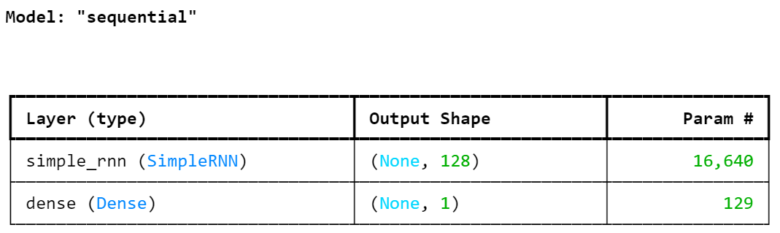
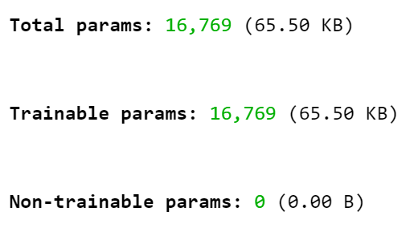
- Train the Model:
  - Fit the model using model.fit()/ model.fit_generator()
- Visualize model performance after training:
  - The loss data is loaded into a dataframe and ploted.
  - The figure below displays the plot.
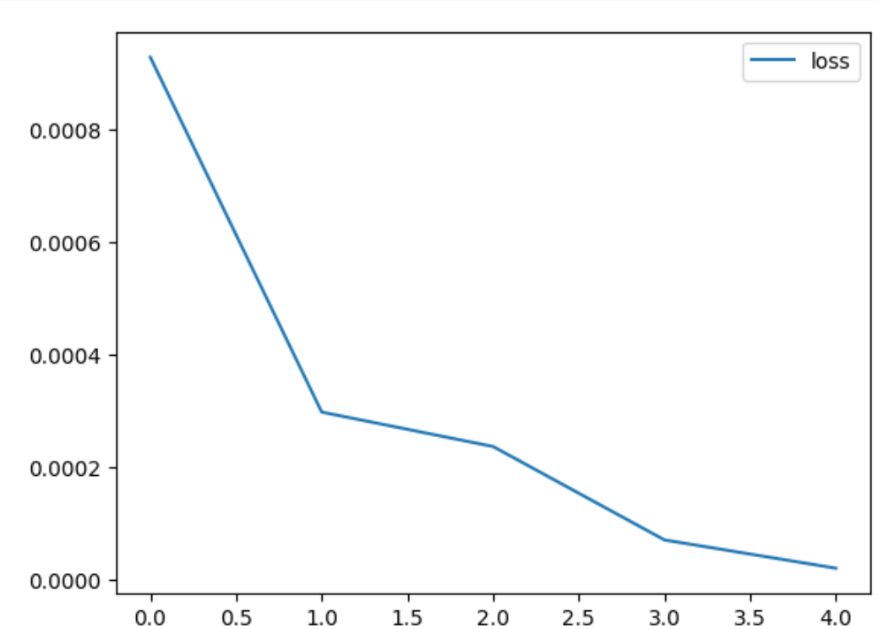
Evaluation of the Model’s performance on Tests Data
  - Store the predictions in a separate list
  - Make predictions for each batch and append it in the list.
  - The below screenshot shows the predictions made by the model.
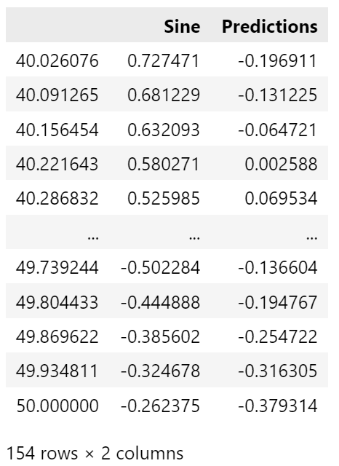
- Revert the scaled values back to real values
  - Use inverse transform to revert the scaled values to real values.
- Loss calculated
  - loss: loss: 3.4385e-05
  - The below screenshot shows the loss calculations from the model
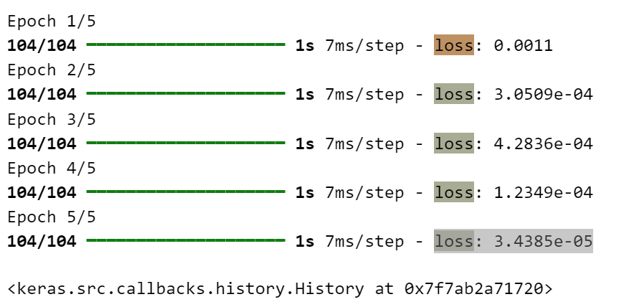

- Append the predictions list to the dataframe
  - Visualize the predicted sine wave and the original sine wave.
  - The below figure shows the same.
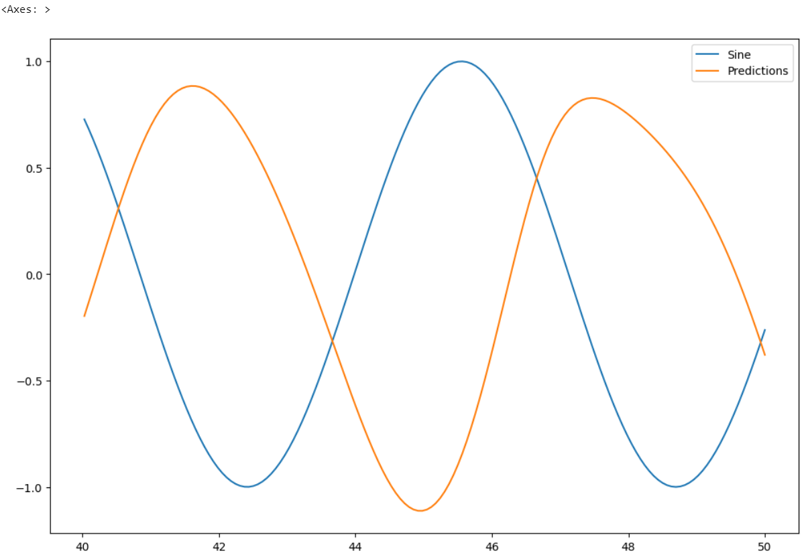
Conclusion: In this part of the assignment we successfully designed a simple RNN to improve the performance of the simple RNN from the previous part by increasing the number of neurons to 128 from 64. We realised a performance improvement of the redesigned model in the loss function and the plotting the predictions.
Performance Improvement:
Number of neurons | Loss realised
64 | 0.00030165
128 | 0.000034385

We can clearly state that the redesigned model with 128 neurons has a smaller loss function hence, it is a better model in terms of accuracy.
Jupyter Notebook: ADTA5560midterm_Part5_128neurons.ipynb
Reference:
https://youtu.be/Pkj0MfM-Nok
https://youtu.be/t5SBFureGxI
https://youtu.be/RCXyEp9yotY
https://youtu.be/TD1MKIbh_F8
https://youtu.be/APb1sXWzwHw
https://youtu.be/uCotuST3e1g
https://youtu.be/CcN7ucFEYIc
https://youtu.be/wFuByXsBCfQ
https://youtu.be/mD3GnwjYM_s
https://youtu.be/jP85vmnvQrA
https://youtu.be/hDrl5osf_ew
ann_rnn_recurrent_neural_networks_PART_II.pdf
ann_rnn_recurrent_neural_networks_PART_I.pdf
ann_ffnn_feedforward_neural_networks.pdf
ann_fundamentals_of_artificial_neural_networks_PART_II.pdf
ann_fundamentals_of_artificial_neural_networks_PART_I.pdf
ann_rnn_sequence_data_fundmentals_PART_II.pdf
ann_rnn_sequence_data_fundmentals_PART_I.pdf

