4.1 Question 1: Natural Language: A Definition (5 Points)
Write a short essay:
- To present a definition of Natural Language discussed in class
- To discuss how the student understands the definition and natural languages’ properties – based on the definition – that have significant impacts on NLP
Answer:
Introduction:
Definition of Natural Language: Natural language is a tool of thought which facilitates knowledge getting passed from one generation to another.
Example:
Writing a journal: When we are writing a journal, we are conveying our thoughts via writing it down.
Expressing our thoughts and ideas: We use various methods to express our ideas to share them with others. We have a certain way of communication for a professional setup and a different method for personal level communication.
In the stone age, people used to communicate in an unarticulated manner with some kind of signs and cries to express their feelings like joy, sadness, fear etc. gradually they associated some sounds with a specific feeling/emotion and the speech became articulated. With these evolutions in place, Language has become a tool of thought. It has become a function to establish communication between people to exchange their knowledge and pass it to their descendants. When language became prevalent, it generated the urge to of people to tell something to others and it kept growing and evolving with which complex and diverse thoughts could be expressed with ease. This enabled the engagement on the development of improved living conditions.
In the context of “Natural Language Processing,” “Language” is a set of tools that human-beings use to reveal, expose, and present their ideas, opinions, or thoughts, i.e., any kinds of mental or intellectual products generated by their brain system.
With the given set of tools, “Language”, human-beings can convey their ideas an knowledge with others and enable better living conditions or a better world for everyone.
Conclusion:
Without the natural language, which enabled the communication among the people who are a part of a community, humanity would not have reached the level of sophistication where it has reached today.

4.2 Question 2: Natural Language Processing (NLP): A Definition (10 Points)
Write a short essay:
- To present a definition of Natural Language Processing (NLP) discussed in class
- To discuss how the student understands the definition and NLP’s most significant property – based on the definition
Answer:
Introduction:
Definition of Natural Language Processing (NLP): Natural Language Processing is a set of techniques and tools based on artificial intelligence (AI) technologies, especially deep learning, to teach computers to understand and use any forms of daily-used human languages in various applications.
NLP: Natural Language: Analysis
There are five major components of Natural Language analysis:
• Lexical Analysis: also known as tokenization, aims to identify and analyzes word structures of some contents.
The process divides a piece of text into major components:
  - Paragraphs
  - Sentences
  - Words
A lexical analyzer, i.e., tokenizer, focuses on the following tasks:
• Take a stream of characters as inputs
• Decode the inputs into high-levelled tokens that a parser can understand.
- Syntactic Analysis: Syntactic analysis, also known as parsing, aims to analyze strings of natural language symbols to detect the grammatical relationship between words in a piece of text, normally, a sentence. A syntactic analyzer, i.e., parser, focuses on the following tasks:
- Take a stream of tokens, i.e., the outputs of a lexical analyzer, as the inputs
- Check syntactic correctness of a sentence, based on the formal grammar rules
- Generate the syntactic data structures of the sentence such as the parse tree and
the symbol table
• Semantic Analysis: Semantic analysis aims to analyze pieces of natural language to find the meanings and detect meaningful relationships between words in some pieces of text or speech, normally, a sentence.
A semantic analyzer tries to perform two significant tasks on each sentence of the
targeted natural language:
- Finding the meanings of individual words of the sentence
- Studying the meanings of groups of words in the sentence
• Discourse Analysis:
Discourse: Is written or spoken communication, or a debate, between people (Oxford Language)
Is a unit of natural languages that is longer than a sentence (linguistics)
Discourse is “longer than a sentence.”
• Normally, a written or spoken communication between people requires more than a sentence.
• It can include only one or two words such as “Stop!” or “No Smoking!”
• It can also include hundreds of thousands of words as a novel does.
More importantly, discourse possesses not only words, phrases, or sentences.
The most important property of discourse is its coherence in a specific context. The context can be social, political, cultural, religious, ethical, scientific, and more.
• Pragmatic Analysis:
Pragmatics:
Is a branch of linguistics which focuses on the study of how the context contributes to the meanings of a natural language.
Pragmatics – Semantics – Syntax – Semiotics
• Pragmatics: The study of how the context contributes to the meanings of a natural language
• Semantics: The study of explicit rule systems that determine the meaning of a natural language.
• Syntax: The rule systems that describe how words can be grouped together to make meaningful sentences of a natural language.
• Semiotics: The study that focuses on the use of signs and symbols of a natural language
NLP’s most significant property: to teach computer to understand and use any given form of human language. It should understand the text as it is given to it in a correct manner.
Conclusion:
Though there are various factors and parts of Natural Language Processing, the main motivation is to make the computer learn how to understand and process the given information in a human language or a natural language. Once the computer learns to process the natural language, it can understand the given input in the human language, process it and give a desired output in the human/natural language.
Example: Now with the advancements in the Natural Language Processing technology and Large Language models applications like ChatGPT, Gemini and Copilot etc are answering any given questions in a human natural language (English).
4.3 Question 3: John Austin’s Speech Act Theory (15 Points)
Write a short essay to discuss the “three simultaneous acts” of human speech stated by John Austin and John Searle:
- To present what John Austin and John Searle aimed to posit with their theories
- To provide adequate support, including examples for the main ideas presented in the essay.

Answer:
Introduction:
In the year 1962, Jhon L Austin’s theory of “How to do things with words” was published. This theory served as a foundation for many fields of study including Artificial Intelligence. It said, “TO SAY SOMETHING IS TO DO SOMETHING”.
Three simultaneous acts of the speech theory are:
Locutionary Act: Physical action of speaking or uttering (Utterance)
Example: The professor speaks to the class during the lecture.
Illocutionary act: The act of intending to do something (Intention)
Example: The intension of the professor during the lecture is to explain the concept to the students.
Perlocutionary act: The act of bringing out some consequences or results (Consequences)
Example: The result of the professor giving a lecture to the class is that the students understand the concept and are ready to do their assignment.
For the speech act theory to be successful, its “felicity” conditions should be fulfilled.
Locutionary: must be successful which means words should be pronounced correctly. If the words are not pronounced correctly, it might cause confusion and lead to misunderstanding of the concept.
Illocutionary: must be appropriate which means the speech should satisfy the conditions of its content and community. If the professor is teaching an undergraduate class, the lecture content should be created for initial level of understanding as some of the undergrad students might be listening the concept for the very first time. If the lecture is for the PHD students, it need not be that detailed as he PHD students have already studied it before.
Perlocutionary: must be effective which means the results should match the speaker’s intention/desires. Or it should be understood the way it was intended to be understood and not misunderstood.
John Searle was Austin’s student who is well-known for deep and profound contribution to the development of the Speech Act Theory. He focused on the intentionality of Speech Acts.
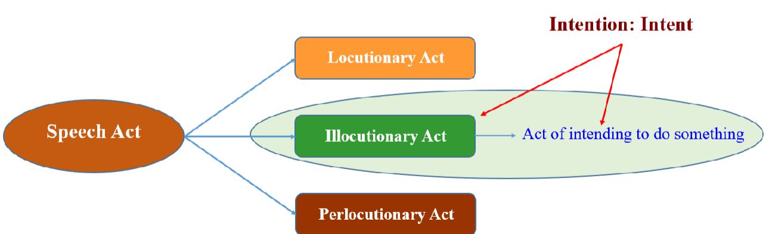
Fig: John Searle, 1969, Speech Acts: An Essay On Speech Act Theory
According to Searle, the basic unit of a natural language is the illocutionary act. Or the intention to do something. One of the three speech acts performed simultaneously when an utterance is produced, i.e., when someone says something. In a conversation, for a token, i.e., a word, to be an instance of the conversation, the audience must take it as being produced to show some intentions, or intents, of the speaker.
Conclusion:
John Searle came up with the “Dialogue Act” which is a concept that directly inherits the meaning from the speech act of Austin’s Speech Act Theory. So, it is the “Intention” of the conversation which is of utmost importance and should be met.
“Intention Is All You Need!”

