Why Automation?

1. Regression requires very less time
2. No of resources require will be reduced
3. Project duration can be reduced.
4. Less human efforts are required.
5. Compatibility is easy in automation.
6. Repeating of Manual test execution is avoid
7. Less human error.
8. Project cost can be reduced.

There are some disadvantages of manual testing:

1. Time required will be more.
2. Large Human human efforts are required.
3. Cost of project can be increased.
4. Test cycle duration will be increased.
5. Regression is time consuming and more resources are required.
6. Impact on project time line.

Disadvantages of Automation:

1. High skilled resources are required.
2. 100% test coverage can’t achieved.
3. Standalone application cannot be automated.

Tool in Automation:

1. Selenium
2. Protractor
3. QTP
4. Appium
5. Sahi
6. selendroid

Advantages of selenium/Why selenium?

1. Open source tool
2. Compatible with different languages (java-selenium, c#-selenium, JavaScript-selenium, phython-selenium)
3. Compatilablity testing is possible

Disadvantages of selenium:

1. We can automate only web based application
2. We cannot automate captcha, Barcode
3. File download and upload is not available in selenium.

Selenium: Test automation tool

Configuration:

Step1: domwnload selenium jar from below link

<https://www.selenium.dev/downloads/>

select: Latest stable version [4.1.1](https://github.com/SeleniumHQ/selenium/releases/download/selenium-4.1.0/selenium-server-4.1.1.jar)

Step2: Go to project and right click

Buildpath -> configure build path

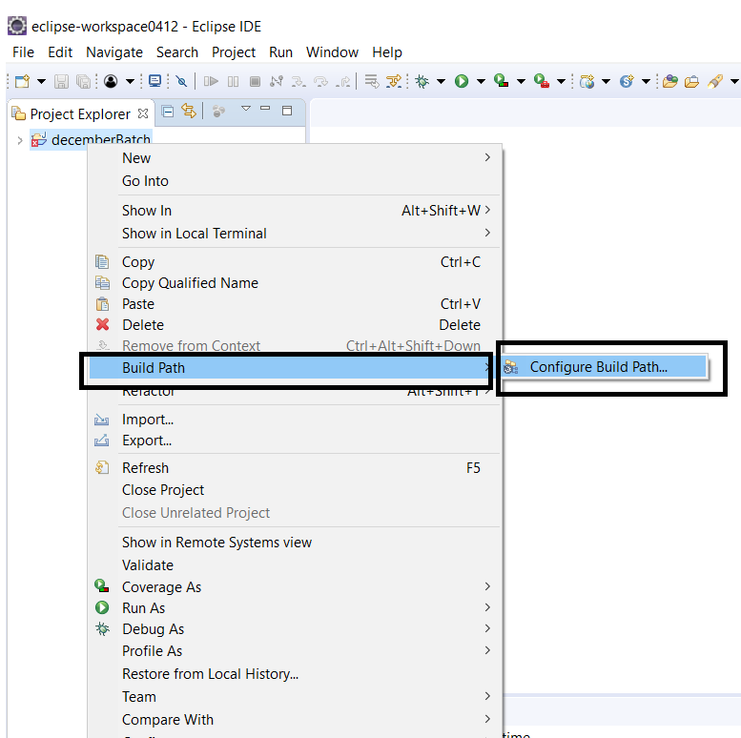

Next popup window will display:

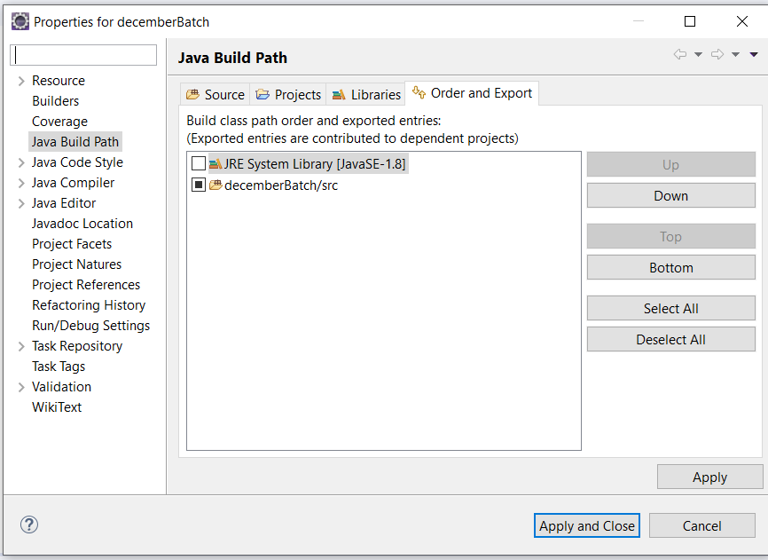

In this window select “Library” Tab as shown below:

