BOOTSTRAP 4

What is Bootstrap?

* Front-end framework for UI’s and themes (used on the client not the server).
* Includes bits of code of HTML/CSS/Javascript.
* Used for building responsive, mobile first web applications and websites.
* Most popular framework by far

UI:- In information technology, the **user interface** (**UI**) is everything designed into an information device with which a person may interact.

Mobile first means it refers to designing for smaller screens first and then working up to the larger screens. It is great for mobile apps and mobile websites.

Why Bootstrap?

* Increase development speed: most important reason to use framework not just a front-end framework but any kind of framework PHP, Javascript. With Bootstrap all your helper classes for alignment, style and positioning are all done for you.
* Responsiveness: It is another huge advantages instead of using custom media queries and creating a responsive site from scratch, you can simply use the grid system and you will have a mobile friendly website or application.
* Consistency: The class name style markup keeps your website and theme very consistent.
* Customizable: It is completely customizable. You can add your own classes and your own design to any bootstrap theme and it allows you to create really custom interfaces.
* Support: Like most frameworks it has documentation. It also has a huge community as it is very popular framework. You can ask any developer to help and they will help you.

HTML/CSS COMPONENTS AND HELPER:

Navbar and Dropdowns

Jumbotron

Alerts and Progress Bars

Form and Input

Buttons and Links

Labels and Badges

Icons

List groups

Wells and Panels

Pagination

Thumbnails

Tables

Grid System

Responsive Utilities

JAVASCRIPT WIDGETS AND HELPER:

Transitions

Modals

Dropdowns

Tabs

Carousel/slider

Alerts

Popovers

Tooltips

Collapsible elements

BOOTSTRAP GRID SYSTEM:

Bootstrap's grid system is built with flexbox and allows up to 12 columns across the page. The grid system is responsive, and the columns will re-arrange automatically depending on the screen size.

Make sure that the sum adds up to 12 or fewer.

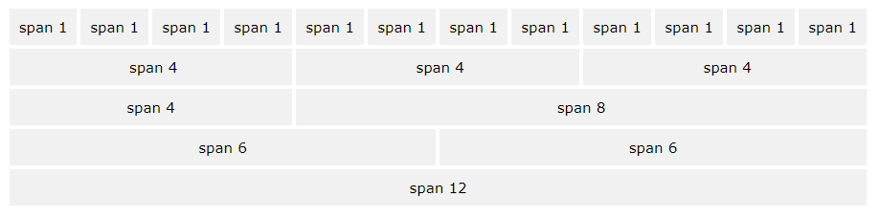

The Bootstrap 4 grid system has five classes:

* .col- (extra small devices - screen width less than 576px)
* .col-sm- (small devices - screen width equal to or greater than 576px)
* .col-md- (medium devices - screen width equal to or greater than 768px)
* .col-lg- (large devices - screen width equal to or greater than 992px)
* .col-xl- (xlarge devices - screen width equal to or greater than 1200px)

SYNTAX/FORMAT FOR BASIC BOOTSTRAP:

Using an HTML5 doctype and including a viewport meta tag for proper responsive behaviours in Bootstrap.

<!DOCTYPE html>

<html lang="en">

<head>

<!-- Required meta tags -->

<meta charset="utf-8">

<meta name="viewport" content="width=device-width, initial-scale=1, shrink-to-fit=no">

<!-- Bootstrap CSS -->

<link rel="stylesheet" href="https://maxcdn.bootstrapcdn.com/bootstrap/4.0.0-alpha.6/css/bootstrap.min.css" integrity="sha384-rwoIResjU2yc3z8GV/NPeZWAv56rSmLldC3R/AZzGRnGxQQKnKkoFVhFQhNUwEyJ" crossorigin="anonymous">

</head>

<body>

<h1>Hello, world!</h1>

<!-- jQuery first, then Tether, then Bootstrap JS. -->

<script src="https://code.jquery.com/jquery-3.1.1.slim.min.js" integrity="sha384-A7FZj7v+d/sdmMqp/nOQwliLvUsJfDHW+k9Omg/a/EheAdgtzNs3hpfag6Ed950n" crossorigin="anonymous"></script>

<script src="https://cdnjs.cloudflare.com/ajax/libs/tether/1.4.0/js/tether.min.js" integrity="sha384-DztdAPBWPRXSA/3eYEEUWrWCy7G5KFbe8fFjk5JAIxUYHKkDx6Qin1DkWx51bBrb" crossorigin="anonymous"></script>

<script src="https://maxcdn.bootstrapcdn.com/bootstrap/4.0.0-alpha.6/js/bootstrap.min.js" integrity="sha384-vBWWzlZJ8ea9aCX4pEW3rVHjgjt7zpkNpZk+02D9phzyeVkE+jo0ieGizqPLForn" crossorigin="anonymous"></script>

</body>

</html>

COMPONENTS OF BOOTSTRAP:

* ALERTS: It provides contextual feedback messages for typical user actions. It uses the .alert-link utility class to quickly provide matching colored links within any alert.

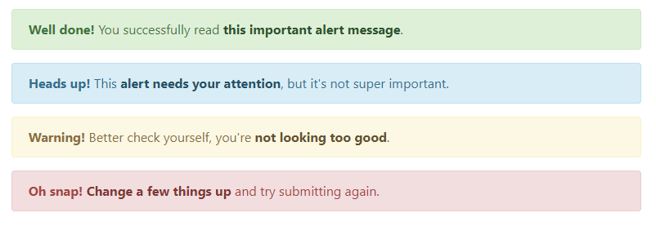

<div class="alert alert-success" role="alert">

<strong>Well done!</strong> You successfully read this important alert message.

</div>

<div class="alert alert-info" role="alert">

<strong>Heads up!</strong> This alert needs your attention, but it's not super important.

</div>

<div class="alert alert-warning" role="alert">

<strong>Warning!</strong> Better check yourself, you're not looking too good.

</div>

<div class="alert alert-danger" role="alert">

<strong>Oh snap!</strong> Change a few things up and try submitting again.

</div>

* Badge: Small and adaptive tag for adding context to just about any content. It includes headings, contextual variation, pill badge (Use the .badge-pill modifier class to make badges more rounded).

C:\Users\User\Desktop\documentation\badge.png

Code:

<span class="badge badge-default">Default</span>

<span class="badge badge-primary">Primary</span>

<span class="badge badge-success">Success</span>

<span class="badge badge-info">Info</span>

<span class="badge badge-warning">Warning</span>

<span class="badge badge-danger">Danger</span>

* Breadcrumb: it Indicate the current page’s location within a navigational hierarchy. Separators are automatically added in CSS through [:before](https://developer.mozilla.org/en-US/docs/Web/CSS/::before) and [content](https://developer.mozilla.org/en-US/docs/Web/CSS/content).

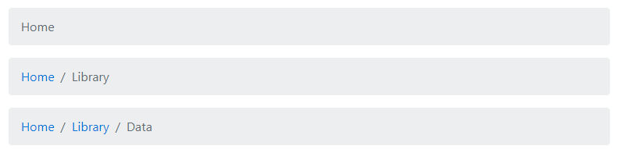

Code:

<ol class="breadcrumb">

<li class="breadcrumb-item active">Home</li>

</ol>

<ol class="breadcrumb">

<li class="breadcrumb-item"><a href="#">Home</a></li>

<li class="breadcrumb-item active">Library</li>

</ol>

<ol class="breadcrumb">

<li class="breadcrumb-item"><a href="#">Home</a></li>

<li class="breadcrumb-item"><a href="#">Library</a></li>

<li class="breadcrumb-item active">Data</li>

</ol>

* Buttons: Bootstrap includes six predefined button styles. Buttons can be of different sizes (larger or smaller) and may be in active or disabled state. Checkboxes, radio or submit buttons are also there.

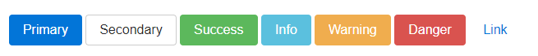

Code:

<!-- Provides extra visual weight and identifies the primary action in a set of buttons -->

<button type="button" class="btn btn-primary">Primary</button>

<!-- Secondary, outline button -->

<button type="button" class="btn btn-secondary">Secondary</button>

<!-- Indicates a successful or positive action -->

<button type="button" class="btn btn-success">Success</button>

<!-- Contextual button for informational alert messages -->

<button type="button" class="btn btn-info">Info</button>

<!-- Indicates caution should be taken with this action -->

<button type="button" class="btn btn-warning">Warning</button>

<!-- Indicates a dangerous or potentially negative action -->

<button type="button" class="btn btn-danger">Danger</button>

<!-- Deemphasize a button by making it look like a link while maintaining button behavior -->

<button type="button" class="btn btn-link">Link</button>

* Button groups: It includes a series of buttons. Button toolbar is of different sizes. Nesting of buttons are also possible by using dropdown button. There are horizontal and vertical variations available.

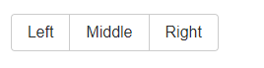

Code:

<div class="btn-group" role="group" aria-label="Basic example">

<button type="button" class="btn btn-secondary">Left</button>

<button type="button" class="btn btn-secondary">Middle</button>

<button type="button" class="btn btn-secondary">Right</button>

</div>

* Card: A card is a flexible and extensible content container. It includes options for headers and footers, a wide variety of content, contextual background colors, and powerful display options.

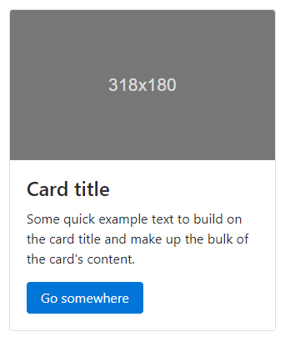

Code:

<div class="card" style="width: 20rem;">

<img class="card-img-top" src="..." alt="Card image cap">

<div class="card-block">

<h4 class="card-title">Card title</h4>

<p class="card-text">Some quick example text to build on the card title and make up the bulk of the card's content.</p>

<a href="#" class="btn btn-primary">Go somewhere</a>

</div>

</div>

* Carousel: it is just like a slideshow. It is available with normal controls, indicators and captions. Different classes are used to add different effects.



Code:

<div id="carouselExampleSlidesOnly" class="carousel slide" data-ride="carousel">

<div class="carousel-inner" role="listbox">

<div class="carousel-item active">

<img class="d-block img-fluid" src="..." alt="First slide">

</div>

<div class="carousel-item">

<img class="d-block img-fluid" src="..." alt="Second slide">

</div>

<div class="carousel-item">

<img class="d-block img-fluid" src="..." alt="Third slide">

</div>

</div>

</div>

* Dropdowns: It can be single button dropdown or split button dropdowns. Different sizing and alignments are used using different classes. Menu header and divider can also be added.

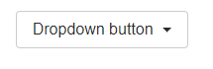

Code:

<div class="dropdown">

<button class="btn btn-secondary dropdown-toggle" type="button" id="dropdownMenuButton" data-toggle="dropdown" aria-haspopup="true" aria-expanded="false">

Dropdown button

</button>

<div class="dropdown-menu" aria-labelledby="dropdownMenuButton">

<a class="dropdown-item" href="#">Action</a>

<a class="dropdown-item" href="#">Another action</a>

<a class="dropdown-item" href="#">Something else here</a>

</div>

</div>

* Forms: It includes textareas, checkboxes, radio buttons etc. It may be stacked( vertical alignment) or inline forms( horizontal alignment). Use of grid makes it more attractive.
* Input groups: Extended form controls by text, buttons, radio, checkbox, buttons with dropdowns, segmented buttons.
* Jumbotron: A lightweight, flexible component that can optionally extend the entire viewport to showcase key marketing messages on your site.
* List group: It includes list which may contains active or disabled items.
* Modal: it is used to add dialogs to your site for lightboxes, user notification or completely custom content. Static modal includes modal header, modal body and modal footer. Live demo will toggle a working modal by clicking the button. It will slide down and fade in from the top of the page. Scrolling long content, vertically centered, tooltips and popovers are also placed within modals as needed. When modals are closed, any tooltips and popovers automatically dismissed.

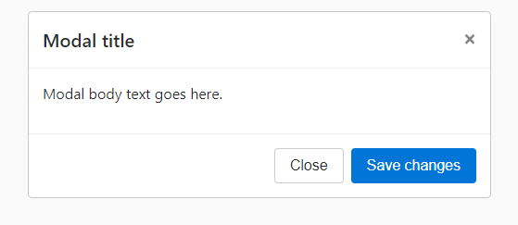

Code:

<div class="modal fade">

<div class="modal-dialog" role="document">

<div class="modal-content">

<div class="modal-header">

<h5 class="modal-title">Modal title</h5>

<button type="button" class="close" data-dismiss="modal" aria-label="Close">

<span aria-hidden="true">&times;</span>

</button>

</div>

<div class="modal-body">

<p>Modal body text goes here.</p>

</div>

<div class="modal-footer">

<button type="button" class="btn btn-primary">Save changes</button>

<button type="button" class="btn btn-secondary" data-dismiss="modal">Close</button>

</div>

</div>

</div>

</div>

* Navs: it is the navigation components. Base .nav class to active and disabled state. It has different styles- horizontal alignment or vertical alignment. .nav tabs class to generate a tabbed interface.

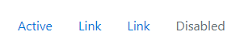

Code:

<ul class="nav">

<li class="nav-item">

<a class="nav-link active" href="#">Active</a>

</li>

<li class="nav-item">

<a class="nav-link" href="#">Link</a>

</li>

<li class="nav-item">

<a class="nav-link" href="#">Link</a>

</li>

<li class="nav-item">

<a class="nav-link disabled" href="#">Disabled</a>

</li>

</ul>

* Navbar: The navbar is a wrapper that positions branding, navigation, and other elements in a concise header.
* Pagination: It is used when you have a lot of pages in your website.
* Popovers: It is sed to display secondary information.
* Scrollspy: A scrollspy is a sophisticated way of changing the links in the navigation bar dynamically as the page is scrolled.

REFERENCE:

1. https://v4-alpha.getbootstrap.com/