INDOOR PLANT MONITORING SYSTEM

**Objective :**

The report mainly details about an Indoor Plant Monitoring System using an AVR ATmega328p based Arduino Uno board using Embedded C programming in Atmel Studio. The main aim of this project is to monitor the moisture content of the soil and water the plant based on the desired conditions. The motivation behind this project comes from the various technologies that were helpful for watering the plants and to monitor few parameters for the growth of the plants. With the help of the moisture content level of the soil, the health level of the plants can also be monitored.

**Components used and techniques implemented :**

The major components used in this project includes, ATmega328p based Arduino Uno board, 16x2 LCD Board, potentiometer, soil moisture sensor, servo motor, 5V Relay, 9V battery, submersible water pump with valve and wires.

A sample of soil with plant, was taken and tested to water the plant based on our given conditions. The soil moisture sensor is used to test or measure the moisture level in the soil, and if it is below the required condition the water pump automatically waters the plant(soil). The servo and LCD is used to indicate about the moisture content, whether the plant needs to be watered or not. And with the help of a submersible water pump connected with a valve, we water the plant and make to soil moist. Once the soil reaches the required moisture level, the pump automatically stops watering.

The following were the techniques used during the implementation of the project:

• Input/Ouput • Timer • Interrupt • ADC • Servo /PWM • LCD  
  
**Circuit design using TINKERCAD:**

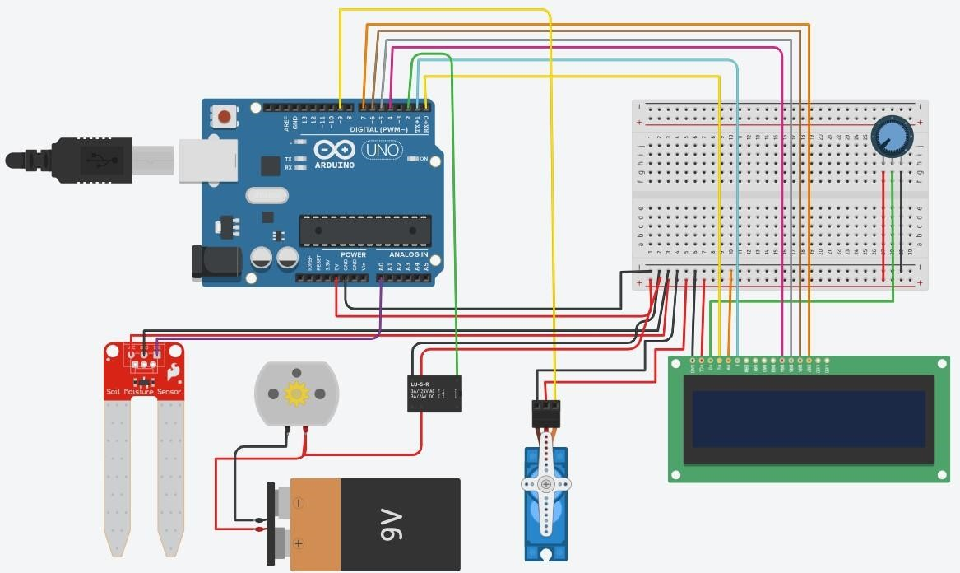

**Images captured during the project:**

1. **Experiment Setup:**

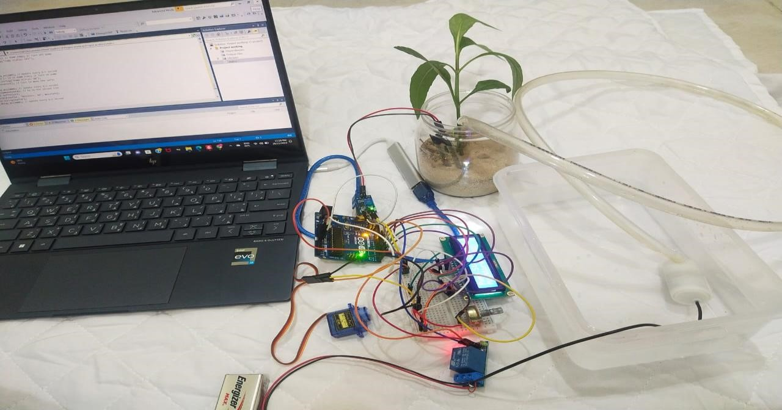

1. **DEMO Results:**

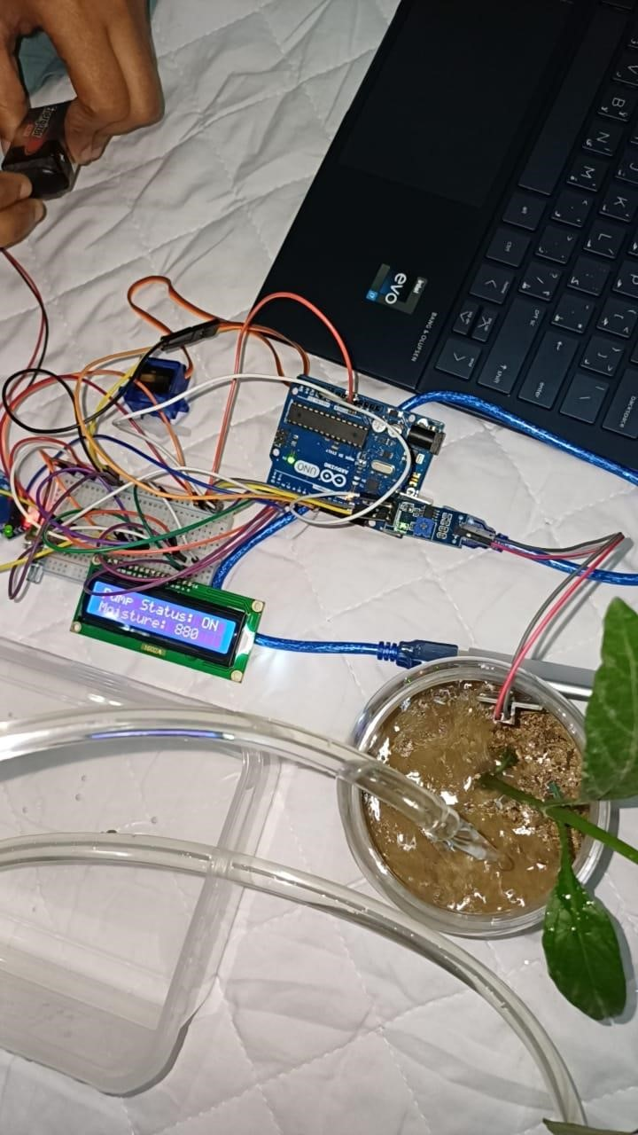

**Project Video Link :** The entire project video link can be found here

<https://youtu.be/xXRsXNmixb0>