"Takes any PDF, understands it deeply, and answers questions about it with cited sources — telling you exactly which page and paragraph the answer came from"

Phase 1 — The Foundation
Goal
Get a basic working pipeline — PDF in, answer out.
1. loader.py
- Opens moac.pdf using PyMuPDF
- Reads each page one by one
- Preserves page numbers (Page 1, Page 2...)
- Output: 18 PageContent objects

2. chunker.py
- Takes those 18 pages
- Splits each page into chunks of 512 tokens
- Uses 100 token OVERLAP between chunks
- (so no sentence gets cut off at a boundary)
- Tags every chunk with:
  - chunk_id (unique hash)
  - page_number
  - paragraph_index
  - token_count
- Output: 38 Chunk objects
3. embedder.py
- Takes those 38 chunks
- Runs each through HuggingFace all-MiniLM-L6-v2
- Converts text → 384-dimensional vector
- Stores everything in ChromaDB on disk
- Output: 38 vectors saved to data/chroma_db/
4. retriever.py
- Takes your question
- Converts it to a vector (same model)
- Asks ChromaDB: "which 5 vectors are most similar?"
- Uses cosine similarity to measure closeness
- Output: top 5 RetrievedChunk objects with scores
6. chain.py
- Takes those 5 chunks as context
- Formats them with their metadata
- Sends to Groq LLM (llama-3.1-8b — free)
- Prompt forces: always answer + always cite
- Output: answer with [Source, Page, Para] citations
7. main.py
- CLI with two commands:
  - python main.py ingest data/raw/moac.pdf
  - python main.py ask -q "your question"
  - python main.py ask (interactive mode)
Phase 1 pipeline:
PDF → Loader → Chunker → Embedder → ChromaDB

Question → Retriever → Chain (Groq) → Answer + Citations

Phase 1 limitation:
- Only uses vector search (semantic similarity)
- Misses exact keyword matches
- No quality check on retrieved chunks
- No way to know if answer is trustworthy
- Simple linear pipeline — no conditions

Phase 2 – Production Quality
Goal
Make retrieval smarter, answers more accurate, pipeline more intelligent.
The 6 new files and what each does
1. bm25_retriever.py
- Traditional keyword-based search
- Tokenizes every chunk by words
- When you ask a question, finds chunks
- containing your exact words
- Saved to data/chunks/bm25_index.json
- Output: top 20 BM25Result objects with scores
2. vector_retriever.py
- Same as Phase 1 retriever but:
  - Returns 20 candidates instead of 5
  - Standardized output format (VectorResult)
  - Designed to plug into hybrid fusion
- Output: top 20 VectorResult objects with scores
3. hybrid_retriever.py
- Runs BM25 and vector search simultaneously
- Merges results using RRF formula:
  - score = 1/(60 + rank)
- Chunks in BOTH lists get boosted scores
- Example from your run:
  - BM25 found: 20
  - Vector found: 20
  - After fusion: 33 unique candidates
  - Found by BOTH: 7 chunks (these are boosted)
- Output: top 20 HybridResult objects ranked by RRF score
4. reranker.py
- Takes those 20 hybrid candidates
- Sends each (question, chunk) PAIR to Cohere API
- Cohere evaluates: "does THIS chunk answer THIS question?"
- From your run:
  - 3 high confidence (score > 0.7)
  - 1 medium confidence (0.4-0.7)
  - 1 low confidence (< 0.4)
- Output: top 5 RerankedChunk objects with Cohere scores
5. citation_enforcer.py
- Runs AFTER the LLM generates an answer
- Extracts every citation from the answer
- Checks: does this (source, page, para) actually exist?
- Flags:
  - Invalid citations (LLM hallucinated a page number)
  - Uncited sentences (claims without any citation)
- Adds confidence footer to answer:
  - HIGH / MEDIUM / LOW / UNCITED
6. graph.py
Connects everything as a stateful graph:
Node 1: retrieve → hybrid retrieval (20 candidates)
Node 2: rerank → Cohere scoring (top 5)
↓
Conditional routing:
high confidence → Node 3a: generate_high (confident prompt)
low confidence → Node 3b: generate_low (careful prompt)
↓
Node 4: validate → citation enforcer checks output
↓
Final answer with confidence level
Phase 2 pipeline
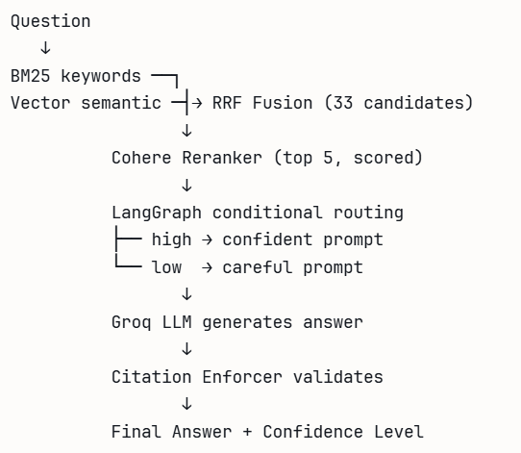

- Language Python 3.11
- PDF Parsing PyMuPDF (fitz)
- Tokenization tiktoken (cl100k_base)
- Embeddings HuggingFace all-MiniLM-L6-v2 (local, free)
- Vector Store ChromaDB (local, persistent)
- Keyword Search rank-bm25
- Fusion Custom RRF implementation
- Re-ranking Cohere rerank-english-v3.0
- LLM Groq llama-3.1-8b-instant (free)
- Orchestration LangChain + LangGraph
- Validation Custom CitationEnforcer
- Version Control Git + GitHubTools & Technologies Used

