|  |
| --- |
| **College:** *Gyalpozhing College of Information Technology* Vision: *“The center of Excellence in information Technology steeped in GNH values”* **Mission:**   * *To provide IT programmes of study at tertiary education level, of relevance and good quality which will meet the needs of the society.* * *To carry out research to support intellectual through innovation to the growth of Information and Communication Technology.* * *To provide training and professional services for continuous enhancement of knowledge, capacity building and community development.* |

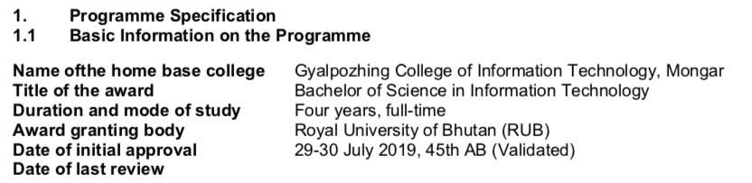

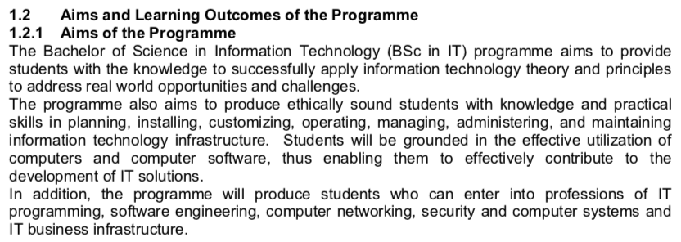

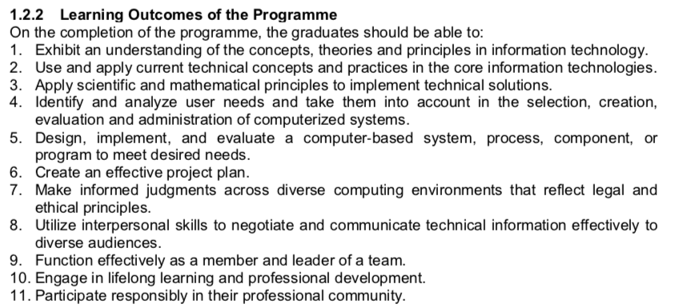

**Notes:** Vision and Missions are not reflected in the DPD of the programme instead are found in the college website. The programme (BSc in IT) aims to provide students with the knowledge to successfully apply information technology theory and principles to address real world opportunities and challenges. This aligns with the vision of the college where the center of excellence in Information technology is achieved by applying the knowledge in the real-world and the society. But somehow the full vision of college which is the **center of** **excellence in IT steeped in GNH values** are not directly included in the programme aims and learning outcomes but indirectly it is aligned. For example, through the usage of principles and knowledge of Information Technology, students can solve the real-world problems and able to deliver the solution to the society which brings harmony to the society which in turns provides IT solutions steeped with GNH values.

Regarding mission of the college, all the missions align with the programme learning outcomes. Details of each mission are given below:

* **To provide IT programmes of study at tertiary education level, of relevance and good quality which will meet the needs of the society :** *This mission aligns with almost all the learning outcomes of the programme. For example we have participating responsibly in their professional community, making informed judgements across diverse computing environment that reflects legal and ethical principles as one of the learning outcome of the programme.*
* **To carry out research to support intellectual through innovation to the growth of Information and Communication Technology:** *This mission aligns with the learning outcome number 10 where it engages in lifelong learning and professional development. Through professional development and research activities, lifelong learning is achieved.*
* **To provide training and professional services for continuous enhancement of knowledge, capacity building and community development :-** *This mission aligns with the learning outcome which engages in lifelong learning and professional development, use and apply current technical concepts, theories and practises in the core information technologies.*

Note: The core values of the college is not reflected in both the college website and the programme.