**Critical Reflection on Unit I: Introduction to Educational Technology**

In PDY512 module (Educational Technology), initially (Week 1), we were presented with the general objective of the module which is to provide fundamental knowledge of educational technology in higher education to make teaching learning more student-centered and practical. Further, the module workplan including the content delivery and the mode of assessments were presented and discussed. We also discussed and shared about the expectation from this course.

**Unit I: Introduction to Educational Technology** was started on week 2 which basically covered the concepts, purpose, trends, changing nature of work, importance, and benefits of Educational Technology. E-learning concepts such as tools and technologies were also covered with series of activities.

**Key concepts learnt In Unit I**

Educational Technology: Is a term used to describe a wide array of teaching-and-learning-related software and hardware that’s increasingly being used in college and university classrooms. Example of software includes Menti-meter, Slido, VLE and so on. As per the hardware, it includes laptop, projector, etc. All those hardware and software are also the part of multimedia technology, e-learning and many more.

The purpose of Educational Technology:

* To provide education though the usage of Information Communication Technology (ICT)
* To provide higher order thinking such as critical, creative, and collaborative skills in higher education settings.
* Enhancing and promoting computer-based educational resources such as Slido.
* Creating awareness of digital tools and usage.

**Activities conducted in unit I**

1. **Activity 1: Creating Blog**

We explored some of the free blogging sites to make personal blogs. Free blogging sites included Wix, WordPress, LinkedIn, Weebly, Medium, Blogger, Joomla etc. Upon much discussion, all the students preferred to use Blogger ([www.blogger.com](http://www.blogger.com)) due to its simplicity in its appearance. Blogger also delivers a bunch of themes to choose from. The main focus of creating blogs was to focus on our reflections of contents learnt in this module.

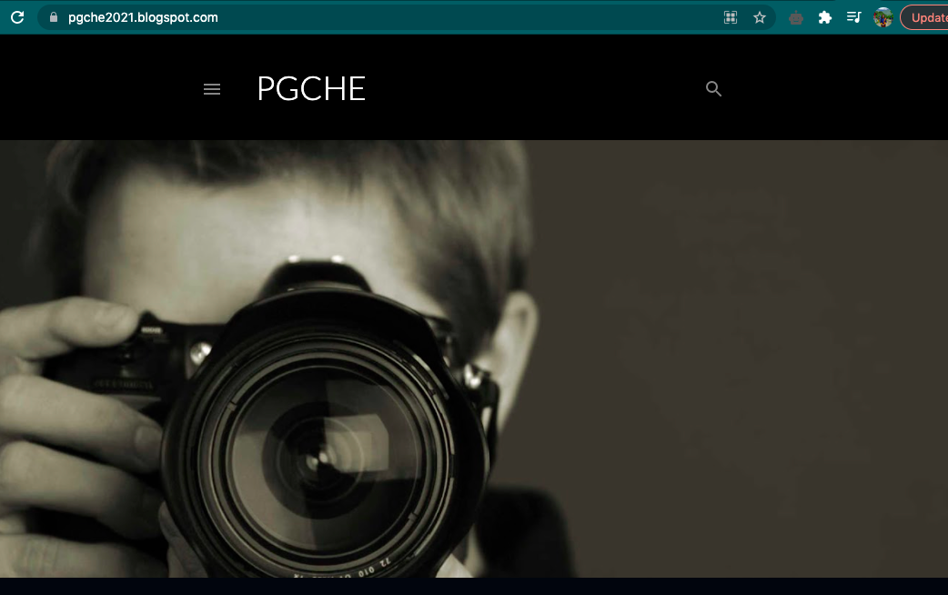

Figure 1: My personal blog(<https://pgche2021.blogspot.com/>)

*Source: https://themeisle.com/blog/best-free-blogging-sites/*

1. **Activity 2: Critical reflection of videos:**
   1. **Video 1:** [21st Century Education - YouTube](https://www.youtube.com/watch?app=desktop&v=nA1Aqp0sPQo)

Figure 2: Screenshot of the video

A 21st century education is about giving students **the talents they have**to **achieve**this new world, and helping them grow **the arrogance**to practice those skills. With **such a lot**information readily available to them, 21st century skills focus more on making sense of that information, sharing and using it in smart ways.

* 1. **Video 2:** [Singapore's 21st-Century Teaching Strategies (Education Everywhere Series) - YouTube](https://www.youtube.com/watch?app=desktop&v=M_pIK7ghGw4)

Figure 3: Screenshot of the video

Firstly the educators from this school have been empowered on the use of the ICT in the classroom. In the past the learning at this school was teacher-centered and yet they moved away from that. It is really true that learning really takes place where learners show interest . The learning in this school is now learner-centered. The teacher is no longer teaching but facilitating because the learners are the ones that are doing the tasks using technology. In my college as well, most of the teacher are facilitating the students because students learn when they do work by themselves else students expect spoon-feeding from the teachers on every content delivered.

* 1. **Video3:** [Technology in Education: A Future Classroom - YouTube](https://www.youtube.com/watch?app=desktop&v=uZ73ZsBkcus)

Figure 4: Screenshot from the video

Without a doubt, technology will be the future of the world and it will be of great help for teachers to teach and there will be drastic change in teaching methods as well.

* 1. **Video 4:** [Artificial Intelligence in Education - YouTube](https://www.youtube.com/watch?app=desktop&v=-nsVW6c2OQU)

Figure 5: AI in Education

When we break it down, a student’s goal is simple: obtain a degree or diploma proving their knowledge. AI can help students achieve this goal by streamlining the education process. By providing access to the proper courses, improving communication with teachers and freeing up longer to specialise in other aspects of life, AI can make a big impact on the students’ educational journey.

***Source:*** <https://thejournal.com/articles/2021/06/23/7-benefits-of-ai-in-education.aspx>

1. **Activity 3: Education reforms in the respective colleges:**

After the Royal Kasho, Every college has come up with the education. Gyalpozhing College of Information Technology have done major initiatives in terms of curriculum, infrastructure, learning and teaching.

Detailed narration is given in the link: <https://vle.sce.edu.bt/mod/forum/view.php?id=27144>

1. **Activity 4: Presenting the MOOC analysis report**

We were given task to choose MOOC platform and get enrolled in it to study its features. The one I referred was from the Udacity platform ([www.udacity.com](http://www.udacity.com)). I have given the detailed exploration in the discussion forum (<https://vle.sce.edu.bt/mod/forum/discuss.php?d=24265>) nevertheless, the main drawback was the assessment methods. The learners just have to watch the content without the assessment such as quizzes and assignments. Hence the clear goal testing of the learners are withheld.

1. **Activity 5: Multimedia in Education**

We explored most of the multimedia tools used in education. Multimedia can be text, audio, images, videos, graphics, animations etc., which can be used to deliver the contents in structured and meaningful way.

We explored the given link for detailed idea of multimedia in education:

<https://youtu.be/ugYYX758obM>

<https://sites.google.com/site/bethanycollegeofteacheredn/multimedia>

In nutshell, the usage of multimedia in education helps our students to work in groups critically, collaboratively and creatively which are the skills of 21st century.

1. **Activity 6: Concept Mapping Software**

In this activity, we explore concept mapping software called Freeplane. It is a free and opensource software for creating electronic outlines. This app is pretty basics and easy to use by the students and tutors. In addition, this software is supported in both Windows operating System and Mac operating system. The basic layout and the designare given below for the reference.

Figure 6: Layout of FreePlane

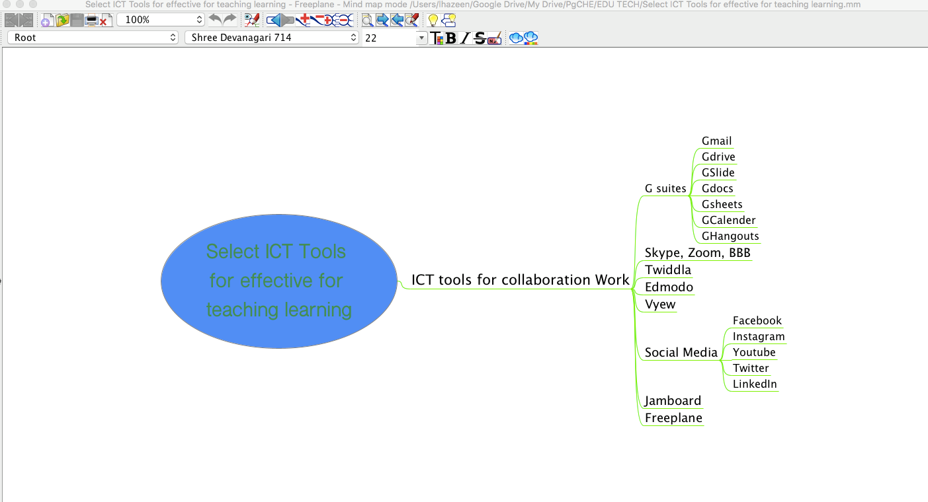

Figure 7: My Work on FreePlane