Project Report
of
Advanced Java Technologies
(CAN604)
BANKING MANAGEMENT SYSTEM

MASTER OF COMPUTER APPLICATION

SESSION 2024-25

SCHOOL OF COMPUTING
Submitted by:
KAVITA CHAUBEY (1000024336)
MUSKAN SAINI (1000025914)
SONAM (1000026084)

Submitted to:
Mr. RAVI SHANKAR JHA
ASSISTANT PROFESSOR
SCHOOL OF COMPUTING

DIT UNIVERSITY,DEHRADUN

Certificate of Completion
This is to certify that Sonam (SAP ID: 1000026084) has successfully completed the project titled "Banking Management System" as part of the academic curriculum for the course MCA at DIT University. The project was undertaken as part of the coursework requirements and demonstrates the application of core concepts in Java programming and software development.
Throughout the project, the student has applied various programming techniques, including the use of Java Swing for UI development, handling multiple sign-up pages, and incorporating features such as account creation, transaction processing, and balance management, showcasing the student’s understanding of both theoretical and practical aspects of object-oriented programming and database integration.
The project was developed under the guidance of Mr. Ravi Shankar Jha and represents the student’s ability to independently research, develop, and present a fully functional software application.
This certificate is awarded in recognition of the student’s dedication, hard work, and successful completion of the project.
Date: 15 – 04 - 2025
Mr. Ravi Shankar Jha
MCA
DIT University

Acknowledgment
We, the team of the "Banking Management System" project, would like to extend our heartfelt gratitude to all those who have contributed to the successful completion of this project. First and foremost, we would like to express our deepest appreciation to our project guide,
Mr. Ravi Shankar Jha, for his continuous support, insightful suggestions, and guidance throughout the development process. His expertise in Java programming and software development, as well as his unwavering patience, helped us navigate through the challenges of the project. We are truly grateful for his mentorship, which played a crucial role in the success of our project.
We also acknowledge the hard work, commitment, and collaborative spirit of our team members, Kavita Chaubey, Muskan Saini, and Sonam, who each brought their unique strengths and dedication to the project. Without their combined efforts, we would not have been able to complete this project. Their willingness to share ideas, work through difficulties, and support one another was essential to achieving our goal.
We would like to express our sincere thanks to DIT University for providing us with the opportunity to undertake this project as part of our academic curriculum. The resources, guidance, and learning environment provided by the university have been instrumental in enhancing our knowledge and skills.
Finally, we would like to extend our gratitude to our friends, peers, and everyone who provided their encouragement, support, and constructive feedback throughout the course of the project. Their contributions have motivated us to strive for excellence, and we are thankful for their continued support.

Index
Sr. No. | Topic | Page Number
1 | Introduction | 1
2 | System Design | 2
3 | Technologies Used | 3
4 | Implementation | 4
5 | Code Screenshots | 5 - 24
6 | Database Used | 25 - 26
7 | Conclusion | 27
8 | References | 27
9 | Appendix | 28

1.Introduction
The Banking Management System is a software application designed to automate the various operations of a banking system. It is aimed at providing a user-friendly and efficient way to manage customer accounts, transactions, and other related banking activities. The system allows users to create accounts, deposit and withdraw money, check account balances, and view transaction history, making it an essential tool for everyday banking operations.
The project is developed using Java and Java Swing for the graphical user interface, ensuring that the application is both functional and easy to use. The backend is supported by a MySQL database, which securely stores customer information, transaction data, and other relevant details.
The primary objective of this project is to demonstrate the practical application of object-oriented programming concepts, data structures, and database management systems. It serves as a valuable learning experience in the development of a real-world banking application, combining both theoretical knowledge and practical skills.
This system provides a seamless experience for both customers and bank employees, offering a range of functionalities that simplify banking tasks while ensuring data integrity and security. The Banking Management System can be further enhanced to include additional features, such as loan management, account types, and user authentication.
In addition to the core banking functions, this system is designed to handle a large volume of data efficiently, ensuring scalability and speed. By focusing on ease of use and data integrity, the application is built to provide a seamless experience for both customers and bank employees. The system also lays the foundation for future improvements, such as integrating features like online transactions, account security measures, and reporting systems.

2.System Design
The Banking Management System has been designed with a focus on simplicity, modularity, and user interaction. The overall architecture is developed using Java Swing for the front-end interface and MySQL for the backend database. The development environment used for the project is Eclipse IDE, which helped us in managing the code in an organized and efficient manner.
The project is divided into multiple modules such as SignUp, SignUp2, Login, Transaction, and Pin Change, each of which is developed as a separate Java class. This modular structure not only makes the system more organized but also improves code readability and makes it easy to test and debug individual components. Each class is connected to a common flow using object-oriented principles such as inheritance and encapsulation.
The SignUp and SignUp2 pages collect basic and additional user details like name, gender, marital status, address, account type, services required, etc., which are then stored in the database. Once the user is registered, the Login page allows the user to log in securely using the credentials saved in the database. After a successful login, users can access the main dashboard and perform operations like deposit, withdraw, balance check, and transaction history.
The data entered through the Swing components (text fields, buttons, combo boxes, etc.) is linked with JDBC (Java Database Connectivity) to interact with the MySQL database. All data such as account details, transactions, and login credentials are stored in properly normalized tables. The database design follows relational principles and uses primary keys to uniquely identify each user and transaction record.
Overall, the system design combines front-end visual interaction with back-end data processing in a clean and maintainable structure. The design also allows for future enhancements like adding an admin panel, generating reports, or integrating online banking features. All these decisions in design were taken considering the scalability and learning aspect of the project.

3.Technologies Used
The Banking Management System was developed using a combination of front-end and back-end technologies that support both functionality and a user-friendly interface. The main technologies used are:
- Java: The primary programming language used to build the structure and logic of the application, utilizing object-oriented programming concepts.
- Java Swing: Used for designing the graphical user interface. Swing components such as JFrame, JPanel, JButton, JLabel, and others were used to create interactive forms like SignUp, Login, and Transactions.
- MySQL: Served as the database system for storing and managing data such as user details, login credentials, and transaction records.
- JDBC (Java Database Connectivity): Enabled smooth communication between the Java application and the MySQL database through SQL queries.
- IntelliJ IDEA: Used as the Integrated Development Environment (IDE) for writing, managing, and debugging the Java code. It provided features like smart code completion, integrated terminal, and version control support, which improved development efficiency.
These technologies together ensured that the project remained practical, reliable, and easy to extend for future enhancements.

4.Implementation
The implementation of the Banking Management System was carried out step-by-step, starting from the user interface design to database integration. The project includes several key modules, each responsible for handling a specific banking operation.
The application begins with the SignUp and SignUp2 pages, where users enter their personal and account-related information. All input fields are created using Java Swing components like JTextField, JRadioButton, JComboBox, and JButton. Once the form is submitted, the data is stored in the MySQL database using JDBC.
After registration, users are directed to the Login page. This module checks the entered credentials against the database records. If the details are correct, users can log in and access the main transaction menu.
The transaction window allows users to deposit, withdraw, check balance, and view mini statements. Each operation is implemented in a separate class, with appropriate event handling using ActionListener. For example, in the withdraw class, after entering the amount and clicking the button, the system checks the current balance and updates it in the database.
To ensure smooth communication between the GUI and the database, proper SQL queries are written inside try-catch blocks to handle exceptions like connection errors or invalid inputs. JOptionPane is used for showing confirmation messages or errors, which improves the user experience.
During implementation, the project was regularly tested for validation and logic errors. Any bugs or unexpected behavior were resolved by checking the flow of data and making use of IntelliJ IDEA’s debugging tools. The teamwork and clear division of responsibilities helped ensure that each part of the system was implemented efficiently and integrated smoothly with other modules.

5.Screenshots of the Application
1 . Login Page:
import javax.swing.*;
import java.awt.*;
import java.awt.event.*;
import java.sql.*;
public class Login extends JFrame implements ActionListener{
JTextField cardField;
JPasswordField pinField;
JButton clear,signIn,signUp;
public Login(){
setTitle("Automated Teller Machine");
setSize(650,500);
setLayout(null);
getContentPane().setBackground(Color.WHITE);
setDefaultCloseOperation(EXIT_ON_CLOSE);
// Heading
JLabel text = new JLabel("Welcome To ATM");
text.setFont(new Font("Arial",Font.BOLD,30));
text.setBounds(80,20,300,70);
add(text);
// Card Label
JLabel cardNumber = new JLabel("Card Number: ");
cardNumber.setFont(new Font("Arial",Font.BOLD,18));
cardNumber.setBounds(80,120,250,50);
add(cardNumber);
cardField = new JTextField();
cardField.setBounds(240,120,300,40);
cardField.setFont(new Font("Arial",Font.BOLD,14));
add(cardField);
// Pin label
JLabel pin = new JLabel("PIN: ");
pin.setFont(new Font("Arial",Font.BOLD,18));
pin.setBounds(80,190,250,50);
add(pin);
pinField = new JPasswordField();
pinField.setBounds(240,190,300,40);
pinField.setFont(new Font("Arial",Font.BOLD,14));
add(pinField);
// Sign In
signIn = new JButton("Sign In");
signIn.setFont(new Font("Arial",Font.BOLD,16));
signIn.setBackground(Color.BLACK);
signIn.setForeground(Color.white);
signIn.setBounds(240,280,140,40);
add(signIn);
signIn.addActionListener(this);
// Clear
clear = new JButton("Clear");
clear.setFont(new Font("Arial",Font.BOLD,16));
clear.setBounds(400,280,140,40);
clear.setBackground(Color.BLACK);
clear.setForeground(Color.white);
add(clear);
clear.addActionListener(this);
//Sign Up
signUp = new JButton("Sign Up");
signUp.setFont(new Font("Arial",Font.BOLD,16));
signUp.setBackground(Color.BLACK);
signUp.setForeground(Color.white);
signUp.setBounds(240,350,300,40);
add(signUp);
signUp.addActionListener(this);
setVisible(true);
}
@Override
public void actionPerformed(ActionEvent e){
if(e.getSource()==clear){
cardField.setText("");
pinField.setText("");
} else if (e.getSource() == signUp){
setVisible(false);
new SignUpDetails().setVisible(true);
} else if (e.getSource() == signIn){
JDBConnector c = new JDBConnector();
String cardNumber = cardField.getText();
String pinNumber = pinField.getText();
String query = "select * from login where cardnumber = '"+cardNumber+"' and pin = '"+pinNumber+"'";
try {
ResultSet rs = c.s.executeQuery(query);
if(rs.next()){
setVisible(false);
new Transaction(pinNumber).setVisible(true);
}else{
JOptionPane.showMessageDialog(null,"Incorrect Card Number or Pin");
}
}catch (Exception ex){
System.out.println(ex);
}
}
}
public static void main(String[] args) {
new Login();
}
}

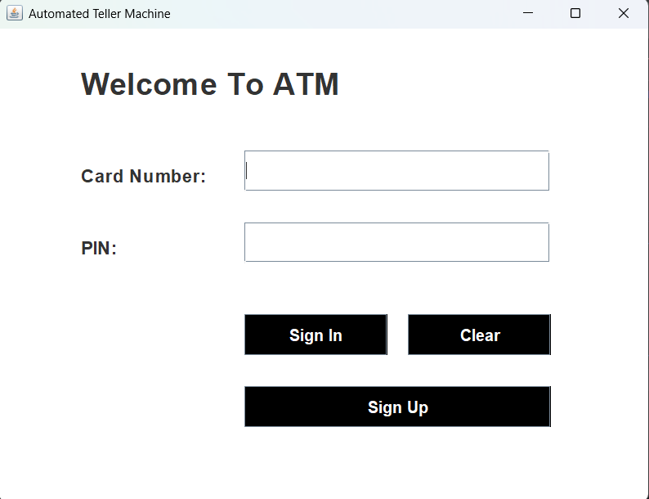
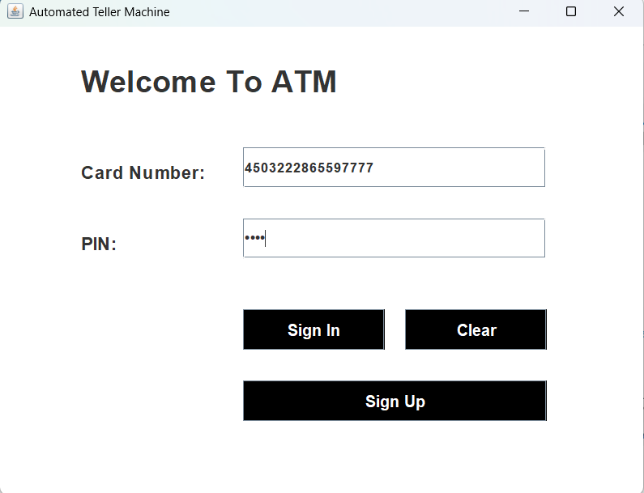

2 . Sign Up:
import java.util.*;
public class SignUpDetails extends JFrame implements ActionListener{
JTextField nameField,fatherNameField,dobField,emailField,addressField,cityField,stateField,pinCodeField;
JRadioButton genderMale, genderFemale,genderOthers;
JButton nextbutton;
Random ran = new Random();
long first4 = (ran.nextLong() % 9000L) + 1000L;
String first = "" + Math.abs(first4);
public SignUpDetails(){
setTitle("New Account Application - Page 1");
setLocation(300,0);
setSize(550,650);
setLayout(null);
setDefaultCloseOperation(EXIT_ON_CLOSE);
JLabel applicationForm = new JLabel("ADD YOUR DETAILS: "+ first);
applicationForm.setBounds(130,20,290,70);
applicationForm.setFont(new Font("Raleway",Font.BOLD,20));
add(applicationForm);
JLabel name = new JLabel("Name:");
name.setBounds(65,100,120,80);
name.setFont(new Font("Raleway",Font.BOLD,14));
add(name);
JLabel fatherName = new JLabel("Father's Name: ");
fatherName.setBounds(65,140,120,80);
fatherName.setFont(new Font("Raleway",Font.BOLD,14));
add(fatherName);
JLabel dob = new JLabel("Date Of Birth:");
dob.setBounds(65,180,120,80);
dob.setFont(new Font("Raleway",Font.BOLD,14));
add(dob);
JLabel gender = new JLabel("Gender");
gender.setBounds(65,220,120,80);
gender.setFont(new Font("Raleway",Font.BOLD,14));
add(gender);
JLabel email = new JLabel("Email Address:");
email.setBounds(65,260,120,80);
email.setFont(new Font("Raleway",Font.BOLD,14));
add(email);
JLabel address = new JLabel("Address:");
address.setBounds(65,300,120,80);
address.setFont(new Font("Raleway",Font.BOLD,14));
add(address);
JLabel city = new JLabel("City");
city.setBounds(65,340,120,80);
city.setFont(new Font("Raleway",Font.BOLD,14));
add(city);
JLabel state = new JLabel("State:");
state.setBounds(65,380,120,80);
state.setFont(new Font("Raleway",Font.BOLD,14));
add(state);
JLabel pinCode = new JLabel("Pin Code:");
pinCode.setBounds(65,420,120,80);
pinCode.setFont(new Font("Raleway",Font.BOLD,14));
add(pinCode);
// Text Fields
nameField = new JTextField();
nameField.setBounds(190, 130, 250, 25);
add(nameField);
fatherNameField = new JTextField();
fatherNameField.setBounds(190, 170, 250, 25);
add(fatherNameField);
dobField = new JTextField("YYYY-MM-DD");
dobField.setBounds(190, 210, 250, 25);
add(dobField);
genderMale = new JRadioButton("Male");
genderMale.setBounds(190, 250, 70, 25);
add(genderMale);
genderFemale = new JRadioButton("Female");
genderFemale.setBounds(270, 250, 80, 25);
add(genderFemale);
genderOthers = new JRadioButton("Others");
genderOthers.setBounds(360, 250, 80, 25);
add(genderOthers);
ButtonGroup genderGroup = new ButtonGroup();
genderGroup.add(genderMale);
genderGroup.add(genderFemale);
genderGroup.add(genderOthers);
emailField = new JTextField();
emailField.setBounds(190, 290, 250, 25);
add(emailField);
addressField = new JTextField();
addressField.setBounds(190, 330, 250, 25);
add(addressField);
cityField = new JTextField();
cityField.setBounds(190, 370, 250, 25);
add(cityField);
stateField = new JTextField();
stateField.setBounds(190, 410, 250, 25);
add(stateField);
pinCodeField = new JTextField();
pinCodeField.setBounds(190, 450, 250, 25);
add(pinCodeField);
//Button
nextbutton = new JButton("Next");
nextbutton.setBounds(310,490,130,40);
nextbutton.setFont(new Font("Raleway", Font.BOLD,16));
nextbutton.setBackground(Color.BLACK);
nextbutton.setForeground(Color.white);
add(nextbutton);
nextbutton.addActionListener(this);
setVisible(true);
}
@Override
public void actionPerformed(ActionEvent e){
String formno = first;
String userName = nameField.getText();
String userFather = fatherNameField.getText();
String userdob = dobField.getText();
String userGender = null;
if(genderMale.isSelected()){
userGender ="Male";
}else if(genderFemale.isSelected()){
userGender ="Female";
}
String gmail = emailField.getText();
String userAddress = addressField.getText();
String userCity = cityField.getText();
String userState = stateField.getText();
String userPin = pinCodeField.getText();
try{
if(userName.equals("")){
JOptionPane.showMessageDialog(null,"NAME REQUIRED");
}
else{
JDBConnector c = new JDBConnector();
String query = "insert into signup values('"+formno+"','"+userName+"','"+userFather+"','"+userdob+"','"+userGender+"','"+gmail+"','"+userAddress+"','"+userCity+"','"+userState+"','"+userPin+"')";
c.s.executeUpdate(query);
setVisible(false);
new SignUp(formno).setVisible(true);
}
}catch (Exception ae){
System.out.println(ae);
}
}
public static void main(String[] args) {
new SignUpDetails();
}
}
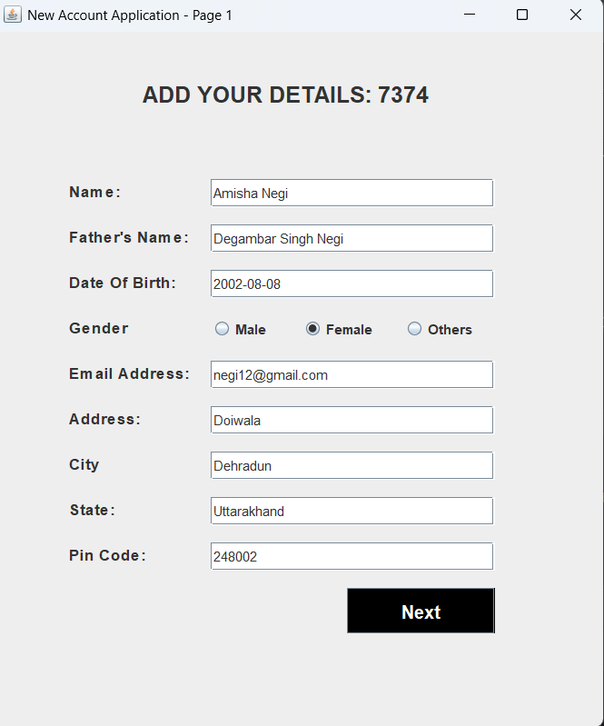
3 . Sign Up 2 :
import javax.swing.*;
import java.awt.*;
import java.awt.event.*;
public class SignUp extends JFrame implements ActionListener{
JComboBox<String> religionBox, categoryBox, incomeBox, educationBox, occupationBox;
JTextField panField, aadharField;
JRadioButton seniorYes,seniorNo,accountYes,accountNo;
String formno;
public SignUp(String formno){
this.formno = formno;
setTitle("New Account Application - Page 2");
setLocation(300,0);
setSize(500,650);
setLayout(null);
setDefaultCloseOperation(EXIT_ON_CLOSE);
JLabel signInDetail = new JLabel("ADD YOUR DETAILS" + formno);
signInDetail.setBounds(140,20,250,70);
signInDetail.setFont(new Font("Raleway",Font.BOLD,20));
add(signInDetail);
JLabel religion = new JLabel("Religion:");
religion.setBounds(40,100,100,40);
religion.setFont(new Font("Raleway",Font.BOLD,14));
add(religion);
JLabel category = new JLabel("Category:");
category.setBounds(40,140,100,40);
category.setFont(new Font("Raleway",Font.BOLD,14));
add(category);
JLabel income = new JLabel("Income:");
income.setBounds(40,180,100,40);
income.setFont(new Font("Raleway",Font.BOLD,14));
add(income);
JLabel education = new JLabel("<html>Education<br>Qualificaton:</html>");
education.setBounds(40,220,100,80);
education.setFont(new Font("Raleway",Font.BOLD,14));
add(education);
JLabel occupation = new JLabel("Occupation:");
occupation.setBounds(40,290,100,40);
occupation.setFont(new Font("Raleway",Font.BOLD,14));
add(occupation);
JLabel panNumber = new JLabel("Pan Number:");
panNumber.setBounds(40,330,100,40);
panNumber.setFont(new Font("Raleway",Font.BOLD,14));
add(panNumber);
JLabel aadharNumber = new JLabel("Aadhar Number:");
aadharNumber.setBounds(40,370,120,40);
aadharNumber.setFont(new Font("Raleway",Font.BOLD,14));
add(aadharNumber);
JLabel seniorCitizen = new JLabel("Senior Citizen:");
seniorCitizen.setBounds(40,410,120,40);
seniorCitizen.setFont(new Font("Raleway",Font.BOLD,14));
add(seniorCitizen);
JLabel existAcc = new JLabel("Existing Account:");
existAcc.setBounds(40,450,140,40);
existAcc.setFont(new Font("Raleway",Font.BOLD,14));
add(existAcc);
// side field
String[] religions = {"Hindu", "Muslim", "Christian", "Sikh", "Other"};
religionBox = new JComboBox<>(religions);
religionBox.setBounds(200, 110, 220, 25);
religionBox.setBackground(Color.WHITE);
add(religionBox);
String[] categories = {"General", "OBC", "SC", "ST", "Other"};
categoryBox = new JComboBox<>(categories);
categoryBox.setBounds(200, 150, 220, 25);
categoryBox.setBackground(Color.WHITE);
add(categoryBox);
String[] incomes = {"< 1 Lakh", "1 - 5 Lakh", "5 - 10 Lakh", "Above 10 Lakh"};
incomeBox = new JComboBox<>(incomes);
incomeBox.setBounds(200, 190, 220, 25);
incomeBox.setBackground(Color.WHITE);
add(incomeBox);
String[] educations = {"Non-Graduate", "Graduate", "Post-Graduate", "Doctorate", "Other"};
educationBox = new JComboBox<>(educations);
educationBox.setBounds(200, 250, 220, 25);
educationBox.setBackground(Color.WHITE);
add(educationBox);
String[] occupations = {"Salaried", "Self-Employed", "Business", "Student", "Retired", "Other"};
occupationBox = new JComboBox<>(occupations);
occupationBox.setBounds(200, 300, 220, 25);
occupationBox.setBackground(Color.WHITE);
add(occupationBox);
panField = new JTextField();
panField.setBounds(200, 340, 220, 25);
panField.setBackground(Color.WHITE);
add(panField);
aadharField = new JTextField();
aadharField.setBounds(200, 380, 220, 25);
aadharField.setBackground(Color.WHITE);
add(aadharField);
seniorYes = new JRadioButton("Yes");
seniorYes.setBounds(200, 420, 50, 25);
add(seniorYes);
seniorNo = new JRadioButton("No");
seniorNo.setBounds(280, 420, 50, 25);
add(seniorNo);
ButtonGroup seniorCitizenGroup = new ButtonGroup();
seniorCitizenGroup.add(seniorYes);
seniorCitizenGroup.add(seniorNo);
accountYes = new JRadioButton("Yes");
accountYes.setBounds(200, 460, 50, 25);
add(accountYes);
accountNo = new JRadioButton("No");
accountNo.setBounds(280, 460, 50, 25);
add(accountNo);
ButtonGroup existingAccountGroup = new ButtonGroup();
existingAccountGroup.add(accountYes);
existingAccountGroup.add(accountNo);
JButton nextButton = new JButton("Next");
nextButton.setBounds(340, 520, 80, 30);
nextButton.setBackground(Color.BLACK);
nextButton.setForeground(Color.WHITE);
nextButton.addActionListener(this);
add(nextButton);
setVisible(true);
}
@Override
public void actionPerformed(ActionEvent e){
String userReligion = (String) religionBox.getSelectedItem();
String userCategory = (String) categoryBox.getSelectedItem();
String userIncome = (String) incomeBox.getSelectedItem();
String userEducation = (String) educationBox.getSelectedItem();
String userOccupation = (String) occupationBox.getSelectedItem();
String userPan = panField.getText();
String userAadhar = aadharField.getText();
String userSeniorCitizen = null;
if (seniorYes.isSelected()) {
userSeniorCitizen = "Yes";
} else if (seniorNo.isSelected()) {
userSeniorCitizen = "No";
}
String userExistingAccount = null;
if (accountYes.isSelected()) {
userExistingAccount = "Yes";
} else if (accountNo.isSelected()) {
userExistingAccount = "No";
}
try{
if(userAadhar.equals("")){
JOptionPane.showMessageDialog(null,"Aadhar Number Required!");
}
else{
JDBConnector c = new JDBConnector();
String query = "insert into signuptwo values('"+formno+"','" + userReligion + "','" + userCategory + "','" + userIncome + "','" + userEducation + "','" + userOccupation + "','" + userPan + "','" + userAadhar + "','" + userSeniorCitizen + "','" + userExistingAccount + "')";
c.s.executeUpdate(query);
setVisible(false);
new SignUp2(formno).setVisible(true);
}
}catch (Exception ae){
System.out.println(ae);
}
}
public static void main(String[] args) {
new SignUp("");
}
}
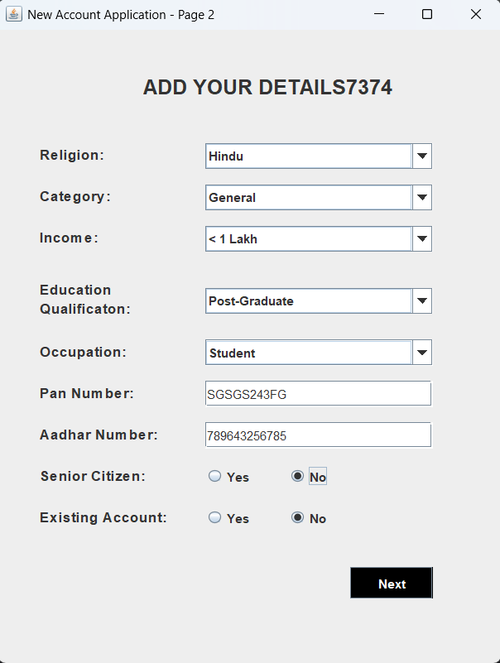

4. Sign up 3:
import javax.swing.*;
import java.awt.*;
import java.awt.event.ActionEvent;
import java.awt.event.ActionListener;
import java.sql.*;
import java.util.*;
public class SignUp2 extends JFrame implements ActionListener {
JRadioButton r1,r2,r3,r4;
JCheckBox c1,c2,c3,c4,c5,c6,c7;
JButton bt1,bt2;
String formno;
public SignUp2(String formno){
this.formno = formno;
setTitle("New Account Application - Page 3");
setLocation(300,0);
setSize(520,720);
setLayout(null);
setDefaultCloseOperation(EXIT_ON_CLOSE);
JLabel signInDetail = new JLabel("ADD YOUR DETAILS" + formno);
signInDetail.setBounds(140,20,250,70);
signInDetail.setFont(new Font("Raleway",Font.BOLD,20));
add(signInDetail);
JLabel acc = new JLabel("Account Type");
acc.setBounds(40,100,130,40);
acc.setFont(new Font("Raleway",Font.BOLD,16));
add(acc);
r1 = new JRadioButton("Saving Account");
r1.setBounds(40,140,120,30);
r1.setFont(new Font("Raleway",Font.BOLD,12));
add(r1);
r2 = new JRadioButton("Fixed Deposit Account");
r2.setBounds(200,140,160,30);
r2.setFont(new Font("Raleway",Font.BOLD,12));
add(r2);
r3 = new JRadioButton("Current Account");
r3.setBounds(40,170,120,30);
r3.setFont(new Font("Raleway",Font.BOLD,12));
add(r3);
r4 = new JRadioButton("Recurring Deposit Account");
r4.setBounds(200,170,180,30);
r4.setFont(new Font("Raleway",Font.BOLD,12));
add(r4);
ButtonGroup b1 = new ButtonGroup();
b1.add(r1);
b1.add(r2);
b1.add(r3);
b1.add(r4);
JLabel card = new JLabel("Card Number");
card.setBounds(40,220,130,40);
card.setFont(new Font("Raleway",Font.BOLD,16));
add(card);
JLabel card1 = new JLabel("XXXX-XXXX-XXXX-4336");
card1.setBounds(200,220,180,40);
card1.setFont(new Font("Raleway",Font.BOLD,16));
card1.setForeground(Color.blue);
add(card1);
JLabel pn = new JLabel("PIN: ");
pn.setBounds(40,280,130,40);
pn.setFont(new Font("Raleway",Font.BOLD,16));
add(pn);
JLabel pn1 = new JLabel("XXXX");
pn1.setBounds(200,280,180,40);
pn1.setFont(new Font("Raleway",Font.BOLD,16));
pn1.setForeground(Color.blue);
add(pn1);
JLabel sr = new JLabel("Service Required: ");
sr.setBounds(40,340,150,40);
sr.setFont(new Font("Raleway",Font.BOLD,16));
add(sr);
c1 = new JCheckBox("ATM Card");
c1.setBounds(40, 380, 150, 30);
c1.setFont(new Font("Raleway", Font.BOLD, 12));
add(c1);
c2 = new JCheckBox("Internet Banking");
c2.setBounds(40, 420, 150, 30);
c2.setFont(new Font("Raleway", Font.BOLD, 12));
add(c2);
c3 = new JCheckBox("Mobile Banking");
c3.setBounds(40, 460, 150, 30);
c3.setFont(new Font("Raleway", Font.BOLD, 12));
add(c3);
c4 = new JCheckBox("Email and SMS Alerts");
c4.setBounds(250, 380, 180, 30);
c4.setFont(new Font("Raleway", Font.BOLD, 12));
add(c4);
c5 = new JCheckBox("Cheque Book");
c5.setBounds(250, 420, 150, 30);
c5.setFont(new Font("Raleway", Font.BOLD, 12));
add(c5);
c6 = new JCheckBox("E-Statement");
c6.setBounds(250, 460, 150, 30);
c6.setFont(new Font("Raleway", Font.BOLD, 12));
add(c6);
c7 = new JCheckBox("<html> I hereby declares that the above entered details are correct to the best <br>of my knowledge.</html>");
c7.setBounds(40, 520, 450, 30);
c7.setFont(new Font("Raleway", Font.BOLD, 10));
add(c7);
bt1 = new JButton("Submit");
bt1.setBounds(100,580,120,40);
bt1.setFont(new Font("Raleway",Font.BOLD,16));
bt1.setForeground(Color.white);
bt1.setBackground(Color.black);
add(bt1);
bt1.addActionListener(this);
bt2 = new JButton("Cancel");
bt2.setBounds(280,580,120,40);
bt2.setFont(new Font("Raleway",Font.BOLD,16));
bt2.setForeground(Color.white);
bt2.setBackground(Color.black);
add(bt2);
bt2.addActionListener(this);
setVisible(true);
}
public void actionPerformed(ActionEvent ae) {
if (ae.getSource() == bt1) {
String accountType = null;
if (r1.isSelected()) {
accountType = "Saving Account";
} else if (r2.isSelected()) {
accountType = "Fixed Deposit Account";
} else if (r3.isSelected()) {
accountType = "Current Account";
} else if (r4.isSelected()) {
accountType = "Recurring Deposit Account";
}
Random ran = new Random();
String cardNumber = "" + Math.abs((ran.nextLong() % 90000000L) + 4503222900000000L);
String pinNumber = String.format("%04d", ran.nextInt(10000));
String services = "";
if (c1.isSelected()) {
services += "ATM Card, ";
}
if (c2.isSelected()) {
services += "Internet Banking, ";
}
if (c3.isSelected()) {
services += "Mobile Banking, ";
}
if (c4.isSelected()) {
services += "Email and SMS Alerts, ";
}
if (c5.isSelected()) {
services += "Cheque Book, ";
}
if (c6.isSelected()) {
services += "E-Statement, "; }
try {
if (accountType.equals("")) {
JOptionPane.showMessageDialog(null, "Account Type is Required");
} else {
JDBConnector con = new JDBConnector();
String query = "INSERT INTO signupthree values('" + formno + "', '" + accountType + "', '" + cardNumber + "', '" + pinNumber + "', '" + services + "')";
String query1 = "INSERT INTO login values('" + formno + "', '" + cardNumber + "', '" + pinNumber + "')";
con.s.executeUpdate(query);
con.s.executeUpdate(query1);
JOptionPane.showMessageDialog(null, "Card Number: " + cardNumber + "\nPin: " + pinNumber);
setVisible(false);
new Deposit(pinNumber).setVisible(false); // Uncomment this line if you have SignUp3
}
} catch (Exception e) {
System.out.println(e);
}
} else if (ae.getSource() == bt2) {
setVisible(false);
new Login().setVisible(true);
}
}
public static void main(String[] args) {
new SignUp2("");
}
}
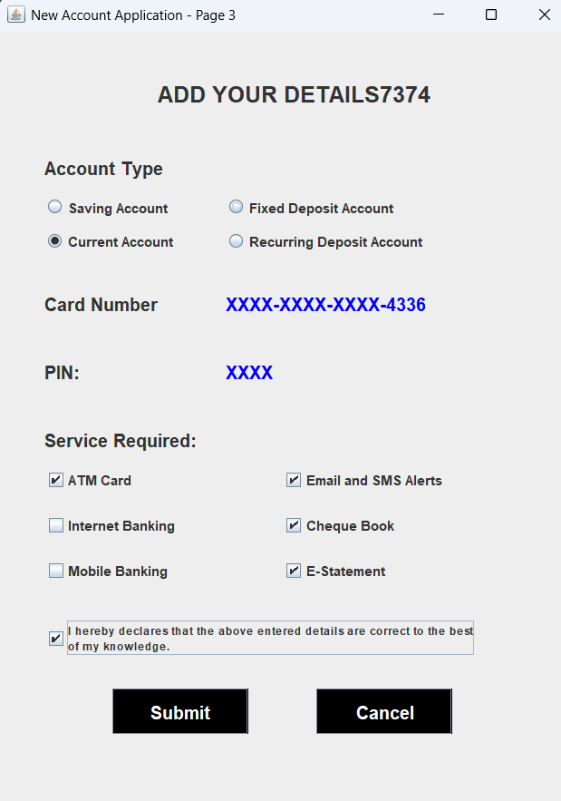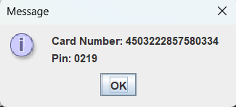

5. Transaction :
import javax.swing.*;
import java.awt.*;
import java.awt.event.ActionEvent;
import java.awt.event.ActionListener;
public class Transaction extends JFrame implements ActionListener {
JButton deposit, withdrawl, fastcash, ministatement, pinchange, balanceenquiry,exit;
String pinNumber;
public Transaction(String pinNumber){
this.pinNumber = pinNumber;
setTitle("Transaction");
setSize(620,580);
setLayout(null );
getContentPane().setBackground(Color.BLACK);
setLocation(300,0);
JLabel text = new JLabel("Please select your Transaction");
text.setBounds(150,50,400,40);
text.setFont(new Font("System", Font.BOLD, 20));
text.setForeground(Color.WHITE);
add(text);
deposit = new JButton("Deposit");
deposit.setBounds(80, 150, 200, 40);
deposit.setFont(new Font("System", Font.BOLD, 16));
deposit.addActionListener(this);
add(deposit);
withdrawl = new JButton("Cash Withdrawal");
withdrawl.setBounds(80, 240, 200, 40);
withdrawl.setFont(new Font("System", Font.BOLD, 16));
withdrawl.addActionListener(this);
add(withdrawl);
fastcash = new JButton("Fast Cash");
fastcash.setBounds(320, 150, 200, 40);
fastcash.setFont(new Font("System", Font.BOLD, 16));
fastcash.addActionListener(this);
add(fastcash);
ministatement = new JButton("Mini Statement");
ministatement.setBounds(80, 330, 200, 40);
ministatement.setFont(new Font("System", Font.BOLD, 16));
ministatement.addActionListener(this);
add(ministatement);
pinchange = new JButton("PIN Change");
pinchange.setBounds(320, 240, 200, 40);
pinchange.setFont(new Font("System", Font.BOLD, 16));
pinchange.addActionListener(this);
add(pinchange);
balanceenquiry = new JButton("Balance Enquiry");
balanceenquiry.setBounds(320, 330, 200, 40);
balanceenquiry.setFont(new Font("System", Font.BOLD, 16));
balanceenquiry.addActionListener(this);
add(balanceenquiry);
exit = new JButton("Exit");
exit.setBounds(370, 420, 100, 40);
exit.setFont(new Font("System", Font.BOLD, 16));
exit.addActionListener(this);
add(exit);
setVisible(true);
}
public void actionPerformed(ActionEvent ae){
if(ae.getSource() == exit){
System.exit(0);
}else if(ae.getSource() == deposit){
setVisible(false);
new Deposit(pinNumber).setVisible(true);
}else if(ae.getSource() == withdrawl){
setVisible(false);
new Withdrawal(pinNumber).setVisible(true);
}else if(ae.getSource() == fastcash){
setVisible(false);
new FastCash(pinNumber).setVisible(true);
}else if(ae.getSource() == pinchange){
setVisible(false);
new PinChange(pinNumber).setVisible(true);
}else if(ae.getSource() == balanceenquiry){
setVisible(false);
new BalanceEnquiry(pinNumber).setVisible(true);
}else if(ae.getSource() == ministatement){
new MiniStatement(pinNumber).setVisible(true);
}
}
public static void main(String[] args) {
new Transaction("");
}
}
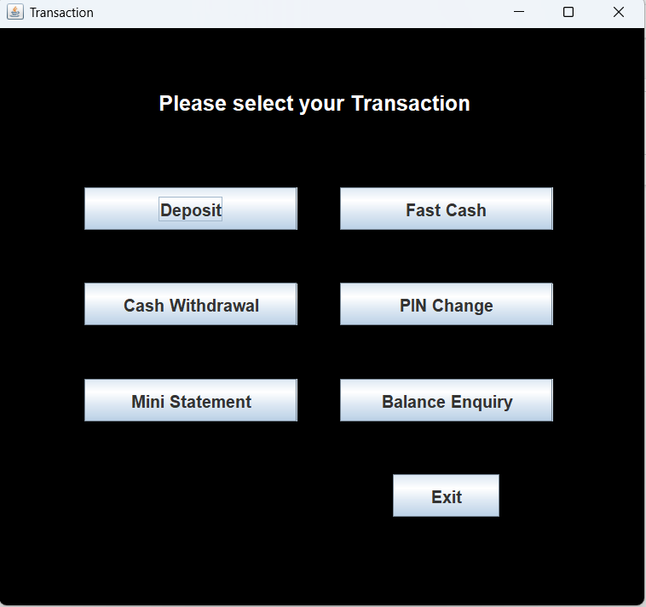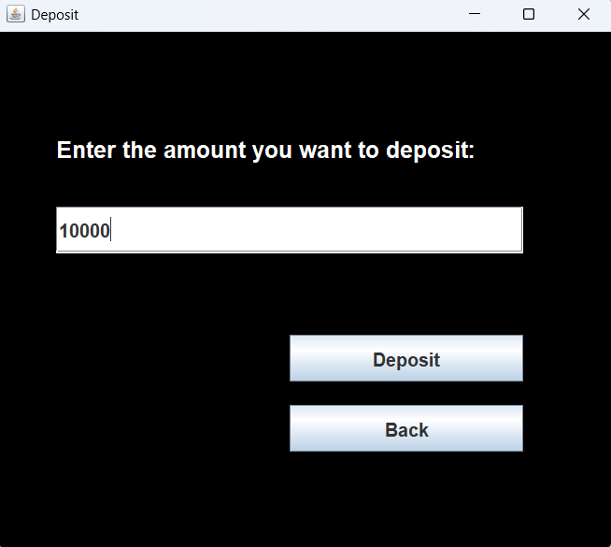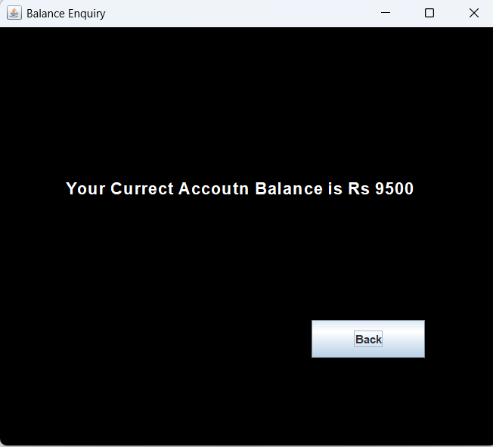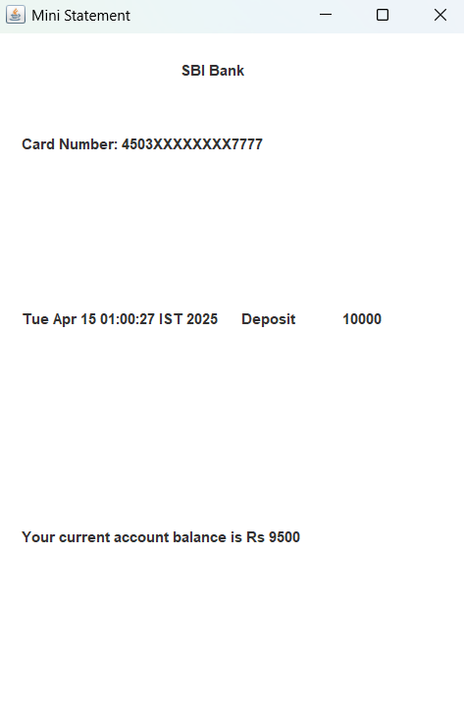

6.Database Used
The Banking Management System utilizes MySQL as the database management system for storing all user information and transaction details. The system is designed with a well-structured relational database that contains multiple tables to manage different data components, such as:
- Users Table: Stores user information like name, address, contact details, and login credentials.
- Transactions Table: Records all deposits, withdrawals, and transaction histories.
- Account Table: Holds account-related data, including balance and account status.
The database is connected to the Java application using JDBC (Java Database Connectivity), which enables smooth interaction between the user interface and the stored data.
USE BankingManagementSystem;
create database BankingManagementSystem;
show databases;

-- Table One
create table signup(formno varchar(20),userName varchar(20),userFather varchar(50),userdob varchar(20),userGender varchar(20),gmail varchar(50),userAddress varchar(50),userCity varchar(20),userState varchar(20),userPin varchar(20));
show tables;
select * from signup;

-- Table Two
CREATE TABLE signuptwo (
formno varchar(20),
religion VARCHAR(50),
category VARCHAR(50),
income VARCHAR(50),
education VARCHAR(50),
occupation VARCHAR(50),
pan_number VARCHAR(80),
aadhar_number VARCHAR(80),
senior_citizen VARCHAR(30),
existing_account VARCHAR(30)
);
select * from signuptwo;

-- Table Three
CREATE TABLE signupthree (
formno VARCHAR(20),
accountType VARCHAR(50),
cardNumber VARCHAR(25),
pinNumber VARCHAR(10),
services VARCHAR(255)
);

select * from signupthree;
create table login(formno varchar(20), cardNumber varchar(25),pin varchar(10));
select * from login;
create table bank(pin varchar(10), date varchar(50), type varchar(20), amount varchar(20));
select *from bank;

Screenshots:
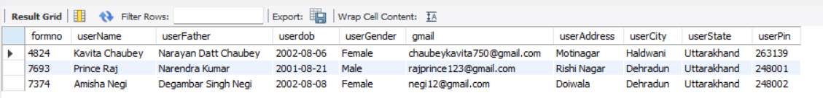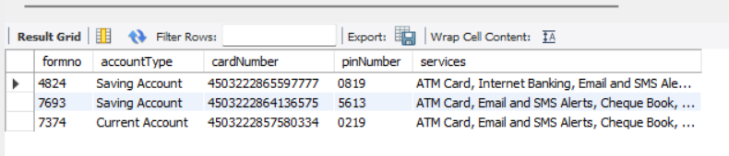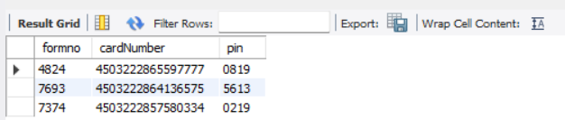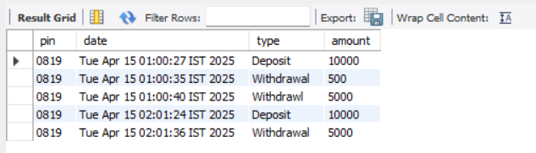

7. Conclusion
In conclusion, the Banking Management System project successfully integrates key concepts of programming, database management, and software design. The system is developed using Java Swing for the front-end and MySQL for back-end data storage, making it a fully functional, user-friendly application. By implementing core banking operations like user registration, login, transactions, and balance management, the project not only demonstrates the application of theoretical knowledge but also provides practical experience in software development.
The project was completed as part of the MCA curriculum, and it helped in enhancing teamwork, problem-solving, and technical skills. The overall implementation was tested for robustness, and the system is ready for further expansion and improvement. This project has provided us with valuable experience in handling real-world challenges, such as ensuring data security, handling user interactions, and performing database operations efficiently.

8. References
- Java Documentation - Oracle, "The Java™ Tutorials," https://docs.oracle.com/javase/tutorial/
- MySQL Documentation - MySQL, "MySQL 8.0 Reference Manual," https://dev.mysql.com/doc/
- GeeksforGeeks, "Java Swing Tutorial," https://www.geeksforgeeks.org/java-swing/
- TutorialsPoint, "JDBC Tutorial," https://www.tutorialspoint.com/jdbc/index.htm

9. Appendix
The appendix includes supplementary materials that provide additional context and details on the development process of the Banking Management System. This may include:
- Screenshots of the Application: Visual representations of the user interface, including SignUp, Login, Transaction, and Mini Statement pages.
- Code Listings: Excerpts of key sections of the Java code used to implement the system’s functionality.
- Database Schema: Diagram or table schema used in the MySQL database to represent the structure of tables like Users, Transactions, and Accounts.
- Test Cases: A set of test cases that were used to verify the functionality and performance of the system.

