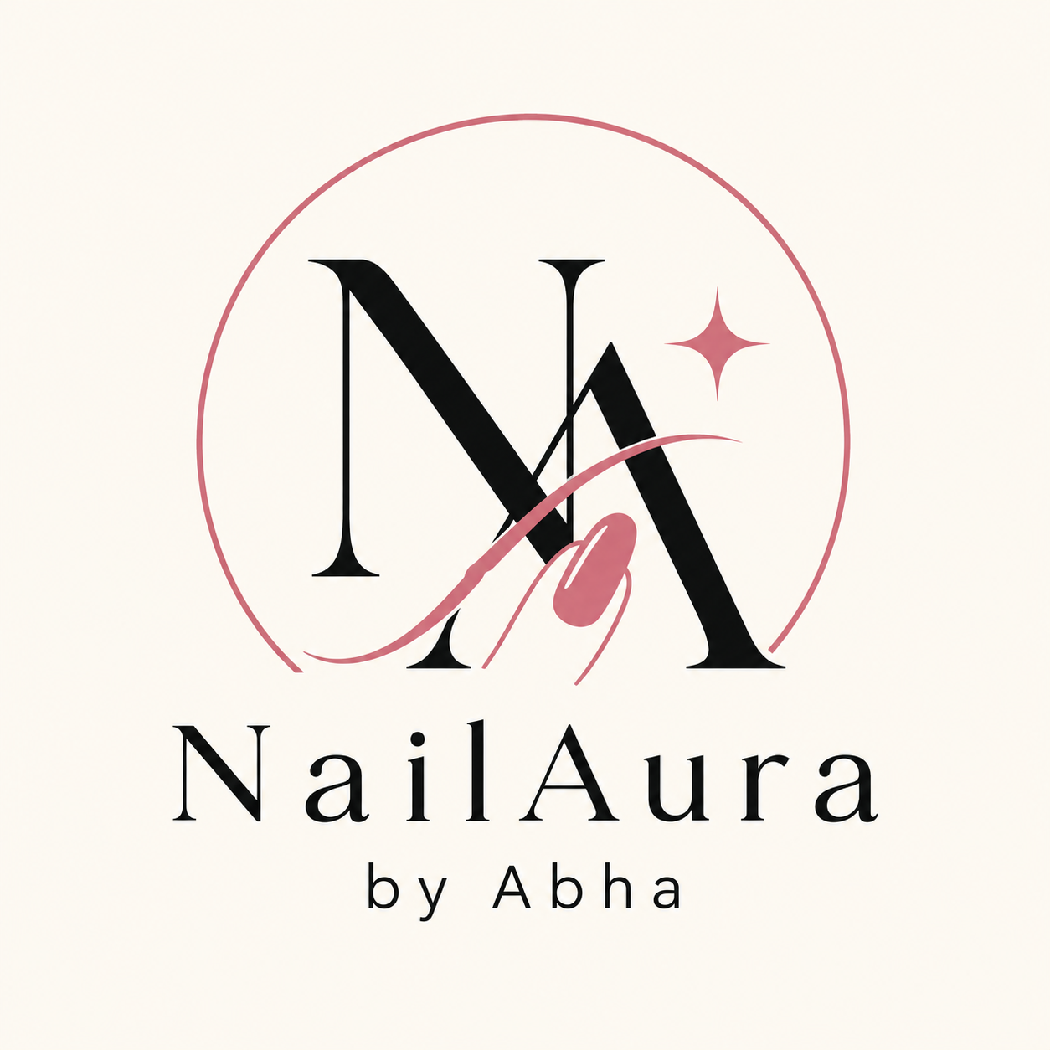
COMPLETE WEBSITE COPYWRITING
Brand story • Homepage • Shop • Product pages • FAQs • SEO
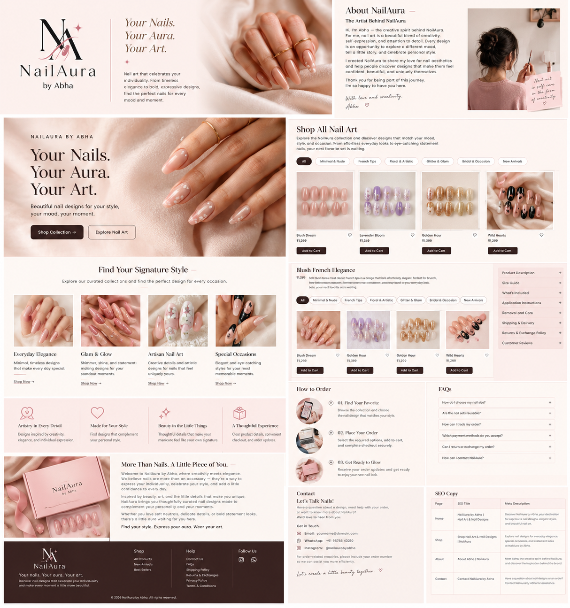

Brand Direction
Brand name: NailAura by Abha
Tagline: Your Nails. Your Aura. Your Art.
Visual style: blush pink, ivory, dusty rose, and charcoal; elegant serif headings; spacious layouts; delicate sparkle details; and polished nail-art photography.
Brand voice: artistic, warm, confident, feminine, and welcoming.

1. Homepage

Hero Section
Eyebrow: NAILAURA BY ABHA
Headline: Your Nails. Your Aura. Your Art.
Discover nail art that reflects your personality. From timeless elegance to bold, expressive designs, find the perfect nails for every mood and moment.
Primary button: Shop Collection
Secondary button: Explore Nail Art

Featured Categories
Everyday Elegance — Minimal, timeless designs that make every day feel special. Button: Explore Collection.
Glam & Glow — Shimmer, shine, and statement-making designs for your standout moments. Button: Shop Glam.
Artisan Nail Art — Creative details and artistic designs for nails that feel uniquely yours. Button: Discover Designs.
Special Occasions — Elegant designs for celebrations, parties, and memorable moments. Button: Shop Occasion Nails.

2. Brand Introduction

More Than Nails. A Little Piece of You.
Welcome to NailAura by Abha, where creativity meets elegance.
We believe nails are more than an accessory — they're a way to express your individuality, celebrate your style, and add a little confidence to every day.
Inspired by beauty, art, and the little details that make you unique, NailAura brings you thoughtfully curated nail designs made to complement your personality and your moments.
Whether you love soft neutrals, delicate details, or bold statement looks, there's a little aura waiting for you here.
Find your style. Express your aura. Wear your art.

3. Shop Page
Title: Shop All Nail Art
Explore the NailAura collection and discover designs that match your mood, style, and occasion. From effortless everyday looks to eye-catching statement nails, your next favorite set is waiting.
Suggested filters:
- All Designs
- Minimal & Nude
- French Tips
- Floral & Artistic
- Glitter & Glam
- Bridal & Occasion
- New Arrivals
- Best Sellers
Only publish categories that match the products actually sold.

4. Product Page Template
Sample product name: Blush French Elegance
Description: Soft blush tones meet classic French tips in a design that feels effortlessly elegant. Perfect for brunch dates, celebrations, or adding a polished touch to your everyday look.

Product details
- Design: Blush pink French tips
- Shape: Almond
- Finish: Glossy
- Size: Customer selects a suitable size
- What's included: List the exact items included in the set
Recommended product sections: Product Description; Size Guide; What's Included; Application Instructions; Removal & Care; Shipping & Delivery; Returns & Exchanges; Customer Reviews.
Confirm the actual shape, finish, sizes, and kit contents before publishing this sample.

5. Why Choose NailAura?
Artistry in Every Detail — Designs inspired by creativity, elegance, and individual expression.
Made for Your Style — Find designs that complement your personal style, from subtle to statement-making.
Beauty in the Little Things — Thoughtful details that make your manicure feel like your own signature.
A Thoughtful Shopping Experience — Clear product details, convenient checkout, and order updates to help you shop confidently.
These are proposed brand messages, not verified claims about manufacturing, quality guarantees, or delivery performance.

6. About Abha

The Artist Behind NailAura
Hi, I'm Abha — the creative spirit behind NailAura.
For me, nail art is a beautiful blend of creativity, self-expression, and attention to detail. Every design is an opportunity to explore a different mood, tell a little story, and celebrate personal style.
I created NailAura to share my love for nail aesthetics and help people discover designs that make them feel confident, beautiful, and uniquely themselves.
Thank you for being part of this journey. I'm so happy to have you here.
With love and creativity,
Abha

7. How to Order
01. Find Your Favorite — Browse the collection and choose the nail design that matches your style.
02. Place Your Order — Select the required options, add your design to the cart, and complete checkout securely.
03. Get Ready to Glow — Receive your order updates and get ready to enjoy your new nail look.
Adjust these steps to reflect the actual order fulfillment and delivery process.

8. Frequently Asked Questions
How do I choose my nail size?
Use our size guide to measure your nails and select the most suitable option. If custom sizing is offered, explain how customers can submit their measurements.
Are the nail sets reusable?
Check each product description for reuse instructions and the recommended application and removal method.
How can I track my order?
Once your order has been shipped, use the tracking link shared in your shipping notification, if available.
Which payment methods do you accept?
Pay using the payment options displayed at checkout. Available methods depend on the payment gateway configuration.
Can I return or exchange my order?
Please review our Returns & Exchanges policy for eligibility, timelines, and product-specific conditions.
How can I contact NailAura?
Reach out through our Contact page or the WhatsApp support link provided on the website.

9. Contact Page

Let's Talk Nails!
Have a question about a design, need help with your order, or want to know more about NailAura? We'd love to hear from you.
- Email: [Your business email]
- WhatsApp: [Your business number]
- Instagram: [Your Instagram handle]
For order-related enquiries, please include your order number so we can assist you more efficiently.
Let's create a little beauty together.

10. Footer Copy
NailAura by Abha
Your nails. Your aura. Your art.
Discover nail designs that celebrate your individuality and make every moment a little more beautiful.
Shop: All Products · New Arrivals · Best Sellers
Help: Contact Us · FAQs · Shipping Policy · Returns & Exchanges · Privacy Policy · Terms & Conditions
© 2026 NailAura by Abha. All rights reserved.

11. SEO Titles & Meta Descriptions
Page | SEO Title | Meta Description
Home | NailAura by Abha | Nail Art & Nail Designs | Discover NailAura by Abha, your destination for expressive nail designs, elegant styles, and beautiful nail art.
Shop | Shop Nail Art & Nail Designs | NailAura | Explore nail designs for everyday elegance, special occasions, and statement looks at NailAura by Abha.
About | About Abha | NailAura | Meet Abha, the creative spirit behind NailAura, and discover the inspiration behind the brand.
Contact | Contact NailAura by Abha | Have a question about nail designs or an order? Contact NailAura by Abha for assistance.

12. Suggested Homepage Structure
- Header: logo, Shop, About, FAQs, Contact, search, account, and cart icons.
- Hero: tagline, short introduction, nail-art image, and Shop Collection button.
- Featured categories: Everyday Elegance, Glam & Glow, Artisan Nail Art, Special Occasions.
- Best sellers and new arrivals with product photos, prices, and Add to Cart.
- Brand introduction with a link to the About page.
- Why NailAura: four concise value statements.
- How to order: three simple steps.
- Customer reviews using genuine customer feedback only.
- Instagram/social gallery with approved brand images.
- Optional newsletter signup with clear consent and privacy notice.
- Footer with shop links, help links, contact details, social links, and legal policies.

13. Before Publishing
- Replace placeholders with real contact details and social links.
- Confirm the products sold: press-on nails, nail accessories, salon services, or a combination.
- Add accurate prices, sizes, materials, kit contents, care instructions, shipping timelines, and return conditions.
- Avoid unsupported claims about manufacturing, quality guarantees, or delivery promises.
- Publish accurate Privacy Policy, Terms & Conditions, Shipping Policy, and Returns & Exchanges pages.
- Use original or properly licensed product photos. The cover moodboard is a design reference, not a substitute for actual product photography.

