Model 2: Architecture and Test Results
Cornell RGB-D robotic grasp prediction | Code and checkpoint review, 24 September 2026

1. Model summary
Model 2 is the improved GG-CNN-inspired fully convolutional encoder-decoder implemented in models/ggcnn.py. It accepts a 4-channel RGB-D image (RGB plus normalized depth, resized to 300 x 300) and predicts full-resolution maps for grasp quality, grasp angle, and gripper opening width. The angle is represented by cos(2 x ) and sin(2 x ), which encodes the antipodal symmetry of parallel-jaw grasps. Training augmentation applies horizontal and vertical flips and 90-degree rotations to training samples only.
This is a compact project model inspired by GG-CNN; it is not a reproduction of the full published GG-CNN architecture.

2. Exact architecture
Unless stated otherwise, each ConvBlock convolution uses bias, followed by BatchNorm2d and in-place ReLU. ConvBlock convolutions use 3 x 3 kernels, stride 1, and padding 1. Downsampling convolutions are followed by ReLU. Skip connections concatenate the encoder feature map with the upsampled decoder feature map.
Stage | Operation | Output shape | Kernel / stride / padding
Input | RGB-D tensor | 4 x 300 x 300 | x
Encoder 1, conv 1 | Conv2d 4 x 32; BN; ReLU | 32 x 300 x 300 | 3 x 3, s1, p1
Encoder 1, conv 2 | Conv2d 32 x 32; BN; ReLU | 32 x 300 x 300 | 3 x 3, s1, p1
Down 1 | Conv2d 32 x 64; ReLU | 64 x 150 x 150 | 4 x 4, s2, p1
Encoder 2, conv 1 | Conv2d 64 x 64; BN; ReLU | 64 x 150 x 150 | 3 x 3, s1, p1
Encoder 2, conv 2 | Conv2d 64 x 64; BN; ReLU | 64 x 150 x 150 | 3 x 3, s1, p1
Down 2 | Conv2d 64 x 128; ReLU | 128 x 75 x 75 | 4 x 4, s2, p1
Bottleneck, conv 1 | Conv2d 128 x 128; BN; ReLU | 128 x 75 x 75 | 3 x 3, s1, p1
Bottleneck, conv 2 | Conv2d 128 x 128; BN; ReLU | 128 x 75 x 75 | 3 x 3, s1, p1
Up 1 | ConvTranspose2d 128 x 64 | 64 x 150 x 150 | 4 x 4, s2, p1
Skip + Decoder 1, conv 1 | Concat with 64-channel Encoder 2; Conv2d 128 x 64; BN; ReLU | 64 x 150 x 150 | 3 x 3, s1, p1
Decoder 1, conv 2 | Conv2d 64 x 64; BN; ReLU | 64 x 150 x 150 | 3 x 3, s1, p1
Up 2 | ConvTranspose2d 64 x 32 | 32 x 300 x 300 | 4 x 4, s2, p1
Skip + Decoder 2, conv 1 | Concat with 32-channel Encoder 1; Conv2d 64 x 32; BN; ReLU | 32 x 300 x 300 | 3 x 3, s1, p1
Decoder 2, conv 2 | Conv2d 32 x 32; BN; ReLU | 32 x 300 x 300 | 3 x 3, s1, p1
Quality head | Conv2d 32 x 1; raw logit map | 1 x 300 x 300 | 1 x 1, s1, p0
Angle heads | Two Conv2d heads, each 32 x 1: cos(2 x ), sin(2 x ) | 2 x (1 x 300 x 300) | 1 x 1, s1, p0
Width head | Conv2d 32 x 1; raw map, sigmoid for width | 1 x 300 x 300 | 1 x 1, s1, p0
The two angle maps are converted at inference to x = 0.5 x atan2(sin(2 x ), cos(2 x )). Quality and width are converted with sigmoid. The four output heads have no explicit activation in the model forward pass.
Total trainable parameters: 847,268 (4-channel RGB-D input, base_channels=32, cos_sin angle heads).

3. Training and optimization
- Run recorded in checkpoints_gpu: 100 epochs; batch size 8; Adam; learning rate 0.001; weight decay 0.00001; seed 42; full precision. CUDA is selected automatically when available. The checkpoint does not record the device used for its original training, so the run x s GPU usage cannot be confirmed from the saved artifacts alone.
- No gradient clipping is implemented. No learning-rate scheduler is implemented; the configured learning rate remains constant.
- Loss weights: quality 1.0, angle 1.0, width 0.5. Quality uses binary cross-entropy with logits. Angle and width losses are applied within annotated grasp-mask pixels; angle uses the mean of Smooth L1 losses for its cosine and sine maps, and width applies sigmoid before Smooth L1.
- Best checkpoint: epoch 77, recorded best validation loss 0.129474. The log contains all 100 epochs; epoch 100 validation loss was 0.134585.

4. 70/15/15 split and held-out test result
The saved checkpoint config uses val_split=0.15, test_split=0.15, and seed 42. The deterministic shuffled split produced 885 samples: 619 train (69.94%), 133 validation (15.03%), and 133 test (15.03%). The subsets are disjoint. Training and checkpoint selection use the train and validation subsets; the test set was evaluated after training.
Held-out test result: 107 / 133 correct = 80.45% accuracy. A sample is counted correct when at least one annotated grasp has rectangle IoU x 0.25 and antipodal angle difference x 30 x . This result was computed from checkpoints_gpu/best.pt using the saved split configuration.

5. Model 2 examples from the test split
Red rectangles show Model 2 predictions; green rectangles show Cornell positive grasp annotations. Examples are drawn from the same held-out test split. x Success x uses the evaluation rule above. This report covers Model 2 only and does not make a Model 1 comparison.
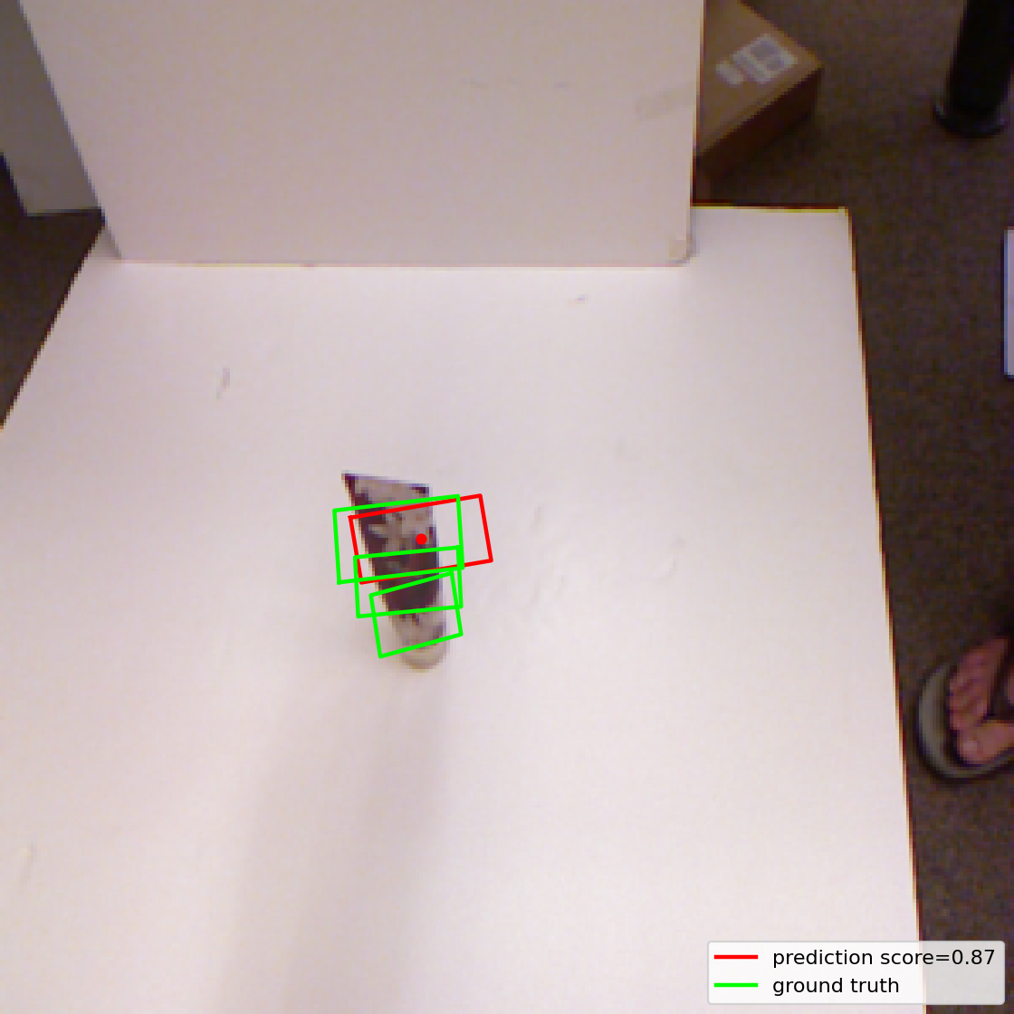
Success - test sample 0 (pcd0243r.png): IoU 0.644; angle error 2.94 degrees.
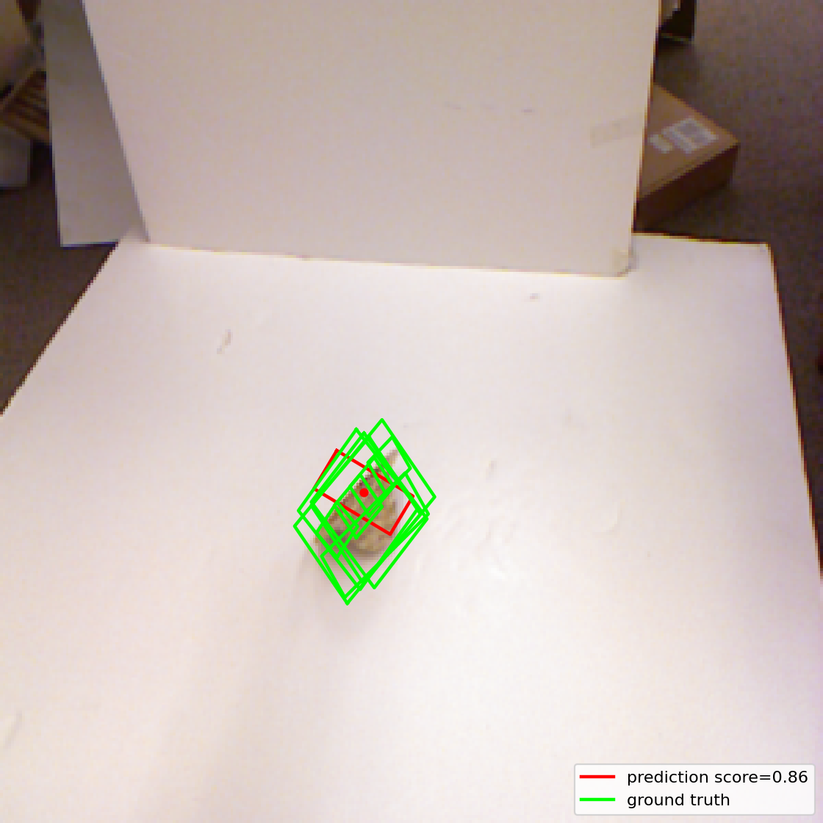
Success - test sample 1 (pcd0893r.png): IoU 0.397; angle error 21.06 degrees.
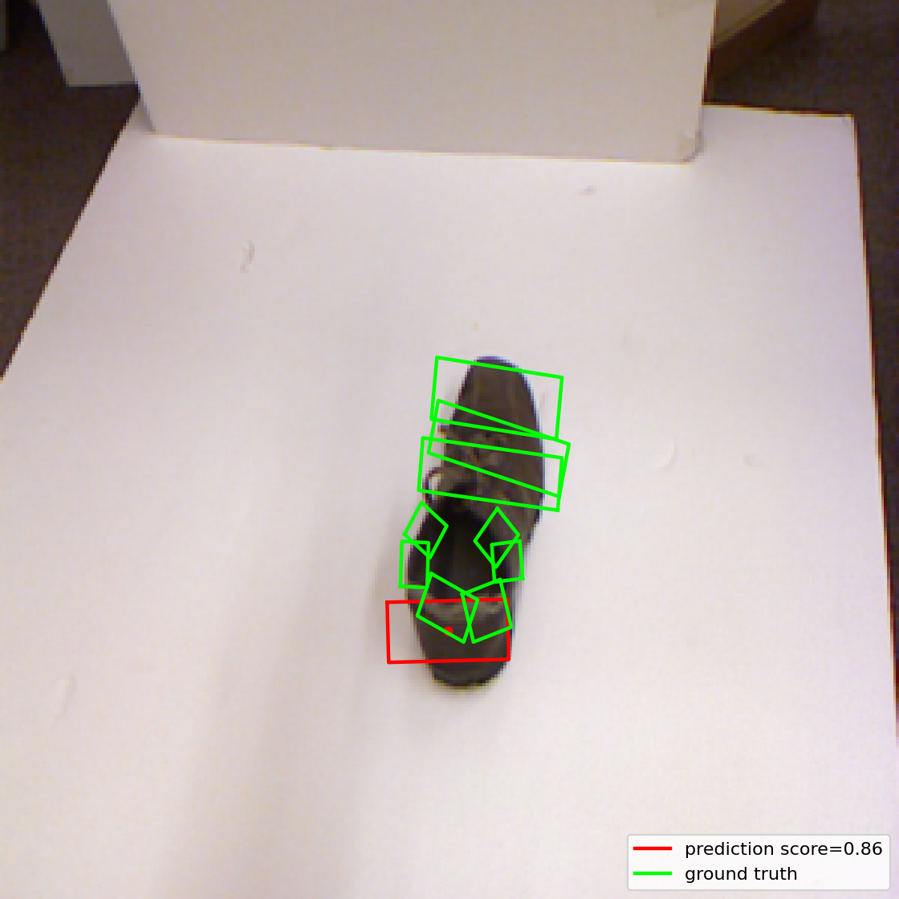
Failure - test sample 9 (pcd0269r.png): IoU 0.195; angle error 70.12 degrees.
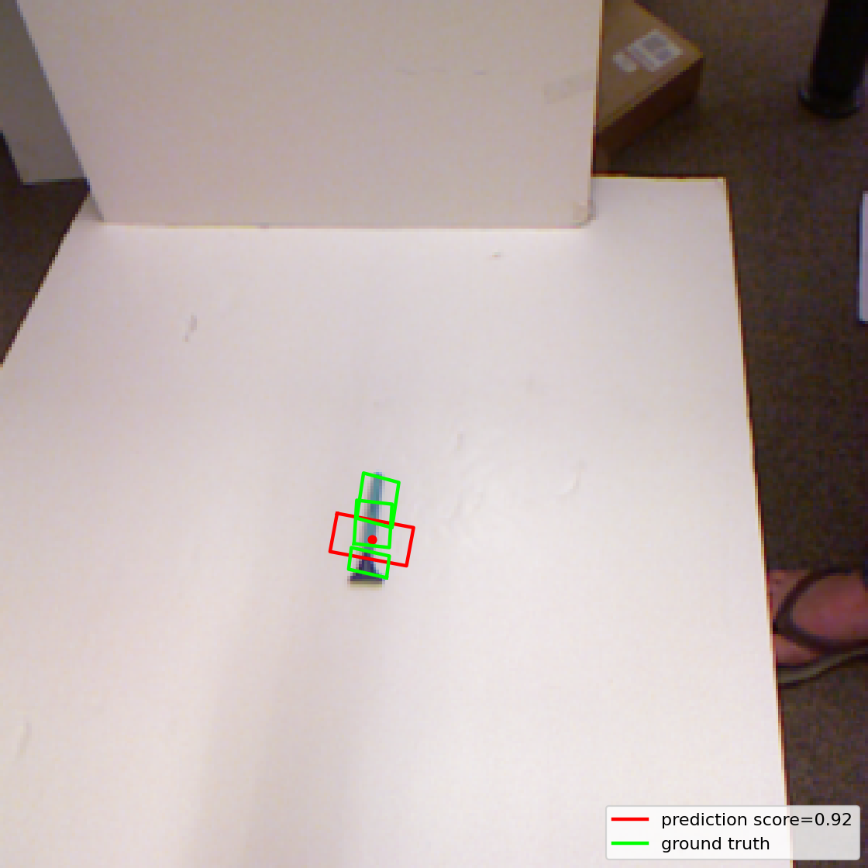
Failure - test sample 19 (pcd0219r.png): IoU 0.247; angle error 4.19 degrees.

6. Files and reproducibility notes
Architecture: models/ggcnn.py. Dataset split and augmentation: data/cornell.py. Optimization loop and loss: train.py. Split and training settings: configs/baseline.yaml. Test evaluation: evaluate.py. Visual test examples are also saved under outputs/model2_test_examples/. No training was launched while preparing this report; the report summarizes the completed checkpoint already present in the project.

