Research Handoff Report: RGB-D Robotic Grasp Prediction
Project: Mihika_grasp_Prediction | Prepared for: Research Team | Date: 2026-05-28

1. Executive Summary
This project implements a lightweight PyTorch baseline for vision-based robotic grasp prediction on the Cornell Grasp Dataset. The system receives RGB-D images and predicts dense per-pixel maps for grasp quality, grasp angle, and gripper opening width. A single grasp proposal is selected from the highest-quality pixel and evaluated against annotated Cornell positive grasp rectangles.
- Dataset used: Cornell Grasp Dataset, 885 detected RGB-D samples.
- Split used in the completed run: 708 training samples and 177 validation samples, with seed 42.
- Best checkpoint: checkpoints/best.pt, selected at epoch 24 by lowest validation loss (0.279850).
- Validation grasp-detection result: 95 correct predictions out of 177 validation samples, accuracy 0.5367.
- Correctness criterion: predicted rectangle IoU >= 0.25 and angular error <= 30 degrees against at least one ground-truth rectangle.

2. Project Objective
The objective is to predict robotic grasp candidates from RGB-D visual observations without robot hardware, ROS, or simulator dependencies. The codebase is positioned as a minimum viable research baseline that can be extended with improved architectures, augmentation, closed-loop simulation, or real-robot experiments.

3. Data Pipeline
- Input source: Cornell Grasp Dataset stored under data/cornell.
- For each sample, the loader searches recursively for an RGB image, a depth image, and a positive grasp annotation file using Cornell naming patterns such as pcd0100r.png, pcd0100d.tiff, and pcd0100cpos.txt.
- Images are resized to 300 x 300 pixels. RGB values are scaled to [0, 1], then normalized to approximately [-1, 1].
- Depth is normalized per image using robust 1st and 99th percentiles, clipped to [0, 1], then normalized to approximately [-1, 1].
- The active input mode is RGB-D, producing a 4-channel tensor with 3 RGB channels plus 1 depth channel.
- Each Cornell grasp annotation is converted from four corner points into dense target maps: quality, angle, and normalized width.
- Quality is 1.0 inside annotated grasp rectangles and 0.0 elsewhere. Angle and width are supervised only inside the grasp mask.
Item | Value
Total detected samples | 885
Training samples | 708
Validation samples | 177
Input mode | rgbd
Input channels | 4
Image size | 300 x 300
Validation split | 0.2
Random seed | 42

4. Model Architecture
The model is a lightweight GG-CNN-inspired fully convolutional encoder-decoder network. It is not a full reproduction of the original GG-CNN paper; it is a pragmatic baseline for dense grasp-map prediction.
- Encoder: two convolutional blocks with downsampling convolutions.
- Bottleneck: convolutional block at reduced spatial resolution.
- Decoder: transposed convolutions with skip connections from encoder feature maps.
- Output heads: three 1 x 1 convolution heads for quality logits, angle regression, and width logits.
- Width is passed through a sigmoid during loss computation and inference to keep it normalized in [0, 1].

5. Training Procedure
Training setting | Value
Epochs | 100
Batch size | 8
Optimizer | Adam
Learning rate | 0.001
Weight decay | 1e-05
Checkpoint policy | Save best.pt on lowest validation loss; save last.pt each epoch
Training log | outputs/train_log.csv

The composite loss combines binary cross entropy for the grasp-quality map with Smooth L1 losses for angle and width. Angle and width losses are masked to annotated grasp regions so background pixels do not dominate the regression objectives.
Loss component | Function | Weight
Quality map | Binary cross entropy with logits | 1.0
Angle map | Smooth L1 on grasp-mask pixels | 1.0
Width map | Smooth L1 on sigmoid(width) over grasp-mask pixels | 0.5

Training curve from outputs/train_log.csv:
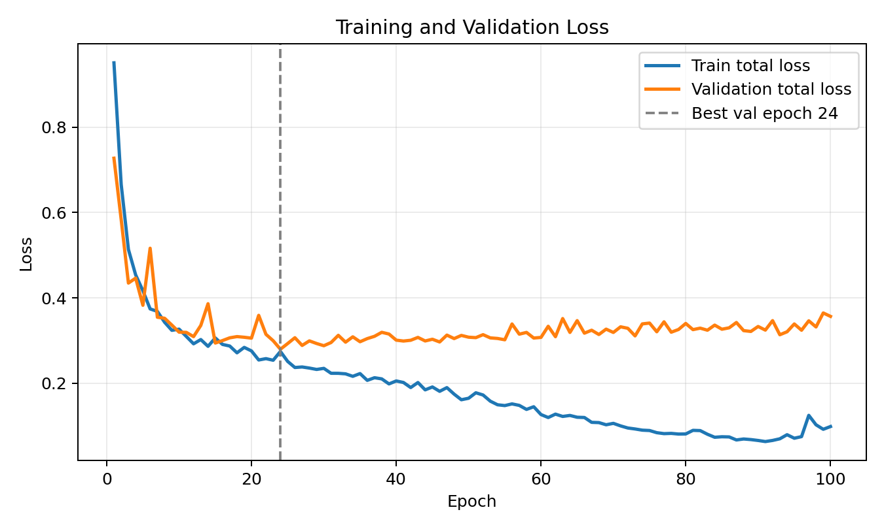

6. Training Metrics
Metric | Best validation epoch | Final epoch
Epoch | 24 | 100
Train loss | 0.274653 | 0.098894
Train quality loss | 0.028133 | 0.020424
Train angle loss | 0.245883 | 0.078020
Train width loss | 0.001274 | 0.000901
Validation loss | 0.279850 | 0.356756
Validation quality loss | 0.028310 | 0.023910
Validation angle loss | 0.250813 | 0.332320
Validation width loss | 0.001452 | 0.001052

The best validation loss occurred at epoch 24. Later epochs continued reducing training loss but validation loss increased, indicating overfitting or limited generalization under the current split and architecture.

7. Evaluation Protocol and Output Metrics
At inference time, the model outputs dense maps. The pipeline applies sigmoid to the quality map, selects the pixel with maximum quality, reads angle and width at that location, and converts those values into an oriented grasp rectangle. A prediction is counted as correct if it matches at least one positive Cornell rectangle under the configured IoU and angular thresholds.
Evaluation item | Value
Checkpoint evaluated | checkpoints/best.pt
Split | Validation
Samples | 177
Correct predictions | 95
Accuracy | 0.5367
IoU threshold | 0.25
Angle threshold | 30.0 degrees

Qualitative example from outputs/prediction_sample_0.png. Red shows the predicted grasp rectangle; green shows Cornell positive grasp annotations.
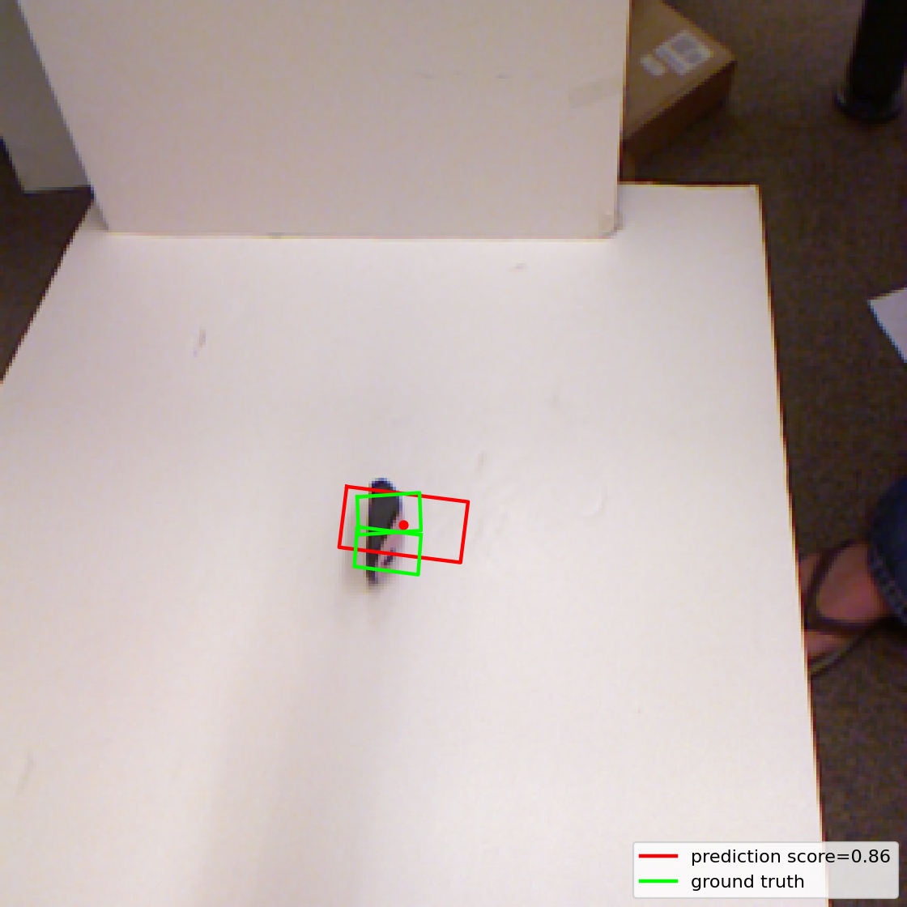

8. Generated Artifacts and Outputs
Artifact | Purpose
checkpoints/best.pt | Best model checkpoint selected by validation loss at epoch 24.
checkpoints/last.pt | Final checkpoint after epoch 100.
checkpoints/config.yaml | Configuration saved with the training run.
outputs/train_log.csv | Per-epoch training and validation losses.
outputs/training_validation_loss_curve.png | Generated loss-curve figure for reporting.
outputs/prediction_sample_0.png | Generated qualitative prediction overlay.
Research_Team_Handoff_Grasp_Prediction.docx | This handoff document.

9. Codebase Map
Path | Role
data/cornell.py | Dataset discovery, RGB-D loading, resizing, normalization, and dense target-map generation.
models/ggcnn.py | GG-CNN-inspired encoder-decoder baseline model.
train.py | Training loop, loss computation, logging, and checkpointing.
evaluate.py | Validation/test evaluation using rectangle IoU and angle threshold.
visualize.py | Qualitative overlay generation for predicted and ground-truth grasps.
utils/geometry.py | Grasp rectangle construction, polygon IoU, and angle utilities.
utils/prediction.py | Conversion from dense output maps to a single grasp proposal.
configs/baseline.yaml | Default configuration for data, training, loss, and evaluation.

10. Research Interpretation
- The baseline demonstrates that a simple dense RGB-D CNN can learn usable grasp proposals on Cornell, reaching 53.67 percent validation accuracy under the common IoU-plus-angle criterion.
- Validation loss is dominated by angle loss, suggesting angle representation is a major limitation of the current direct-radian regression approach.
- The gap between final training loss and final validation loss suggests overfitting and motivates augmentation, stronger regularization, object-wise cross-validation, or a more robust evaluation protocol.
- The current evaluation selects only one highest-confidence grasp per image. Future work could evaluate top-k proposals or use non-maximum suppression over quality peaks.

11. Recommended Next Steps for Paper-Ready Work
- Replace direct angle regression with cos(2 theta) and sin(2 theta) targets to handle antipodal grasp symmetry and angle wraparound.
- Add spatial and photometric augmentation, including rotations, crops, depth noise, and brightness/contrast perturbations.
- Report results across multiple random seeds and preferably object-wise or image-wise cross-validation folds.
- Compare against stronger baselines or published methods under the same Cornell evaluation criterion.
- Add ablations for RGB-only, depth-only, and RGB-D inputs; loss weights; and architecture capacity.
- Record hardware, training runtime, inference latency, and model parameter count for reproducibility.
- Consider simulator or real-robot closed-loop experiments if the target paper requires physical grasp-success validation.

12. Reproducibility Commands
- python train.py --config configs/baseline.yaml
- python evaluate.py --checkpoint checkpoints/best.pt
- python visualize.py --checkpoint checkpoints/best.pt --sample_id 0
Environment observed while preparing this handoff: PyTorch 2.12.0+cpu, NumPy 2.2.6, Pillow 12.2.0, Matplotlib 3.10.9, CUDA unavailable.

