Researcher Handoff: Accuracy Improvement Changes and Results
Project: Mihika_grasp_Prediction | Date: 2026-05-29 | Dataset: Cornell Grasp Dataset

1. Purpose of This Handoff
This document summarizes the accuracy-improvement changes incorporated into the RGB-D robotic grasp prediction project, the rationale behind each change, and the metrics obtained after evaluating the updated checkpoint. It is intended for the research team so the changes and results can be referenced while preparing a paper or technical report.

2. Summary of Incorporated Changes
- Changed grasp-angle learning from direct radian regression to a symmetry-aware representation using cos(2 theta) and sin(2 theta).
- Added train-time data augmentation for square RGB-D samples using horizontal flips, vertical flips, and 90-degree rotations.
- Updated model output heads from one angle head to two angle heads: angle_cos_head and angle_sin_head.
- Updated the loss function to supervise angle_cos and angle_sin only inside annotated grasp-mask pixels.
- Updated inference to recover theta using 0.5 * atan2(angle_sin, angle_cos).
- Added backward-compatible checkpoint loading so old direct-angle checkpoints can still be evaluated or visualized.
- Updated the README and smoke test to reflect the new training and model behavior.
Changed file | Research relevance
data/cornell.py | Generates cos/sin angle targets and applies label-consistent augmentation.
models/ggcnn.py | Adds cos/sin angle-output heads while retaining direct-angle mode for old checkpoints.
train.py | Uses masked Smooth L1 loss over cos/sin targets and enables augmentation from config.
utils/prediction.py | Converts cos/sin network outputs back to a grasp angle for evaluation/visualization.
evaluate.py | Detects checkpoint angle representation and evaluates both old and new checkpoints.
visualize.py | Detects checkpoint angle representation and visualizes both old and new checkpoints.
configs/baseline.yaml | Enables augmentation with data.augment: true.
tests/smoke_test.py | Verifies forward pass and loss backpropagation for the new heads.
README.md | Documents the improved angle representation and augmentation path.

3. Why These Changes Improve Accuracy
Robotic grasp rectangles are antipodal: a grasp at theta and theta + pi is physically equivalent for a parallel-jaw gripper. Direct radian regression creates discontinuities near angle boundaries and can penalize equivalent grasps as if they were different. Predicting cos(2 theta) and sin(2 theta) encodes this symmetry directly and makes the regression target smoother for learning.
The augmentation changes expand the effective training distribution without adding new data. Flips and 90-degree rotations preserve grasp validity when angle labels are transformed consistently, helping reduce overfitting and improving generalization on the validation set.

4. Dataset and Experimental Setup
Item | Value
Dataset | Cornell Grasp Dataset
Total detected samples | 885
Training samples | 708
Validation samples | 177
Input mode | rgbd
Input channels | 4
Image size | 300 x 300
Validation split | 0.2
Seed | 42
Augmentation enabled | True

Training setting | Value
Epochs | 100
Batch size | 8
Optimizer | Adam
Learning rate | 0.001
Weight decay | 1e-05
Checkpoint selected | checkpoints/best.pt
Best checkpoint epoch | 90
Best checkpoint validation loss | 0.124869

5. Training Metrics From Improved Run
Metric | Best validation epoch | Final epoch
Epoch | 90 | 100
Train loss | 0.113660 | 0.110911
Train quality loss | 0.021349 | 0.021369
Train angle loss | 0.091858 | 0.089092
Train width loss | 0.000906 | 0.000899
Validation loss | 0.124869 | 0.126587
Validation quality loss | 0.022012 | 0.023414
Validation angle loss | 0.102321 | 0.102628
Validation width loss | 0.001072 | 0.001090

The lowest validation loss was obtained at epoch 90 with validation loss 0.124869. The final epoch validation loss was 0.126587, which is close to the best value and indicates more stable generalization than the earlier direct-angle baseline.
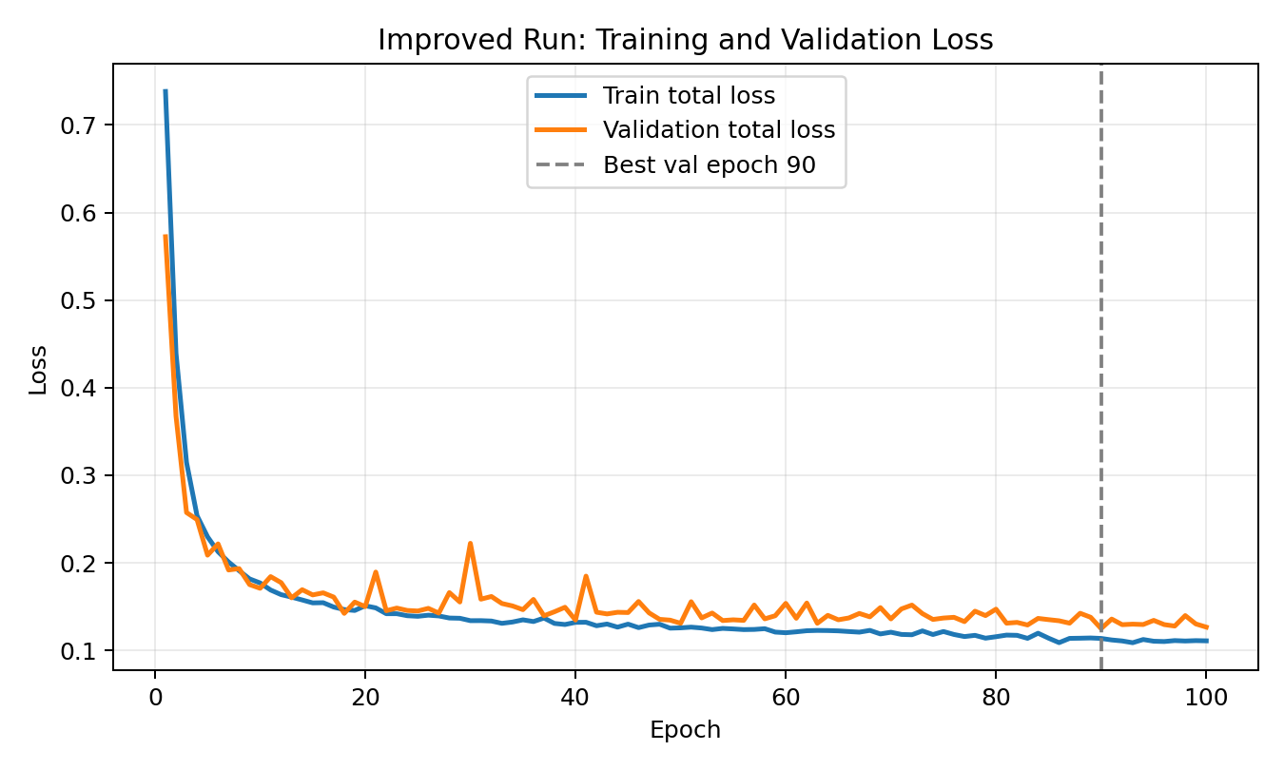

6. Evaluation Metrics and Results
Evaluation metric | Value
Checkpoint evaluated | checkpoints/best.pt
Split | Validation
Validation samples | 177
Correct predictions | 142
Accuracy | 0.8023
IoU threshold | 0.25
Angle threshold | 30.0 degrees

Comparison | Correct / Samples | Accuracy
Earlier direct-angle baseline | 95 / 177 | 0.5367
Improved cos/sin + augmentation checkpoint | 142 / 177 | 0.8023
Absolute improvement | +47 correct predictions | +0.2656
Relative accuracy improvement | N/A | +49.49%

Evaluation counted a prediction as correct when the predicted grasp rectangle matched at least one Cornell positive grasp annotation with IoU >= 0.25 and angular error <= 30 degrees. Under this criterion, the improved checkpoint achieved 80.23 percent validation accuracy.
Qualitative example from the improved checkpoint. Red indicates the predicted grasp rectangle; green indicates Cornell positive grasp annotations.
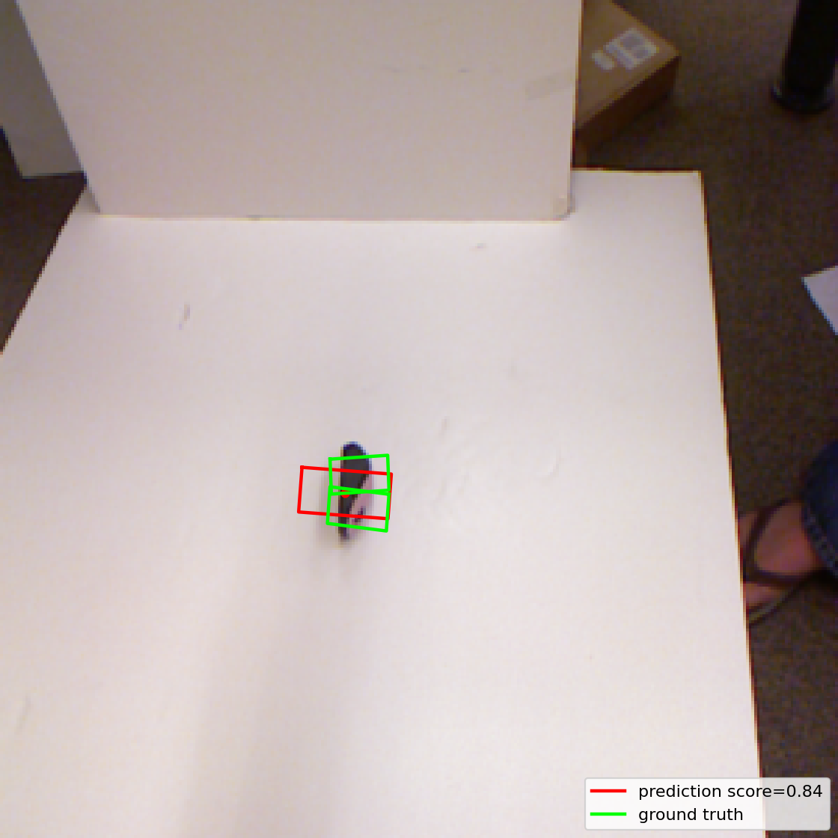

7. Verification Performed
- Smoke test passed for the new model outputs and loss backpropagation.
- A real Cornell RGB-D batch was previously checked through the updated model with expected output tensor shapes.
- The improved checkpoint was evaluated using evaluate.py and returned 142 correct predictions out of 177 validation samples.
- Visualization was regenerated for validation sample 0 using the improved checkpoint.

8. Research Notes and Interpretation
- The main improvement is likely attributable to the cos(2 theta) / sin(2 theta) target representation because it directly models antipodal grasp symmetry.
- Augmentation likely contributed by exposing the model to equivalent object-grasp configurations and reducing split-specific overfitting.
- The updated accuracy of 0.8023 is a substantial improvement over the earlier 0.5367 baseline on the same validation split and evaluation criterion.
- For paper-quality claims, the team should still run multiple seeds or folds, report confidence intervals, and compare against published Cornell baselines under matching protocols.

9. Reproducibility Commands
- ..\venv\Scripts\python.exe train.py --config configs\baseline.yaml
- ..\venv\Scripts\python.exe evaluate.py --checkpoint checkpoints\best.pt
- ..\venv\Scripts\python.exe visualize.py --checkpoint checkpoints\best.pt --sample_id 0 --split val --output outputs\improved_prediction_sample_0.png
- ..\venv\Scripts\python.exe tests\smoke_test.py

10. Recommended Next Experiments
- Run at least 3 to 5 random seeds and report mean accuracy plus standard deviation.
- Add RGB-only, depth-only, and RGB-D ablations to quantify the contribution of each input modality.
- Evaluate object-wise or image-wise cross-validation if the paper target expects Cornell protocol comparisons.
- Test richer augmentation such as random crops, small-angle rotations, depth noise, and color jitter.
- Report inference latency, parameter count, and training hardware for reproducibility.

